**EXP 2 EMPLOYEE DATABASE**

**Aim:**

Consider the employee database given below

**emp** (emp_id,emp_name, Street_No, city)

**works** (emp_id, company name, salary)

**company** (company name, city)

**manages** (emp_id, manager_id)

**Note: Emp_id should start with ‘E’ in Emp table and emp_id in works table must be the emp_id from emp table .emp_id and manager_id in manages table must be the emp_id from emp table**

create table emp(empid varchar(20) primary key check(empid like 'e%'),empname varchar(30),Street_no varchar(30),city varchar(30));

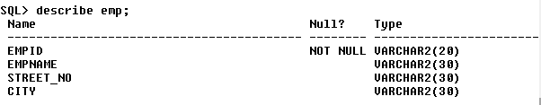

create table company(company_name varchar(30) primary key,city varchar(30));



create table works(empid varchar(20) references emp(empid),company_name varchar(30) references company(company_name),salary int);

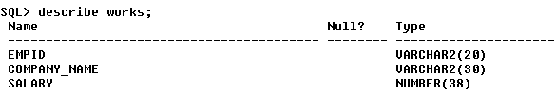

create table manages(empid varchar(20) references emp(empid),manager_id varchar(20) references emp(empid));



**Emp table**

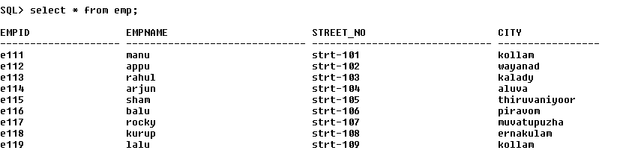

**Company table**



**Works table**

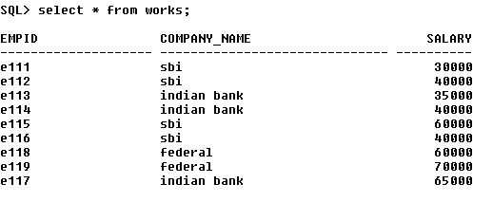

**Manages table**

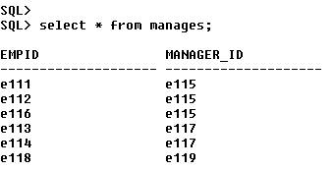

1. Find the names of all employees who work for SBI.

select empname from emp where empid in(select empid from works where company_name='sbi');

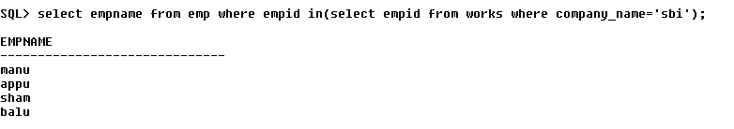

b. Find all employees in the database who live in the same cities as the companies for

which they work.

select empname from emp e,works w,company c where e.empid=w.empid and e.city=c.city and w.company_name=c.company_name;



c. Find all employees who earn more than the average salary of all employees of their

company.

select empname from emp e,works w where e.empid=w.empid and w.salary>(select avg(salary) from works s where w.company_name=s.company_name);

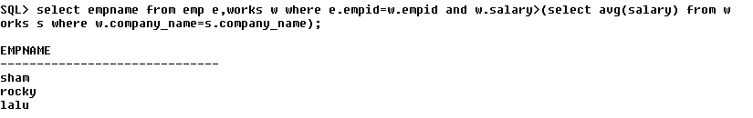

d. Give all managers of SBI a 10 percent raise.

update works w set salary=salary+salary*0.1 where company_name='sbi' and empid in(select manager_id from manages);

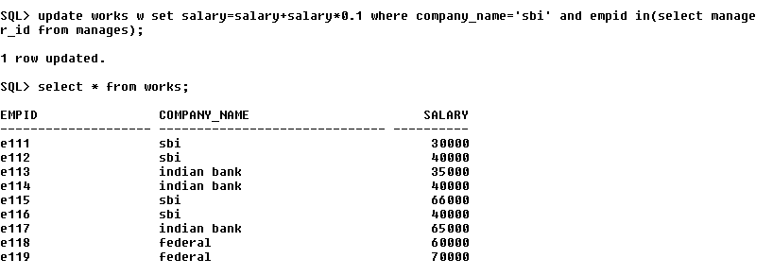

e. Find the company that has the most employees

select company_name from works,emp group by company_name having count(empname) = (select max(count(empname))from works,emp group by company_name);



f. Find those companies whose employees earn a higher salary, on average than the

average salary at Indian Bank.

select company_name from works group by company_name having avg(salary) > (select avg(salary) from works where company_name='indian bank');

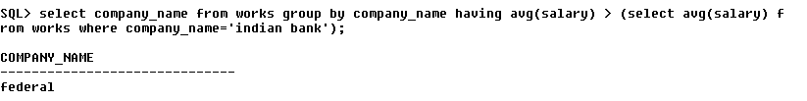

g. Query to find name and salary of all employees who earn more than each employee

of ‘Indian Bank’