**PL/SQL**

Q1: Write a PL/SQL program to find the factorial of a given number

set serveroutput on;

declare

fact number:=1;

n number:=&n;

begin

for i in 1..n

loop

fact:=fact*i;

end loop;

dbms_output.put_line('factorial='||fact);

end;

/

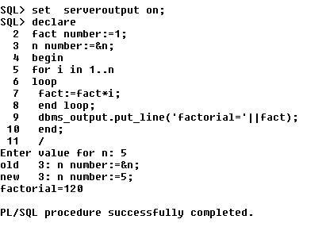

Q2: Write a PL/SQL program to check whether the given no is prime or not

set serveroutput on;

declare

i number:=2;

f number:=1;

n number:=&n;

begin

for i in 2..n/2

loop

if n mod i=0

then

f:=0;

exit;

end if;

end loop;

if f=1

then

dbms_output.put_line('prime');

else

dbms_output.put_line('not prime');

end if;

end;

/

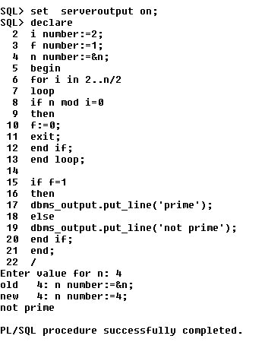

**Functions**

1. Write a PL/SQL program to Check whether a number is Armstrong or not using functions
2. Create table that contains itemid,item_name & price of several items sold in a grocery shop, Using functions retrieve the item name & price from table when itemid is given as input.
3. Write a PL/SQL function called POW that takes two numbers as argument and return the value of the first number raised to the power of the second .