**1.Work with built-in packages**

**Math module**

import math

print("The value of pi ",math.pi)

import math as m

print("The value of pi ",m.pi)

from math import pi,sqrt

print(math.pi)

print(math.sqrt(2))

print(math.tan(90))

print(math.cos(30))

**Output**

The value of pi 3.141592653589793

The value of pi 3.141592653589793

3.141592653589793

1.4142135623730951

-1.995200412208242

0.15425144988758405

**Time Module**

import time

print("current time in sec",time.time())

print("current time",time.ctime())

print("current time after 30 s",time.ctime(time.time()+30))

t=time.localtime()

print("time ",t)

print("current year",t.tm_year)

print("current month",t.tm_mon)

print("current day",t.tm_mday)

print("current hour",t.tm_hour)

print("current week",t.tm_wday)

print("day of year",t.tm_yday)

**Output**

current time in sec 1639933877.1339073

current time Sun Dec 19 22:41:17 2021

current time after 30 s Sun Dec 19 22:41:47 2021

time time.struct_time(tm_year=2021, tm_mon=12, tm_mday=19, tm_hour=22, tm_min=41, tm_sec=17, tm_wday=6, tm_yday=353, tm_isdst=0)

current year 2021

current month 12

current day 19

current hour 22

current week 6

day of year 353

**Calendar module**

import calendar

mm=int(input("Enter month"))

yy=int(input("Enter year"))

print(calendar.month(yy,mm))

print(calendar.calendar(2021))

**Output**

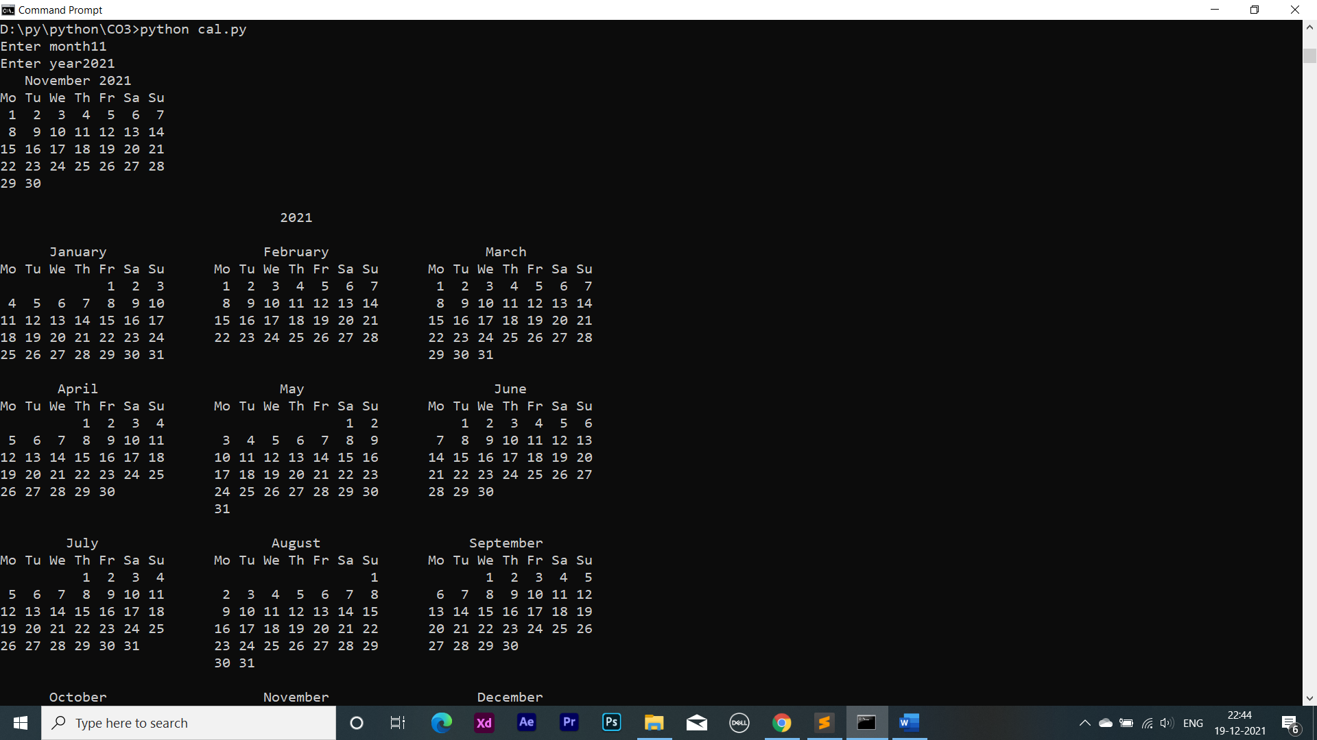

**Date time module**

import datetime

t=datetime.time(22,56,44)

print(t)

print("hour",t.hour)

print("Minute",t.minute)

print("second",t.second)

print("Micro second",t.microsecond)

d=datetime.date.today()

print(d)

print("year",d.year)

print("month",d.month)

print("day",d.day)

d1=datetime.date.today()

print(d1)

td=datetime.timedelta(days=2)

print(td)

d2=d1+td

print(d2)

dt=datetime.datetime.combine(d1,t)

print(dt)

**Output**

22:56:44

hour 22

Minute 56

second 44

Micro second 0

2021-12-19

year 2021

month 12

day 19

2021-12-19

2 days, 0:00:00

2021-12-21

2021-12-19 22:56:44

**Statistics module**

import statistics as s

print("harmonic_mean ",s.harmonic_mean([20,30,40]))

print("mean ",s.mean([9,10,24,35,36]))

print("median ",s.median([9,10,24,35,36]))

print("mode ",s.mode([9,10,24,35,36]))

print("variance ",s.variance([9,10,24,35,36]))

**Output**

harmonic_mean 27.69230769230769

mean 22.8

median 24

mode 9

variance 169.70000000000002

**Random module**

import random

random.seed(10)

print(random.random())

print(random.uniform(20, 60))

lst = ["orange", "apple", "graphes"]

print(random.sample(lst, k=2))

print(random.random())

lst2 = ["orange", "apple", "graphes"]

random.shuffle(lst2)

print(lst2)

lst3 = ["orange", "apple", "graphes"]

print(random.choice(lst3))

**Output**

0.5714025946899135

37.155562187004584

['graphes', 'orange']

0.20609823213950174

['orange', 'graphes', 'apple']

Graphes

**Graphics**

**Circle**

def perimeter(r):

return(2*3.14*r)

def area(r):

return(3.14*r*r)

**Rectangle**

def perimeter(l,b):

return(2*(l+b))

def area(l,b):

return(l*b)

**Threedgraphics**

**Cuboid**

def perimeter(l,b,h):

return(4*(l+b+h))

def area(l,w,h):

return(2*l*w+2*l*h+2*h*w)

**Sphere**

def perimeter(r):

return(2*3.14*r)

def area(r):

return(4*3.14*r*r)

**Area**

from threedgraphics import cuboid

from threedgraphics import sphere

from graphics import rectangle

from graphics import circle

l=int(input("Enter length of cuboid:"))

w=int(input("Enter width of cuboid:"))

h=int(input("Enter height of cuboid:"))

b=int(input("Enter breadth of cuboid:"))

print("Area of cuboid=",cuboid.area(l,w,h))

print("perimeter of cuboid=",cuboid.perimeter(l,b,h))

r=int(input("Enter the radius of sphere:"))

print("Area of sphere=",sphere.area(r))

print("perimeter of sphere=",sphere.perimeter(r))

l=int(input("Enter length of rectangle:"))

b=int(input("Enter breadth of rectangle:"))

print("Area of rectangle=",rectangle.area(l,b))

print("Perimeter of rectangle=",rectangle.perimeter(l,b))

r=int(input("Enter radius of circle:"))

print("Area of Circle:",circle.area(r))

print("Perimeter of Circle:",circle.perimeter(r))

**Output**

Enter length of cuboid:5

Enter width of cuboid:4

Enter height of cuboid:3

Enter breadth of cuboid:7

Area of cuboid= 94

perimeter of cuboid= 60

Enter the radius of sphere:5

Area of sphere= 314.0

perimeter of sphere= 31.400000000000002

Enter length of rectangle:3

Enter breadth of rectangle:4

Area of rectangle= 12

Perimeter of rectangle= 14

Enter radius of circle:6

Area of Circle: 113.03999999999999

Perimeter of Circle: 37.68