Deep Learning & Convolutional Neural Networks

1. Introduction to Deep Learning
Deep Learning (DL) is a specialized subset of Machine Learning (ML) inspired by the structural architecture and information processing mechanism of the human brain. While traditional machine learning algorithms rely heavily on manual feature engineering, deep learning algorithms automatically learn hierarchical abstractions from raw input data using multi-layered Artificial Neural Networks (ANNs).
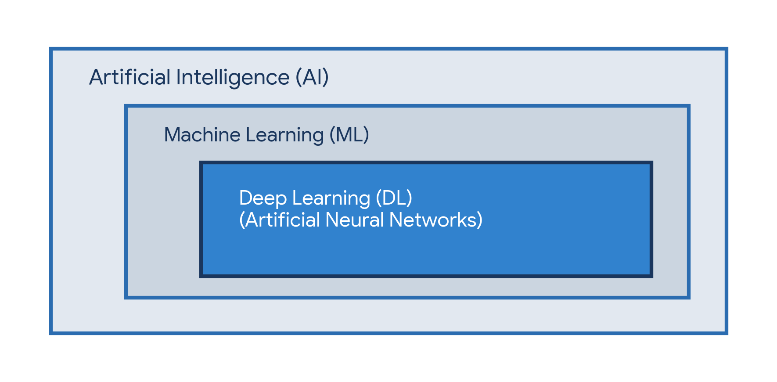
Figure 1: Relationship between AI, Machine Learning, and Deep Learning

2. Types of Deep Learning Architectures
Deep learning encompasses several neural network architectures, each tailored for specific data modalities and computational goals:
- Feedforward Neural Networks (FNNs / MLPs): The simplest form of neural networks where information moves in one direction—from input nodes to output nodes—without feedback loops.
- Convolutional Neural Networks (CNNs): Engineered primarily for grid-structured data such as image synthesis, spatial pattern recognition, and video parsing.
- Recurrent Neural Networks (RNNs & LSTMs): Designed with recurrent feedback loops to handle sequential and time-series data such as natural language processing (NLP) and speech recognition.
- Generative Adversarial Networks (GANs): Composed of a Generator and a Discriminator competing against each other to generate realistic synthetic data.
- Transformers & Autoencoders: Transformers utilize self-attention mechanisms for complex contextual processing (LLMs), while Autoencoders compress and reconstruct data for noise reduction.

3. Convolutional Neural Networks (CNNs)
A Convolutional Neural Network (CNN) is a specialized class of deep neural networks designed to automatically and adaptively learn spatial hierarchies of features from multi-dimensional visual inputs. Unlike standard fully connected networks, CNNs preserve spatial relationships using localized receptive fields, parameter sharing, and spatial subsampling.
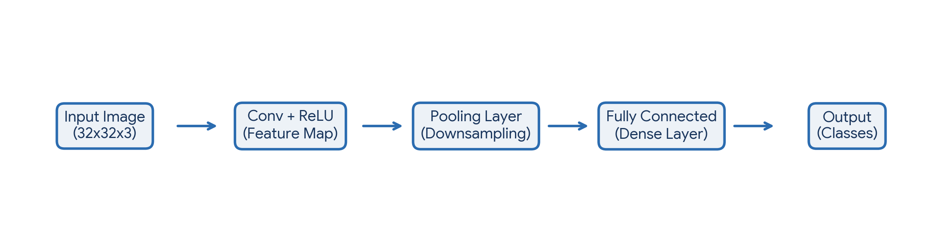
Figure 2: Architectural Data Flow within a Typical Convolutional Neural Network

4. Primary Layers of a CNN
A standard CNN architecture consists of an interleaved sequence of specialized layers designed for feature extraction, dimensionality reduction, and final classification:
Layer Type | Primary Function | Key Operation / Parameters
Input Layer | Receives raw pixel data | Height × Width × Color Channels (e.g., 224x224x3)
Convolutional Layer | Extracts spatial features | Applies small kernel matrices (filters) with dot products
Activation Layer (ReLU) | Introduces non-linearity | Applies f(x) = max(0, x) to prevent linear saturation
Pooling Layer | Reduces spatial dimensions | Max Pooling or Average Pooling (downsampling)
Fully Connected (Dense) | Performs final classification | Flattened vector mapped to category probabilities (Softmax)

A. Convolutional Layer
The core building block of a CNN. It applies sliding filters (kernels) across the input image to generate Feature Maps. These filters detect fundamental edges in early layers, expanding to textures, patterns, and complex object parts in deeper layers.
B. Activation Function (ReLU)
Without non-linearity, a neural network behaves like a single linear regression model. The Rectified Linear Unit (ReLU) sets negative activation values to zero, enabling the network to learn complex non-linear functional mappings.
C. Pooling Layer (Downsampling)
Pooling reduces the spatial size (width and height) of the representation, decreasing computational complexity, memory overhead, and controlling overfitting. Max Pooling takes the maximum value in a window, retaining dominant features.
D. Fully Connected (FC) & Softmax Layer
After multiple convolution and pooling stages, the multi-dimensional feature map is flattened into a 1D vector. This vector is passed through fully connected layers, culminating in a Softmax output layer that converts outputs into normalized class probabilities.

