TASK 1: OWASP JUICE SHOP CHALLENGE
Intermediate Cyber Security — 2nd Year
Student Name | ASWIN PRASATH S
Department | B.Tech CSE
Roll No. | RA2511003020032
Task | Task 1 – OWASP Juice Shop

1. Objective
The objective of this task was to run the intentionally vulnerable OWASP Juice Shop application locally, successfully complete at least four distinct security challenges, document the exploitation process with screenshots/PoC evidence, explain the real-world security risk of each issue, and summarize what was learned.

2. Environment Used
- Application: OWASP Juice Shop v20.2.0 (local instance)
- Target: http://localhost:3000
- Browser: Google Chrome
- Testing scope: Local training application only

3. Challenges Successfully Completed
Challenge | Security Area | Evidence | Result
DOM XSS | Cross-Site Scripting (XSS) | Figures 3–5 | Successfully solved
Login Admin | Injection / Authentication bypass | Figure 6 | Successfully solved
Admin Section | Broken Access Control | Figure 6 | Successfully solved
Score Board | Security through Obscurity / Hidden functionality | Figures 2 and 7 | Successfully solved
The Juice Shop Score Board displayed 5/182 challenges solved after the completed practical work. The four challenges documented below are the distinct challenges used to satisfy the task requirement.

4. Challenge 1 — DOM XSS
Description: Perform a DOM-based Cross-Site Scripting attack through the application's search functionality.

Exploitation Steps / PoC
- Started the local OWASP Juice Shop instance at localhost:3000.
- Opened the Score Board and filtered the challenges by the XSS category.
- Located the DOM XSS challenge.
- Entered the challenge payload into the application's Search field:
<iframe src="javascript:alert('xss')">
- 5. Submitted the input by pressing Enter. The application displayed the successful challenge notification, confirming that the DOM XSS challenge condition had been met.
The official Juice Shop companion guide for v20.2.0 documents the same DOM XSS challenge and payload. It explains that the payload is entered in the Search field and that successful execution produces an alert.
Security Risk:
DOM XSS can allow attacker-controlled JavaScript to execute in a victim's browser context. Depending on the application, this can lead to unauthorized actions, data exposure, or manipulation of page content.
Mitigation:
Treat client-side input as untrusted, avoid dangerous DOM sinks where possible, use safe DOM APIs, and apply appropriate output encoding and Content Security Policy controls.

5. Challenge 2 — Login Admin
Description: Log in with the administrator's user account. This challenge demonstrates SQL injection against an authentication query.

Exploitation Steps / PoC
- Opened the Juice Shop login functionality.
- Used the administrator-login SQL injection technique in the Email field.
' or 1=1--
- 3. Entered any value in the Password field and submitted the login form.
4. The application authenticated the session as the administrator. The success notification visible in Figure 6 confirms that the Login Admin challenge was solved.
The official v20.2.0 Juice Shop challenge solution documents this SQL injection method: the injected condition causes the authentication query to match the first user record, which is the administrator in the training data.
Security Risk:
SQL injection in an authentication query can bypass login controls and allow unauthorized access to privileged accounts.
Mitigation:
Use parameterized queries/prepared statements, avoid constructing SQL from raw user input, validate inputs, and apply least privilege to database accounts.

6. Challenge 3 — Admin Section
Description: Access the administration section of the store. The challenge demonstrates broken access control when privileged functionality is insufficiently protected.

Exploitation Steps / PoC
- After obtaining an administrator session through the Login Admin challenge, navigated to the administration route.
- The local application route used was:
http://localhost:3000/#/administration
- 3. The Administration page became accessible and displayed administrative data and controls.
4. Figure 6 shows the Administration page together with the green success notifications for both Login Admin and Admin Section.
Security Risk:
Broken access control can expose administrative pages, user information, customer feedback, or privileged actions to users who should not have access.
Mitigation:
Enforce authorization on the server for every privileged request. Do not rely only on hiding frontend routes or menu items; verify the user's role/permissions before returning sensitive data or performing administrative actions.

7. Challenge 4 — Score Board
Description: Find the carefully hidden Score Board page. This challenge demonstrates security through obscurity / hidden application functionality.

Exploitation Steps / PoC
- Started from the normal Juice Shop interface and inspected the available navigation.
- Located the hidden Score Board route and opened the Score Board page.
- The route used by the local instance was:
http://localhost:3000/#/score-board
- 4. The application displayed the Score Board and generated the successful Score Board challenge notification, as shown in Figures 2 and 7.
The official Juice Shop guide explains that the Score Board challenge is intended to be found even though it is not part of the normal customer navigation path.
Security Risk:
Hiding a route is not an access-control mechanism. If sensitive functionality is protected only by obscurity, an attacker can discover the route through application mapping, source inspection, or predictable URL structures.
Mitigation:
Use real authorization controls for sensitive functionality. Hidden or unlinked routes should still enforce authentication and authorization on the server.

8. Evidence Screenshots
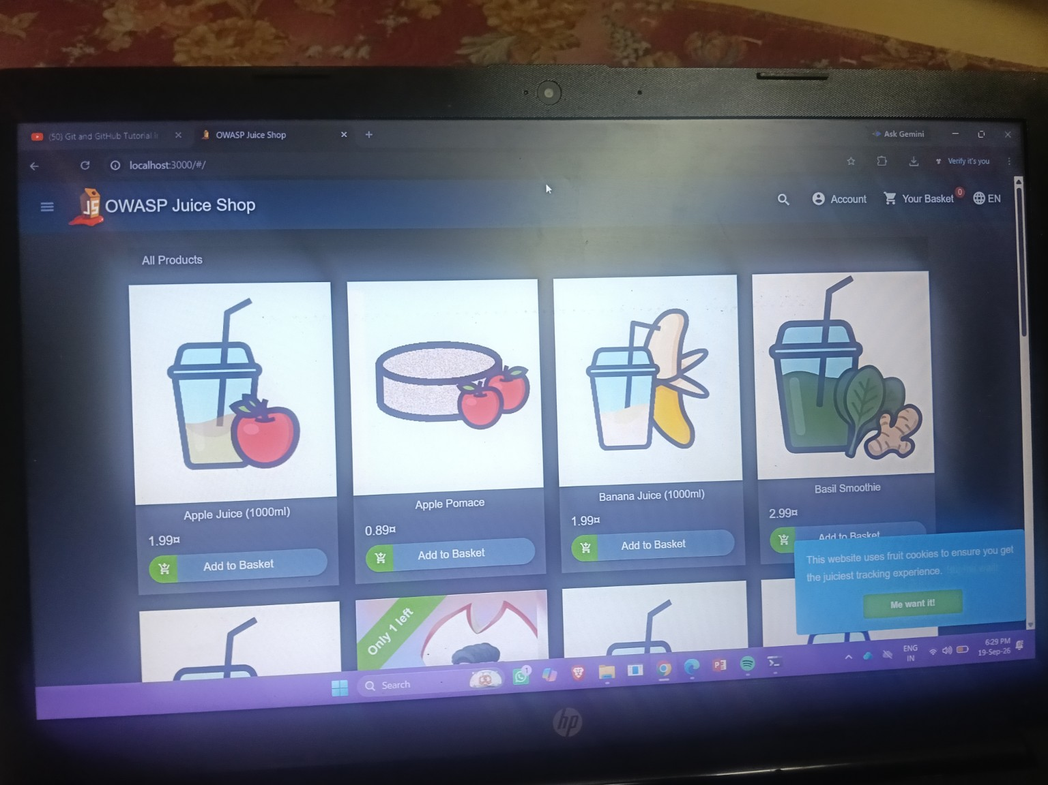
Figure 1 — OWASP Juice Shop running locally at localhost:3000.
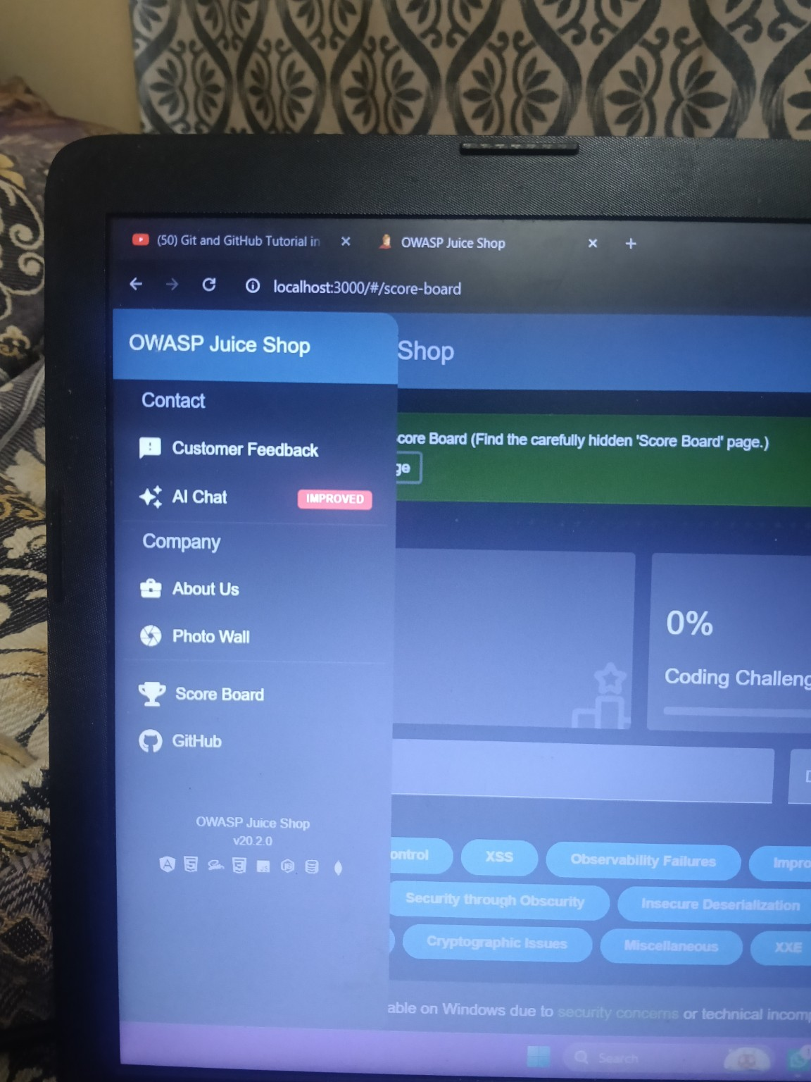
Figure 2 — Juice Shop Score Board discovered and opened.
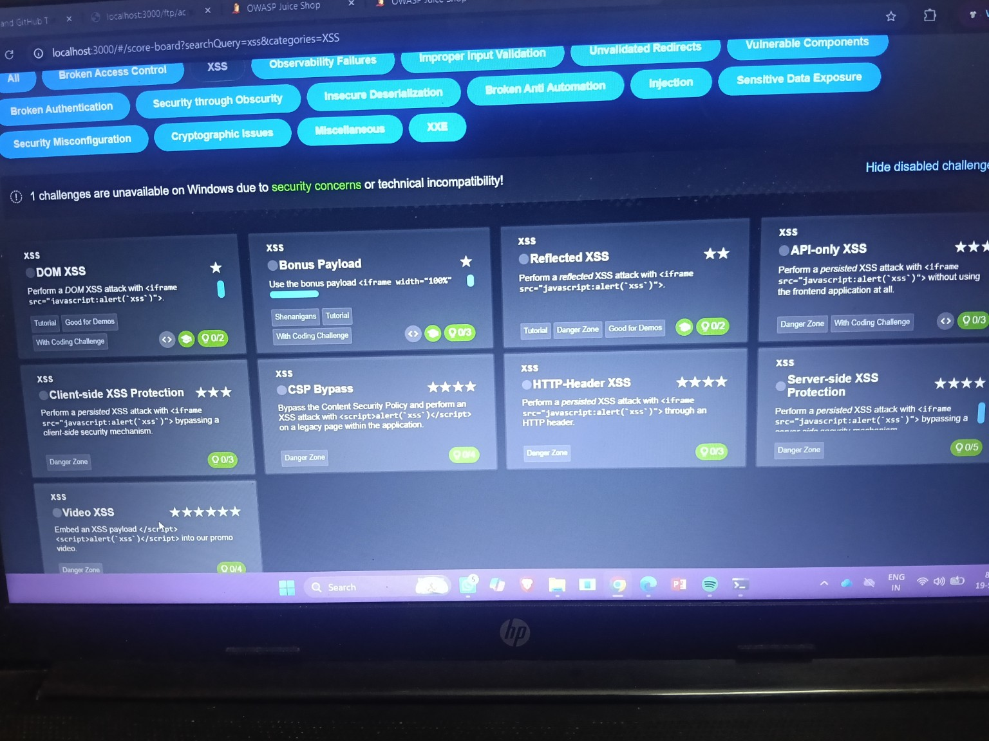
Figure 3 — Score Board filtered to XSS challenges, showing the DOM XSS challenge.
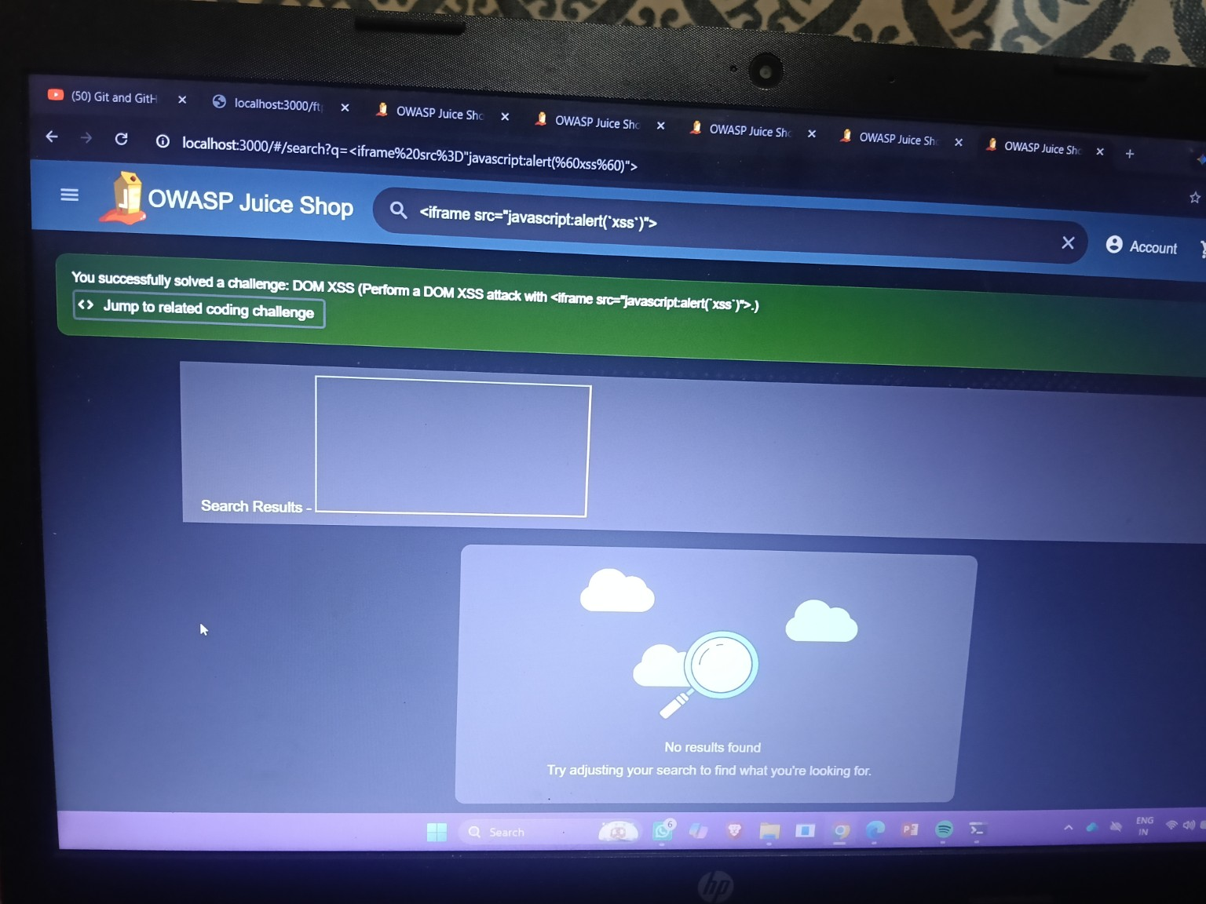
Figure 4 — DOM XSS payload entered in the search field with the challenge-success notification.
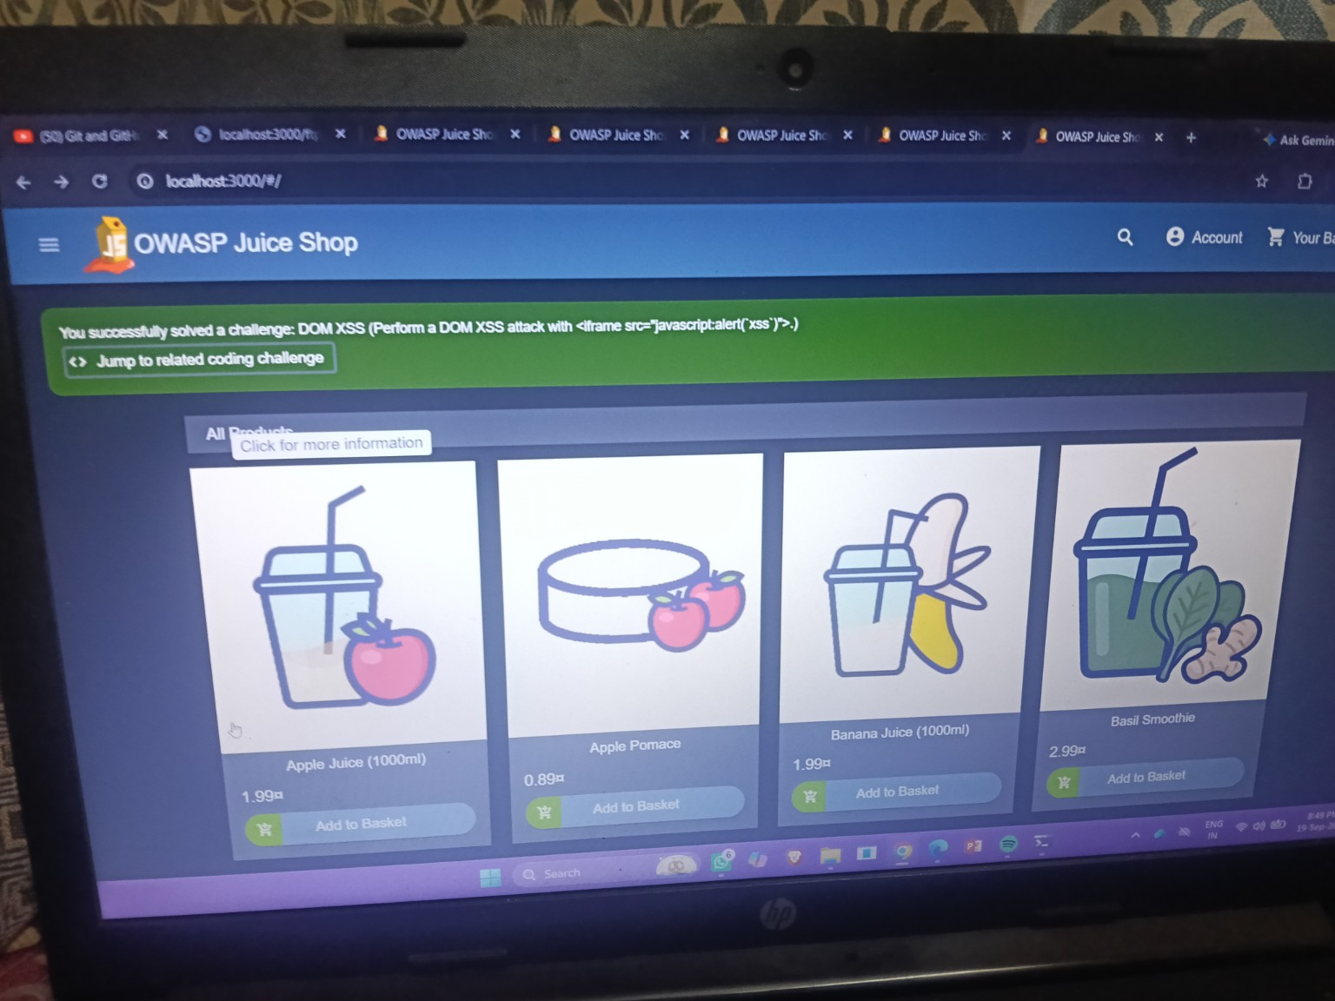
Figure 5 — DOM XSS success notification in the Juice Shop application.
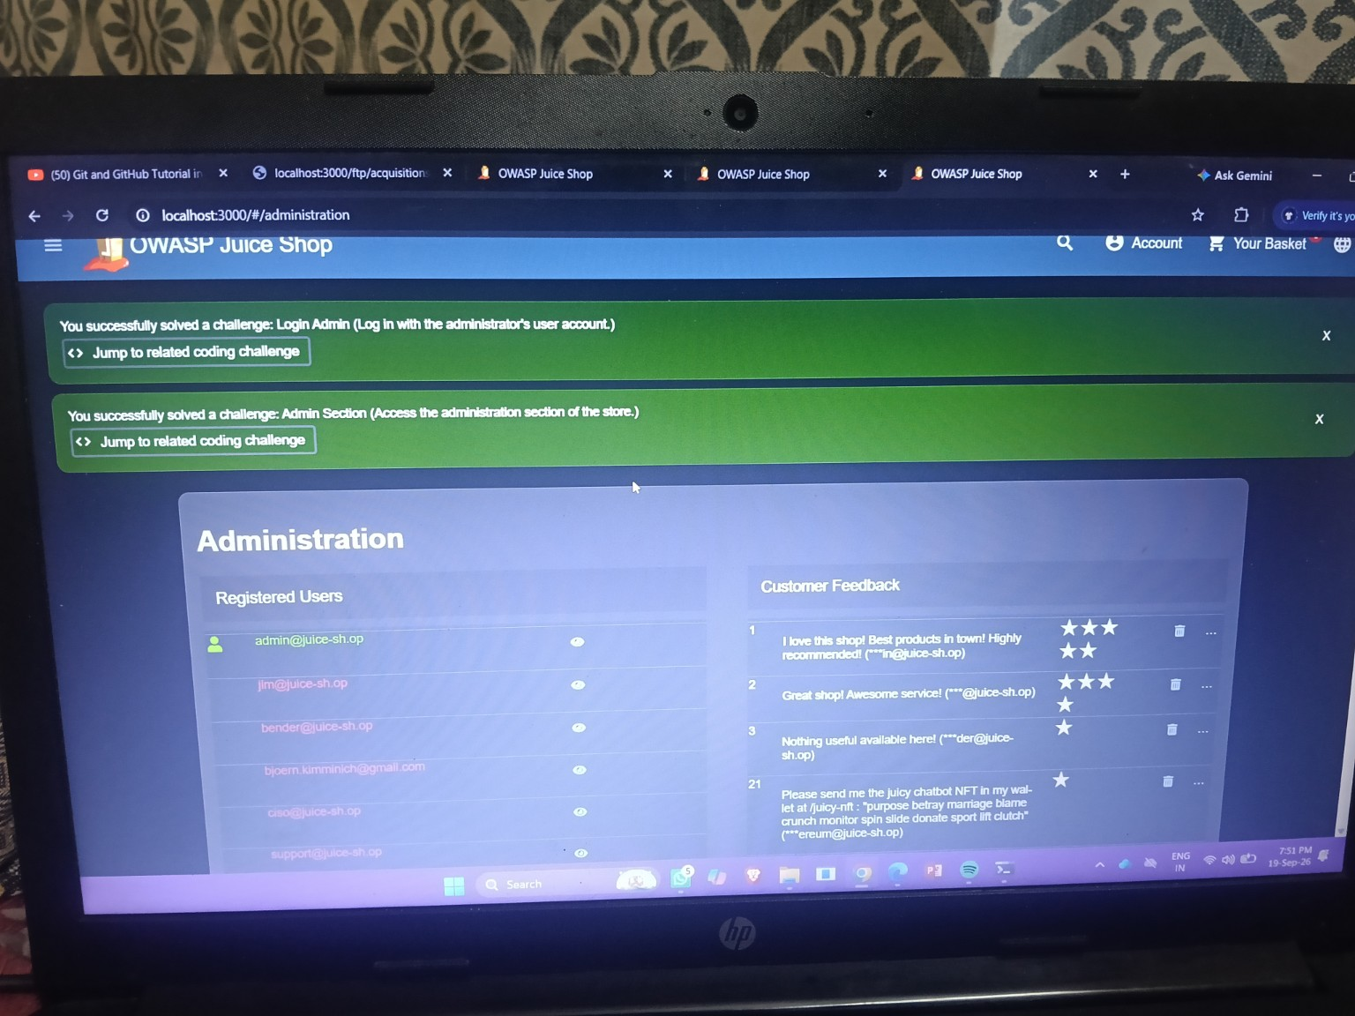
Figure 6 — Successful Login Admin and Admin Section notifications, with the Administration page visible.
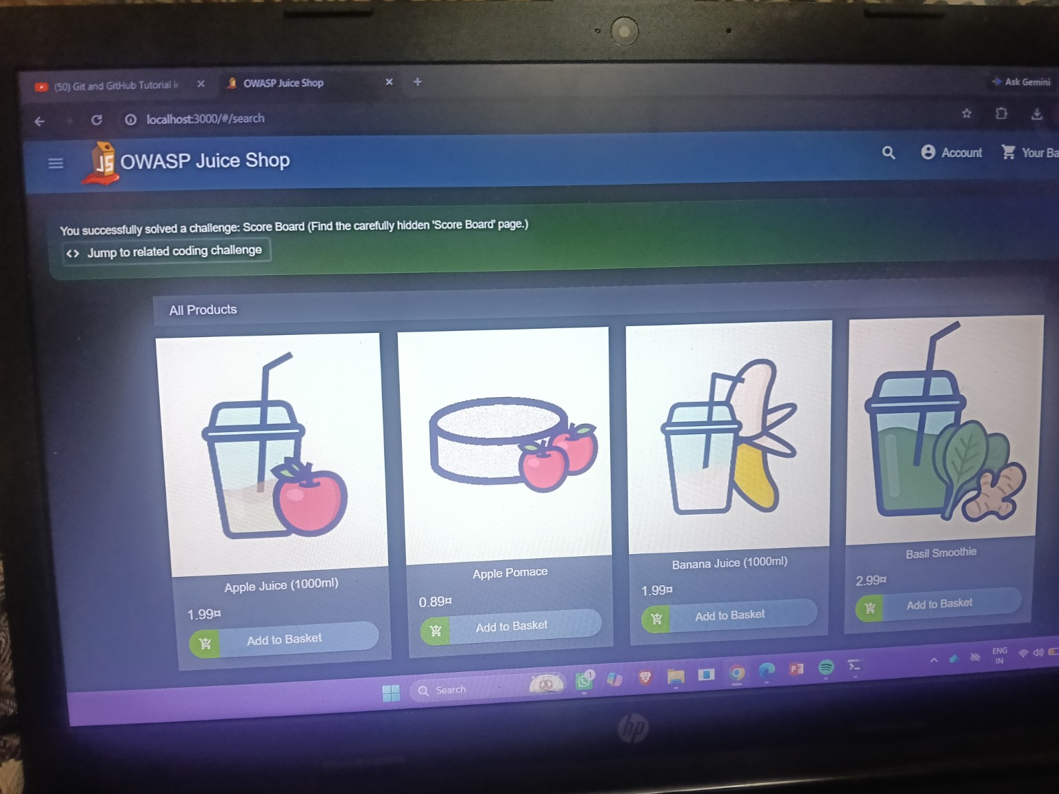
Figure 7 — Successful Score Board challenge notification.
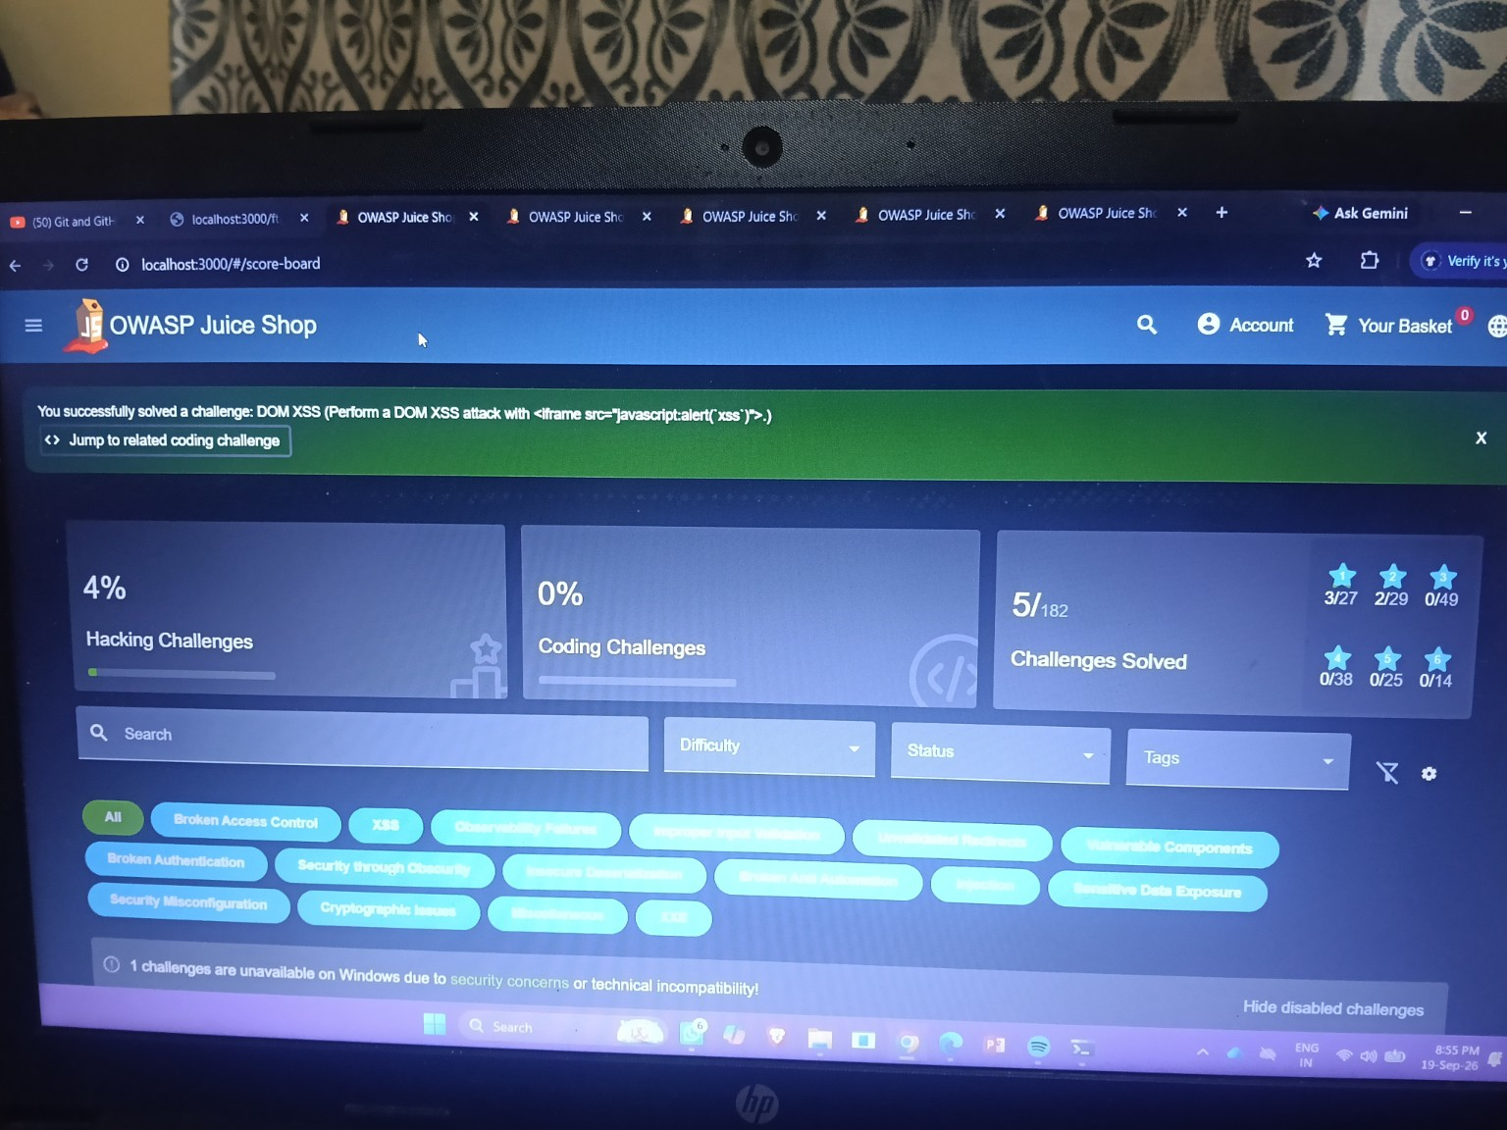
Figure 8 — Score Board showing 5/182 challenges solved after the completed work.

9. What I Learned
- I learned how to run and test an intentionally vulnerable web application in a controlled local environment.
- I learned how DOM XSS can occur when attacker-controlled input reaches a dangerous browser-side DOM execution context.
- I learned how SQL injection can affect authentication when user input is inserted into a database query without parameterization.
- I learned that frontend routes and hidden pages are not security controls; authorization must be enforced for privileged functionality.
- I learned how a challenge-based application such as Juice Shop provides immediate success notifications and a Score Board for tracking completed work.
- I learned the importance of documenting the actual exploitation steps and preserving screenshots as evidence.

10. Overall Security Observations
The four completed challenges covered multiple security concepts: XSS, injection, broken access control, and security through obscurity. Together they showed that secure applications need both safe input handling and strong authorization controls. The practical work also demonstrated why client-side behavior, routes, and application feedback should be examined during security testing.

11. Conclusion
The OWASP Juice Shop practical task was completed in the local training environment. At least four distinct challenges were successfully solved and documented with exploitation steps, security risks, mitigations, and screenshot evidence. The practical exercise improved understanding of common web application security weaknesses and the importance of validating security controls rather than relying on frontend behavior or hidden functionality.

12. Submission Check
- Local OWASP Juice Shop was used for the practical exercise.
- At least four distinct challenges were successfully solved.
- Each documented challenge includes what it was, exploitation steps/PoC, security risk, and mitigation.
- Screenshots are embedded as evidence.
- A short overall learning summary is included.
- Student details are included.
- The document is saved in the required Word .docx format.

Reference Used for Challenge Mechanics
OWASP Juice Shop Companion Guide, v20.2.0-compatible challenge documentation. The guide was used only to verify the documented challenge descriptions and standard solution mechanics; the screenshots in this report are from the student's own local Juice Shop work.

