TASK 2: BASIC WIRESHARK TRAFFIC CAPTURE & ANALYSIS

1. Objective
The objective of this task was to capture my own network traffic using Wireshark, identify common protocols, and examine an individual network exchange packet-by-packet. The capture was made on my own device/network for learning and analysis.

2. Protocols Identified
Protocol | Evidence observed | What it does
DNS | Standard query/response for f.clarity.ms; UDP destination port 53 | Resolves domain names into IP addresses and other DNS records.
TCP | SYN, SYN/ACK and ACK traffic to port 443 | Provides reliable, ordered transport and establishes TCP connections.
TLS | TLS 1.2/1.3 Client Hello and Server Hello messages | Negotiates encrypted communication between the client and server.
QUIC | QUIC Initial and Handshake packets visible in the capture | Provides a modern secure transport protocol commonly used with HTTP/3.

3. Packet-by-Packet Analysis: DNS Exchange
I selected a DNS request and its matching response because the exchange is easy to follow in Wireshark. Packet 145 is linked to packet 152 by the DNS transaction information.

Packet 145 — DNS Query
- Protocol: DNS
- Message: Standard query
- Requested domain: f.clarity.ms
- Query type: A (IPv4 address record)
- Source port: 55488
- Destination port: 53
- Wireshark shows Response In: 152.
Explanation: My device sent a DNS request asking the DNS server to resolve f.clarity.ms to an IPv4 address. The request was sent to port 53, the standard DNS service port shown in the capture.

Packet 152 — DNS Response
- Protocol: DNS
- Message: Standard query response
- Status: No error
- Questions: 1
- Answer RRs: 2
- Request In: 145
- Response time: approximately 12.694 ms.
Explanation: The DNS server replied to packet 145 successfully. The response contains two answer records. Wireshark reports a response time of about 12.7 ms, showing that the name resolution completed successfully.

4. Other Traffic Observed
The capture also contained TCP traffic used with HTTPS connections. I observed TCP SYN, SYN/ACK and ACK packets, demonstrating the TCP three-way handshake. TLS traffic included Client Hello and Server Hello messages, showing the negotiation stage of encrypted communication. QUIC Initial and Handshake packets were also visible in the capture.

5. Unencrypted Information Observed
The DNS exchange examined above was visible as standard DNS traffic using UDP port 53. The domain name f.clarity.ms was therefore visible in the capture. In contrast, the TLS traffic was represented by encrypted protocol data after the handshake, so application content was not readable from the captured TLS packets.

6. What I Learned
I learned how Wireshark can be used to observe what is happening on a network at the packet level. I learned that DNS works as a request-and-response process, where a device asks for information about a domain and receives an answer from a DNS server. I also understood the TCP three-way handshake using SYN, SYN/ACK and ACK packets. The TLS handshake showed me how secure communication is negotiated before encrypted application data is exchanged. I also noticed that standard DNS can expose the domain being requested even when the later web communication uses encryption. Overall, the capture helped me connect networking concepts I had learned in theory with actual packets from my own traffic.

7. Evidence Screenshots
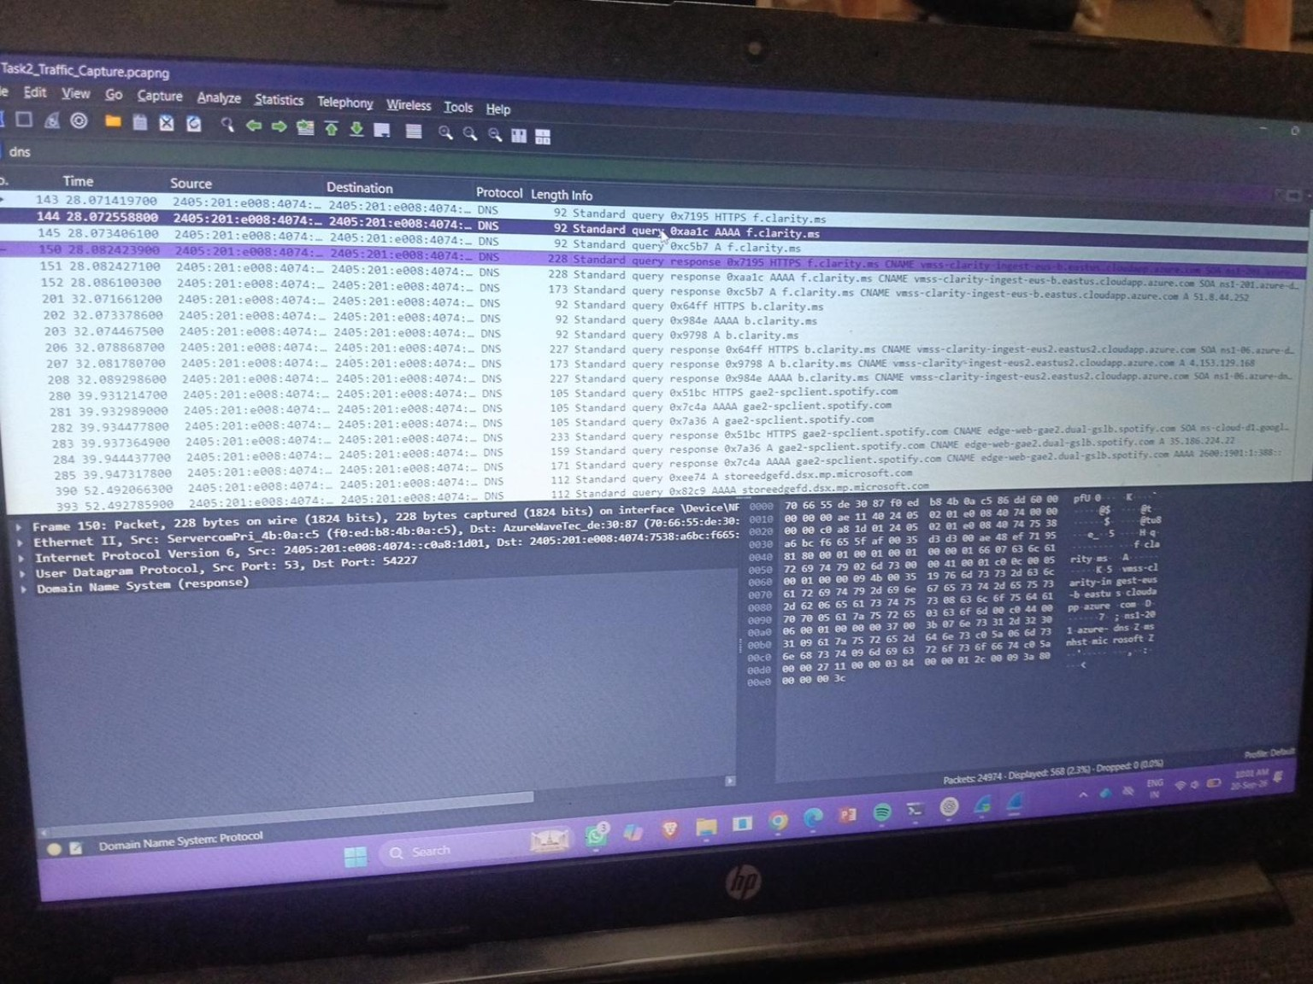
Figure 1 — DNS response for f.clarity.ms (Packet 152).
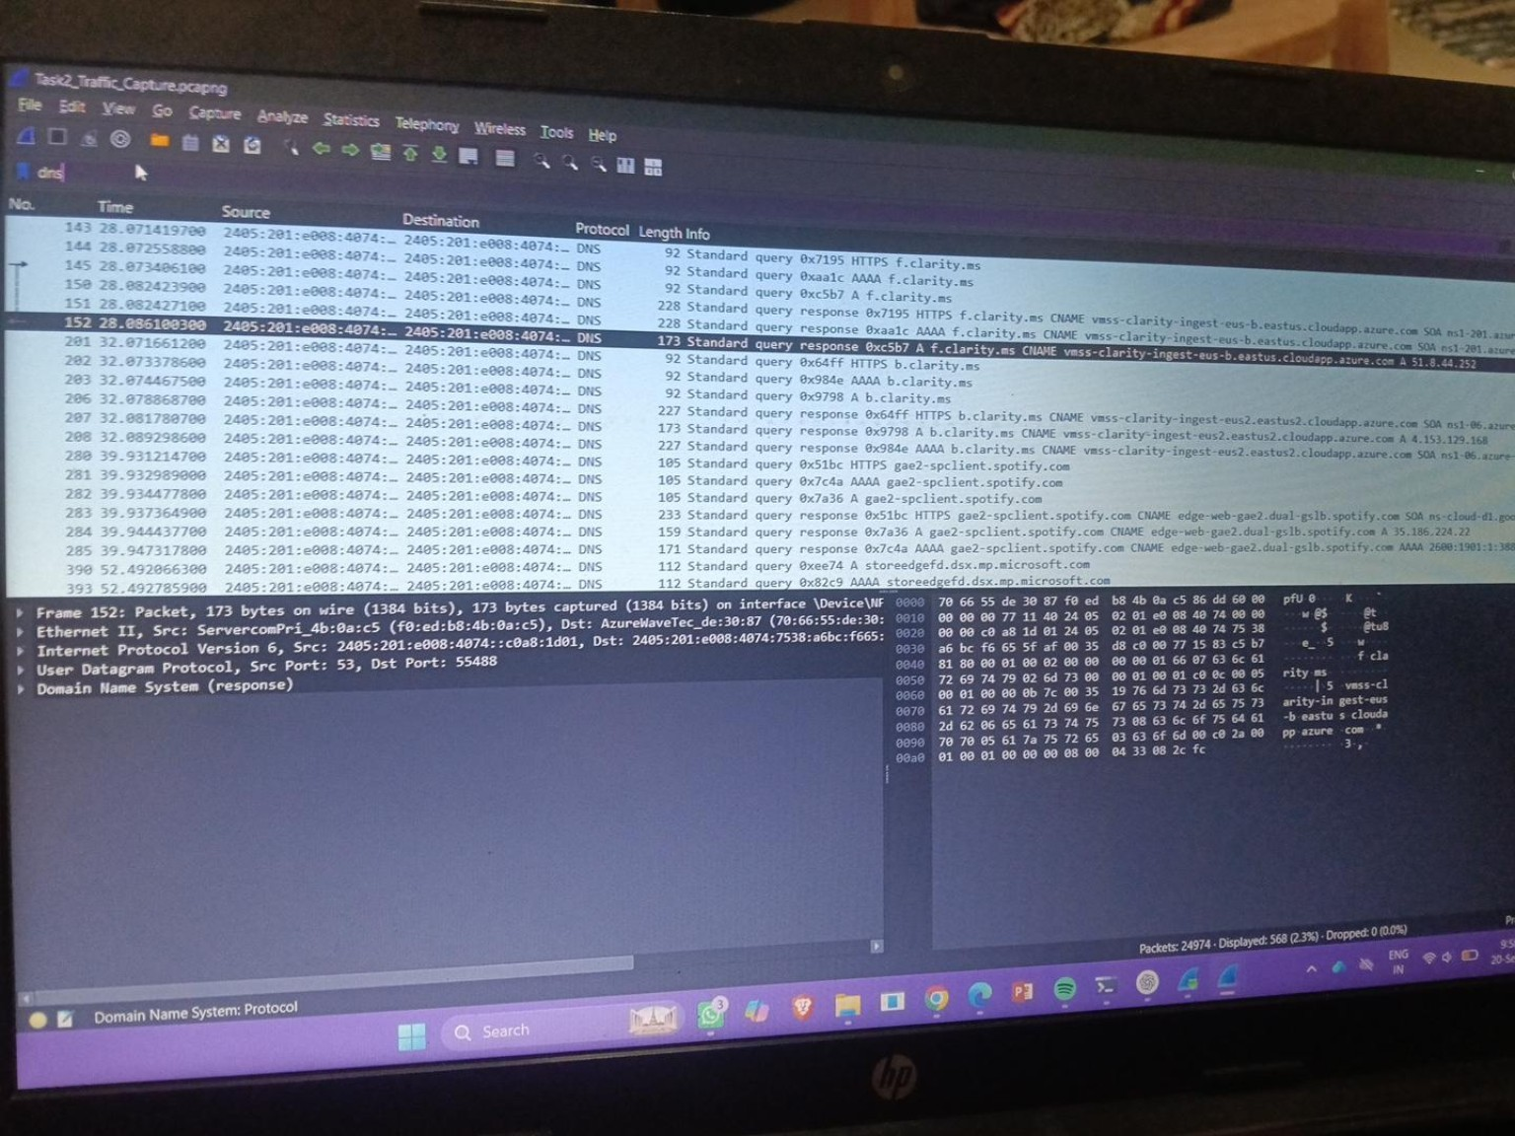
Figure 2 — DNS query/response exchange showing packets 145 and 152.
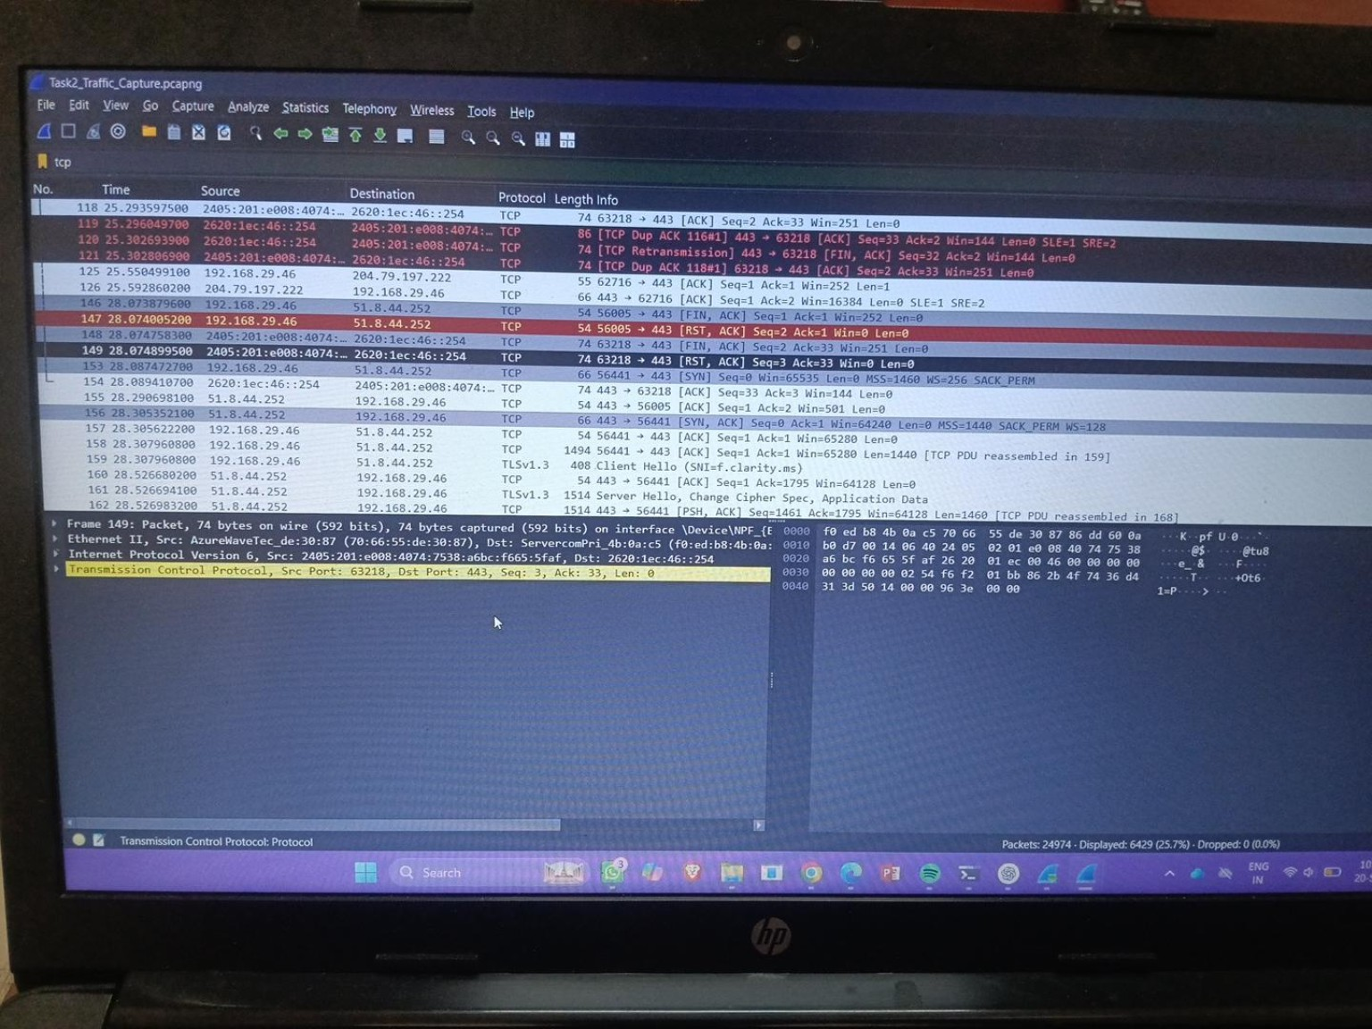
Figure 3 — TCP traffic showing handshake and HTTPS-related traffic.
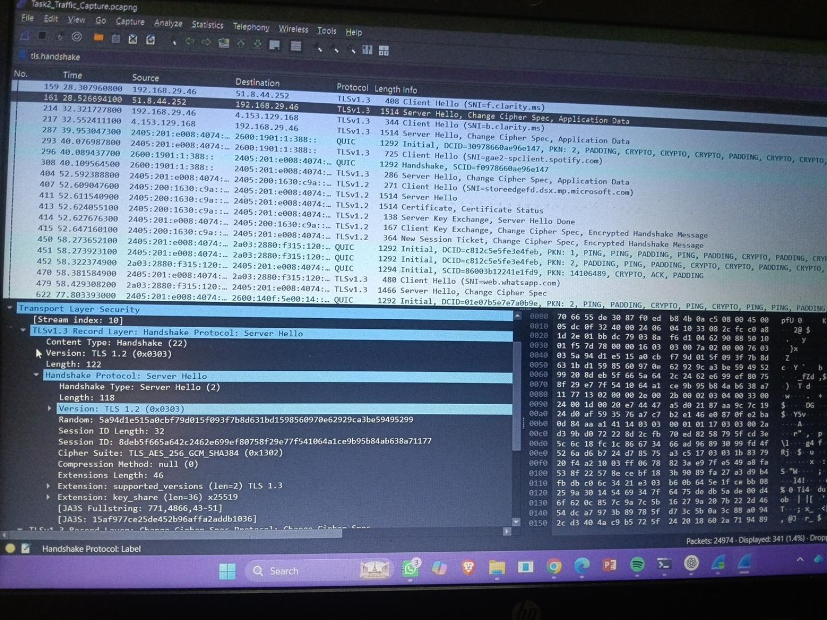
Figure 4 — TLS and QUIC traffic visible in the capture.

8. Conclusion
This analysis showed how different protocols work together during normal network activity. DNS handled name resolution, TCP provided transport and connection establishment, TLS provided secure communication, and QUIC traffic demonstrated another modern transport approach. Examining the packets directly made the protocol behaviour easier to understand.

Additional Evidence Screenshot
Figure 5 — TCP traffic capture showing packet 149 and related TCP/HTTPS traffic. The packet details pane identifies Transmission Control Protocol with source port 63218 and destination port 443.
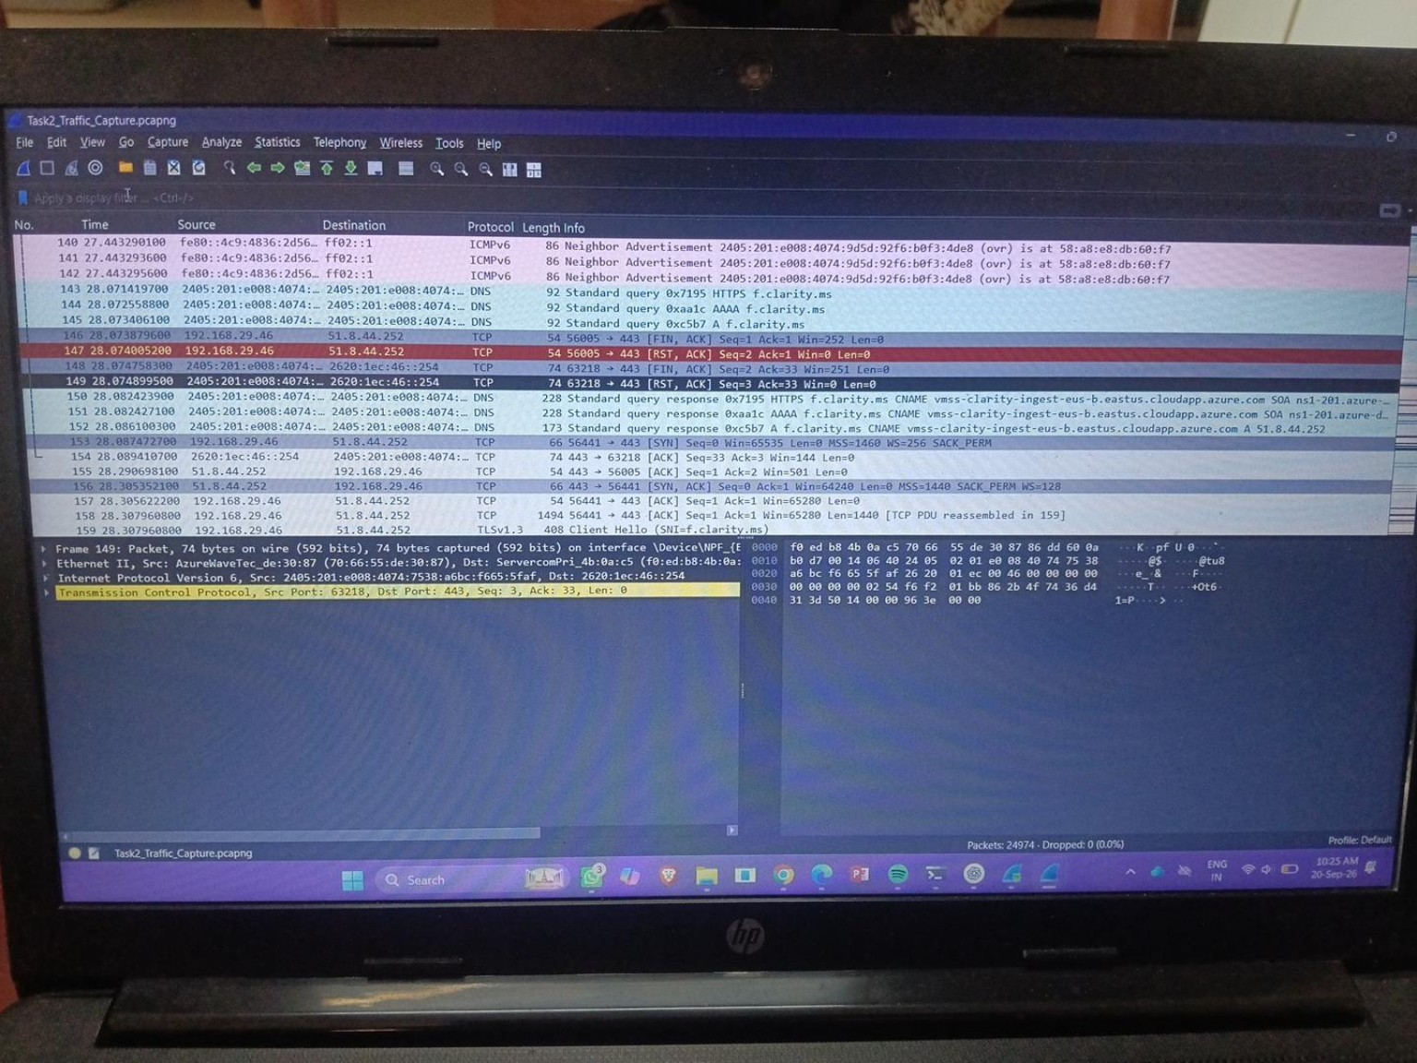
Figure 5. TCP traffic evidence from the Task2_Traffic_Capture.pcapng capture.

Final Submission Check
- Wireshark capture file: Task2_Traffic_Capture.pcapng
- Four required protocols documented: DNS, TCP, TLS, and QUIC.
- Packet-by-packet DNS exchange documented using packets 145 and 152.
- Evidence screenshots included for DNS, TCP, TLS/QUIC, plus the additional TCP evidence screenshot.
- What I Learned and Conclusion sections included.
Student Name: ASWIN PRASATH S
Department: B.Tech CSE
Roll No.: RA2511003020032
Task: Task 2 – Wireshark Traffic Analysis

