Magnus Villumsen, Kim An Lim, Aswin Putra

13034222, 11883170 ,11836210

Interactive Media

Assignment 1

Building 11

Executive Summary

This purpose of this report is to explain our idea of using people counter in UTS Building 11 and visualise it in a way that is more interesting, engaging and accessible by everyone. This document will explain how we can use people counter sensors and transform the data from graph/number into a more visual and interactive visualisation. The concept of this idea is basically to use the data from EIF Research Data API and change the data from number and graph into a more visual data such as dots or green lines that represent people movement. The design of this system can be done by using the data taken from the people counter and cast it as dots or green lines that represent people getting in and out of the area. This document will also contain the inspiration of design and concept such as, Earth map, Because-Recollection and Top 500 Password. This document will also involve the personas including student, security and staff and scenarios for each persona. In particular, as a student it is hard to find an empty area to study however, using this system it can help them to find an empty area to study.

Introduction

To a lot of people data is often something complicated and quite boring. Interactive media has the power to make data a lot more interesting, engaging, and accessible. Few would question the fact that data is a powerful tool in many ways, but it is too often confined to those who are specialized in academia involving quantitative and/or qualitative data. Using interactive media as an approach, there are numerous new ways to make data meaningful to everyone.

Even in an academic environment such as UTS, data is still presumably something to use when a point has to be proven. Little do most know that data is actually all around us - we conjure data, we are data. Building 11 is a perfect example of how data is an integrate part of our surroundings, but also how it has yet to be set free. Sensors all over the building record various types of data every day, data that could be valuable to some people. We want to set this data free, and not just that, we want to do this in a manner that actually makes it engaging to the people who would be using it.

So how are going to achieve this? It basically involves succeeding on three different parameters: Usability, accessibility, and aesthetics. Usability is perhaps the most obvious thing that has to succeed. The user experience is key, as traditional data representation is often simply focused on precision and becomes too preoccupied with the numbers, and not the eyes that have to look at them.

In this report, we will present the base concept that we will be designing, go through some examples that inspired us, establish some potential personas and scenarios connected to these personas, and finally we will try and form a path for what work lies in front of us.

Concept

As we already established in the introduction, our aim is to make data more accessible, more engaging, and in general, create a data visualization that is focused on usability to the users that have potential use for it.

The specific context that we will be working with is, as mentioned, visualizing data from building 11 at UTS. The building is just a few years old and its inside is just as modern as the impressive facade imposes. In fact, it has more to it than what the eye catches at first glance, hence the sensory equipment incorporated into the building. A large variety of data is captured within the building, but, unfortunately, this data is not just very hard to track down, it is also fairly difficult to make sense of. The database containing all of this data can be described as very traditional, meaning it has all the numbers and everything there, but the only way it is shown is by numbers or graphs. Basically, if you know the data, the sensors, and the database, then it is simple enough, but it is not very intuitive or clear to someone who would look at it for the first time. This is especially supported by the fact that it comes with a whole wiki of its own, in order to explain everything that is there. Naturally, this is a legitimate method of making it more accessible and understandable, however, it is not very engaging at all.

Consequently, we have all of this data stored away in a rigorous database that does not exactly invite use. So how can we change this? First of all, the platform has to be changed. We imagine that our concept would make most sense in the form of an app, but could just as easily be a webpage. The reason for this lies in the context that we envision for our concept. Essentially, we want to create a data visualization that can have an immediate impact on people’s actions. This will become a lot clearer later in the report when we introduce different personas and scenarios. Basically, our concept will primarily focus on data from the people counter sensors, which can be useful in several situations. We believe some of these situations will require the data to be available while on the go, and therefore, the data has to be ready at hand at any time. To understand what we want to achieve, we will be going into the design of our concept.

Design

A quintessential part of our concept will be the aesthetic experience. As mentioned, currently the data can be retrieved as numbers or as graphs. Our design will revolve around the familiarity of building 11. Essentially, we want to show the data in its relevant context, which is building 11. The design of building 11 is very distinct and the grey facade with the characteristic green lights illuminating Broadway in the dark is easily recognizable (as shown in figure 1).

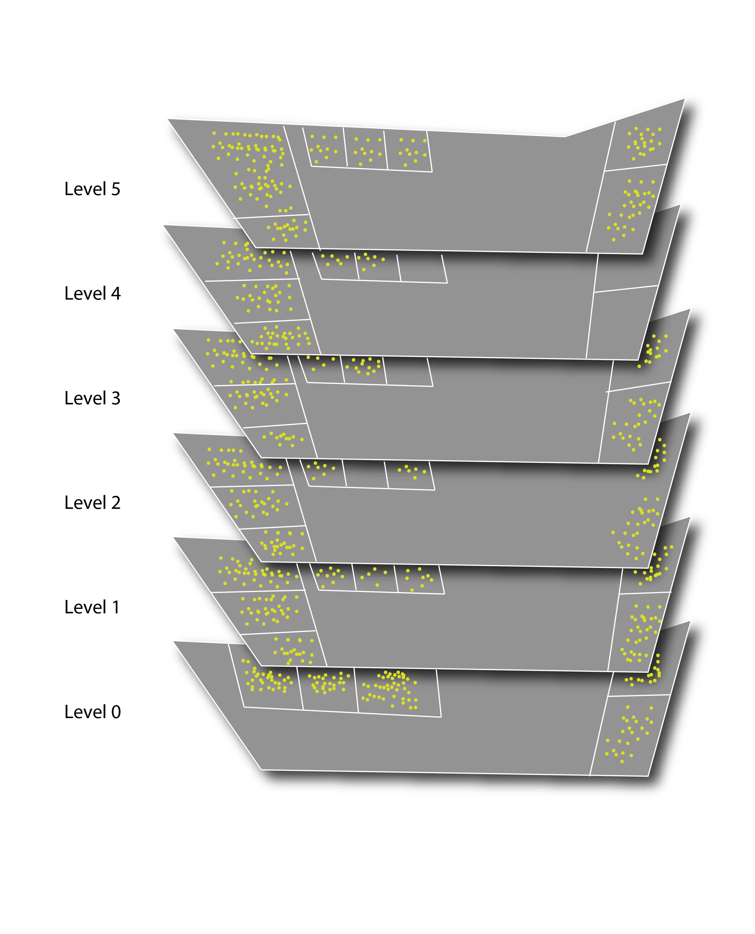

Figure 1 Propose system example

With the people counter data, registering people entering and exiting the various rooms in the building, we want to show this in the way that makes more sense than probably any other, being the exact context in question. Thus, we will want to create a model of building 11 which can be viewed from different angels and different floors (as shown in figure 1&2).

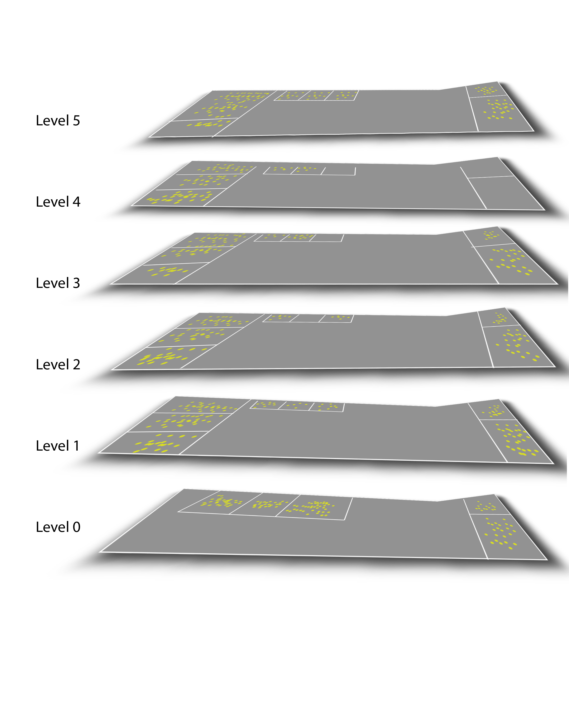

Figure 2. Horizontal view of the system

The data itself, in this case, people entering and exiting rooms will be shown by green lights flowing through the building (as shown in Figure 3).

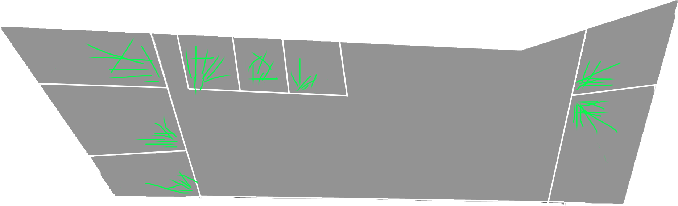

Figure 3. Moving people visualisation

We want the building, and the data, to represent the life that exists beyond the great facade. This could also be visualized outside of the building in public, to show the sprawling student life that the building contains, and should ultimately represent. Either way, we aim to use the data to breathe life into a visualization of the building, utilizing the iconic architecture it withholds.

Inspirations

In the process of forming our concept, we all gathered some interactive media examples that helped inspire us. They have not all directly influenced our concept, but it is always important to seek inspiration with an open mind, in order to broaden the spectrum of potential concept outcomes. We will quickly go through the most important of the interactive media works that we looked at in our ideation process.

# Top 500 passwords

The first example is actually a chart, something that we want to avoid in our project, but it was interesting to us still because of its interactive element. It is a chart that shows the 500 most frequently used passwords, showing alphabetic placement on one axis and popularity on another. Additionally, the size of the passwords indicates how strong/safe the passwords are. The interesting thing is the filtering system that can found in the top of the page. It allows you to filter passwords according to different categories. The data is all accessible at first sight, but can still be altered by the hand of the user. It shows how a lot of data can be represented in a way that makes it easy to understand.

# Because-recollection

This example was radically different than what we are aiming to create; however, it is a very interesting example of interactive media. It showcases a number of songs, every song having a unique aesthetic and user experience. The amount of thought and creativity that has been put into every piece of information (in the case a musical piece), makes for a very special user experience. The focus has clearly been on how to make the interaction interesting, but at the same time every interactive element derives from the album cover of the particular song. Basically, it is album covers coming to life through interaction. Similarly, we want to make building 11 come to life, and the visualization to be based on the appearance of the building itself.

# Earth

“Earth” is possibly the interactive media project that inspired us the most. It shows just how important and impactful the aesthetic aspect can be. The project is a visualization of various meteorological data, shown in the form of the Earth. This can be customized to be as a globe, a traditional map or other depictions of Earth. A simple menu makes it easy to change the type of data that is shown, and is it very subtle to make sure it does not disturb the aesthetic. Similar to Because-recollection, the data “comes to life” here. For example, the wind systems are visualized as currents moving around in the world. It makes the data become a lot more meaningful by giving it movement. We will try to achieve the same by using movement to visualize the entering and exiting of people in building 11.

Personas and scenarios

In this section, we will present three potential user personas, accompanied by scenarios that will depict how our design could be useful to them. The personas will be visualized and beneath them will be the scenario in relation to the above persona. The personas will be categorized in three types: faculty, security, and student.

# Faculty

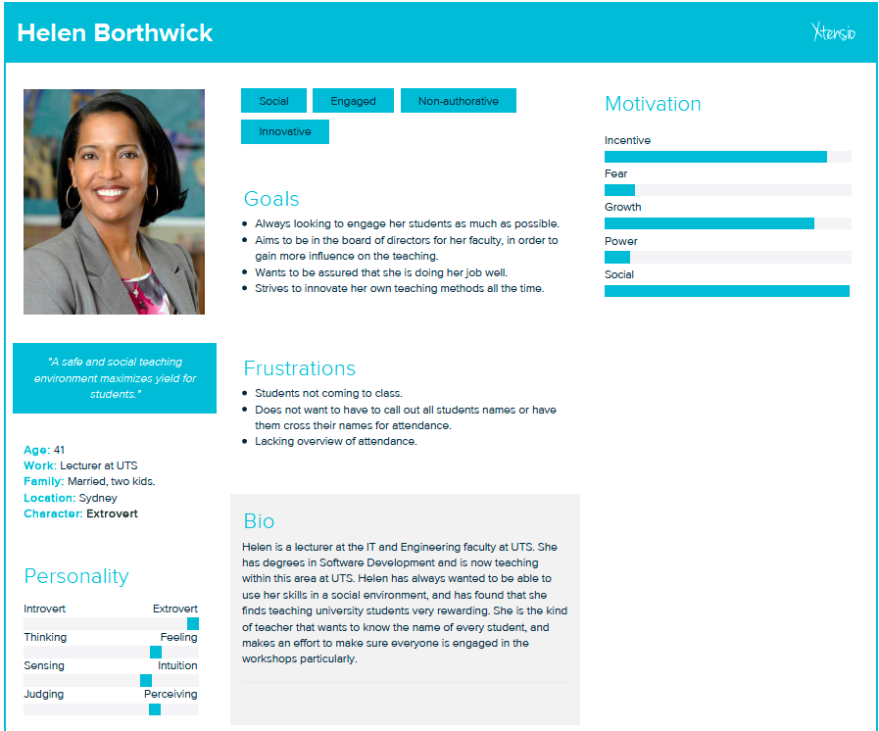

Figure 4. Potential user persona of the UTS faculty.

**Scenario**

It is time for a new semester to begin, and the board of the faculty has told the teachers that they need to show an increase in student attendance for the new semester. Helen is wondering if she should continue with a new novel teaching method she tried out last semester. She believes it is an interesting new way of teaching, however, she is unsure if it increases student attendance. In the first class, she asks the students that she will need to spend time each session to do attendance. One of the students tells her that there is a tool with open access to track entries and exits of all rooms in Building 11. Helen is sceptical as she does not want to seem like she is monitoring the students; however, they express that they would rather want that than to spend time being crossed off a sheet. Additionally, Helen realizes that it would enable her to see the attendance, without having to alter her teaching principles. Furthermore, it would make her able to see how many students transit from the lecture to the workshop, and how many uses the computer rooms delegated for students to delve deeper into the practical work afterwards.

# Security



Figure 5. Potential user persona for the UTS Faculty

**Scenario**

Kevin works full time from 3pm until 1am at midnight at building 11. One day, building 11 has emergency evacuation. Everyone have to evacuate from the building into the Alumni Green area. Usually Kevin would have to look over every level and every room to check if there are any students left on the building. Using the software for the building 11, Kevin and the other security officers can look through the software to check the number of people that are left in the building. In this way, Kevin can only focus to check to the area where there are people in it.

# Student



Figure 6. Potential user persona for the UTS Faculty

**Scenario**

It is the assignment week of the semester and the University is starting to get crowded. Every student is looking for an area to study either individually or as a group. Around this week, it is getting hard to find an area to do a group meeting. Nick is an engineering student who likes to hang around with his friends. One day, he needs to do a group meeting together with his friends in building 11. However, he does not know which area is free in order to do a proper group meeting. Usually, he has to walk around the building to find an empty area to have a group meeting. Using the building 11 software, Nick will be able to find which area is vacant to have a group meeting. Nick realised that he could find a vacant area by looking through all area in the building 11 where there are no bullet points. Therefore, the software will determine that those area are available to use for a group meeting.

Next Steps

Moving forward, we will be moving into the prototyping phase. It is important here to understand that even though the initial ideation/brainstorming session is over, and a concept has been identified, the concept can still change. Prototyping will discover possibilities, as well as limits, and is ultimately an integrate part of the design process as a whole.

Reference:

Because Recollection, viewed 20th August 2017, <<http://www.because-recollection.com/>>

Information is Beautiful 2016, *International number ones*, viewed 20th August 2017, <<http://www.informationisbeautiful.net/visualizations/because-every-country-is-the-best-at-something/>>

Earth 2017, viewed 20th August 2017, <<https://earth.nullschool.net/#current/wind/surface/level/patterson=190.85,-0.59,204/loc=55.320,-6.364>>

Information is Beautiful 2016, *Top 500 Passwords,* viewed 20th August 2017, <[http://www.informationisbeautiful.net/visualizations/top-500-passwords-visualized/>](http://www.informationisbeautiful.net/visualizations/top-500-passwords-visualized/%3e)