Petroserve

gateway: petroservedxb.dyndns.org
username: psi22
pswd: psi22

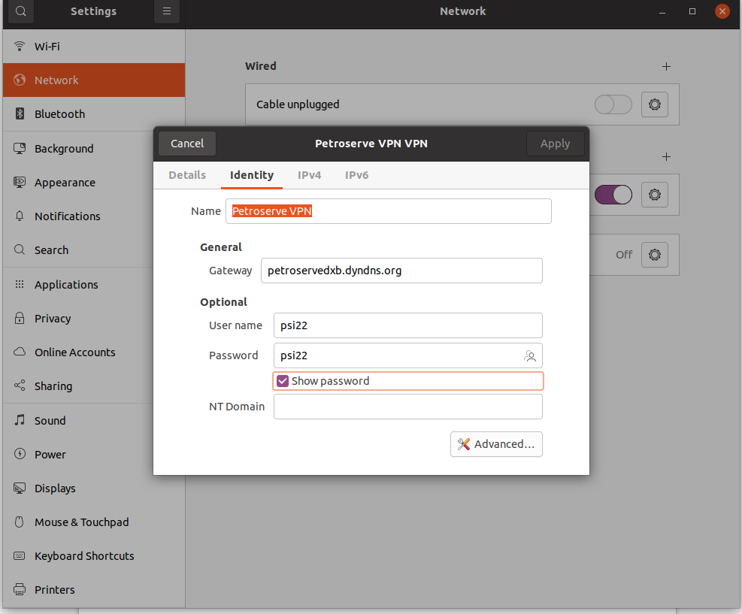

Petroserve Server Details

Petroserve
192.168.2.39
administrator
pETRO@pSIDXB6232

Petroserve-staging
192.168.2.38
administrator
pETRO@pSIDXB6232

Sample:
connecting to staging ->
open terminal >> ssh administrator@192.168.2.38

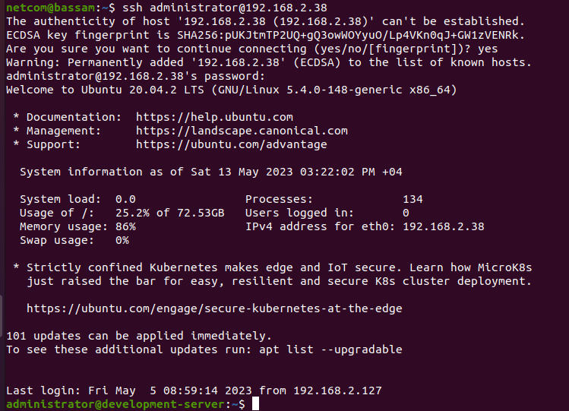

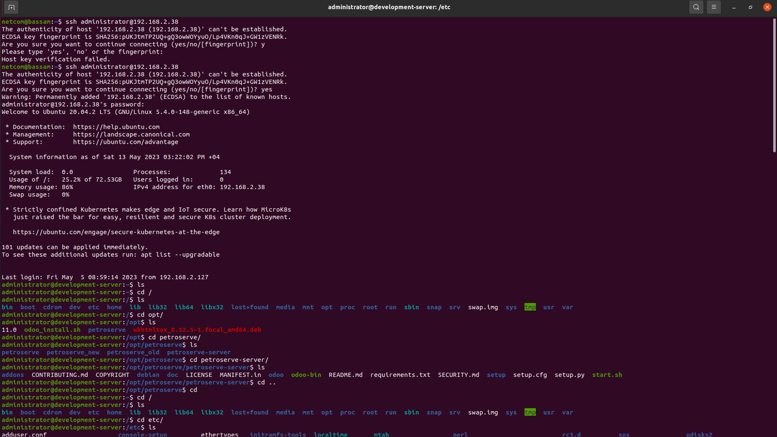

Pulling from repo
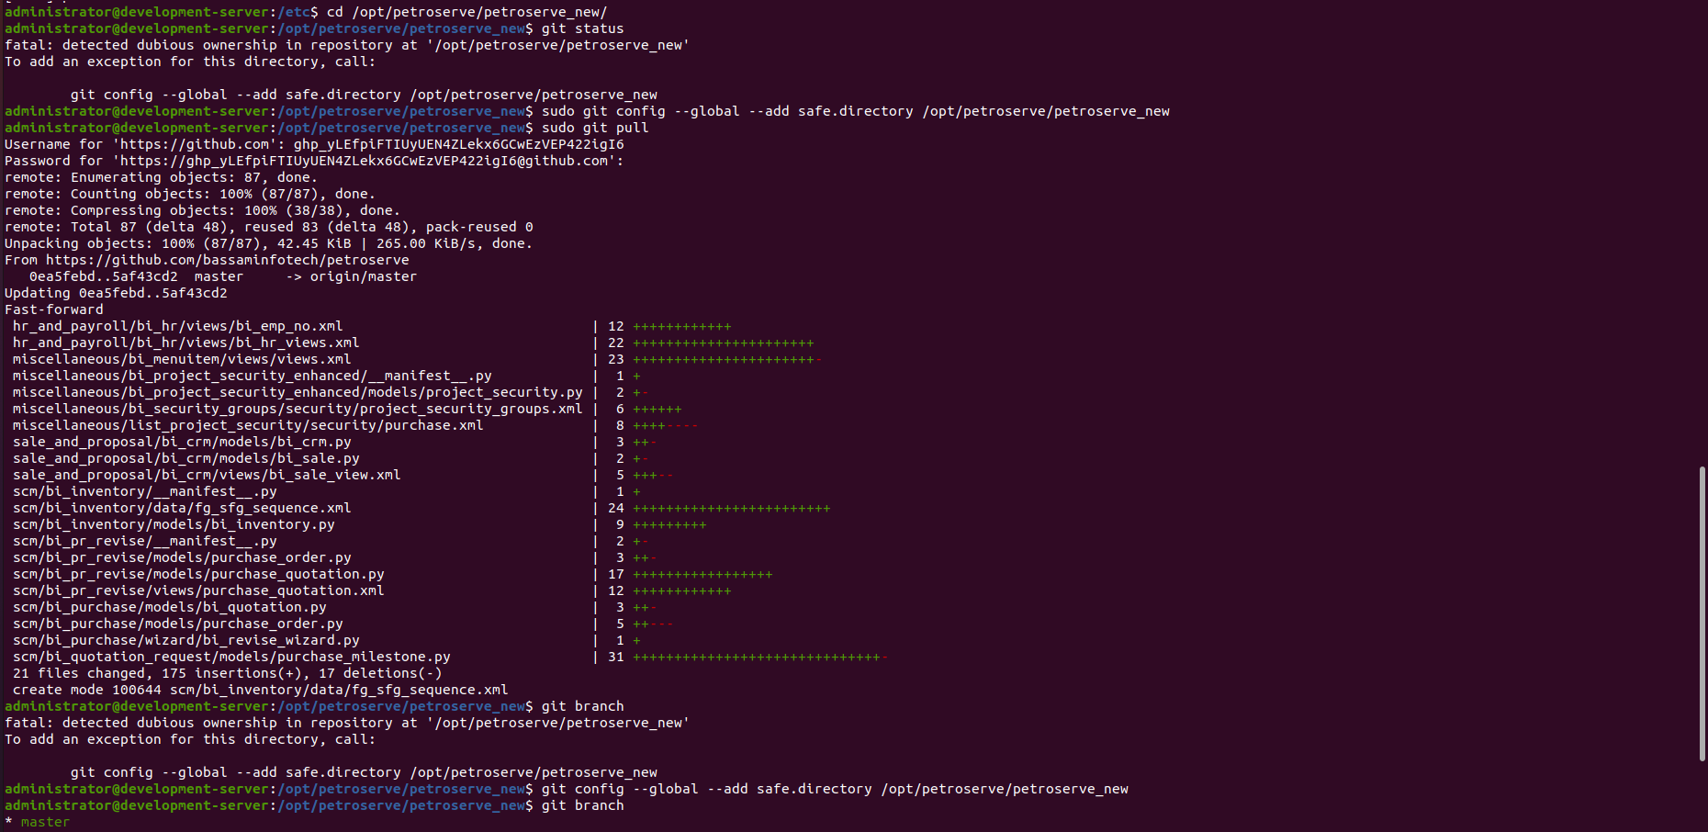

Sstarting or Stoping Server :

