KARUNYA INSTITUTE OF TECHNOLOGY AND SCIENCES
Department of Computer Science and Engineering
23CS2024 – Data Science Ecosystem
Project Based Learning – 2026-2027 Odd Semester
RailSaathi AI
AI-Powered Complaint Management for Rail Madad:
Multimodal Categorisation, Cost-Sensitive Prioritisation
and Predictive Maintenance Analytics
Smart India Hackathon 2024 – Problem Statement SIH1711
Ministry of Railways
Submitted by
Aswin Samuel.A
Register Number: URK24CS9014
III B.Tech, Semester V
Course Coordinator: Dr. Naveen Sundar
October 2026

TABLE OF CONTENTS
1. Problem Statement 1
2. Objectives 1
3. Literature Review 2
4. Existing System 2
5. Proposed Solution 3
6. Methodology 4
6.1 Dataset 4
6.2 Pre-processing and Feature Engineering 5
6.3 Models and Evaluation 5
7. Implementation 6
8. Results 7
8.1 Complaint Categorisation and Routing 7
8.2 Urgency Detection and Prioritisation 9
8.3 Data Extraction and Duplicate Grouping 10
8.4 Predictive Maintenance 11
8.5 Sentiment, SLA Risk and Performance Monitoring 11
9. Discussion 12
10. Conclusion 13
11. Future Scope 13
References 13

1. Problem Statement
Rail Madad is the single-window grievance platform of Indian Railways. Passengers lodge complaints through a mobile app, a web portal, the 139 helpline and social media, often attaching photographs, videos or voice notes. Each complaint receives a reference number, is assigned a category and is forwarded to the department that must act on it [1]. Problem statement SIH1711 of Smart India Hackathon 2024 [2] observes that this registration and categorisation is largely manual, which delays resolution, and that it is especially difficult when the passenger shares only an image, a video or an audio clip. The statement asks for AI that categorises and prioritises complaints, extracts extra information (OCR, image metadata), routes complaints to the right official, predicts recurring problems for proactive maintenance and monitors the process using feedback sentiment.
In data-science terms this is a group of linked problems: multi-class text classification on noisy, code-mixed and multimodal input; ordinal severity prediction in which errors have unequal cost; information extraction; near-duplicate detection; count time-series forecasting; and sentiment and service-level analytics. As required by the course, the project focuses on these analytical methods rather than on a user interface.

2. Objectives
1. Build a realistic, multimodal complaint dataset that reflects Rail Madad categories, departments, severity levels, language noise and operational seasonality.
2. Categorise complaints into 13 classes and 7 departments by fusing text, OCR text and image tags, and measure what each input stream contributes.
3. Route complaints automatically only when the model is confident, and defer the rest to a human desk.
4. Predict urgency with a cost-sensitive decision rule that minimises dangerous under-prioritisation, and quantify the effect on waiting times through queue simulation.
5. Extract train number, coach, PNR and location from text, OCR and EXIF/GPS metadata, and merge duplicate reports of the same incident into one ticket.
6. Forecast weekly maintenance-related complaints per train and flag deteriorating trains early.
7. Analyse feedback sentiment, predict service-level (SLA) breaches at registration time and define monitoring KPIs.

3. Literature Review
Text categorisation. Representing documents with TF-IDF weights [3] and training a linear classifier remains a strong baseline for short texts. Joachims showed that support vector machines suit the high-dimensional, sparse feature spaces of text [4], and Rennie et al. proposed Complement Naive Bayes to correct the bias of standard Naive Bayes on imbalanced classes [5]. Ensemble methods such as random forests [6] and gradient boosting [7] are widely used for tabular prediction. Character n-grams make models robust to spelling variation, which is important because Indian users frequently mix Hindi and English in Roman script [8].
Calibration and selective prediction. SVM scores are not probabilities; Platt scaling maps them to calibrated probabilities [9]. Selective classification lets a model abstain on low-confidence inputs, trading coverage for accuracy [10], which matches a human-in-the-loop routing desk.
Cost-sensitive decisions. When misclassification costs are unequal, the optimal decision is the class with minimum expected cost under the predicted class probabilities rather than the most probable class [11]. Ordinal agreement can be measured with weighted kappa [12]. Priority queues from queueing theory [13] explain why ordering by urgency shortens waits for critical jobs.
Multimodal extraction and analytics. OCR engines such as Tesseract [14], image classifiers such as ResNet [15] and speech recognisers such as Whisper [16] turn images and audio into text or tags that a text pipeline can use. Count data are modelled with Poisson generalised linear models [17]. Clustering quality is measured with the adjusted Rand index [18], feature relevance with permutation importance [19], and opinion mining techniques are surveyed in [20]. scikit-learn [21] implements most of these methods.

4. Existing System
In the present workflow described in SIH1711 [2], a complaint is registered, acknowledged with an ID and categorised by staff or by the passenger choosing from drop-down menus, then forwarded to a department. Its main limitations are:
- Manual categorisation: slow, and wrong categories cause re-routing between departments.
- First-come-first-served handling: a medical emergency can wait behind dozens of minor complaints.
- Unused media: photos, videos and audio are viewed manually; their text and metadata are not extracted.
- Duplicate tickets: many passengers in one coach report the same AC or water failure separately.
- Reactive maintenance: recurring faults on particular trains are not predicted from complaint trends.
- Limited feedback analytics: free-text feedback is not systematically analysed.

5. Proposed Solution
The proposed system, named RailSaathi AI (Fig. 1), is an analytical pipeline that sits behind the existing Rail Madad front end. Every complaint, whatever its medium, is converted into a single fused document: typed text or an ASR transcript, OCR text from attached images, tags from an image classifier, and structured metadata (channel, media type, train type, time). Three models act on this document: a calibrated categoriser that decides the department, a cost-sensitive urgency model that decides the priority, and a grouping step that merges duplicate reports. An analytics layer forecasts maintenance hotspots, predicts SLA breaches and tracks sentiment.
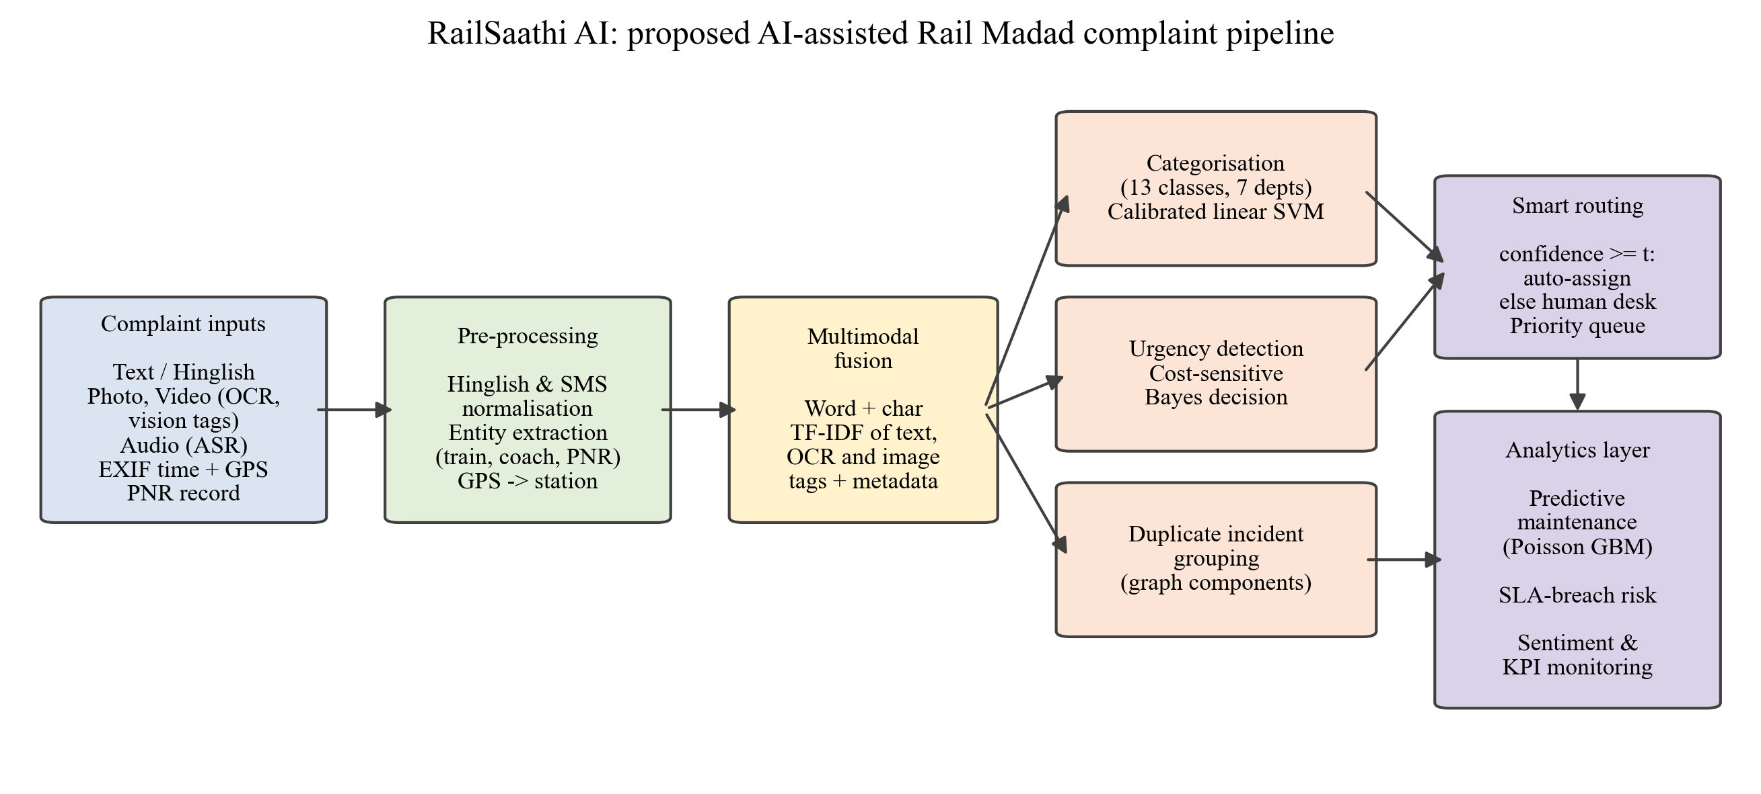
Fig. 1. Architecture of RailSaathi AI, the proposed AI-assisted Rail Madad complaint pipeline.
The novel elements, compared with a plain text classifier, are: (i) multimodal late-fusion of text, OCR and vision tags in one sparse feature space; (ii) confidence-aware routing with a tunable accuracy target; (iii) a minimum-expected-cost severity rule evaluated with a discrete-event queue simulation; (iv) graph-based incident grouping; and (v) Poisson forecasting that turns complaints into predictive maintenance signals.

6. Methodology

6.1 Dataset
Real Rail Madad records are not publicly released, so a synthetic dataset was generated with a purpose-built simulator (src/generate_dataset.py). The 13 categories and their departments follow the Rail Madad portal [1]. The simulator is process-driven rather than random: every train carries a latent condition score per category that evolves as an AR(1) process, eight trains deteriorate steadily, older rakes produce more mechanical and electrical faults, and seasonal multipliers raise AC and water complaints in summer, leakage in the monsoon, fog-related delays in winter and crowding in festival months. Weekly complaint counts are drawn from a Poisson distribution and each complaint is then written in natural language.
To keep the task realistic, 18.2% of complaints are in Hinglish, about 30% contain typing errors or SMS spellings, 15% mention a second minor issue, 4% are vague, and 3% carry a deliberately wrong label (annotation noise). Photos and videos come with OCR text, imperfect vision tags (correct about 70% of the time, mimicking a CNN), EXIF capture time and GPS, while audio complaints arrive as noisy ASR transcripts. Some faults are reported by 2 to 5 passengers, giving ground-truth incident IDs. Resolution time follows a log-normal model driven by department, severity, zone efficiency, night-time and evidence; feedback ratings fall as resolution time exceeds the SLA.
Table 1. Schema of the synthetic Rail Madad dataset.
Group | Attributes
Complaint | complaint_text, channel, media_type, timestamp, is_hinglish
Media-derived | ocr_text, vision_tags, exif_capture_lag_min, gps_lat, gps_lon
Journey | train_no, train_type, zone, train_age_years, coach, pnr, nearest_station
Labels | category (13), department (7), severity (4), incident_id
Process | resolution_hours, sla_hours, sla_breached, feedback_rating, feedback_text

The final dataset holds 25,133 complaints (20,605 distinct incidents) on 60 trains from 2025-01-06 to 2026-09-30. A time-based split is used: complaints before 1 April 2026 (17,077) for training and the last six months (8,056) for testing, so every model is evaluated on future data exactly as it would be deployed.
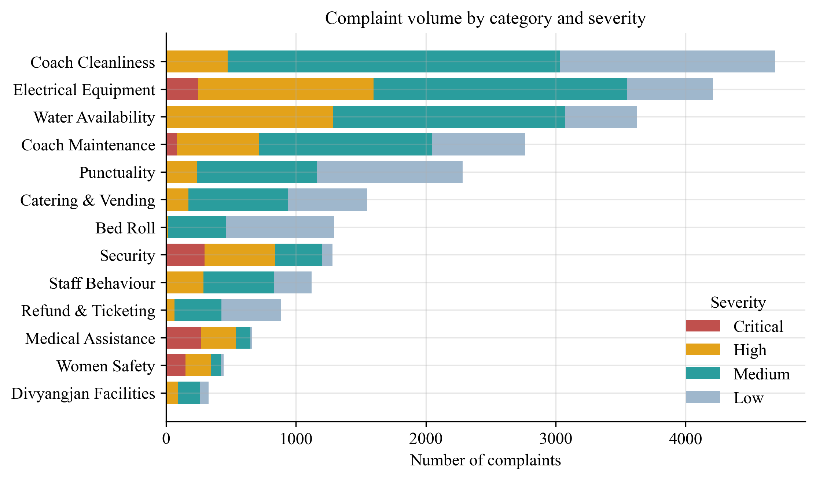
Fig. 2. Complaint volume by category, split by severity level.

6.2 Pre-processing and Feature Engineering
Text is lower-cased; handles, PNRs and train numbers are replaced by placeholder tokens so that the classifier cannot memorise them; a compact (about 50-word) Hinglish lexicon (for example pani to water, ganda to dirty) and an SMS dictionary normalise code-mixed and abbreviated words. OCR tokens are prefixed with ocr_ and vision tags with img_, and all are concatenated into one document. Features are word 1-2-gram and character 2-5-gram TF-IDF vectors [3]; the urgency model also receives one-hot metadata.

6.3 Models and Evaluation
- Categorisation: Complement Naive Bayes, Logistic Regression, a Platt-calibrated linear SVM and a Random Forest, compared on accuracy, macro-F1 and department-routing accuracy.
- Routing: a complaint is auto-assigned if the top calibrated probability exceeds a threshold chosen so that auto-routed complaints reach 97% accuracy; the rest go to a human desk.
- Urgency: a cost matrix C penalises under-triage quadratically (Critical predicted as Low costs 16, over-triage costs 1). The predicted class is argmin_k sum_j p(j|x) C[j,k] [11].
- Queue simulation: test complaints arrive at their real timestamps at a single triage desk (mean handling 30 min, 92% utilisation), handled by FIFO, by AI priority or by true priority.
- Extraction and grouping: regular expressions for train number, coach and PNR; haversine nearest station from GPS; complaints on the same train within 6 h with the same predicted category are linked if they share the booked coach or exceed a cosine-similarity threshold, and connected components become incidents, scored with pairwise F1 and ARI [18].
- Forecasting: weekly counts per train of five maintenance categories, predicted with lag, rolling, trend and seasonal features using a Poisson GLM [17] and Poisson-loss gradient boosting [7].
- Sentiment and SLA: a TF-IDF logistic-regression sentiment model trained on feedback text with labels from star ratings, and a gradient-boosting SLA-breach classifier explained by permutation importance [19].

7. Implementation
The project is written in Python 3.11 using pandas, NumPy, SciPy, scikit-learn [21] and Matplotlib. Each stage is a separate module in src/, and run_all.py executes the full pipeline (data generation, EDA, modelling, figures and result tables) in under two minutes on a laptop. All random processes are seeded, so every number in this report can be reproduced. Results are written as CSV/JSON files to results/ and figures as 300-dpi PNG files to figures/. The source code is available at https://github.com/aswinsamuel-codes/RailSaathi-AI.
Table 2. Implementation modules.
Module | Responsibility
generate_dataset.py | Process-driven multimodal complaint simulator
common.py | Paths, plotting style, Hinglish/SMS normalisation, multimodal fusion
eda.py | Descriptive statistics, seasonality and operational analysis
categorize.py | Model comparison, ablation, confusion matrix, confidence routing
urgency.py | Cost-sensitive severity prediction and queue simulation
extraction_dedup.py | Entity extraction, GPS location, duplicate-incident grouping
predictive_maintenance.py | Weekly Poisson forecasting and hotspot detection
sentiment_sla.py | Sentiment model, SLA-breach risk model, KPI monitoring

Exploratory analysis confirmed that the simulated operational patterns are visible in the data. Fig. 3 shows the relative monthly share of each category: electrical and water complaints peak in April-June, maintenance complaints in the monsoon, punctuality complaints in the foggy months of December-January and security complaints around festivals. The overall SLA breach rate is 28.1%, ranging from 19.0% in the best zone to 43.6% in the worst.
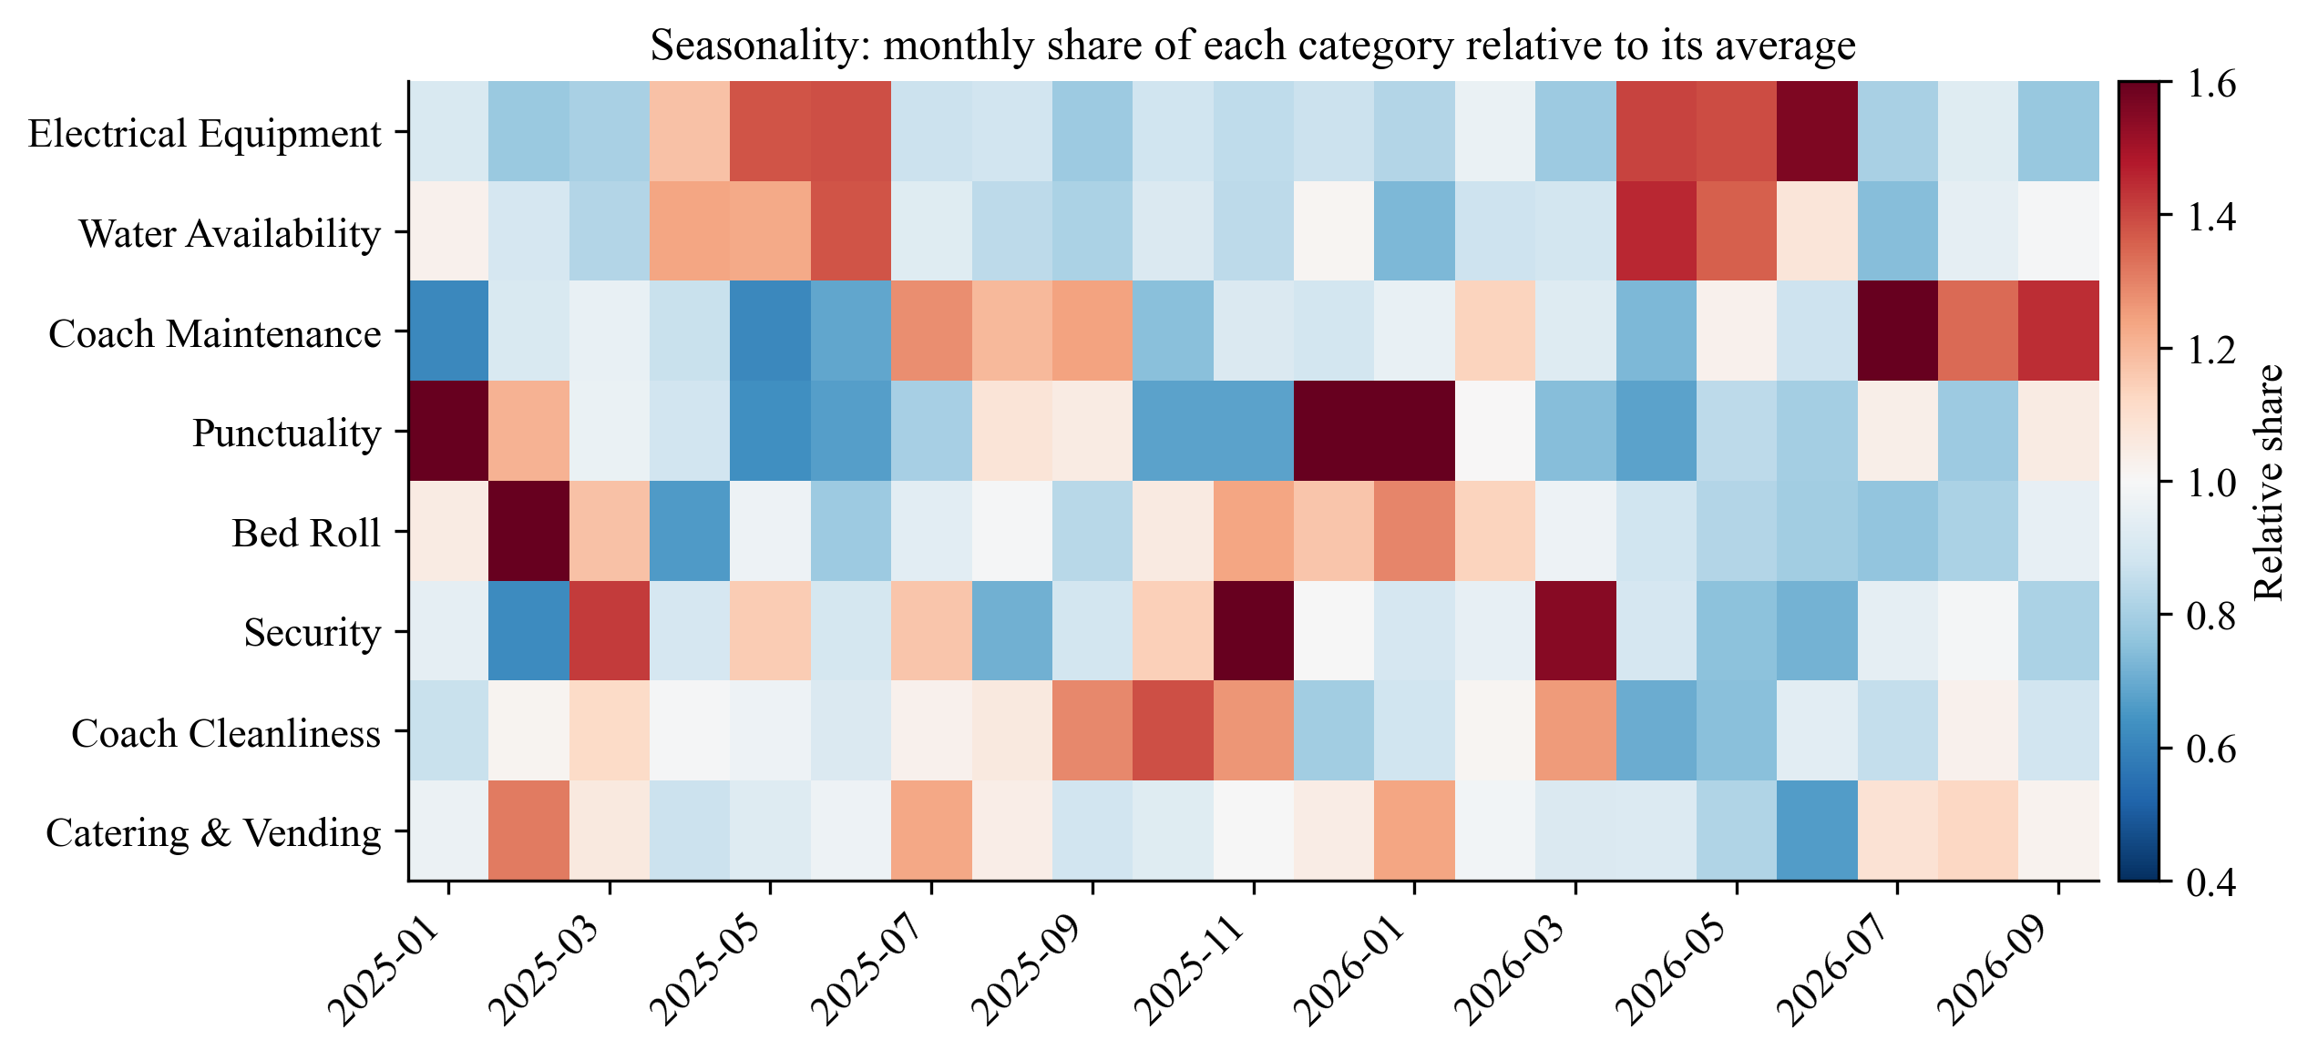
Fig. 3. Seasonality of complaint categories (share relative to the category average).

8. Results

8.1 Complaint Categorisation and Routing
Table 3. Categorisation performance on the six-month test set (* best model).
Model | Accuracy (%) | Macro-F1 (%) | Dept. routing (%) | Train time (s)
Complement Naive Bayes | 93.17 | 90.63 | 94.23 | 0.1
Logistic Regression | 93.81 | 90.35 | 94.55 | 6.4
Linear SVM (calibrated)* | 95.05 | 93.42 | 95.93 | 5.7
Random Forest | 92.90 | 90.38 | 93.94 | 19.3

The calibrated linear SVM is the best model with 95.05% accuracy and 93.42% macro-F1, and it sends 95.93% of complaints to the correct department. It needs about 6 s to train and well under 0.1 ms per complaint to predict, so it can classify a complaint the moment it is lodged. Fig. 4 shows that most remaining errors involve the two smallest classes, Divyangjan Facilities and Women Safety, whose complaints share vocabulary with other classes.
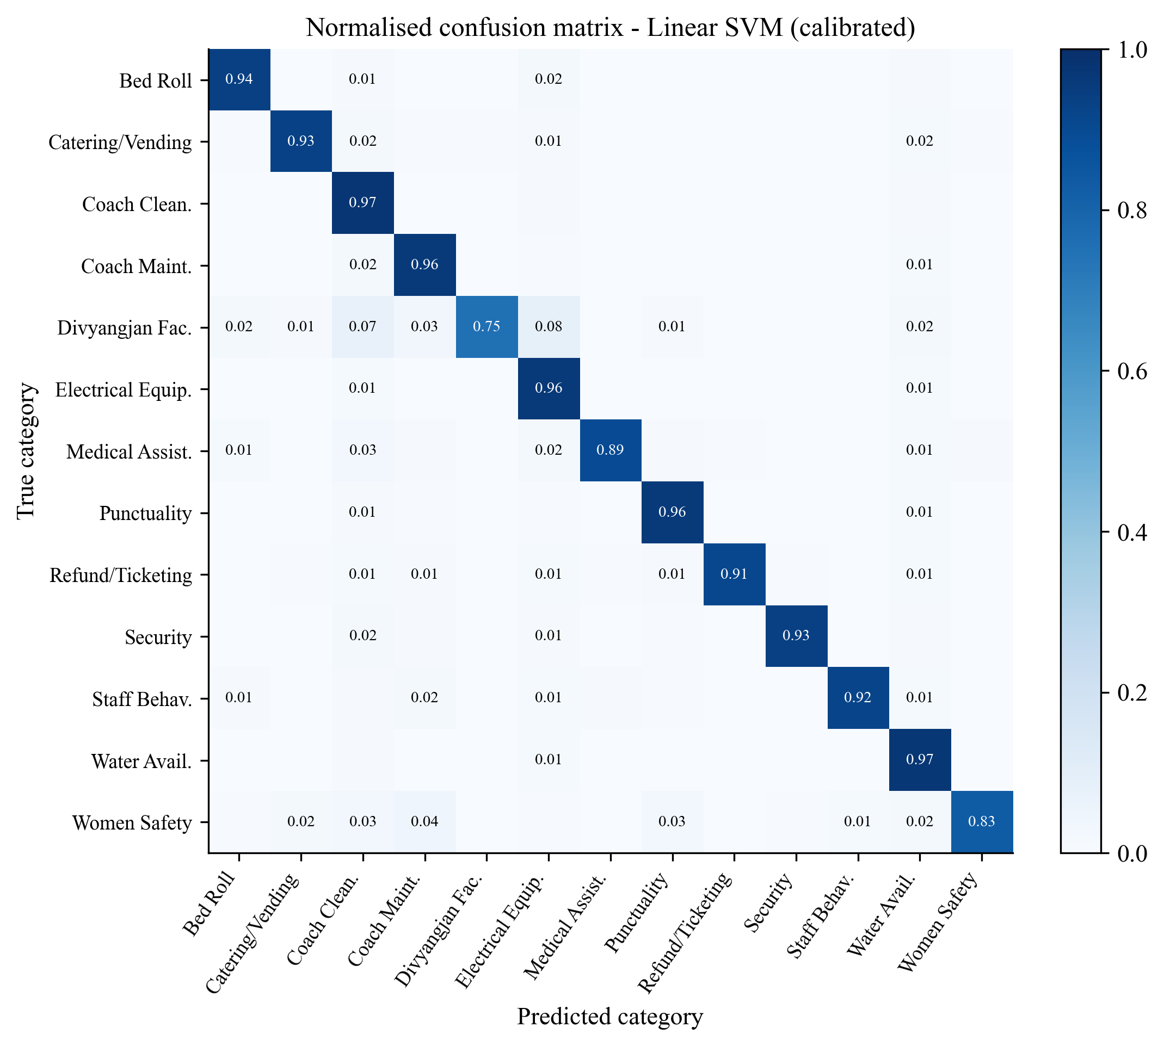
Fig. 4. Normalised confusion matrix of the calibrated linear SVM.
Table 4. Ablation study: contribution of each input stream (accuracy and macro-F1 in %).
Input streams (linear SVM) | Macro-F1 (all) | Accuracy (all) | Accuracy (photo/video) | Accuracy (Hinglish)
Word n-grams, raw text | 90.12 | 93.52 | 93.74 | 93.74
Word n-grams + Hinglish/SMS lexicon | 90.16 | 93.55 | 93.71 | 93.74
+ Character n-grams | 90.45 | 93.57 | 93.74 | 93.74
+ OCR text | 90.25 | 93.74 | 94.25 | 93.94
+ Vision tags (full fusion) | 92.2 | 94.8 | 96.47 | 94.98

The ablation (Table 4) shows that the Hinglish lexicon and character n-grams add only small gains, because character n-grams already match spelling variants. OCR text and especially vision tags help most: with full fusion, accuracy on photo/video complaints rises from 93.74% to 96.47%, showing that the media passengers attach carry useful category information. Across sub-groups the model stays robust: 94.1% on audio transcripts and 95.0% on Hinglish complaints.
For confidence-aware routing (Fig. 5), a threshold of 0.19 auto-routes 97.6% of complaints with 97.0% accuracy. Only 2.4% go to the human desk, and on these the model would have been right just 15.4% of the time, which confirms that the abstention targets genuinely ambiguous complaints.
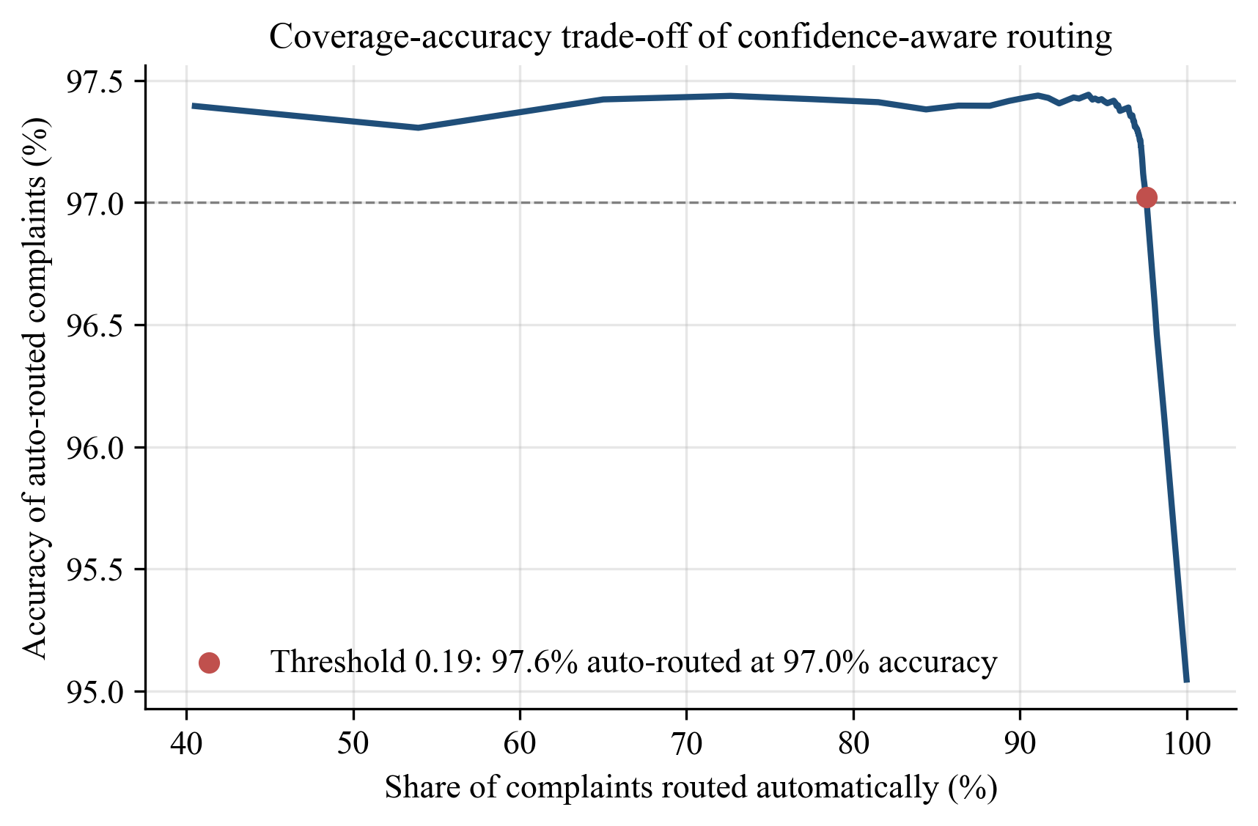
Fig. 5. Coverage versus accuracy of confidence-aware routing.

8.2 Urgency Detection and Prioritisation
Table 5. Severity prediction on the test set (* proposed). Lower cost and under-triage are better.
Method | Acc. (%) | QW kappa | Crit. recall (%) | Crit.+High recall (%) | Under-triage (%) | Mean cost
Keyword rules only | 48.2 | 0.299 | 70.5 | 11.3 | 24.2 | 1.078
Linear SVM | 87.7 | 0.873 | 90.9 | 88.3 | 6.1 | 0.250
Logistic Regression (arg-max) | 86.7 | 0.839 | 90.9 | 89.5 | 6.4 | 0.267
LR + minimum expected cost* | 83.5 | 0.738 | 94.9 | 96.9 | 1.6 | 0.195
LR + min. cost + safety lexicon | 83.3 | 0.733 | 94.9 | 96.9 | 1.6 | 0.198

Plain arg-max logistic regression is the most accurate learner after the SVM, but it misses 9.1% of critical cases. The minimum-expected-cost rule accepts a lower overall accuracy (83.5%) in exchange for higher critical recall (94.9%), Critical+High recall of 96.9% and an under-triage rate of only 1.6%, four times lower than arg-max. It has the lowest mean cost of all methods. A keyword-only rule system performs poorly, and adding a safety-keyword override on top of the model gave no further benefit, because the learned model already captures those cues.
The queue simulation (Fig. 6b) shows the operational impact: with FIFO handling, critical complaints wait 535 min on average; with AI priority this falls to 32 min, within 2 min of the ideal (30 min). High-severity waits fall from 570 to 62 min. The price is a longer wait for low-severity complaints, which have the most relaxed (48 h) SLA.
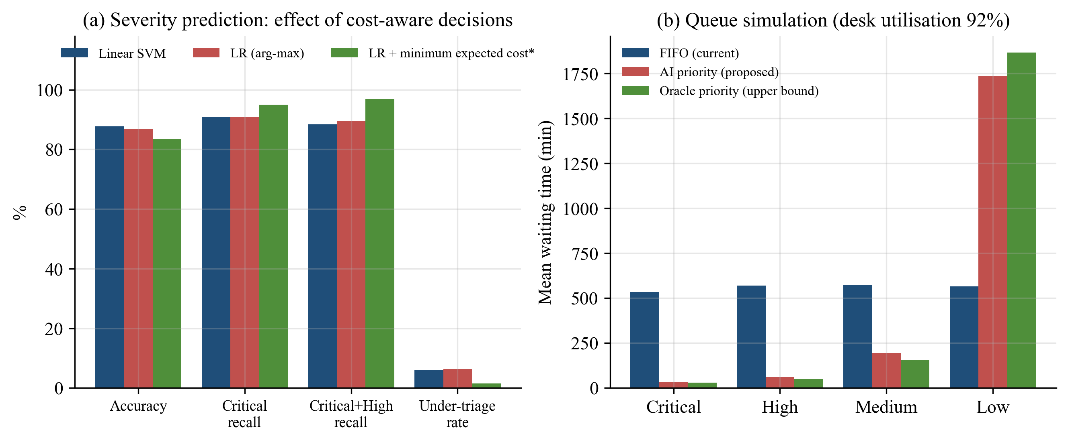
Fig. 6. (a) Effect of the cost-sensitive decision rule; (b) mean waiting time by severity under three queueing policies.

8.3 Data Extraction and Duplicate Grouping
The extractors are precise (train number 98.7%, coach 92.2%, PNR 98.4% precision) and recover almost every value that is actually mentioned. Reading the attached images with OCR raises the share of complaints with a recovered train number from 41.3% to 50.9% and coach from 52.3% to 60.4%. EXIF GPS was present in 26.6% of complaints and identified the nearest station correctly in 99.8% of them.
For duplicate grouping (Fig. 7), text similarity alone reaches at best a pairwise F1 of 0.741, because different passengers describe the same fault in different words. Adding the booked coach from the PNR record raises pairwise F1 to 0.972 (ARI 0.972) and reduces 8,056 complaints to 6,630 tickets, close to the 6,621 true incidents. This removes about 18% of redundant work.
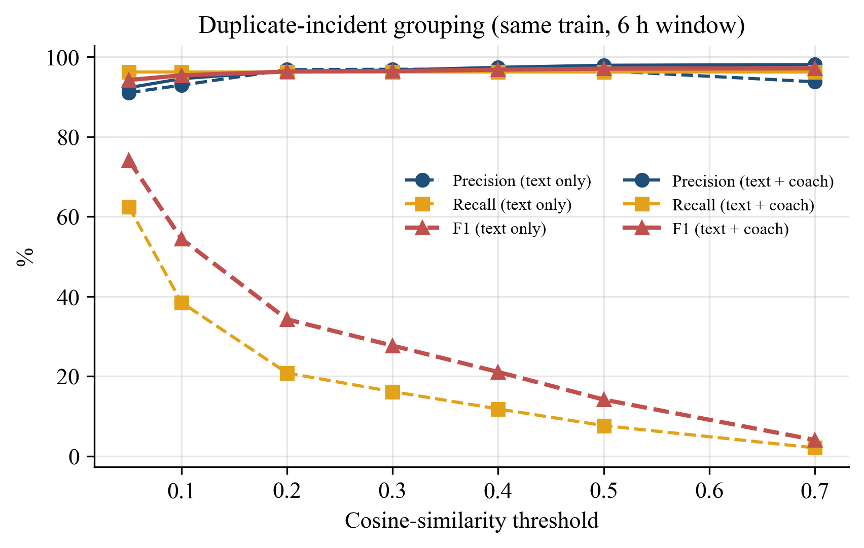
Fig. 7. Pairwise precision, recall and F1 of duplicate grouping versus the similarity threshold.

8.4 Predictive Maintenance
Table 6. Weekly maintenance-complaint forecasting per train (test period, * proposed).
Model | MAE | RMSE | Poisson deviance
Naive (last week) | 2.482 | 3.54 | 6.599
Moving average (4 wk) | 2.073 | 2.934 | 2.437
Poisson GLM | 2.249 | 3.98 | 2.39
Gradient Boosting (Poisson)* | 2.098 | 3.026 | 2.326

Poisson-loss gradient boosting gives the lowest Poisson deviance, the proper error measure for counts, and cuts the deviance of the naive last-week forecast by about 65%. The 4-week moving average is competitive on MAE, which is expected for noisy weekly counts, but it cannot use season or train age. More importantly, ranking trains by forecast complaints flags hotspots: of the eight trains flagged at the start of the test period, 50% are truly deteriorating trains, against a random rate of 13.3%, and 62.5% are among the eight trains that actually produced the most complaints later. These rakes can be sent for inspection before failures pile up.
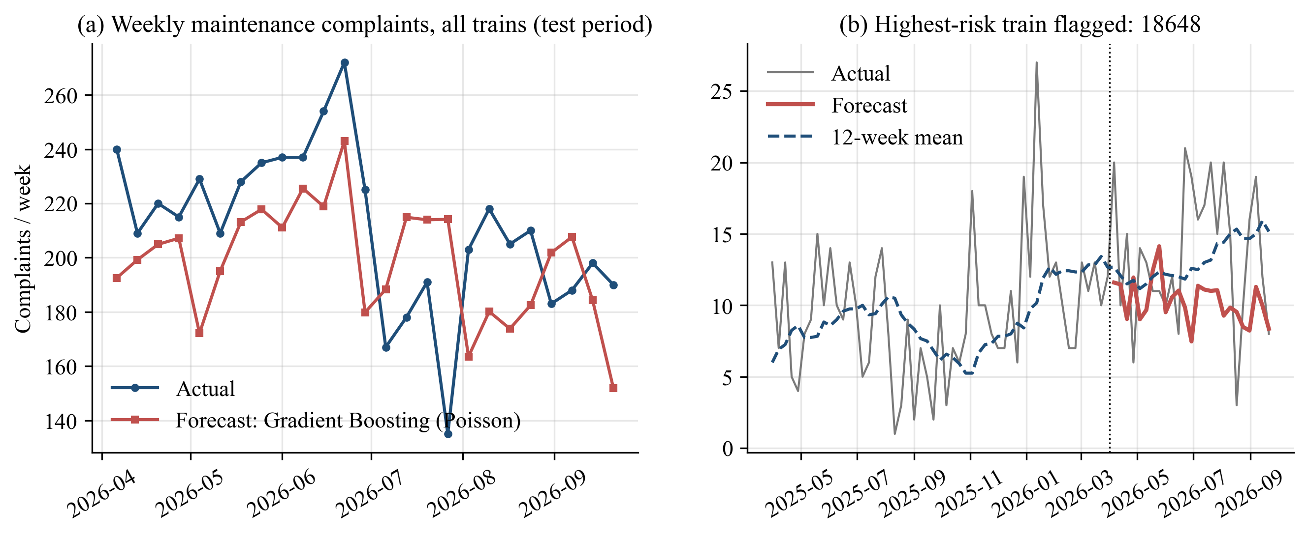
Fig. 8. (a) Network-level weekly forecast; (b) history and forecast of the highest-risk train.

8.5 Sentiment, SLA Risk and Performance Monitoring
The sentiment model classifies feedback with 80.8% accuracy (macro-F1 0.759) and recalls 86.9% of negative feedback. Negative sentiment is strongly tied to service level: within SLA only 5-8% of feedback is negative in every department, while after an SLA breach it rises to 31-42%, highest for Medical (42.3%). Monthly breach rate and negative-feedback share are correlated (r = 0.60), so both can serve as KPIs. The SLA-breach model predicts breaches at registration with ROC-AUC 0.731 (logistic regression) and 0.718 (gradient boosting); the top 20% riskiest complaints contain 36.4% of all breaches. Severity, category, zone and night-time registration are the main drivers (Fig. 9a).
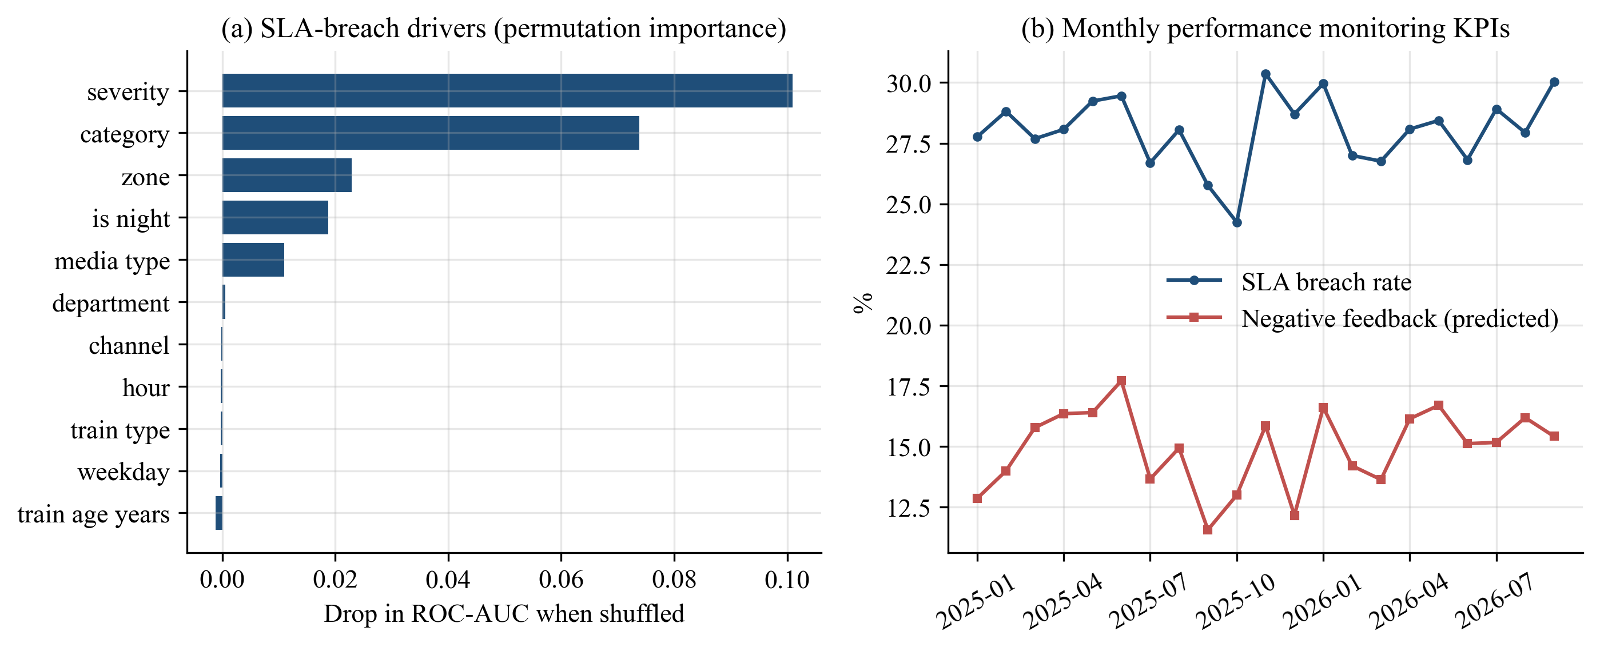
Fig. 9. (a) Permutation importance of SLA-breach drivers; (b) monthly KPI trend.

9. Discussion
The results support each objective, and Table 7 links them. Three observations stand out. First, multimodal fusion matters most where the existing system struggles: photo and video complaints. Second, accuracy is the wrong target for urgency. Accepting a few points of accuracy loss to reduce under-triage four-fold is the right trade-off when the cost of a missed emergency is far greater than the cost of a false alarm. The queue simulation turns this into waiting minutes that managers can understand. Third, structured metadata (PNR coach, GPS, train ID) often beats sophisticated text similarity, as seen in duplicate grouping, so integrating the model with railway databases is as important as the model itself.
Table 7. Summary of results against the objectives.
Objective | Key result
Categorisation and routing | 95.0% accuracy; 97.6% auto-routed at 97.0%
Multimodal analysis | Photo/video accuracy 93.7% to 96.5% with OCR + vision tags
Urgency detection | Critical recall 94.9%; under-triage 1.6%
Prioritisation | Critical wait 535 to 32 min
Data extraction | Train number recovered +9.5 pts with OCR; GPS station 99.8%
Duplicate grouping | Pairwise F1 0.972; 18% fewer tickets
Predictive maintenance | Deviance -65% vs naive; 50% precision@8 vs 13% random
Feedback and monitoring | Sentiment accuracy 80.8%; SLA-breach AUC 0.73

Limitations. The dataset is synthetic. Its patterns are realistic by design, but the absolute scores, especially for duplicate grouping, where reports of one incident always share a coach, would be lower on real data. The vision tags and ASR transcripts are simulated outputs rather than the outputs of trained image and speech models. The SLA model reaches only moderate AUC because much of the resolution-time variation is random by construction, as it is in real operations.

10. Conclusion
This project designed and evaluated RailSaathi AI, a complete data-science pipeline for SIH1711 that turns raw, multimodal passenger complaints into routed, prioritised and de-duplicated tickets, and turns the complaint stream into maintenance and service-quality intelligence. A calibrated linear SVM on fused text, OCR and image tags categorised 95% of complaints correctly. Confidence-aware routing automated almost 98% of assignments at 97% accuracy. A cost-sensitive urgency rule cut the average wait for critical complaints in a simulated triage desk from about nine hours to about half an hour. Graph-based grouping removed 18% of redundant tickets, and Poisson forecasting identified deteriorating trains nearly four times better than chance. All components are lightweight, fast and reproducible, so they could be added to the existing Rail Madad back end without changing the passenger interface.

11. Future Scope
- Validate on real, anonymised Rail Madad records obtained from the Ministry of Railways.
- Replace simulated vision tags with a fine-tuned CNN or vision transformer on coach images, and use a speech model such as Whisper [16] on real voice complaints.
- Use multilingual transformer embeddings for regional languages beyond Hindi and English.
- Add a chatbot that asks for missing details (PNR, coach) when the extractors find none.
- Link predictive-maintenance alerts with depot maintenance schedules and optimise staff allocation across zones from the forecasts.

References
[1] Ministry of Railways, Government of India, "Rail Madad - For inquiry, assistance and grievance redressal." [Online]. Available: https://railmadad.indianrailways.gov.in
[2] Ministry of Education's Innovation Cell, "Smart India Hackathon 2024 - Problem statement SIH1711: Enhancing Rail Madad with AI-powered complaint management," 2024.
[3] G. Salton and C. Buckley, "Term-weighting approaches in automatic text retrieval," Information Processing & Management, vol. 24, no. 5, pp. 513-523, 1988.
[4] T. Joachims, "Text categorization with support vector machines: Learning with many relevant features," in Proc. 10th European Conf. Machine Learning (ECML), 1998, pp. 137-142.
[5] J. D. M. Rennie, L. Shih, J. Teevan, and D. R. Karger, "Tackling the poor assumptions of naive Bayes text classifiers," in Proc. 20th Int. Conf. Machine Learning (ICML), 2003, pp. 616-623.
[6] L. Breiman, "Random forests," Machine Learning, vol. 45, no. 1, pp. 5-32, 2001.
[7] J. H. Friedman, "Greedy function approximation: A gradient boosting machine," The Annals of Statistics, vol. 29, no. 5, pp. 1189-1232, 2001.
[8] K. Bali, J. Sharma, M. Choudhury, and Y. Vyas, "'I am borrowing ya mixing?' An analysis of English-Hindi code mixing in Facebook," in Proc. First Workshop on Computational Approaches to Code Switching, 2014, pp. 116-126.
[9] J. Platt, "Probabilistic outputs for support vector machines and comparisons to regularized likelihood methods," in Advances in Large Margin Classifiers, MIT Press, 1999, pp. 61-74.
[10] Y. Geifman and R. El-Yaniv, "Selective classification for deep neural networks," in Advances in Neural Information Processing Systems 30 (NeurIPS), 2017.
[11] C. Elkan, "The foundations of cost-sensitive learning," in Proc. 17th Int. Joint Conf. Artificial Intelligence (IJCAI), 2001, pp. 973-978.
[12] J. Cohen, "Weighted kappa: Nominal scale agreement with provision for scaled disagreement or partial credit," Psychological Bulletin, vol. 70, no. 4, pp. 213-220, 1968.
[13] L. Kleinrock, Queueing Systems, Volume 1: Theory. New York, NY, USA: Wiley, 1975.
[14] R. Smith, "An overview of the Tesseract OCR engine," in Proc. 9th Int. Conf. Document Analysis and Recognition (ICDAR), 2007, pp. 629-633.
[15] K. He, X. Zhang, S. Ren, and J. Sun, "Deep residual learning for image recognition," in Proc. IEEE Conf. Computer Vision and Pattern Recognition (CVPR), 2016, pp. 770-778.
[16] A. Radford, J. W. Kim, T. Xu, G. Brockman, C. McLeavey, and I. Sutskever, "Robust speech recognition via large-scale weak supervision," in Proc. 40th Int. Conf. Machine Learning (ICML), 2023, pp. 28492-28518.
[17] P. McCullagh and J. A. Nelder, Generalized Linear Models, 2nd ed. London, U.K.: Chapman & Hall, 1989.
[18] L. Hubert and P. Arabie, "Comparing partitions," Journal of Classification, vol. 2, no. 1, pp. 193-218, 1985.
[19] A. Altmann, L. Tolosi, O. Sander, and T. Lengauer, "Permutation importance: A corrected feature importance measure," Bioinformatics, vol. 26, no. 10, pp. 1340-1347, 2010.
[20] B. Pang and L. Lee, "Opinion mining and sentiment analysis," Foundations and Trends in Information Retrieval, vol. 2, no. 1-2, pp. 1-135, 2008.
[21] F. Pedregosa et al., "Scikit-learn: Machine learning in Python," Journal of Machine Learning Research, vol. 12, pp. 2825-2830, 2011.

