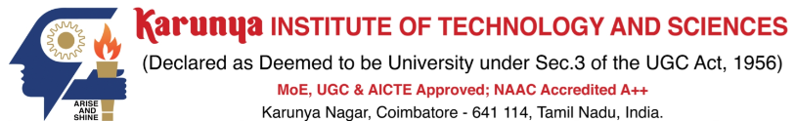
S.No | Rubrics | Maximum Marks | Marks Obtained
1 | Evaluation of Problem Statement, Methodology, and Dataset | 5
2 | Implementation and Result Analysis | 5
3 | Demonstration and Viva | 5
4 | Report | 5
5 | Microsoft Certificate | 20
Total |  | 40

