Introduction to Java Programming

Java is a powerful object-oriented programming language introduced by Sun Microsystems in 1995, which has built-in support to create programs with a graphical user interface (GUI), utilize the Internet, create client-server solutions, and much more. Programs written in Java can run, without change, on any of the common computer operating systems Windows 95/NT, Macintosh, and Unix. A variant of Java programs called applets can be embedded inside a web page and execute on the computer that is viewing the page, automatically and in a secure environment.

As a language, Java is closely related to C++, which is also object-oriented but retains a lot of idiosyncrasies inherited from its predecessor language C. Java has removed the inconsistent elements from C++, is exclusively object-oriented, and can be considered a modern version of C++. Because of its logical structure Java has quickly become a popular choice as a teaching language, and because of its extensive Internet support and the promise of writing programs once and using them on every operating system Java is becoming more and more accepted in industry.

Basic Java Programming Guidelines
Every Java program must follow these guidelines:

- Java is case sensitive, i.e. the word Program is different from program.
- Curly brackets { and } are used to group statements together.
- An executable Java program must contain at least the following lines as a framework:

public class Name
{ public static void main(String args[])
{ ... program code ...
}
}

- Every statement whose next statement is not a separate group must end in a semicolon.
- A Java program containing the above framework must be saved using the filename Name.java, where Name (including correct upper and lower cases) is the word that follows the keywords public class and the file extension is .java.

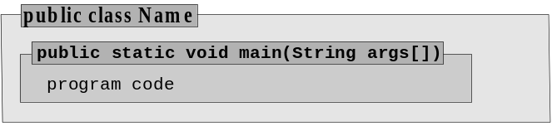

In other words, to create a Java program you first create a text file containing the lines

public class Name
{
public static void main(String args[])
{
... more lines ...
}
}

The file containing our code is called the source code file.

Source Code
A Java source code file is a text file that contains programming code written according to the Java language specifications, resembling a mixture of mathematical language and English. A computer cannot execute source code, but humans can read and understand it.

Java source code files should be saved as Name.java, where Name is the name that appears in the first line of the program: public class Name. That Name is referred to as the name of the class, or program. By convention its first letter is capitalized.

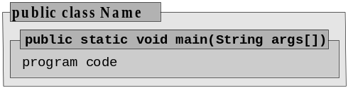 |  | 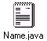
Figure: Saving a Java source code file

Here is an example of a Java source code file. We will later explain what the various lines mean; for now it is simply a text file that looks as shown.

Example: The first source code file
Create a source code file containing the necessary Java code to get the computer to write "Hi – this is my first program" on the screen.

Our first Java program looks as follows:

public class Test
{
public static void main(String args[])
{
System.out.println("Hi – this is my first program");
}
}

This program, or class, is called Test and must be saved under the file name Test.java.
■

Compiling a Java Program or Class

A source code file, which is more or less readable in plain English, needs to be transformed into another format before the computer can act upon it. That translation process is called compiling and is accomplished using the Java compiler javac from the Java Developer's Kit (JDK), which could be invoked by an IDE such as BlueJ.

Compiling
Compiling is the process of transforming the source code file into a format that the computer can understand and process. The resulting file is called the byte-code, or class, file. The name of the class file is the same as the name of the program plus the extension .class. The program javac from the Java Developer's Kit is used to transform a source code file into a class file.

 |  |  | 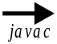 | 
Figure: Compiling and creating class file

If a source code contains any errors, they are flagged by the compiler. You need to fix them and re-compile until there are no further errors.

■

Tip: In case of an error, the javac compiler shows the line number and position of where it thinks the error occurred in your source code.

- If the compiler points out an error, then there is an error at or before the indicated position.
- If the compiler reports a certain number of errors, than this is the least amount of errors.
- If one error is fixed, other errors may automatically disappear or new ones may appear.

Fix your source code a few errors at a time. Recompile often to see if the number of errors and the error messages change until no errors are reported. If you can not find an error at the position indicated by the compiler, look at the code before that position.

Executing a Java Program or Class

The Java compiler does not produce an executable file, so Java programs can not execute under the operating system of your machine. Instead they execute inside a Java Virtual Machine, which is invoked using the java program of the JDK.

Executing a Class File
To execute a Java program the Java Developer's Kit provides a program called java. When executing that program with your class file as parameter the following happens:

- the Java Virtual Machine (JVM) is created inside your computer
- the JVM locates and reads your class files
- the JVM inspects your class file for any security violations
- the JVM executes, or interprets, your class file according to its instructions if possible

Under Windows and Unix, execute a program by typing at the command prompt java Name, where Name is the name of the program (no extension). On a Macintosh, double-click the java icon and select the appropriate class file.

Most IDE’s allow for a convenient way to execute a file. In BlueJ you right-click on a compiled class and select the “main” method.

 |  |  |  |  | 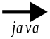 | 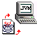
Figure: Executing a class file

A good question at this point is which line in a Java program executes first.

Default Program Entry Point
The default program entry point is that part of a class (or program) where execution begins. For every Java class (or program), the standard program entry point consists of the line:

public static void main(String args[])

If that line is not present in your source code, the JVM can not execute your program and displays an error message.

At this point, we need to explain what the Java Virtual Machine is and how it relates to the operating system and to Java class files.

Java Virtual Machine (JVM)
The Java Virtual Machine (JVM) is a platform-independent engine used to run Java applets and applications. The JVM knows nothing of the Java programming language, but it does understand the particular file format of the platform and implementation independent class file produced by a Java compiler. Therefore, class files produced by a Java compiler on one system can execute without change on any system that can invoke a Java Virtual Machine.

When invoked with a particular class file, the JVM loads the file, goes through a verification process to ensure system security, and executes the instructions in that class file.

The JVM, in other words, forms a layer between the operating system and the Java program that is trying to execute. That explains how one Java program can run without change on a variety of systems: it can not! A Java program runs on only one system, namely the Java Virtual Machine. That virtual system, in turn, runs on a variety of operating systems and is programmed quite differently for various systems. To the Java programmer, it provides a unified interface to the actual system calls of the operating system.

You can include graphics, graphical user interface elements, multimedia, and networking operations in a Java program and the JVM will negotiate the necessary details between the class file(s) and the underlying operating system. The JVM produces exactly the same results – in theory – regardless of the underlying operating system. In the Basic (or C, or C++) programming language, for example, you can create code that specifies to multiply two integers 1000 and 2000 and store the result as another integer. That code works fine on some systems, but can produce negative numbers on others. In Java, this can not happen: either the code fails on all platforms, or it works on all platforms.

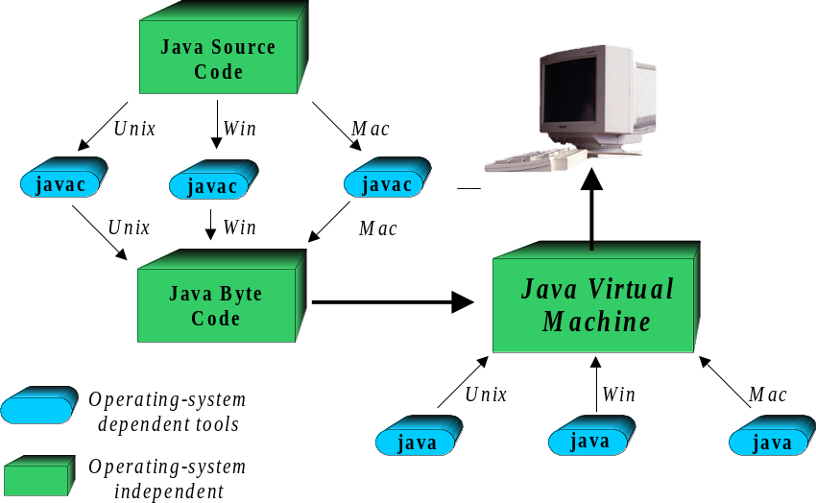
Figure 1.09: Illustrating the machine dependent/independent parts of Java programs

Because the JVM is in effect its own computer, it can shield the actual computer it is running on from potentially harmful effects of a Java program. This is especially important because Java programs known as applets can automatically start executing on your machine when you are surfing the web if the appropriate feature of your web browser is enabled. If these programs were allowed to meddle with your system, you could accidentally execute a program that would proceed to erase your entire disk. That, of course, would prompt people to disable Java on their web browser, which in turn would be bad news for anyone who supports the Java concept.

Basic Data Types:

Primitive Java Data Types
Java supports the following primitive, or basic, data types:

- int, long, or short to represent integer numbers
- double or float to represent decimal numbers
- char to represent character values
- boolean to represent logical values
- void to represent "no type"

Each numeric type has a largest and smallest possible value, as indicated in table 1.10.

Most programs use int for integers and double for decimal numbers, while long, short, and float are needed only in special situations.

Type | Range
double | largest positive/negative value: | ±1.7976931348623157E308
double | smallest non-zero value: | ±4.9E-324
double | significant digits: | 16 digits after decimal point
float | largest positive/negative value: | ±3.4028235E38
float | smallest non-zero value: | ±1.4E-45
float | significant digits: | 8 digits after decimal point
int | largest value | 2147483647
int | smallest value: | -2147483648
short | largest value | 32767
short | smallest value: | -32768
long | largest value | 9223372036854775807
long | smallest value: | -9223372036854775808
Table: Ranges for valid decimal types

Each type can contain values called literals or unnamed constants in a particular format.

Literals
Literals are constant values for the basic data types. Java supports the following literals:

- int, short: digits only, with possible leading plus (+) or minus (-) sign
- long: like int literals, but must end with an "L"
- double: digits including possible periodic point or leading plus (+) or minus (-) sign, or numbers in scientific notation #.###############E±###, where each # represents a digit
- float: like double literals, but must end with an "F"
- char: Single Unicode characters enclosed in single quotes, including the special control sequences described in table 1.11
- boolean: true or false

In addition, Java has an object literal called null for object references.

Character literals include the following special characters called control sequences:

Control Sequence | Meaning | Control Sequence | Meaning
\n | new line | \t | tab character
\b | backspace | \r | return
\f | form feed | \\ | backslash
\' | single quote | \" | double quote
Table: Common character control sequences

The ranges for the numeric types are the same, regardless of the underlying operating system (after all, programs run under the JVM, not the native operating system). In languages such as C or C++ an integer sometimes has a range similar to a Java short, and sometimes that of a Java int, depending on the underlying operating system, which can cause different results if the same program runs on different systems.

To use the basic data types to store information, we must define variables that have one of these types:

Declaration of Variables
To declare a variable that can store data of a specific type, the syntax:

type varName [, varName2,..., varNameN];

is used, where type is one of the basic data types, varName is the name of the variable, and varName2, ..., varNameN are optional additional variables of that type. Variables can be declared virtually anywhere in a Java program.

Variables must have a name and there are a few rules to follow when choosing variable names:

Valid Names for Variables
A variable name must start with a letter, a dollar sign '$', or the underscore character '_', followed by any character or number. It can not contain spaces. The reserved keywords listed in the table below can not be used for variable names. Variable names are case-sensitive.

Java Reserved Keywords
Abstract | boolean | break | byte | case | catch
Char | Class | const | continue | default | do
Double | Else | extends | false | final | finally
Float | For | goto | if | implements | import
instanceof | Int | interface | long | native | new
null | Package | private | protected | public | return
short | Static | super | switch | synchronized | this
throw | Throws | transient | true | try | void
volatile | While
Table 1.12: Reserved keywords in Java

Example: Declaring variables
Declare one variable each of type int, double, char, and two variables of type boolean.

This is an easy example. We declare our variables as follows:

int anInteger;
double aDouble;
char aChar;
boolean aBoolean, anotherBoolean;
■

Assigning a Value to a Variable
To assign a value to a declared variable, the assignment operator "=" is used:

varName = [varName2 = ... ] expression;

Assignments are made by first evaluating the expression on right, then assigning the resulting value to the variable on the left. Numeric values of a type with smaller range are compatible with numeric variables of a type with larger range (compare table 13). Variables can be declared and assigned a value in one expression using the syntax:

type varName = expression [, varname2 = expression2, ...];

The assignment operator looks like the mathematical equal sign, but it is different. For example, as a mathematical expression

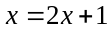

is an equation which can be solved for x. As Java code, the same expression

x = 2*x + 1;

means to first evaluate the right side 2*x + 1 by taking the current value of x, multiplying it by 2, and adding 1. Then the resulting value is stored in x (so that now x has a new value).

Value and variable types must be compatible with each other, as shown in table 1.13.

Value Type | Compatible Variable Type
double | double
int | int, double
char | char, int, double
boolean | boolean
Table 1.13: Value types compatible to variable types

Example: Declaring variables and assigning values
Declare an int, three double, one char, and one boolean variable. Assign to them some suitable values.

There are two possible solutions. Variables can be declared first and a value can be assigned to them at a later time:

int anInteger;
double number1, number2, number3;
anInteger = 10;
number1 = number2 = 20.0;
number3 = 30;

char cc;
cc = 'B';
boolean okay;
okay = true;

Alternatively, variables can be declared and initialized in one statement:

int anInteger = 10;
double number1 = 20.0, number2 = 20.0, number3 = 30;
char cc = 'B';
boolean okay = true;
■

Software Engineering Tip: Variables serve a purpose and the name of a variable should reflect that purpose to improve the readability of your program. Avoid one-letter variable names. Do not reuse a variable whose name does not reflect its purpose.

Whenever possible, assign an initial value to every variable at the time it is declared. If a variable is declared without assigning a value to it, all basic types except boolean are automatically set to 0, boolean is set to false, and all other types are set to null.

Declare variables as close as possible to the code where they are used. Do not declare all variables at once at the beginning of a program (or anywhere else).

Example: Using appropriate variable names
The code segment below computes the perimeter of a rectangle and the area of a triangle. Rewrite that segment using more appropriate variable names and compare the readability of both segments:

double x, y, z;
x = 10.0;
y = 20.0;
z = 2*(x + y);
w = 0.5 * x * y;

This code computes the perimeter z of a rectangle with width x and length y and the area w of a triangle with base x and height y, so the variable names should reflect that. In addition, variables should be assigned a value when they are declared, so the code segment should be rewritten as follows:

double width = 10.0, height = 20.0;
double perimeterOfRectangle = 2*(width + height);
double base = width;
double areaOfTriangle = 0.5 * base * height;

It is immediately clear that the formulas used are correct. Choosing appropriate variable names clarifies the code significantly and makes it easy to locate potential problems.
■

Basic Arithmetic for Numeric Types
Java support the basic arithmetic operators + (addition), - (subtraction), * (multiplication), / (division), and % (remainder after integer division) for numeric variables and literals. The order of precedence is the standard one from algebra and can be changed using parenthesis.

Each operator has a left and right argument and the type of the result of the computation is determined according to the rules outlined in the table below

Left Argument | Right Argument | Result
int | int | int
int | double | double
double | int | double
double | double | double
Table: Resulting types of the basic arithmetic operations

Example: A Temperature Conversion Program
Create a complete program that converts a temperature from degrees Fahrenheit in degrees Celsius. Use comments to explain your code.

public class Converter
{
public static void main(String args[])
{
// Printing out a welcoming message
System.out.println("Welcome to my Temperature Converter.");
System.out.println("\nProgram to convert Fahrenheit to Celcius.\n");

// Defining the temperature value in Fahrenheit
double temp = 212.0;

// Applying conversion formula and storing answer in another variable
double convertedTemp = 5.0 / 9.0 * (temp - 32.0);

// Printing out the complete answer
System.out.println(temp + " Fahrenheit = " + convertedTemp + " Celcius.");
}
}

Java does have disadvantages. For example, programs written in Java are generally slower than those in C++ and it is difficult to accomplish system-level tasks in Java.
Java compilers and tools are available for free, an important consideration for academic and student budgets.
In general, the Java Virtual Machine is an abstractly specified class file interpreter that can be realized by different software makers. The JVM that comes with the JDK was created by SUN Microsystems, but any other JVM is also able to run the same class files. Different JVM's can vary in efficiency, but they all must run the same class files.
This is somewhat similar to old Basic programs: a simple Basic program can run on virtually any system that has a Basic interpreter installed since the interpreter mediates between the program trying to run and the operating system.
Programming languages have a largest possible integer whose value can differ on different systems. A C++ program executing on a machine with a largest integer bigger than 2,000,000 produces the correct result, but on a system where the largest integer is, say, 32,767 it fails. The JVM has the same largest integer on every platform.
Java also supports a basic type byte, which we do not need currently, and another very useful type String, introduced later
For example, the double number 1.23456E002 = 1.234562 = 123.456
Unicode characters support characters in multiple languages and are defined according to their "Unicode Attribute table" (see http://www.unicode.org/). Every character on a standard US keyboard is a valid Unicode character.
If a variable serves a minor role in a code segment (such as a counter in a loop) it can be declared using a one-letter variable name.
The compiler may display an error message if it encounters variables that are not explicitly initialized.

