Skill -01

Step 1 : Open PowerShell as Administrator
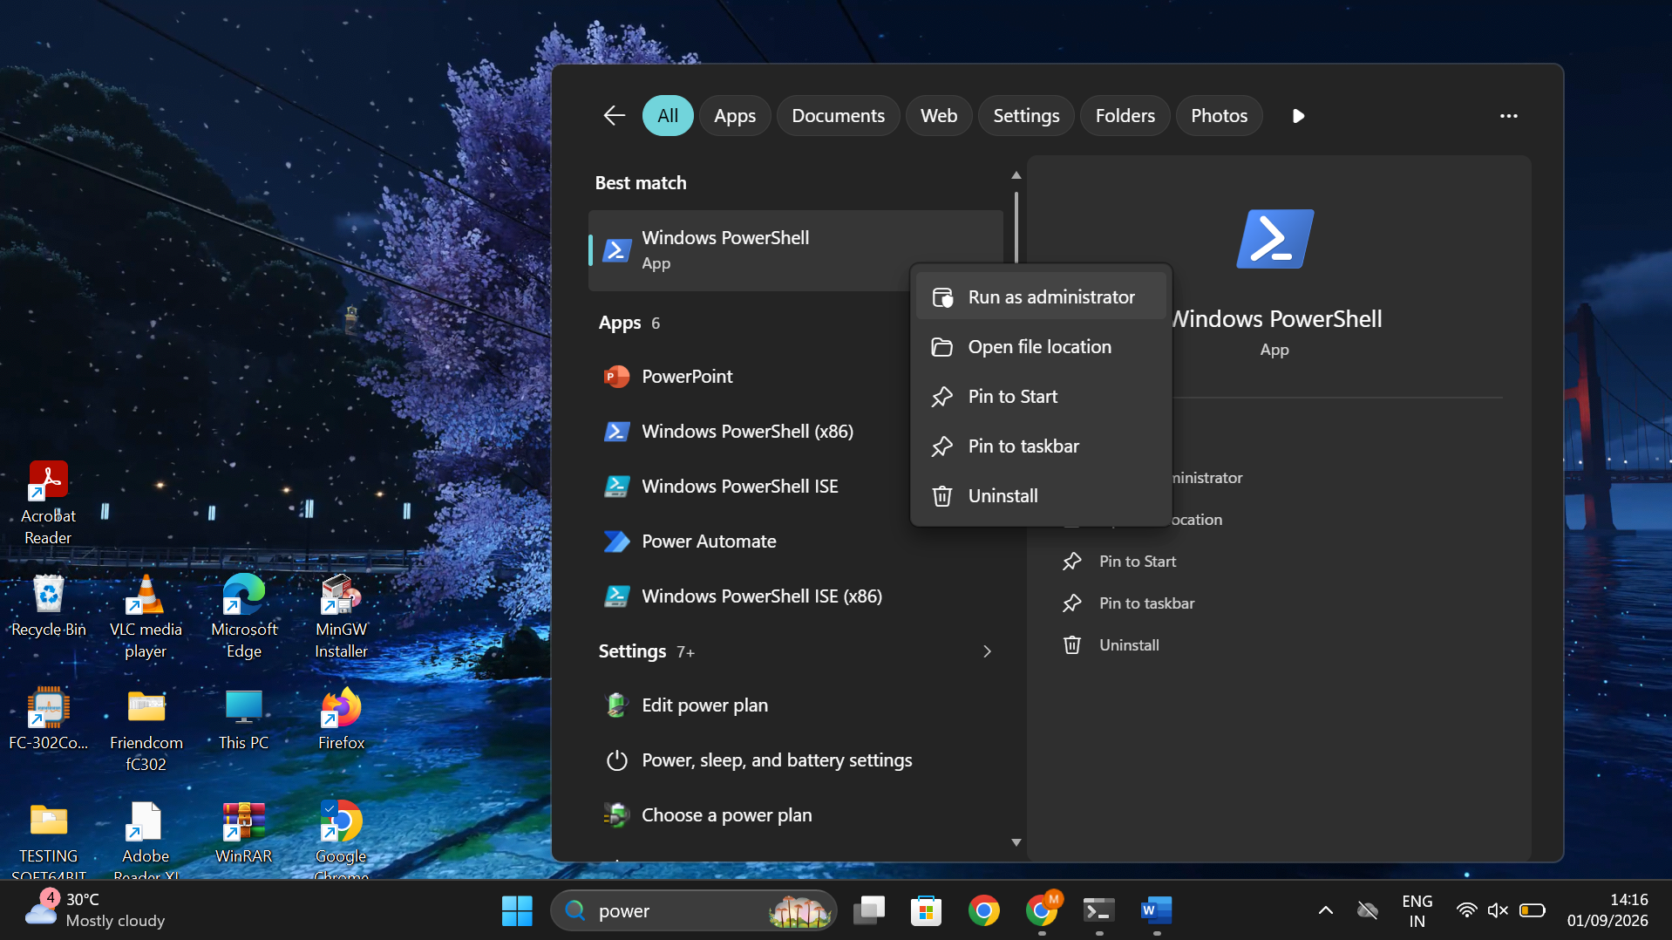
Step 2 : wsl –install
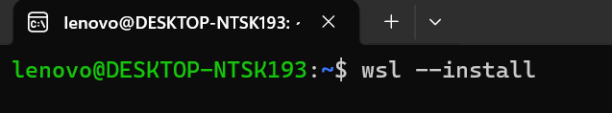
Step 3: Restart Your Computer
Step 4: Complete Ubuntu Setup
Step 5: Create a Password Step
Step 6: Update Ubuntu
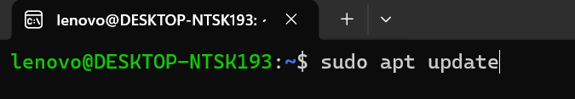
Step 7: Install GCC (C complier)
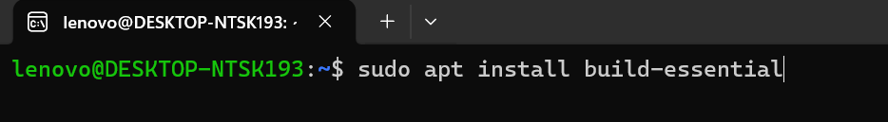
Step 8: Verity the Installation
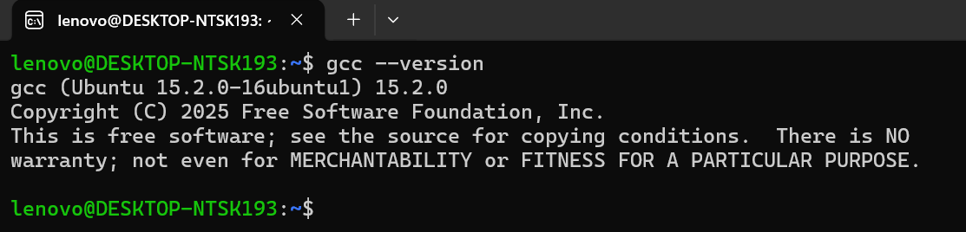
Step 9: Create Your C Program
Step 10: Compile the Program
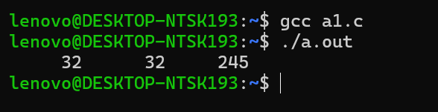

B)
Code output:
