Practical-03: -
A)
Code Output: -
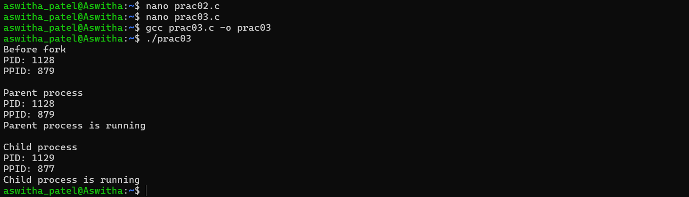
B)
ps command
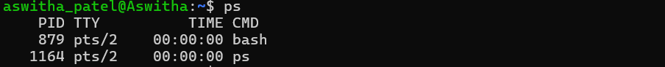
Top command
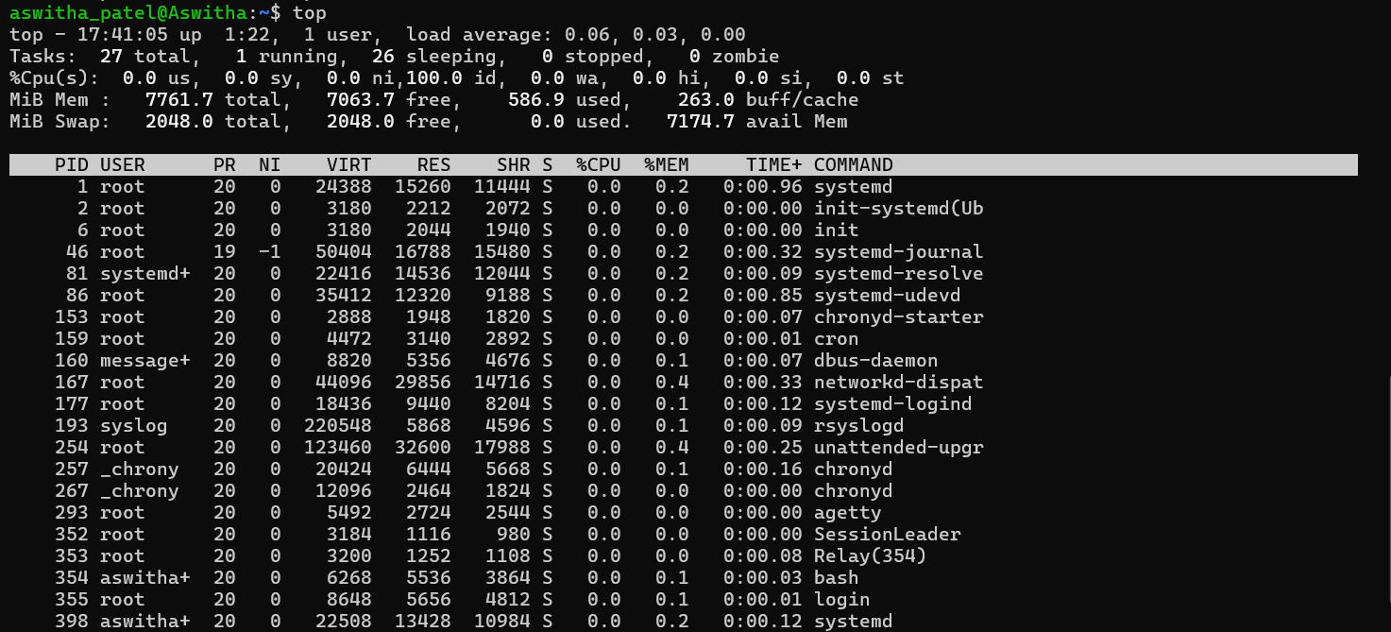

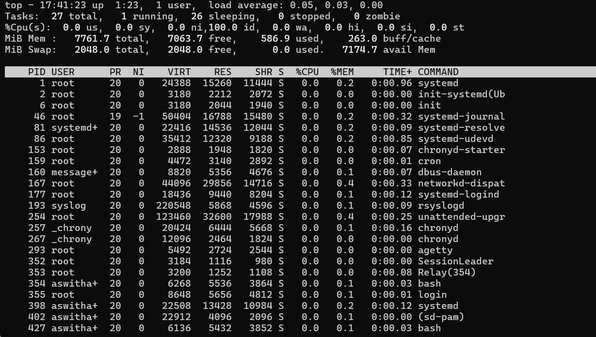
/proc
