### Subtask 1: The No-Entry Sign Detector

#### Training Performance

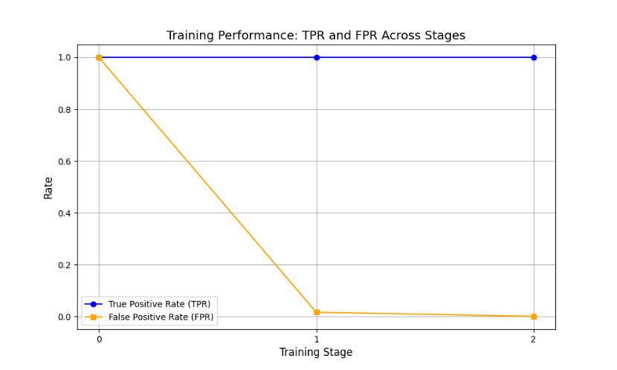

At stage 0, the model falsely detects faces at a high rate. The cascade then manages to remove redundant features that causes the model to immensely improve its detection prowess, reducing its false positive rate to nearly 0. It then dropped amore features, reducing its false positive rate.

#### Testing Performance

|  |  |  |
| --- | --- | --- |
| **Image** | **TPR** | **F1** |
| NoEntry0.bmp | 1 | 0.4444 |
| NoEntry1.bmp | 1 | 0.6666 |
| NoEntry2.bmp | 1 | 0.5 |
| NoEntry3.bmp | 1 | 0.5 |
| NoEntry4.bmp | 1 | 0.4 |
| NoEntry5.bmp | 0.3 | 0.3333 |
| NoEntry6.bmp | 0.25 | 0.2222 |
| NoEntry7.bmp | 0 | 0 |
| NoEntry8.bmp | 0.5 | 0.6 |
| NoEntry9.bmp | 0.5 | 0.6666 |
| NoEntry10.bmp | 0.6666 | 0.5714 |
| NoEntry11.bmp | 0 | 0 |
| NoEntry12.bmp | 0.4285 | 0.4285 |
| NoEntry13.bmp | 0 | 0 |
| NoEntry14.bmp | 1 | 0.3333 |
| NoEntry15.bmp | 1 | 0.5714 |

The model manages to successfully detect all signs for half of the images. However, its F1 scores are relatively low due to low precision due to high false positives and/or low recall due to low true positives. The model struggles to find small stop signs or blocked stop signs. Hence, the model produces lower TPR values than in (a).

### Subtask 2: Integration with Shape Detectors

1. *HOUGH DETAILS*

|  |  |
| --- | --- |
| **NoEntry3.bmp** | **NoEntry12.bmp** |
| Figure 1: NoEntry3.bmp thresholded gradient magnitude image | Figure 2: NoEntry12.bmp thresholded gradient magnitude image |
| Figure 3: NoEntry3.bmp 2D representation of the Hough Space | Figure 4: NoEntry12.bmp 2D representation of the Hough Space |
| Figure 5: NoEntry3.bmp with green bounding boxes of detection and red bounding boxes for ground truth | Figure 6: NoEntry12.bmp with green bounding boxes of detection and red bounding boxes for ground truth |

1. *EVALUATION*

|  |  |  |  |  |
| --- | --- | --- | --- | --- |
| **Image** | **TPR** | **+/-** | **F1** | **+/-** |
| NoEntry0.bmp | 1 | 0 | 0.4444 | 0 |
| NoEntry1.bmp | 1 | 0 | 0.6666 | 0 |
| NoEntry2.bmp | 1 | 0 | 0.3076 | -0.193 |
| NoEntry3.bmp | 1 | 0 | 0.3076 | -0.193 |
| NoEntry4.bmp | 1 | 0 | 0.4 | 0 |
| NoEntry5.bmp | 0.3 | 0 | 0.3 | 0 |
| NoEntry6.bmp | 0.75 | +0.5 | 0.5 | +0.278 |
| NoEntry7.bmp | 0 | 0 | 0 | 0 |
| NoEntry8.bmp | 0.5 | 0 | 0.6 | 0 |
| NoEntry9.bmp | 0.5 | 0 | 0.6666 | 0 |
| NoEntry10.bmp | 1 | +0.3444 | 0. 4615 | -0.11 |
| NoEntry11.bmp | 0 | 0 | 0 | 0 |
| NoEntry12.bmp | 0.4285 | 0 | 0.4285 | 0 |
| NoEntry13.bmp | 0 | 0 | 0 | 0 |
| NoEntry14.bmp | 1 | 0 | 0.3333 | 0 |
| NoEntry15.bmp | 1 | 0 | 0.3333 | -0.2381 |

The mixed detector model increased the total number of predicted detections. Some of the detections made by the shape detector model, included some signs or other “circle-shaped” objects such as other signs. For some images, TPR increases, but for most images, F1 reduced.

1. *DETECTION PIPELINE*

With overlapping boundary boxes from detectors, a non maximum suppression can reduce the redundant detections, reducing f1.

### Subtask 3: Improving Detector

#### IDEA

1. For the Shape Detector portion of the detector, an additional Horizontal Line Hough can be used to prevent detection of other signs.
2. Incorporate color information in the Viola Jones portion of the detector, by searching only regions where red exists in the image.
3. A gaussian blur that’s biased to blur vertical edges would be beneficial for the Shape Detector.