What’sOpen USER’S GUIDE

Hardware Requirements

1. Internet connection:
   1. User needs to have reliable Internet connection from provider to use the software
2. Physical network device:
   1. User needs a physical device which can access internet
      1. Examples: laptop, tablet, smart phone

Software Requirements

1. Web Browser
   1. User needs supported, updated browser to facilitate internet access

Instructions

1. Open Web Browser of your choice. Examples of web browsers are Internet Explorer, Firefox, Chrome.
2. Enter the website address into the URL address bar: [cs.neiu.edu/~mthakore](http://www.cs.neiu.edu/~mthakore)/ and hit enter.

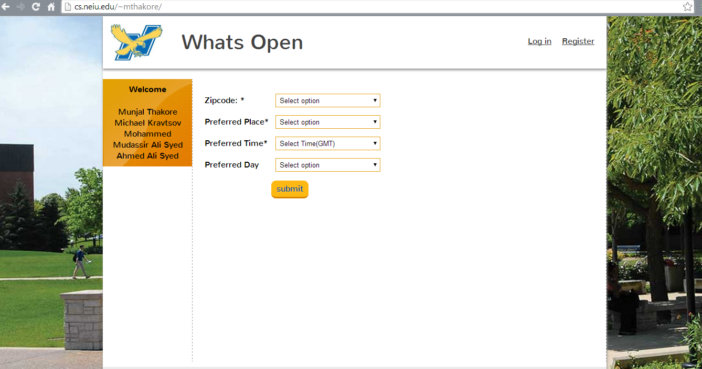

1. Select one of the available zip codes from the drop down menu titled: Zipcode  
   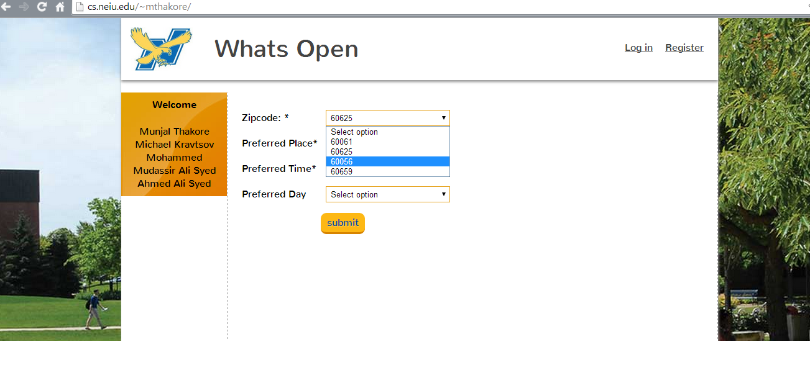
2. Select one of the available types of establishment, such as Restaurant, Clinics from the drop down menu titled: Preferred Place.  
     
   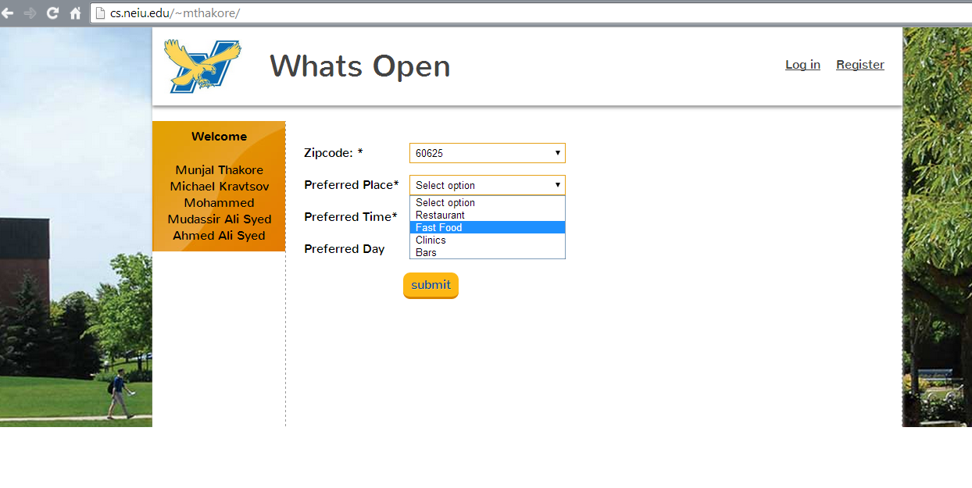

1. Select the time that you will be visiting the establishment chosen in the previous step. The times are listed in a drop down menu in 24 hour time format in half hour increments. The drop down menu is titled: Preferred Time.  
   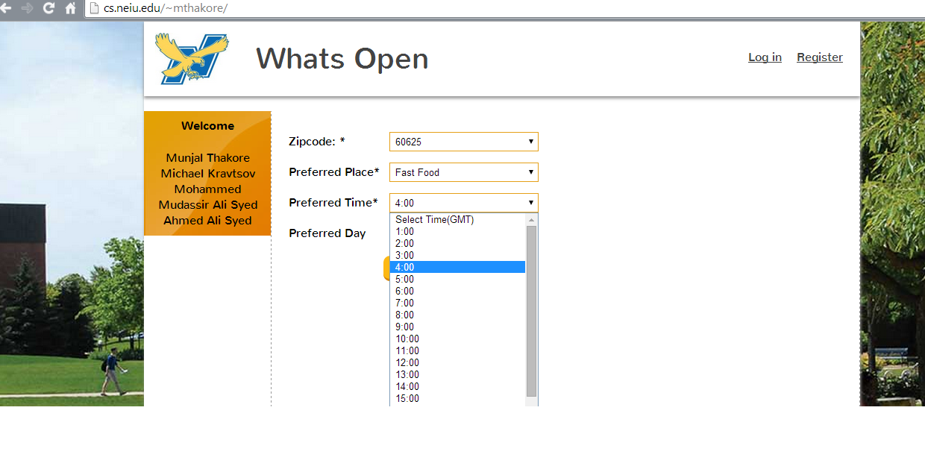
2. Select the day of the week from the drop down menu titled: Preferred Day.   
   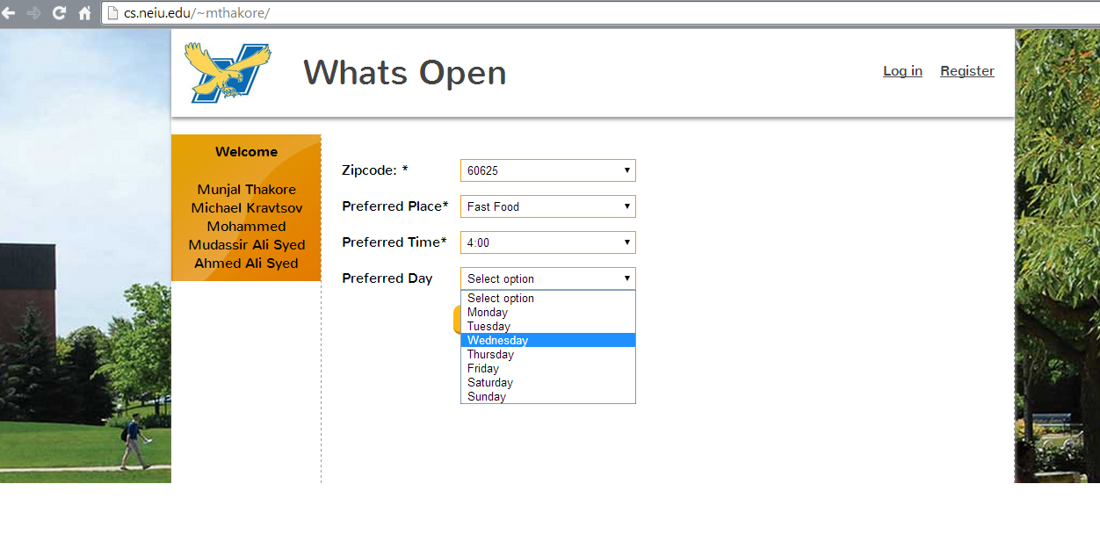

1. Click the submit button to see your results.

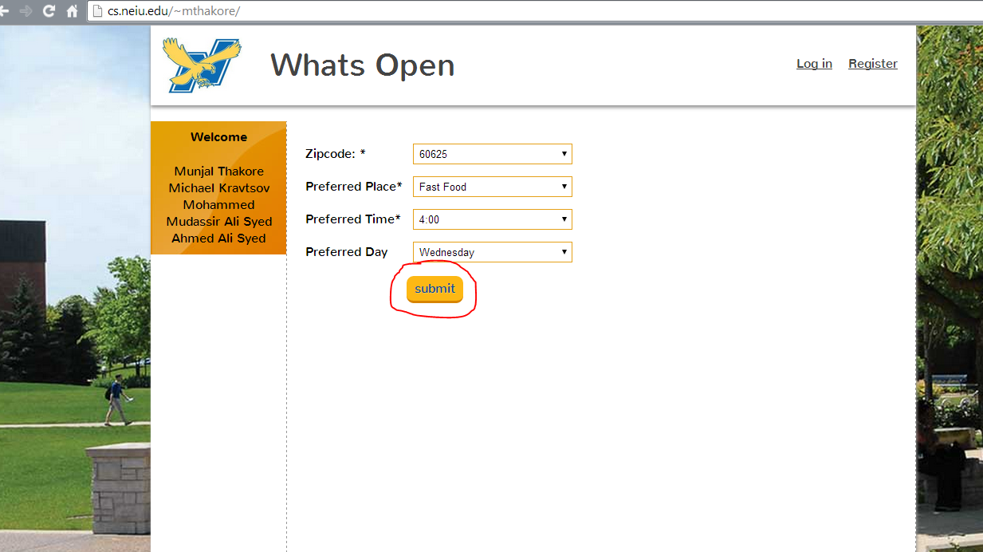

1. You will then be taken to the results page which will list all of the open places of that type in that particular place at that particular time.  
   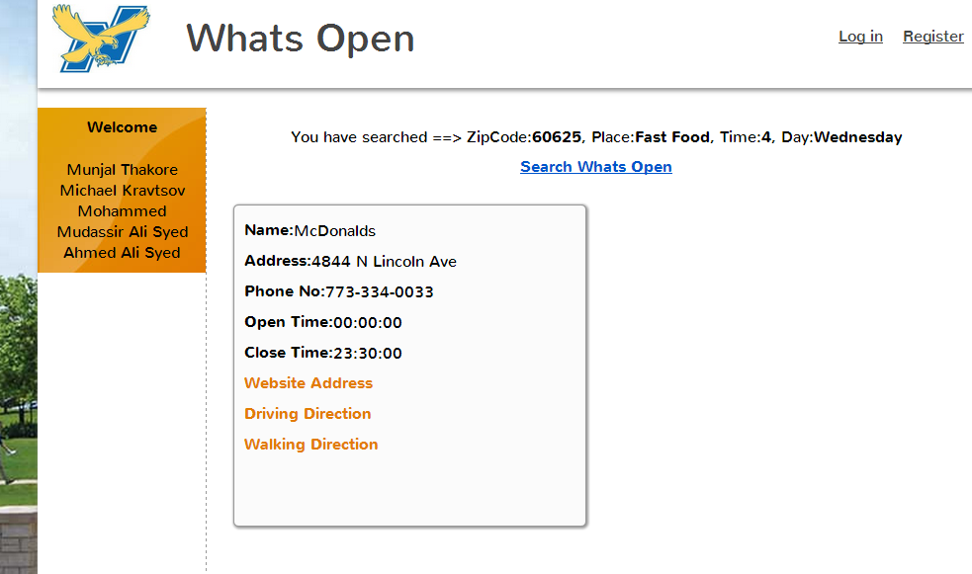
2. If there are no places that meet your criterion, you will see no results returned. You will be able to click on a link to search for another place.  
   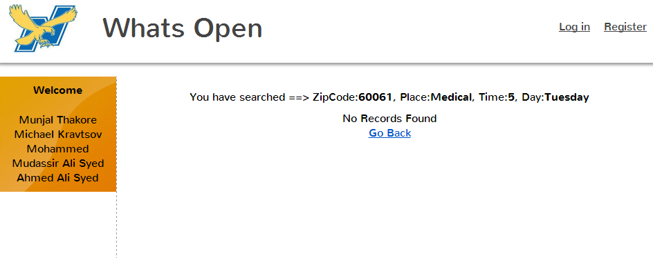
3. Once you see the list of open places, you will see the name of the places, their address, phone number, and clickable links to go to the company website, a link to go to google driving directions, and a link to go to the google walking directions. At the top of the screen, you will also see a link to return to the first page, where you can start the process all over again.

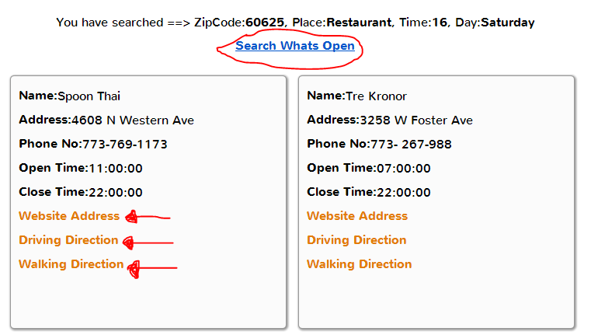

We hope you enjoy our product. If you have any questions, comments, or concerns, we appreciate all feedback. Please reach us at incredible@whatsopen.com