**Aboubacar sidiki SYLLA**

**ID : SYL23568693**

**DATE : 29/10/2023**

Coursework 1

**TASK 1: flowchart**

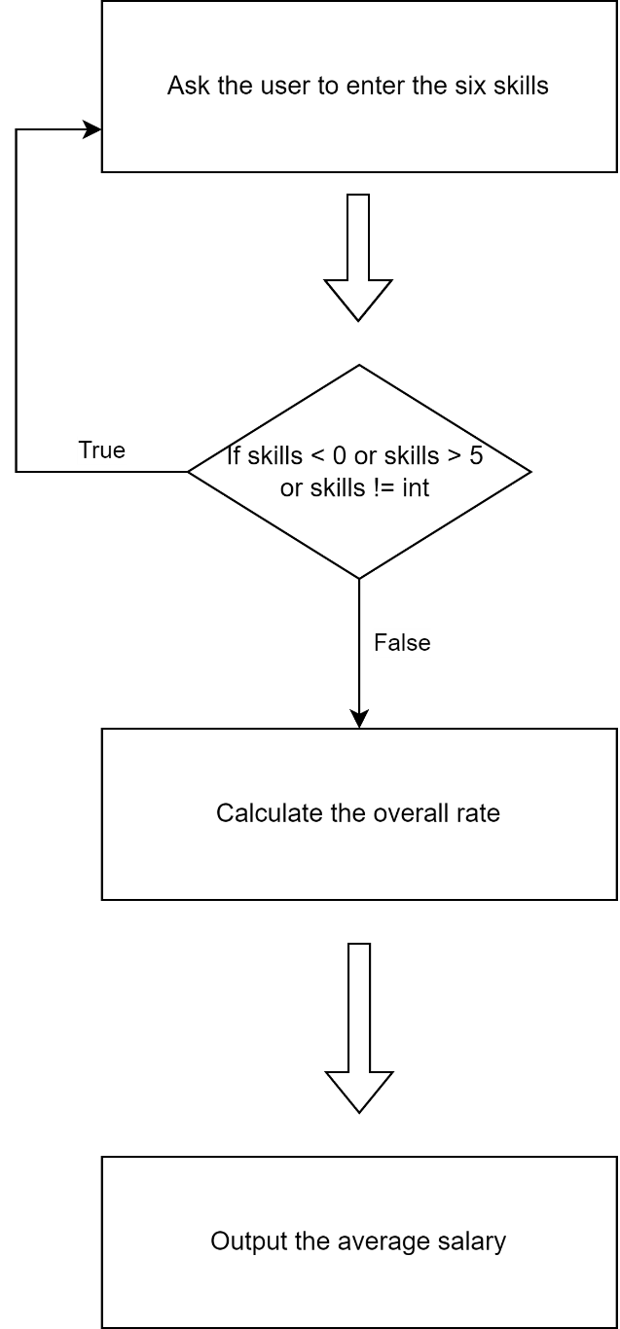

**TASK 3: reflection on the code**

I decompose the problem into three major parts as you can see on the diagram above. At first, I ask the user to enter the different skills, then the program calculate the overall rate and finally the average output is displayed. The flowchart can be useful while working on a much bigger program. For instance, the “while” and “if” loops are more defined when we can clearly see what the outcomes are, based on the conditions. The most difficult part in this coursework was looping the code to ask the user to enter the skills again if the values were not in the format we asked. The use of “break” was the solution in my case. I learned, by watching some YouTube videos and using w3schools, that the “break” instruction is often used to instantly get out of a loop.

My favourite part in this coursework was coding the interaction with the user because I could finally see that coding wasn’t just between the developer and the computer. There are much more factors involved in the process of developing an application. And if I had more time, I would have found a better way to display to the user how to input the values needed, explain in a better way what went wrong if something is not right, and I would have implemented a better display than just numbers.

**TASK 4: Gantt Chart**