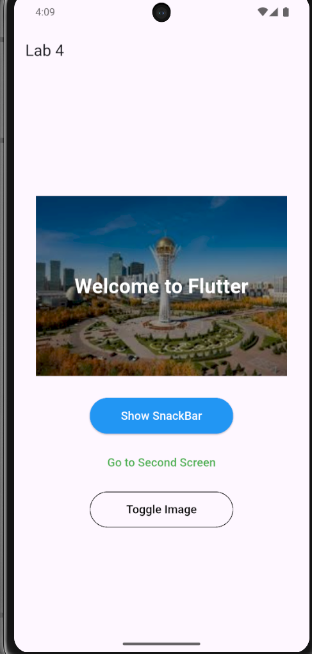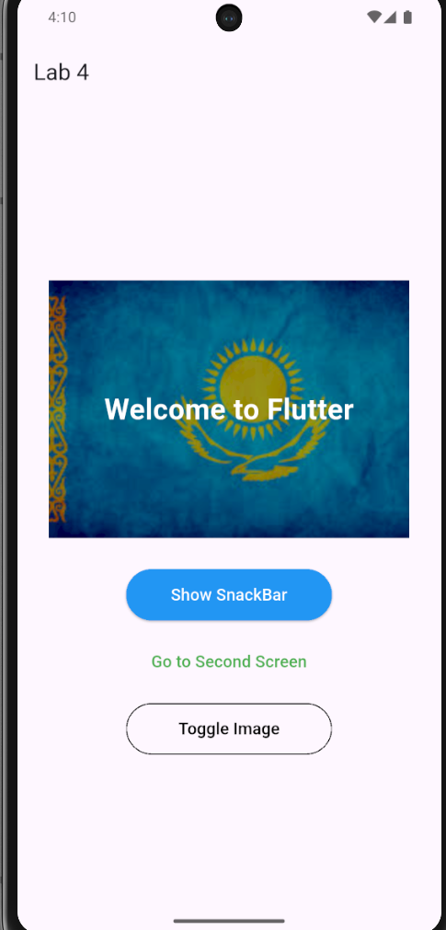

import 'package:flutter/material.dart';

void main() {
runApp(const MyApp());
}

class MyApp extends StatefulWidget {
const MyApp({super.key});

@override
State<MyApp> createState() => _MyAppState();
}

class _MyAppState extends State<MyApp> {
bool showFirstImage = true;

@override
Widget build(BuildContext context) {
return MaterialApp(
debugShowCheckedModeBanner: false,
home: Scaffold(
appBar: AppBar(
title: const Text('Lab 4'),
),
body: Center(
child: SingleChildScrollView(
child: Column(
children: [
Stack(
alignment: Alignment.center,
children: [
Image.asset(
showFirstImage
? 'assets/image1.jpg'
: 'assets/image2.jpg',
width: 350,
height: 250,

// BoxFit.fill stretches image
// BoxFit.contain keeps whole image
// BoxFit.cover fills area and may crop
// BoxFit.fitWidth fits width
// BoxFit.fitHeight fits height
// BoxFit.none keeps original size
// BoxFit.scaleDown shrinks if needed
fit: BoxFit.cover,
),

Container(
width: 350,
height: 250,
color: Colors.black.withOpacity(0.4),
),

const Text(
'Welcome to Flutter',
style: TextStyle(
color: Colors.white,
fontSize: 28,
fontWeight: FontWeight.bold,
),
),
],
),

const SizedBox(height: 30),

SizedBox(
width: 200,
height: 50,
child: ElevatedButton(
style: ElevatedButton.styleFrom(
backgroundColor: Colors.blue,
foregroundColor: Colors.white,
),
onPressed: () {
ScaffoldMessenger.of(context).showSnackBar(
const SnackBar(
content: Text('Hello from SnackBar!'),
),
);
},
child: const Text(
'Show SnackBar',
style: TextStyle(fontSize: 16),
),
),
),

const SizedBox(height: 15),

SizedBox(
width: 200,
height: 50,
child: TextButton(
onPressed: () {
Navigator.push(
context,
MaterialPageRoute(
builder: (context) => const SecondScreen(),
),
);
},
child: const Text(
'Go to Second Screen',
style: TextStyle(
fontSize: 16,
color: Colors.green,
),
),
),
),

const SizedBox(height: 15),

SizedBox(
width: 200,
height: 50,
child: OutlinedButton(
onPressed: () {
setState(() {
showFirstImage = !showFirstImage;
});
},
style: OutlinedButton.styleFrom(
foregroundColor: Colors.black,
side: const BorderSide(
color: Colors.black,
),
),
child: const Text(
'Toggle Image',
style: TextStyle(fontSize: 16),
),
),
),
],
),
),
),
),
);
}
}

class SecondScreen extends StatelessWidget {
const SecondScreen({super.key});

@override
Widget build(BuildContext context) {
return Scaffold(
appBar: AppBar(
title: const Text('Second Screen'),
),
body: const Center(
child: Text(
'Welcome to the Second Screen!',
style: TextStyle(
fontSize: 24,
fontWeight: FontWeight.bold,
),
),
),
);
}
}

