Creating tables
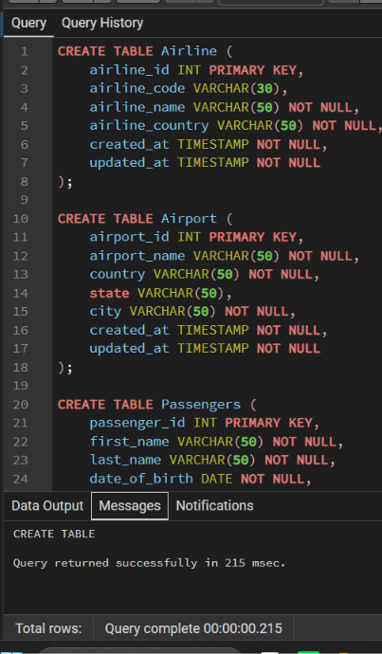

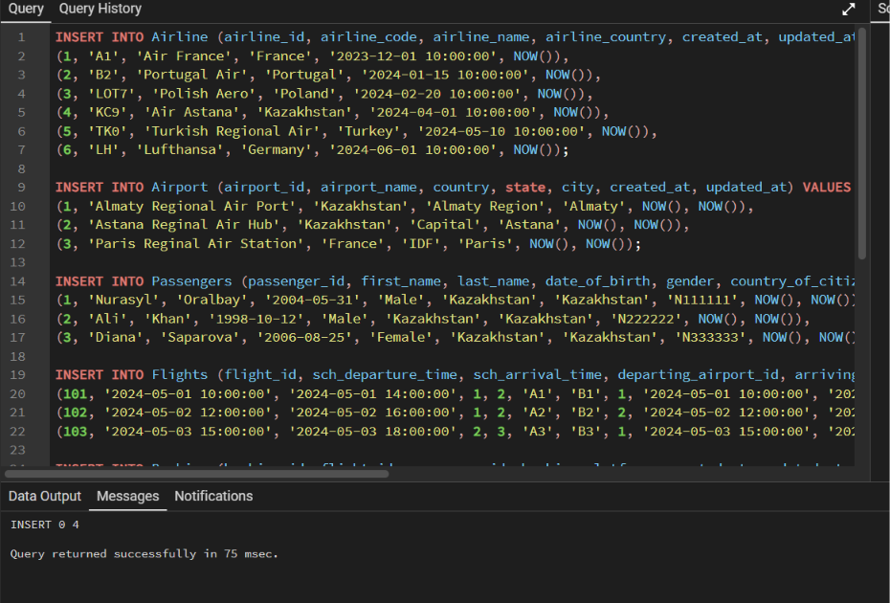
Filling in the data in accordance with the conditions of the 4th laboratory.

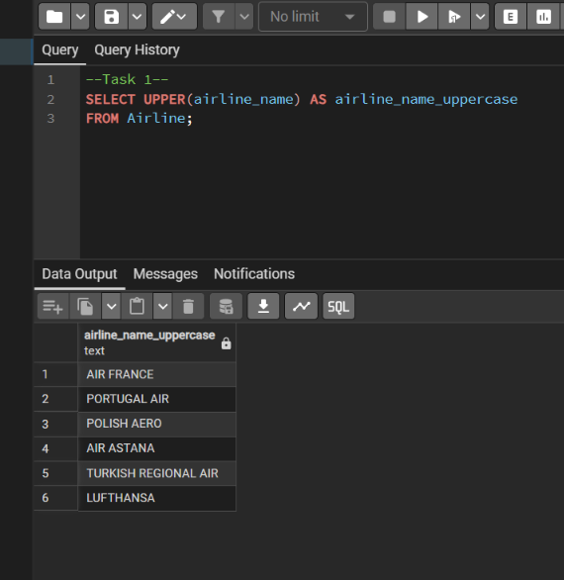
Task 1. Retrieve all airline names in uppercase.

Task 2. Replace any occurrence of the word "Air" in airline names with "Aero".

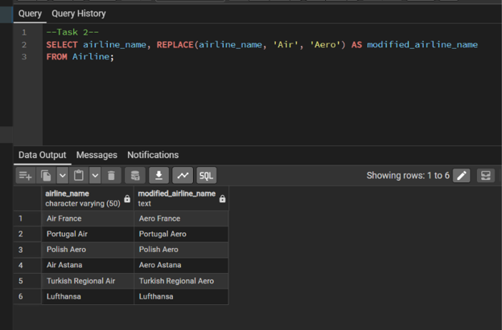

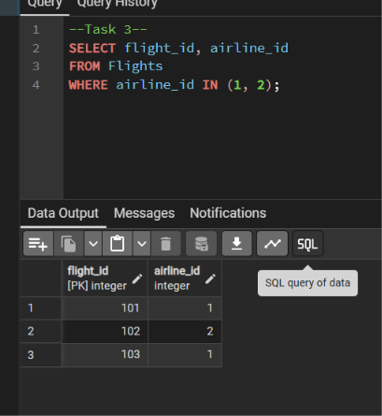
Task 3. Fing all flight numbers that coordinates with both airline 1 and airline 2.

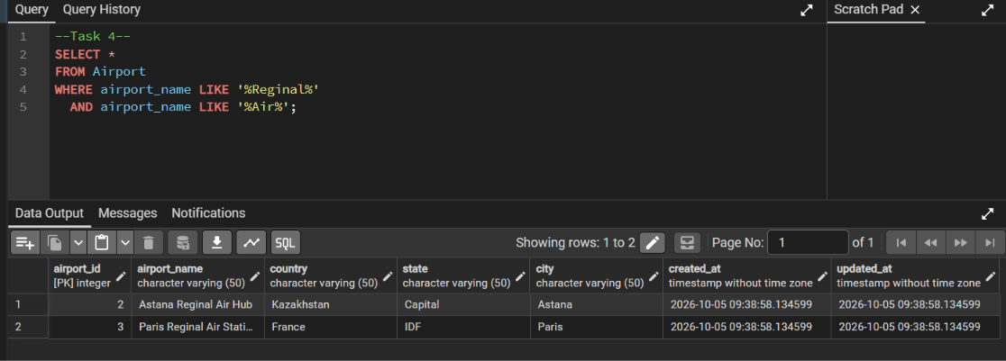
Task 4. Retrieve airports that contain the word "Reginal" and "Air" in their names.
Task 5. Retrieve passenger names and format their birth dates as 'Month DD, YYYY'.

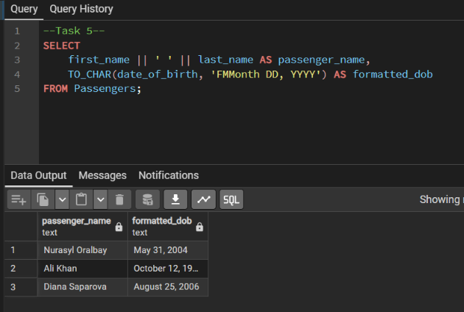

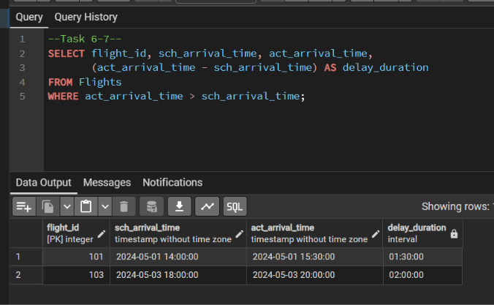
Task 6-7. Find flight numbers that have been delayed based on the actual arrival time& Find flights that arrived late according to their actual arrival time compared to the scheduled arrival time.

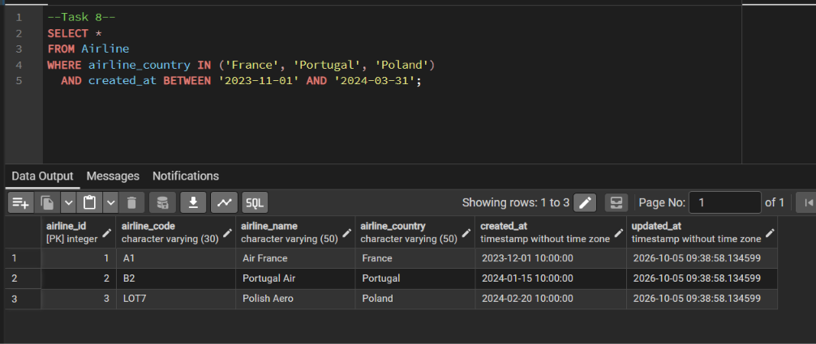
Task 8. Show airlines from any of: ('France','Portugal','Poland') created between '2023-11-01' and '2024-03-31'.
Find top3 overweighted baggage with more than 25kg.

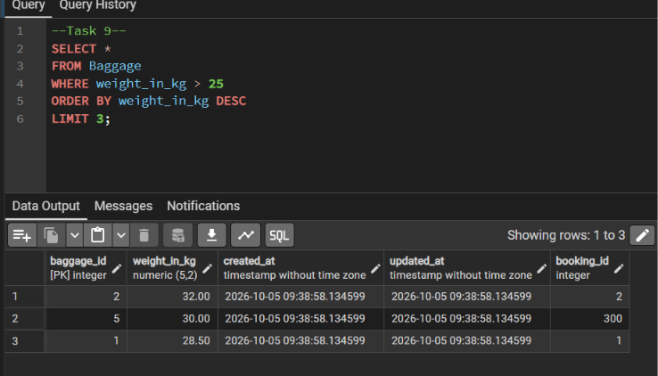
Task 10. Find the youngest passengers’ full name.

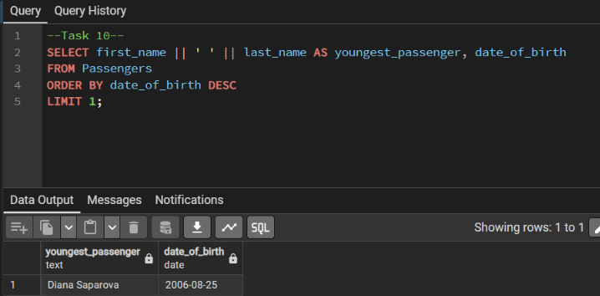

Task 11. Find the cheapest booking price on each booking platform.

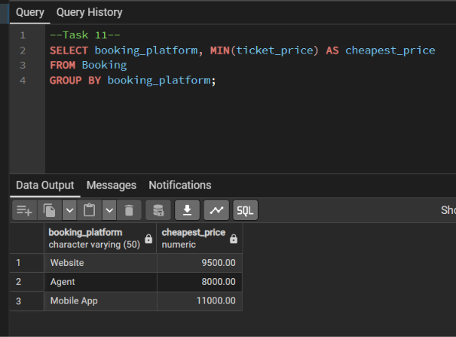

Task 12. Return airlines whose airline_code contains a digit.

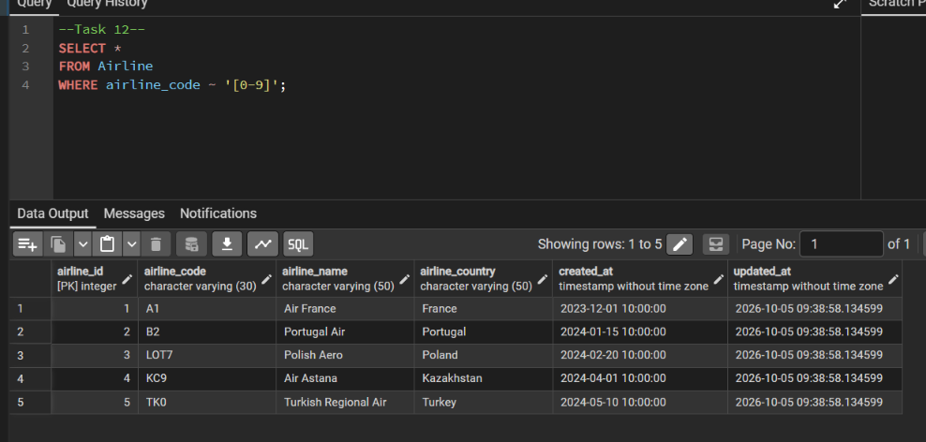
Task 13. List the top5 most recently created airlines.

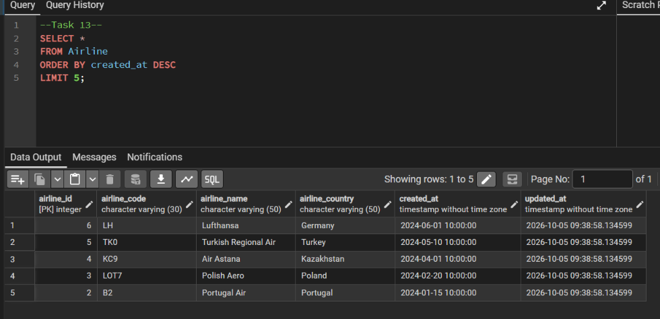
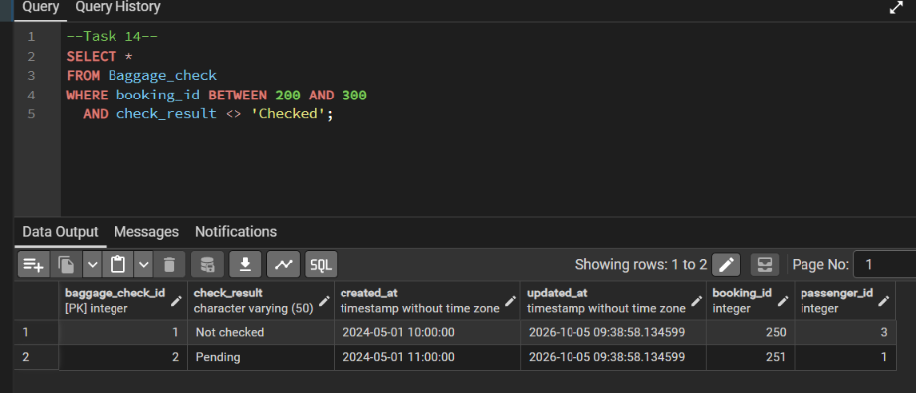
Task 14. Return all rows where booking_id is between 200 and 300 inclusive and check_result <> 'Checked'.

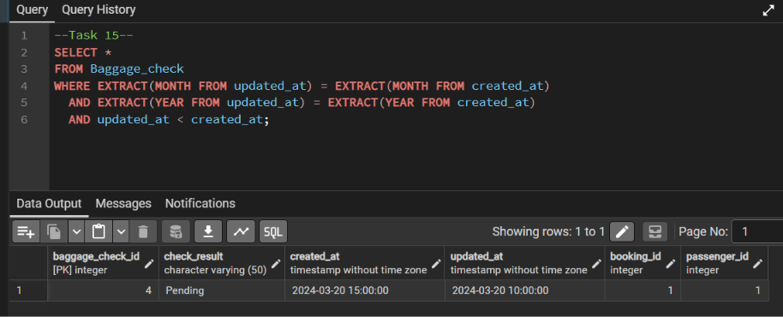
Task 15. Baggage checks where update_at is in the same month as created_at but occurs earlier than created_at.

