**UNIVERSITI PUTRA MALAYSIA**

**FACULTY OF COMPUTER SCIENCE AND INFORMATION TECHNOLOGY**

**DEPARTMENT OF MULTIMEDIA**



**HOTEL MANAGEMENT PROPOSAL**

**GROUP : 4**

**COURSE CODE : SSK3408**

**COURSE NAME : DATABASE APPLICATION DEVELOPMENT**

**LECTURER NAME : PROF. MADYA DR. MAS RINA BINTI MUSTAFFA**

|  |  |
| --- | --- |
| **STUDENT NAME** | **MATRIC NUMBER** |
| NUR AMIRAH FATIHAH BINTI NORAZMI | 206661 |
| NIK MUHAMMAD ASYRAF BIN NIK ISMAIL | 206630 |
| NUR KHAIRINA BATRISYIA BINTI MOHD NAZRI | 208181 |
| NURUL SHAREFA HANEEM BINTI SHAHRI | 208199 |

**TABLE OF CONTENTS**

|  |  |
| --- | --- |
| **Topic** | **Page** |
| Group Members Description | 3 |
| Project Title | 5 |
| Project Description | 5 |
| Modules Description | 5 |
| Conceptual Database Design | 7 |
| 1. Entity Relationship diagram (ERD) | 7 |
| 1. Relational Model | 8 |
| 1. Normalization | 9 |
| GUI Design | 12 |
| Project Timeline | 14 |

**GROUP MEMBERS DESCRIPTION**



**NUR AMIRAH FATIHAH BINTI NORAZMI**

**206661**

Born and still live in Ampang, Selangor. Love art since young and properly took lessons when studying in high school. Also started to learn about computers when enrolling in Malacca Matriculation. Currently, have been trying to merge those interests which are computer and arts and that is one of the reasons to apply to a Multimedia course today.



**NIK MUHAMMAD ASYRAF BIN NIK ISMAIL**

**206630**

I was born and raised in Selangor, and I currently reside in Banting. I was enrolled in a Science programme at Penang Matriculation College. I chose computer science as my topic of study because I want to broaden my computer knowledge and skills. There is a lot more about computing skills that I have yet to master, and I am really eager to do so.

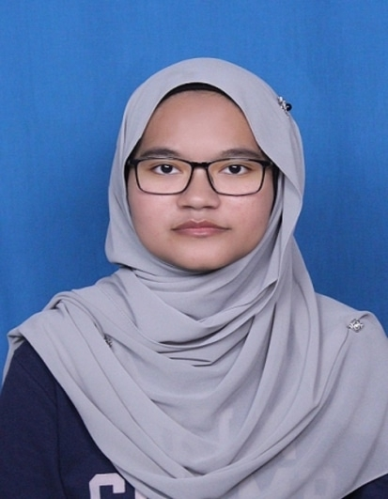

**NUR KHAIRINA BATRISYIA BINTI MOHD NAZRI**

**208181**

I was born in Kuala Lumpur but raised in Selangor. I was an Asasi Sains Pertanian UPM student and I miss the green scenery in UPM. I hoped to set foot on campus soon. Computer Science in Multimedia degree was my last option in UPU selection, however I do not regret enrolling in this degree as I have learned a lot of new things that have piqued my interest. My hobby is drawing and hopefully I can use that skill in my degree and even job later.



**NURUL SHAREFA HANEEM BINTI SHAHRI**

**208199**

I am born a Johorean and I’m proud of it. I am 20 years old and currently a second year Bachelor in Computer Science of Multimedia at University of Putra Malaysia (UPM). I graduated from UPM's Foundation of Agricultural Science (ASPER), but I changed my major to computer science because I want to learn more about this course, specifically computer-generated imagery (CGI).

**PROJECT TITLE**

Hotel Del Luna Management

**PROJECT DESCRIPTION**

This project is a hotel management project. There are six main modules which are Reservation, Room, Employee, Billing, Guest and the Hotel itself and each member is responsible for at least one module. The main module which is the Hotel module has its own ID and other details including its name, address, phone number, email and star rating.

**MODULES DESCRIPTION**

1. **Room by Nur Khairina**

The first module is the Room module which consists of several attributes. The key attribute is the Room_No which contains the information of the room numbers of the hotel. Every room has a different room number, therefore it is the primary key. The next attribute is Availability. This attribute displays whether a room is available for guests or not. Another attribute is the Type attribute which is a composite attribute. The Type attribute has three component attributes which are Price, used to display the price of a room, Desc, used to display more information of a room and last but not least, Bed_Qty which is used to display the number of beds in a room.

1. **Reservation by Nur Khairina**

The second module is the Reservation module. The key attribute is Reserve_ID which is used to display the reservation ID number for guests. There is also an attribute regarding the number of guests staying in a room and it is divided into two categories which are the number of adults and the number of children. The number of guests per hotel room is limited however. Data regarding the reservation date and reservation time are also stored. There will also be information about guests’ check-in date and check-out date, from both of the dates, the number of nights can be retrieved. This will be used to calculate the price of the stay. If the guests have any special request they want to make, information of the request will be saved as well.

1. **Guest Registration by Nik Asyraf**

This Hotel Guest Registration Form was created with the goal of making online reservations as simple and straightforward as possible for our visitors and clients. We can collect guest information such as name, ID card number, email, mobile number, and other pertinent information using this form. All of the information gathered will be securely maintained in our database in order to gain the necessary information about our hotel's guests. We may **update** or **retrieve** any information we need to attend to our guests through this module, whether it's about accommodation reservations, services, or billing. Instead of asking the guest multiple times, we only need them to fill out the form once so that we can **generate** a table with the information. We may simply **erase** the data loaded into our database if the guest decides to cancel their registration.

1. **Billing by Sharefa Haneem**

When it comes to billing, the first thing customers want to see in the bill is the item names and the prices. However, for the hotel management, the things needed in the database to create the bill are item names, item prices, discount as well as a unique identifier of item ID and bill number. Other than that, payment date and payment mode are added into the table of the database to know whether the guest already paid and what method of payment they use. The data in the module can be updated; as for example, there are things that need to change in the data such as item name or item ID. The deletion of the data also can be done in case the guest has canceled the guest registration or reservation.

1. **Employee Management by Nur Amirah**

Our hotel will be managed by the employees which will be identified by their own IDs and also group by their Job ID. Other details such as their names, addresses, emails, hire date and phone numbers will be collected by the administrator. One hotel employs many employees however one employee only can work at one hotel. Whenever an employee wants to quit or has been promoted, management can directly edit the data in the database which can be accessed by using their unique ID.

In this current situation, each employee is required to take vaccination to avoid the spreadness of the current virus. Employees need to provide data for their vaccination like the type of the vaccine, when their first dose and second dose were. If any employee who will not be taking any vaccination which is compulsory, then management needs to remove those employees' data to ensure visitors safety and health.

**CONCEPTUAL DATABASE DESIGN:**

1. **ENTITY RELATIONSHIP DIAGRAM (ERD)**

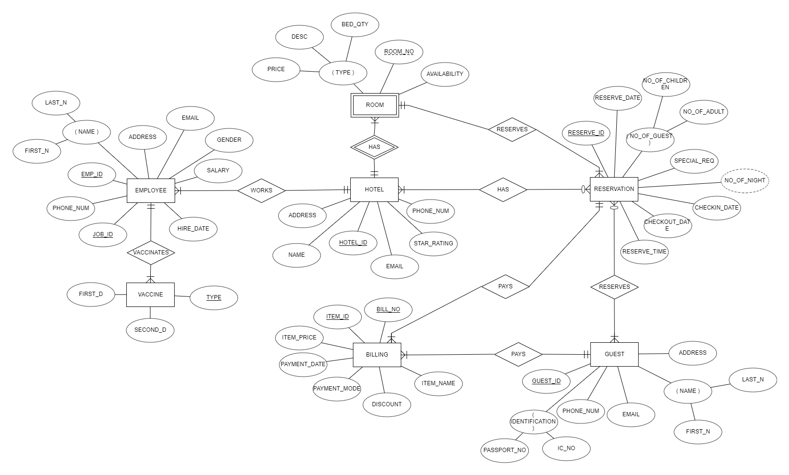

1. **RELATIONAL MODEL**

**ROOM** (Room_No, Hotel_ID, Reserve_ID, Price, Desc, Bed_Qty, Availability)

**HOTEL** (Hotel_ID, Address, Name, Email, Star_Rating, Phone_Num)

**HOTEL_RESERVATION** (Hotel_ID, Reserve_ID)

**RESERVATION** (Reserve_ID, No_of_Children, No_of_Adult, Reserve_Date, Special_Req, Checkin_date, Checkout_date, Reserve_time*, Room_No*)

**GUEST** (Guest_ID, Passport_No, IC_No, Phone_Num, Email, First_N, Last_N, Address)

**GUEST_RESERVATION** (Guest_ID, Reserve_ID)

**BILLING** (Bill_No, *Reserve_ID, Guest_ID,* Item_ID, Item_name, Item_Price, Payment_Date, Payment_Mode, Discount)

**EMPLOYEE** (Em_ID, Job_ID, *Hotel_ID*, Address, Email, Salary, First_N, Last_N, Phone_Num, Hire_Date, Gender)

**VACCINE** (Vac_Type, *Em_ID*, *Job_ID*,First_D, Second_D)

1. **NORMALIZATION**

**ZERO NORMAL FORM ( 0NF ) : Initial Relation**

**HOTEL** (Hotel_ID, Address, Name, Email, Star_Rating, Phone_Num)

**HOTEL_RESERVATION** (Hotel_ID, Reserve_ID)

**ROOM** (Room_No, Hotel_ID, Reserve_ID, Price, Desc, Bed_Qty, Availability)

**RESERVATION** (Reserve_ID, No_of_Children, No_of_Adult, Reserve_Date, Special_Req, Checkin_date, Checkout_date, Reserve_time, Room_No)

**GUEST** (Guest_ID, Passport_No, IC_No, Phone_Num, Email, First_N, Last_N, Address)

**BILLING** (Bill_No, Reserve_ID, Guest_ID, Item_ID, Item_name, Item_Price, Payment_Date, Payment_Mode, Discount)

**EMPLOYEE** (Em_ID, Job_ID, Address, Email, Salary, First_N, Last_N, Phone_Num, Hire_Date, Gender)

**VACCINE** (Vac_Type, First_D, Second_D)

**FIRST NORMAL FORM ( 1NF ) : Atomic Attributes**

**HOTEL** (Hotel_ID, Address, Name, Email, Phone_Num, Star_Rating)

**HOTEL_RESERVATION** (Hotel_ID, Reserve_ID)

**ROOM** (Room_No, Hotel_ID, Reserve_ID, Price, Desc, Bed_Qty, Availability)

**RESERVATION** (Reserve_ID, Room_No)

**GUESTS_RESERVATION** (Reserve_ID, No_of_Children, No_of_Adult, Reserve_Date, Checkin_date, Checkout_date, Reserve_time, Special_Req)

**GUEST** (Guest_ID, Passport_No, IC_No, Phone_Num, Email, First_N, Last_N, Address)

**BILLING** (Bill_No, Reserve_ID, Guest_ID, Item_ID, Item_name, Item_Price, Payment_Date, Payment_Mode, Discount)

**EMPLOYEE** (Em_ID, Job_ID, *Hotel_ID*, Address, Email, Salary, First_N, Last_N, Phone_Num, Hire_Date, Gender)

**VACCINE** (Vac_Type, *Em_ID*, *Job_ID*,First_D, Second_D)

**SECOND NORMAL FORM ( 2NF ) : No Partial Dependencies**

**HOTEL** (Hotel_ID, Address, Name, Email, Phone_Num, Star_Rating)

**HOTEL_RESERVATION** (Hotel_ID, Reserve_ID)

**ROOM** (Room_No, Hotel_ID, Reserve_ID)

**ROOM_DETAILS** (Room_No, Price, Desc, Bed_Qty, Availability)

**RESERVATION** (Reserve_ID, Room_No)

**GUESTS_RESERVATION** (Reserve_ID, No_of_Children, No_of_Adult, Reserve_Date, Checkin_date, Checkout_date, Reserve_time, Special_Req)

**GUEST** (Guest_ID, Passport_No, IC_No, Phone_Num, Email, First_N, Last_N, Address)

**GUEST_INFO** (Guest_ID, Phone_Num, Email)

**ITEMS** (Item_ID, Item_Name, Item_Price)

**PAYMENT** (Bill_No, Reserve_ID, Guest_ID, Item_ID, Discount, Payment_Date, Payment_Mode)

**EMPLOYEE** (Em_ID, Job_ID, *Hotel_ID*, Address, First_N, Last_N, Phone_Num, Gender)

**JOB** (Job_ID, *Hotel_ID*, Email, Salary, Hire_Date)

**VACCINE** (Vac_Type, *Em_ID*, *Job_ID*, First_D, Second_D)

**THIRD NORMAL FORM ( 3NF ) : No Transitive Dependencies**

**HOTEL** (Hotel_ID, Address, Name, Email, Phone_Num, Star_Rating)

**HOTEL_RESERVATION** (Hotel_ID, Reserve_ID)

**ROOM** (Room_No, Hotel_ID, Reserve_ID)

**ROOM_DETAILS** (Room_No, Price, Desc, Bed_Qty, Availability)

**RESERVATION** (Reserve_ID, Room_No)

**GUESTS_RESERVATION** (Reserve_ID, No_of_Children, No_of_Adult)

**TIME_RESERVED** (Reserve_ID, Reserve_Date, Checkin_date, Checkout_date, Reserve_time, Special_Req)

**GUEST** (Guest_ID, Passport_No, IC_No, Phone_Num, Email, First_N, Last_N, Address)

**GUEST_INFO** (Guest_ID, Phone_Num, Email)

**ITEMS** (Item_ID, Item_Name, Item_Price)

**PAYMENT** (Bill_No, Reserve_ID, Guest_ID, Item_ID, Discount, Payment_Date, Payment_Mode)

**EMPLOYEE** (Em_ID, Job_ID, *Hotel_ID*, Address, Last_N, Phone_Num, Gender)

**EMPLOYEE_NAME** (Last_N, First_N)

**JOB** (Job_ID, *Hotel_ID*, Email, Salary, Hire_Date)

**VACCINE** (Vac_Type, *Em_ID*, *Job_ID*, First_D, Second_D)

**GUI DESIGN**

1. **MAIN PAGE**

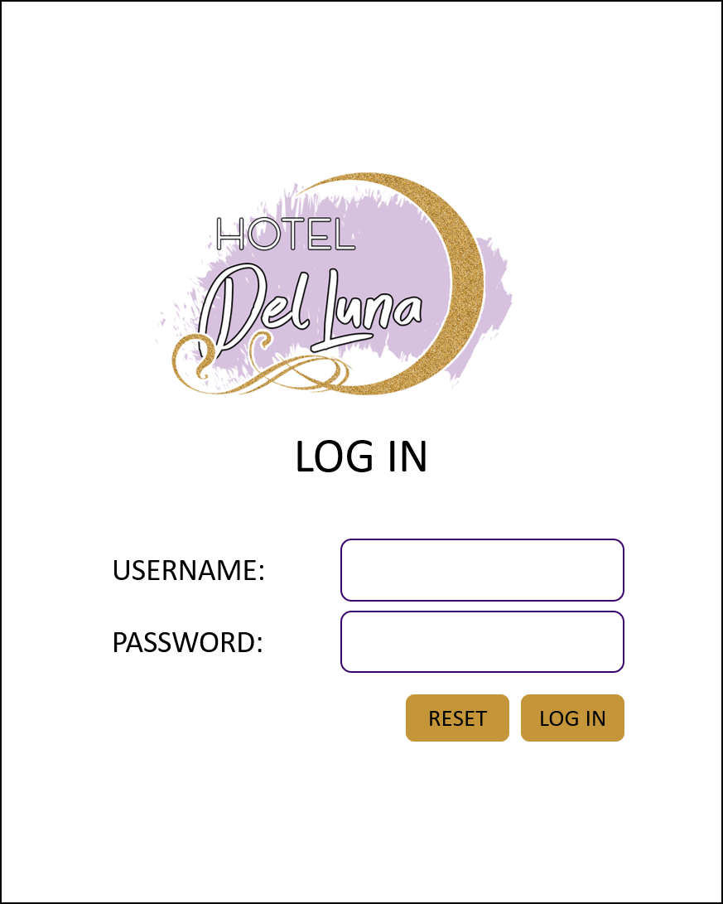 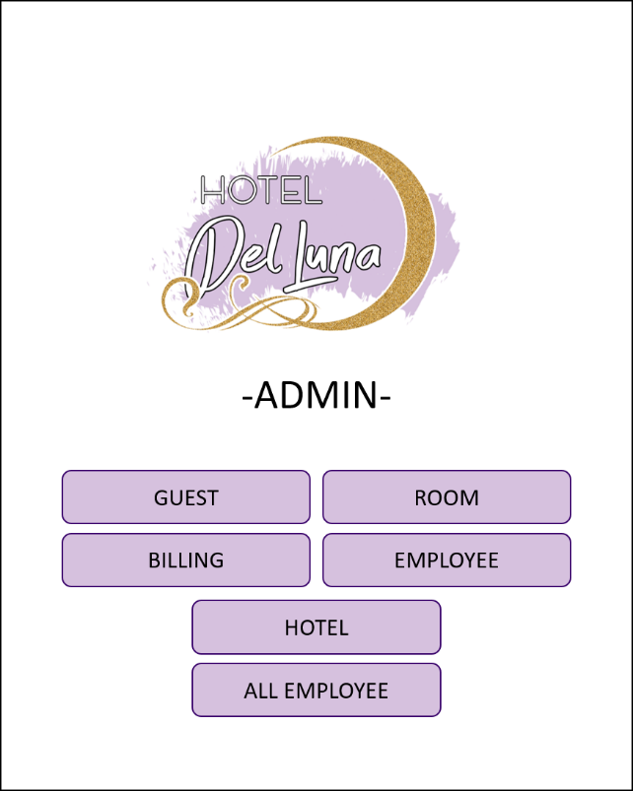

1. **ROOM AND RESERVATION**

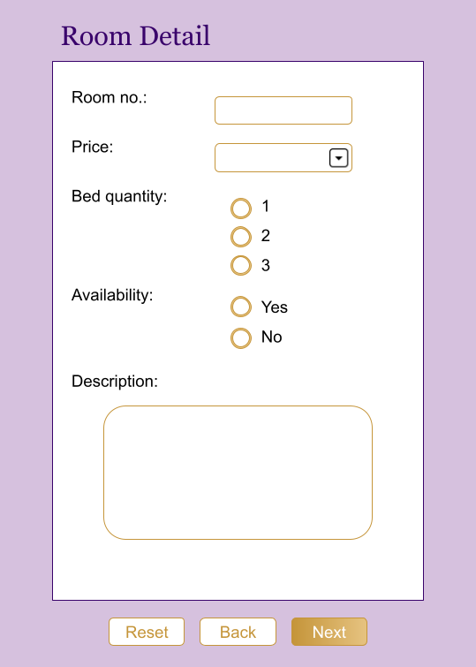 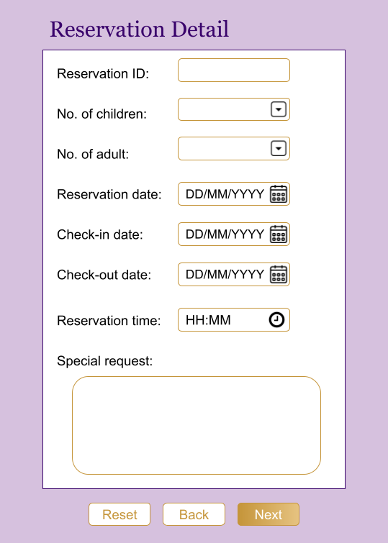

1. **GUEST**

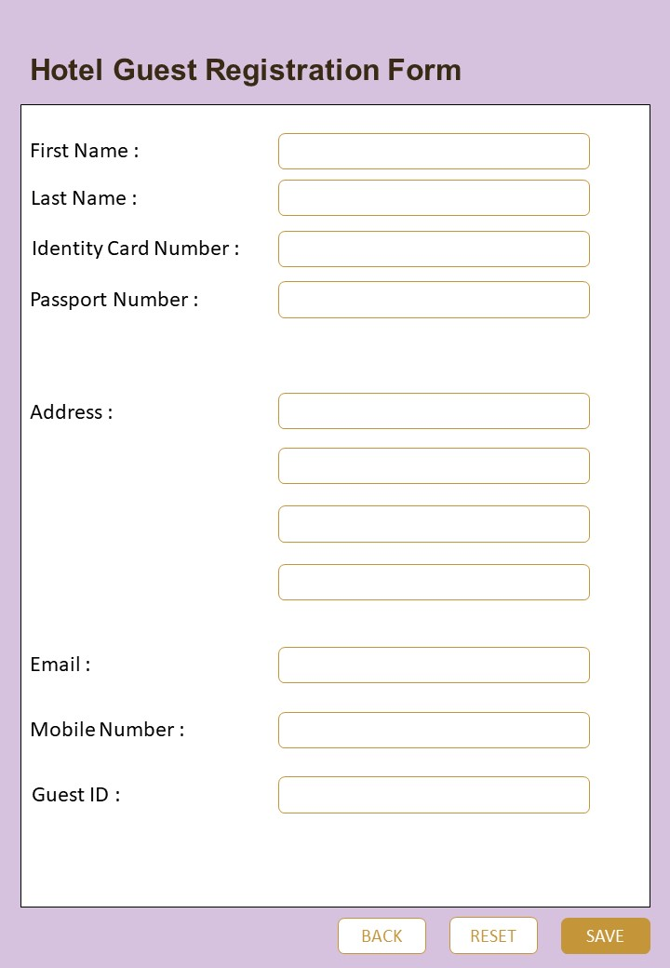

1. **BILLING**

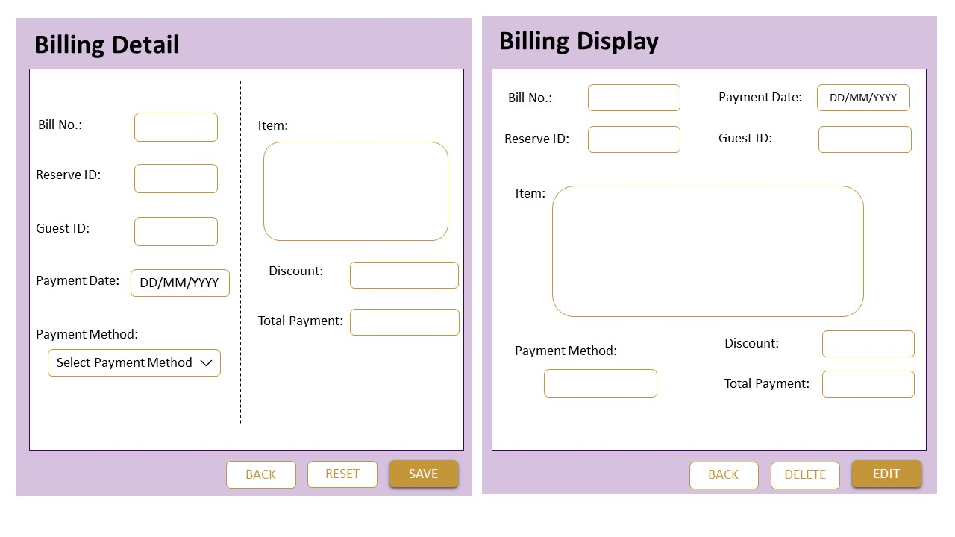 

1. **EMPLOYEE**

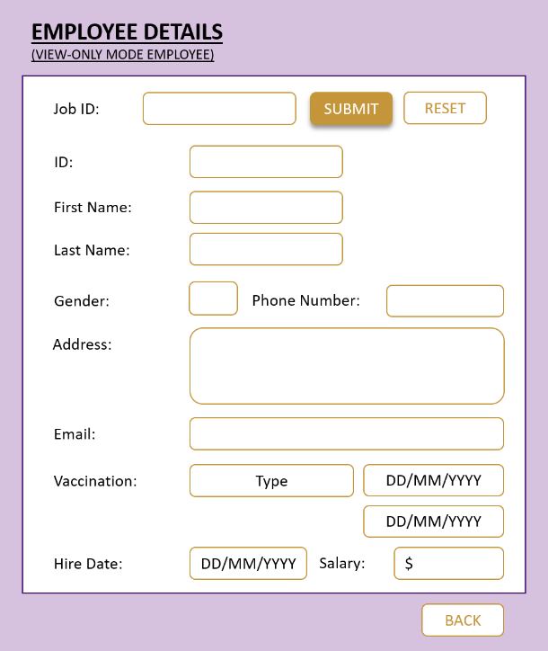 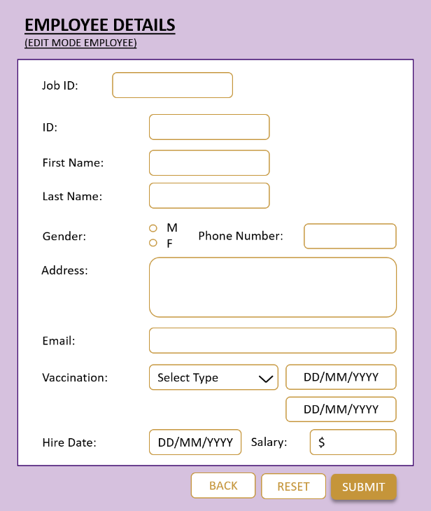

**PROJECT TIMELINE**

<https://docs.google.com/spreadsheets/d/1Xq1EVsTc4IEVA2D1Dr_qZoyimn19_9Xf/edit#gid=2100655493>