Lab 1 Reflection

Proof
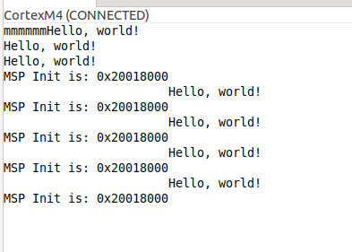

Image 1: Proof of the m printing, Hello World to console using printf and the printing of MSP register values.
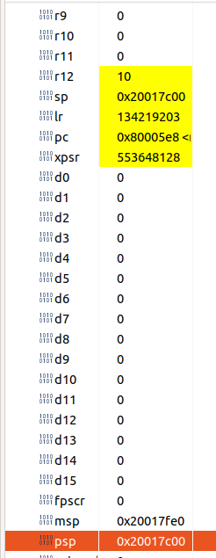

Image 2: Image showing psp register being 0x400 smaller than psp and sp and psp having the same values.

Question 1
In your own words, explain what the HAL is and why it is used in a general embedded project.

Answer:
The Hardware Abstraction Layer (HAL) is a software layer that serves as an intermediary between high-level software and the underlying hardware. It provides a set of standardized APIs that abstract away the hardware-specific details, allowing developers to interact with hardware peripherals (like GPIOs, UARTs, and timers) uniformly. By using the HAL, the same high-level code can run on different hardware platforms with minimal modifications, which significantly simplifies the development process of embedded systems. It enhances portability and maintainability, enabling developers to focus on application logic rather than hardware intricacies.

Question 2
In your own words, explain what the __io_putchar function does and why it is needed.

Answer:
The __io_putchar function is a low-level output function used by the printf function to send individual characters to an output device. It acts as a bridge between high-level standard I/O operations and the specific hardware used for output on the microcontroller, such as the UART interface on the STM32 board. Since printf relies on __io_putchar to output characters, we need to provide a custom implementation of this function to handle the hardware-specific details of character transmission. This is necessary because different projects may use different hardware interfaces for output—like UART, USB, or LCD screens—so __io_putchar must be tailored to the specific hardware to ensure that printf can output characters correctly.

Question 3
Why did we have to use the debugger in this lab? Why didn’t we just use printf to instrument our code and make sure it worked?

Answer:

We used the debugger in this lab to inspect and verify the values of processor registers such as the Program Status Register (PS), Process Stack Pointer (PSP), and Main Stack Pointer (MSP). The debugger allows us to examine the internal state of the microcontroller in real-time, providing precise, low-level insight into register values and memory addresses. Using printf for this purpose is not feasible because it cannot access or display register values directly, and it may not provide accurate timing or context for low-level operations. Additionally, relying on printf could interfere with the system's behavior, especially when dealing with stack manipulation and context switching. The debugger offers a non-intrusive way to monitor and verify that functions like __set_PSP and __set_CONTROL are working correctly.

Question 4
Explain how the stack allocation method we used works. Start by assuming that we have obtained the value for MSP_init_val. How did we get a new value for PSP_val? Why did we need to know the initial location of MSP for this to work?

Answer:
We began by obtaining the initial value of the Main Stack Pointer (MSP) from address 0x0, using the code uint32_t* MSP_INIT_VAL = *(uint32_t**)0x0;. This value represents the starting address of the main stack in memory. To allocate a new Process Stack Pointer (PSP) value, we subtracted a defined stack size (e.g., 0x400 bytes) from MSP_INIT_VAL, like so: uint32_t PSP_val = (uint32_t)MSP_INIT_VAL - 0x400;. This calculation positions the PSP at a lower memory address than the MSP, allocating a separate stack region for processes.
Knowing the initial location of the MSP was crucial because it served as a reference point for calculating the PSP's starting address. Without it, we wouldn't know where the main stack ends and where to place the process stack to prevent overlap. This method ensures that each stack is allocated contiguously in memory without interfering with each other, which is essential for maintaining memory integrity and preventing corruption. By adjusting the value subtracted from MSP_INIT_VAL, we can flexibly allocate different stack sizes as needed.

Question 5
Say that we wanted to use the same stack allocation method to allocate a number of new stacks for use in multiple threads. Say this number is known at compile-time. What would we need to change in our code to make this work? Do not worry about actually using multiple stacks. This question is purely asking about how you would know where each stack starts in memory.

Answer:
To allocate multiple stacks for different threads when the number of threads is known at compile-time, we need to calculate the starting address for each stack based on the initial value of the main stack pointer (MSP_INIT_VAL). The first thread's stack starts at MSP_INIT_VAL. Subsequent stacks are located at addresses calculated as MSP_INIT_VAL - (n * THREAD_STACK_SIZE), where n is the thread number starting from one. This approach ensures that each stack starts at a different memory location, providing enough separation for independent operation without overlapping. By performing this calculation at compile-time, we can determine where each stack starts in memory, facilitating proper stack allocation for multiple threads.

Grading
Each question is evaluated based on the following scale.
Meets expectations: The answer is entirely correct. The answer is sufficiently detailed to include the major ideas necessary to prove that the student understands the concept. The answer is clear.
Approaching expectations: The answer contains no incorrect statements, but requires more detail or is too vague to convince the grader that the student understands the concept. The answer is clear.
Does not meet expectations: The answer either contains some incorrect statements or lacks detail to the degree that major portions of the question are left unanswered. The answer is not clear.
Not observed: the answer is largely incorrect or absent.
To get a grade for a question, you must obtain a rating of “meets expectations” on that question. You may resubmit as many times you like until you achieve that rating.

