Lab 4 Reflection

Proof
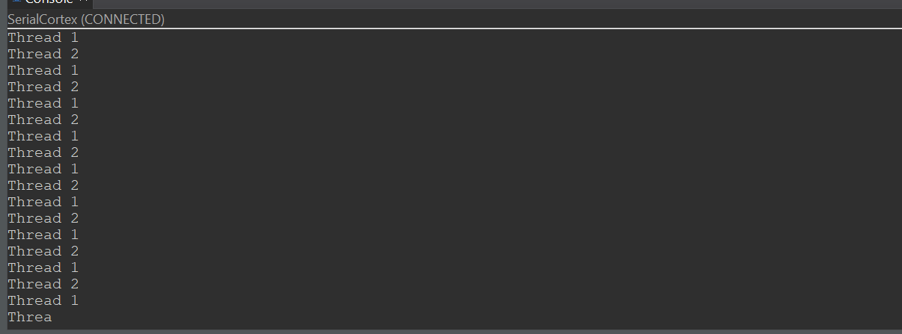
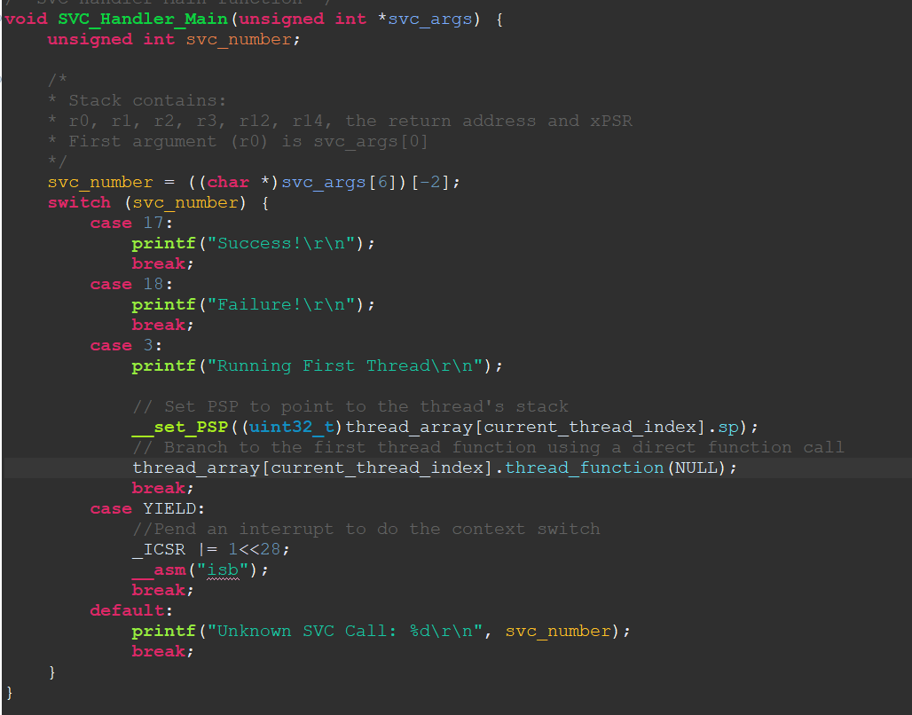
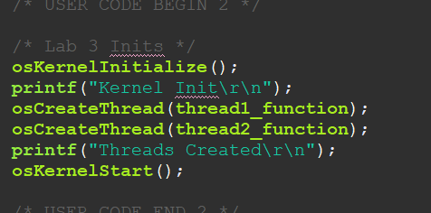
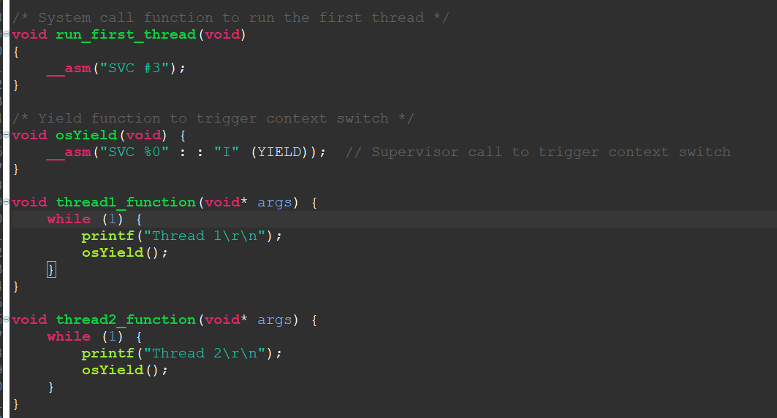

Question 1
In the lab manual, it is mentioned that using a queue to store your TCBs is interesting. Explain how round-robin scheduling can work using a queue instead of just an array. Are there any benefits?

Answer:

In round-robin scheduling, each thread is assigned a fixed time slice in a cyclic order. Implementing this with a queue involves enqueuing each thread's Task Control Block (TCB) into the queue. The scheduler dequeues the TCB at the front, allows it to execute for its time slice, and then enqueues it back at the rear, ensuring all threads get an equal share of CPU time.
Using a queue offers several benefits over an array:
- Dynamic Management: Queues can easily handle dynamic addition and removal of threads, which is more cumbersome with arrays that have fixed sizes.
- Simplified Scheduling: Enqueuing and dequeuing operations naturally align with the round-robin mechanism, making the scheduler's implementation more straightforward.
- Memory Efficiency: Queues can be more memory-efficient, especially when the number of threads varies, as they don't require pre-allocating space for the maximum possible number of threads.
However, arrays provide constant-time access to elements, which can be advantageous in certain scenarios. The choice between using a queue or an array depends on the specific requirements and constraints of the operating system being designed.

Question 2
Explain in your own words how the PendSV_Handler function executes a context switch.

Answer:
The PendSV_Handler is an interrupt service routine specifically designed to perform context switching in ARM Cortex-M processors. A context switch occurs when the operating system decides to change the currently running thread to another. The PendSV_Handler is invoked when the PendSV interrupt is triggered by setting the PendSV interrupt pending flag. The function executes the following steps:
- Save the Current Thread's Context:
  - The current thread's CPU context, including general-purpose registers (R0-R12), link register (LR), program counter (PC), and processor status register (xPSR), is pushed onto its stack. These registers are saved because they hold the thread's state and are necessary to resume its execution later.
  - The Process Stack Pointer (PSP) is used to manage the stack for user threads, ensuring that the correct stack is used for saving the current thread's context.
- Select the Next Thread to Run:
  - The osSched function is called to determine the next thread to execute. This function selects a thread based on scheduling algorithms and updates internal operating system data structures with the new thread's information.
- Load the Next Thread's Context:
  - The PendSV_Handler retrieves the stack pointer of the selected thread from the operating system's thread control block (TCB).
  - Using the PSP, it restores the saved context of the selected thread by popping the saved registers (R0-R12, LR, PC, and xPSR) from the stack.
By saving the current thread's state and restoring the next thread's state, the PendSV_Handler ensures that each thread resumes execution exactly where it left off. This process allows for seamless multitasking, maintaining the integrity and continuity of the system.
Question 3
Presume we modify our OS as follows: we add an integer, “priority”, to the TCB, where a higher integer means a higher priority, and we change the scheduler so that it always chooses the task with highest priority. This is a bad idea. Why?

Answer:
Implementing a scheduler that always selects the highest-priority task can lead to starvation of lower-priority tasks. If high-priority tasks are continuously ready to run, lower-priority tasks may never get CPU time, causing them to be perpetually delayed or never executed. This undermines system responsiveness and can lead to unhandled tasks, especially in real-time systems where timely execution is critical.
A more balanced approach is priority-based round-robin scheduling, where tasks are grouped by priority levels, and within each level, round-robin scheduling is applied. This ensures that while higher-priority tasks receive more attention, lower-priority tasks are not entirely neglected, promoting fairness and system stability.

Question 4
In PendSV_Handler we called a C function, osSched. Similarly, in SVC_Handler, we called a C function, SVC_HandlerMain. Theoretically we could have done all of the required tasks in assembly. Comment on the benefits and downsides to calling the C functions like we did compared to writing everything in assembly.

Answer:
Benefits of Calling C Functions:
- Readability and Maintainability: C code is generally more readable and easier to maintain than assembly. It abstracts low-level details, making the codebase more understandable.
- Portability: C code is more portable across different architectures. Assembly code is processor-specific, so using C functions enhances the portability of the operating system.
- Development Speed: Writing in C allows for faster development and debugging, as high-level languages provide better tooling support and error checking.
Downsides of Calling C Functions:
- Performance Overhead: Calling C functions from assembly can introduce overhead due to function call mechanics, such as stack frame setup and parameter passing.
- Control Over Hardware: Assembly provides finer control over hardware, which can be crucial in low-level operations like context switching. Relying on C may limit this control.
- Predictability: Assembly code can be more predictable in terms of execution time, which is important in real-time systems. High-level languages may introduce unpredictability due to compiler optimizations.
- In summary, while writing everything in assembly offers maximum control and potential performance benefits, using C functions enhances code readability, maintainability, and portability. The choice depends on the specific requirements and constraints of the system being developed.

Question 5
What would happen if, instead of creating multiple threads as we did in the lab, you created only a single thread? For concreteness, assume that the single thread is just the print_continuously thread from the previous two labs, modified so that it yields once it has printed. Will the OS still work? Explain.

Answer:

If the operating system is designed to handle multiple threads but only one thread is created, the system will still function, but the benefits of multitasking are lost. In this scenario, the single thread (print_continuously) will execute, and upon calling osYield, the scheduler will attempt a context switch. However, with no other threads to switch to, the scheduler will likely return control to the same thread.
This behavior is functionally correct but inefficient, as the context switch incurs unnecessary overhead without any gain in concurrency. The operating system remains operational, but the design is suboptimal for single-thread execution. In such cases, a simpler system without multitasking capabilities would be more appropriate.

Grading
Each question is evaluated based on the following scale.
Meets expectations: The answer is entirely correct. The answer is sufficiently detailed to include the major ideas necessary to prove that the student understands the concept. The answer is clear.
Approaching expectations: The answer contains no incorrect statements, but requires more detail or is too vague to convince the grader that the student understands the concept. The answer is clear.
Does not meet expectations: The answer either contains some incorrect statements or lacks detail to the degree that major portions of the question are left unanswered. The answer is not clear.
Not observed: the answer is largely incorrect or absent.
To get a grade for a question, you must obtain a rating of “meets expectations” on that question. You may resubmit as many times you like until you achieve that rating.

