NWAM GUI Specification, Draft 1.6

05/12/08

Table of Contents
Panel Icon 2
Panel Icon – Animation and Notifications 4
Changes required to GNOME Network Monitor Applet 5
Editable Tables 6
Editable Tables (Cont'd) 8
Rule Construction Component 9
Network Preferences Window : Overview 11
Network Preferences – Status View 12
Network Preferences: Network Profile 13
Network Preferences: Network Profile (cont'd.) 15
Network Preferences: Connection Properties: IP Address 16
Connection Properties: IP Address: IPv4 17
Connection Properties: IP Address: IPv6 18
Connection Properties: Wireless 19
Connection Properties: Wireless (cont'd) 20
Location Preferences: Overview 21
Location Preferences: Proxies 23
Location Preferences: Rules 24
Location Preferences: Name Services 25
Location Preferences: IPFilter 26
Location Preferences: Network Services 27
Location Preferences: Extensible Properties 28
Add/Join/Edit Wireless Network 29
Add/Join/Edit Wireless Network (Cont'd.) 30
Wireless Network Chooser 31
VPN Preferences 32

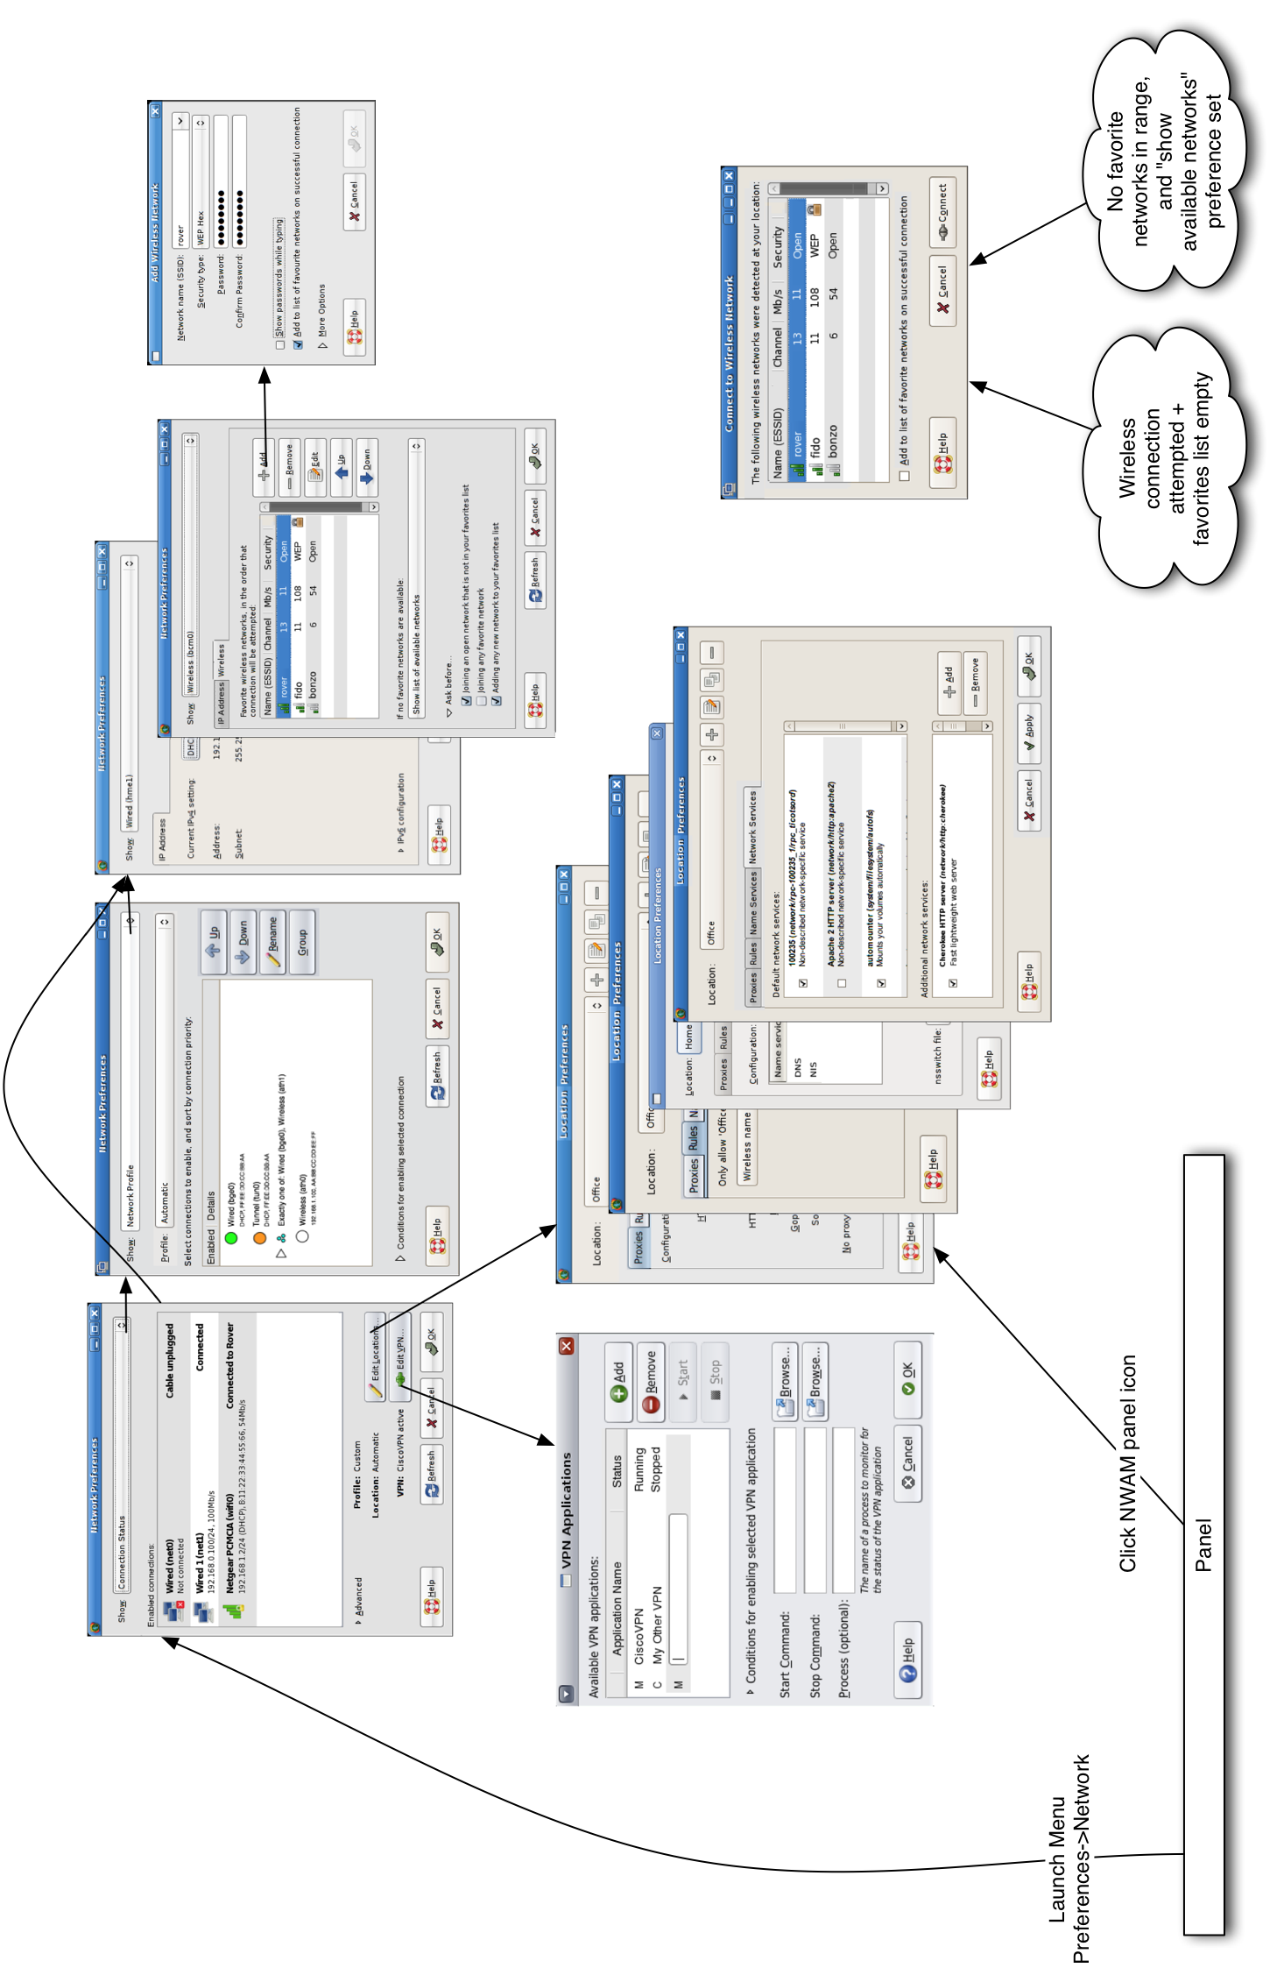

Panel Icon
The Location panel icon is shown inthe panel's status notification area at all times, and is the primary means by which you will interact with NWAM on a day-to-day basis. It is the focus for information messages about changes to your network status, and its menu allows quick access toessential network functionality.
The icon's appearance indicates the overall health of the network (problems indicated by an emblem overlaid on the icon)
 | All enabled connections in the current location are disconnected
 | One or more (but not all) enabled connections in the current location are connected; the others are disconnected or pending
 | All enabled connections in the current location are connected
When the mouse is over the icon, the tooltip shows the name of the currently active location and the status of enabled connections. Connection names are shown here (and elsewhere) in the format Vanity Name (Device Name). If no vanity name has been defined by the user, an appropriate default is used: “Wired N” for wired NICs (where N is not shown for the first wired NIC, and >=1 for susbequent NICs), or “Wireless N” for wireless NICs (again, N is either not shown or >=1). In later phases, “Tunnel”, “Bluetooth”, “Modem” etc. might be other possible default vanity names.
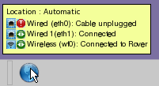
Clicking the panel icon opens the Location Preferences dialog (p23). Right clicking the icon pops up its context menu-- a rescan of available wireless networks is performed before posting. May need to reconsider if this typically takes longer than 1 second.

Panel Icon – Context Menu
This menu is posted by right-clicking the panel icon.
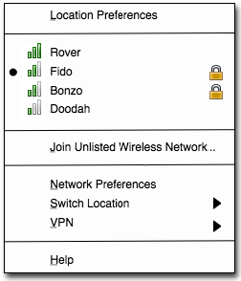
The function of the menu items is as follows:
- Location Preferences opens the Location Preferences dialog (p23).
- The next section of the menu is a combined list of available favorite networks (p21), and other currently available networks that are broadcasting their ESSID. The list is ordered by current signal strength, strongest first. Format is signal strength indicator, ESSID, secure/open indicator (right-aligned). Additionally, any network to which you are currently connected is indicated with a radio button indicator to the left of the signal strength indicator.
If no networks are available to be listed in this section, a single disabled menu item is shown: “No wireless networks detected”
Selecting the ESSID of a network to which you are not currently connected attempts to connect to that network. If connection fails, you are re-connected to your previous wireless network, if any. This manual switching of networks does not affect any stored network configuration, and lasts until the next manual or automatic switch of locations occurs. [CFB: If you have more than one wireless NIC available, a dialog should appear (TBD) asking you to choose which one to use for the new connection. Probably too much of a corner case for Phase 1, though]
Selecting the ESSID of a network to which you are already connected has no effect.
- Join Unlisted Wireless Network... opens the Join Wireless Network dialog (p31) with no details pre-filled, to allow you to connect to a network that is not broadcasting its ESSID. Once connected to any such network, it appears on this context menu in the list of favorite and available networks. If the network was not added to the list of favorites when connecting, it will disappear from this list again at the next disconnection.
- Network Preferences opens the Network Preferences dialog (p13).
- Switch Location submenu lists (with radio button menu items)the defined locations in alphabetical order, with the current location selected.
Select another location from the menu to switch to it.
* Automatic
Home
Office
- VPN submenu has one menu entry for each VPN application defined in the VPN Preferences dialog (p34) if any, in the same order as they are defined there, followed by a VPN Preferences menu item. E.g:
The entry for each script is Start <name> for VPN apps that are not running, and Stop <name> for those that are. The VPN Preferences menu item is always available and opens the VPN Preferences dialog (p34).
Start CiscoVPN
Stop Punchin

VPN Preferences
- Help opens the help browser at a page appropriate to this context menu.

Panel Icon – Animation and Notifications
As well as the panel icon's appearance and tooltip giving you a summary of the current status of the network location, notification messages will alert you when the status changes significantly:

Animation
The panel icon should animate (simply, perhaps 2or 4 frames/sec) when a status change is pending but not complete, in particular when:
- a scan for available wireless networks is in progress
- an attempted connection to a wired or wireless network is in progress but not yet established
This animation should be controlled by the /desktop/gnome/interface/enable_animations gconf key so that sysadmins can turn it off for thin clients etc.

Notification
A notification message balloon appears when a significant change of network status occurs. All balloons are shown for the system default length of time before disappearing again. (The examples below are not visually indicative of the final appearance of the balloons, which should include an icon and a close button, and be coloured according to the user's current theme).
- A wired or wireless connection is established. For wired networks, the primary text is “vanityname is connected”. For wireless networks, the primary text is “Connected to ESSID”. Secondary text shows the real device name, Ipv4 and/or Ipv6 address obtained, connection speed, and (for wireless networks) signal strength.
- A wired or wireless connection is disconnected. For wired networks, the primary text is “vanityname is disconnected”. For wireless networks, the primary text is “Disconnected from ESSID”. The secondary text gives the reason for the disconnection. For wireless networks, the message is clickable, which opens the wireless network chooser dialog (p33):
'Wired' is connected
Interface: net0
Address: 192.168.1.100
Speed: 100 Mb/s
Connected to 'Rover'
Interface: wifi0
Address: 192.168.1.100
Speed: 11 Mb/s
Signal Strength: 85%
- The location has changed. Primary text is “Switched to location Name”. The secondary text is “Now configuring your network”.
'Wired' is disconnected
Cable unplugged
Disconnected from 'Rover'
Wireless signal lost.
Click here to join another
wireless network.
- No wireless networks are detected. This is shown following a switch to a location with an enabled wireless NIC, when the initial scan reveals no available wireless networks for it to connect to. Clicking the balloon opens the Join Wireless Network dialog (p31), to allow the user to join a network that is not broadcasting is ESSID.
Switched to location 'Office'
Now configuring your network
- A wireless network has been automatically added to your favorites list. Automatic addition of networks can be over-ridden by the 'Ask before' preference in the Wireless tab (p21). Clicking the balloon opens this tab.
No wireless networks detected
Click here to join an unlisted
wireless network.
Wireless network 'Rover' added to favorites
Click here to view or edit your list of favorite
wireless networks.

Changes required to GNOME Network Monitor Applet
This NWAM design is largely independent of the exsiting Network Monitor (aka gnome-netstatus) panel applet, which has existed in GNOME and JDS for some time. Users are still free to add and remove netstatus applets as they wish in the usual way, to monitor individual connections.
Most of the changes required to make gnome-netstatus interact well with NWAM were made in Phase 0.5:
- Wireless indicator made to work on Solaris
- Option added to have applet track the active network interface
- Option added to toggle between NWAM and manual network configuration
- Nimbus look and feel implemented
Another change to consider for Phase 1 would be for the gnome-netstatus applet's Properties menu item to open the appropriate connection properties view in NWAM's Network Preferences dialog (p13), rather than its own Properties dialog.

Editable Tables
The remainder of this document describes the Network Preferences and Locations dialog, both of which include, in various places, tables whose contents can be edited by the user.
To ensure consistency, and avoid repetition (and copy/pate errors!), the general specification for editable tables is described here, and will be referenced as required from elsewhere in the document.

Initial State
Editable tables have adjacent Add and Remove buttons, and inline help text that reads “Double click table cells to edit”: An empty table will therefore look something like this:
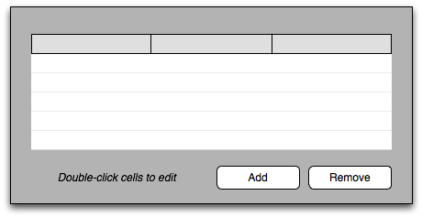

Entering a new row
User initiates entry of a new row by clicking the Add button, or by double-clicking any cell on any empty row. The Add button is enabled at all times, except while a row is already being added.
When a row is added, an input control is shown overlaying the first cell in the first empty row, and given keyboard focus. This control will usually be a text field, but it may also be a combo box or a popup menu:
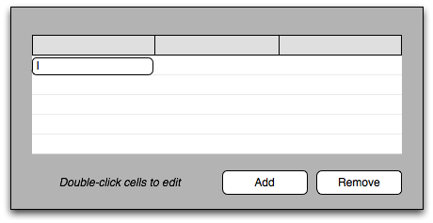
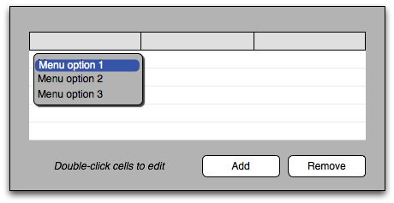
At this point, the user has three choices:
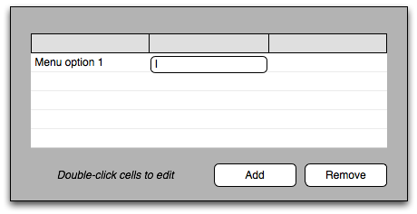
- Complete the entry for this cell: enter text and press Return or Tab (for a text field), or select a menu item using up/down arrows and press Return (for a menu choice), or click the desired menu choice with the mouse. The overlaid control is replaced by the text that was entered/chosen, and focus moves to the next cell in the row:
When the last cell in a row is entered, focus moves to the first cell of the next row, allowing entry of another row, unless otherwise specified for a particular table.
- Move to another cell: press Tab to move focus to the next cell in the row, or Shift-Tab to move focus to the previous cell in the row. If the user enters any text before pressing Tab, the text is retained. Focus wraps between rows, but not between the first cell and the last cell in the table.
- Cancel entry for the entire row: press Esc. All cells in the row are cleared, and keyboard focus returns to the Add button in the dialog.

Editing a cell
Double-clicking a non-empty cell causes its input field to be displayed and focused, with the current cell contents pre-selected:
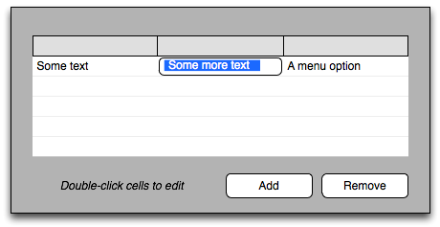
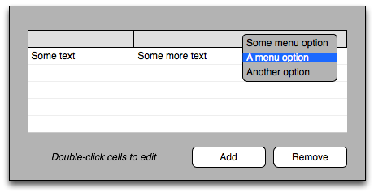
From here, behaviour proceeds as though the user were part way through entering a new row, except that pressing Esc does not clear the row. Instead, Esc cancels any pending changes to that cell, and returns focus to the Add button.

Removing a row
A row can be removed in two ways.
- Select the row, then click the Remove button. A row is selected by clicking any cell in the row, causing the entire row to be highlighted. Multiple row selection is allowed in the usual way (using Ctrl and/or Shift) unless otherwise specified for a particular table. Empty rows cannot be selected.
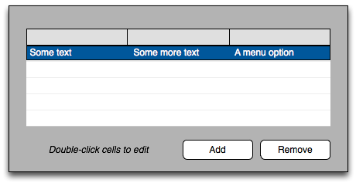
- Click the Remove button while any cell is being edited. That cell's entire row will be removed.
The Remove button is disabled at all other times.
(Cont'd next page.)

Editable Tables (Cont'd)

Other behaviour
Table cells whose contents are not fully visible are ellipsised, and given a tooltip that shows the entire cell contents.
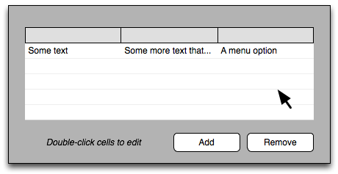
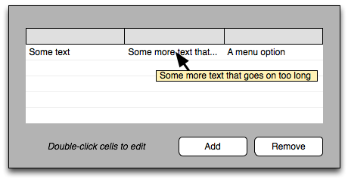
Input validation is performed whenever focus leaves a cell that is being edited, either explicitly (e.g. by pressing Enter) or implicitly (e.g. by clicking the dialog's OK button whilst editing a cell). If validation fails, an alert is shown that indicates the problem and the input required:
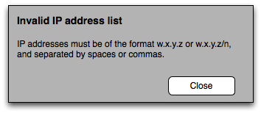
Closing the alert returns focus to the invalid cell in the table.

Rule Construction Component
The remainder of this document describes the Network Preferences and Locations dialog, both of which include, in various places, an embedded GUI component for constructing rules to dynamically enable/disable certain NWAM features.
To ensure consistency, and avoid repetition (and copy/pate errors!), the general specification for this component is described here, and will be referenced as required from elsewhere in the document.

Initial State
The initial state of a rule construction component will look something like this:
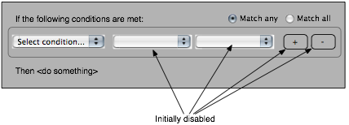
While some aspects of the component may vary for specific instances, the following is true for all such components:
- “Match any” is initially selected by default, if the all/any radio buttons are present
- One row of controls is initially visible, the first of which is a dropdown menu showing the entry “Select condition...”. The remaining controls in the row are disabled.
The user proceeds by selecting a condition from the first dropdown list. When any item other than “Select condition...” is selected, all the remaining controls in the row become active, and the Select Condition item is removed from the list so it can no longer be directly selected. Also, one or more of the intermediate controls may change type, e.g. from a dropdown list to a text field, to accommodate the chosen condition:
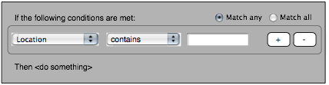
At this point, the user can either return to the intial “Select Condition...” state by clicking the Remove (“-”) button, or add a new rule row by clicking the Add (“+”) button:
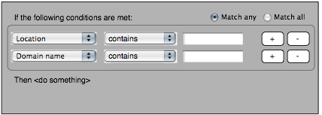
The user need not complete any blank fields before clicking the Add button; rule validation will not be performed until later.
Each new rule added should begin with the first as-yet unspecified condition in the first dropdown list, where possible. For example, if the available conditions are Location, Domain Name and IP Address:
- User adds an initial rule, “Location is Home”, then clicks Add
- The first dropdown of the new rule is set to the first item on its list that hasn't been used yet, “Domain Name”
- User edits new rule to read “IP Address is 192.168.1.1”, then clicks Add
- At this point, “Domain Name” is still the first unused item on the list, so the first dropdown of the new rule is set to “Domain Name”.
When all rule types have been exhausted, clicking Add adds another rule of the same type, if two rules of the same type are permissible for that component. If they are not permissible, a rule of the first permissible type on the list is added.

Removing Rows
The user can remove any row at any time by clicking its Remove (“-”) button. When the Remove button of the last remaining row is clicked, the component is returned to its initial “Select Condition...” state.

Validation
Rule validation is performed whenever the user closes the dialog containing the component. If validation fails, an alert is shown that indicates the problem and the input required:
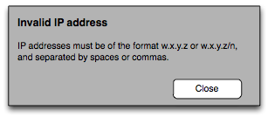
Closing the alert returns focus to the invalid entry field in the rule construction component.

Network Preferences Window : Overview
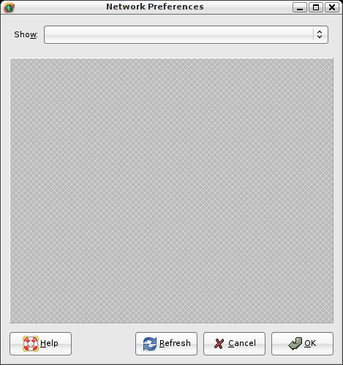
You open this dialog by either:
- Selecting Launch->Administration->Network (currently launches network-admin)
- Right-clicking the panel applet and selecting Network Preferences
The Show dropdown list comprises Connection Status, Network Profile, and a list of all currently-defined connections. Connection names are shown in the format described on p3, e.g.:
Default view is Connection Status (p14)
Connection Status
Network Profile

Wired (hme0)
Wired 1 (hme1)
Wireless (bcm0)
Selecting Connection Status from the dropdown list switches to the Connection Status View (p14)
Selecting Network Profile switches to the Network Profile View (p15)
Selecting a connection name from the dropdown list, or double-clicking it in connection status view, switches to the Connection Properties View (p18)
Refresh causes the NWAM subsystem to be refreshed, wireless networks rescanned, and the dialog updated if required.
Cancel closes the dialog without applying any pending changes.
OK closes the dialog and applies any pending changes, causing the NWAM subsystem to be refreshed.

Network Preferences – Status View
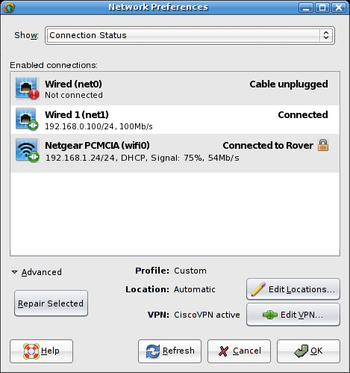
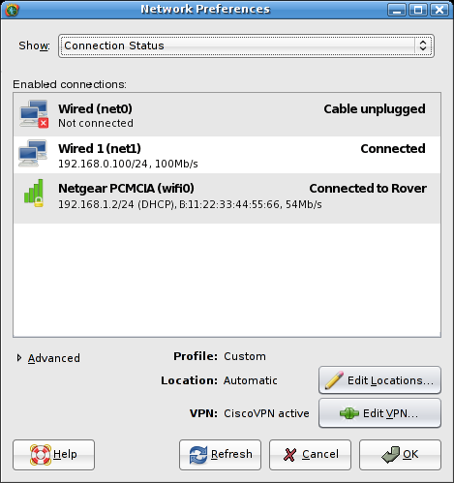
Show this view by selecting Connection Status in the dropdown list at the top. Shows information about each enabled connection in the NCP, as configured in the Network Profile view (next page). Connections disabled there are not shown here.
Enabled Connections lists enabled connections in the same order as in the Network Profile View (p15); that is, the order in which connections are attempted. The order cannot be changed here however, this functionality is only in the Network Profile View.
Bold text for each connection shows vanity name, followed by the interface name in parentheses. Current status is shown on the same line, right-aligned. Suggested status messages (depends on exactly what statuses we can be informed about, but the more specific the better):
- Connecting... : A wired link is coming up but is not yet connected.
- Connected : A wired link is up and running.
- Connecting to ESSID... : A wireless link is attempting to connect to ESSID. ESSID should be followed by the 'secure' icon if the network employs WEP, WPA or other security.
- Connected to ESSID : Wireless link is up an running on network ESSID. ESSID should be followed by the 'secure' icon if the network employs WEP, WPA or other security.
- Network unavailable : E.g. if DHCP server or default gateway cannot be contacted.
- Cable unplugged : if wired link is enabled but cable is unplugged.
Secondary text for each active connection:
- “Not connected” for disconnected wired or wireless interfaces
- Address: [[Ipv4 address | Ipv6 link local address] / CIDR subnet mask], or “Multiple Addresses”; “DHCP” if applicable, “Signal: n%” for wireless NICs, connection speed.
Icon indicates type of connection (wired or wireless; in later phases, tunnel, aggregation etc.) and current status (connected/disconnected for wired or wireless, plus signal strength and security type for wireless).
Double-clicking a connection switches the status view to that connection's properties view (p18)
Profile shows the current network configuration profile (NCP). In Phase I, this is ether Automatic or Custom.
Current Location shows the currently active location. Edit Locations... button opens the Location Preferences dialog (p23)
VPN lists any currently-running VPN applications, e.g. “CiscoVPN active”, “N active” (n>=2) if two or more applications are running, or “None active”. Edit VPN... button opens the VPN configuration dialog (p34) where such scripts can be configured, started and stopped.
Advanced expander, collapsed by default, reveals a Repair Selected button that is enabled for interfaces that are reporting connectivity problems (except those for which the cause is physical, e.g. unplugged cable). Clicking the button attempts to re-establish the connection by whatever means available, e.g. renewing the DHCP lease.

Network Preferences: Network Profile
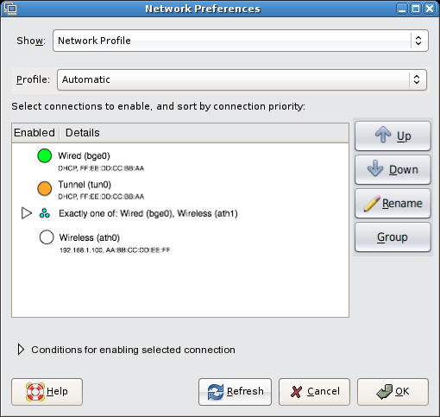
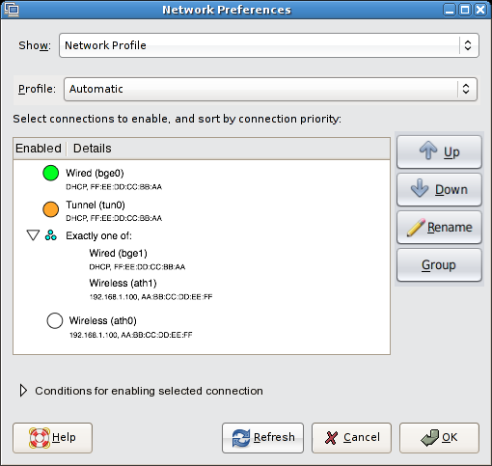
Show this view by selecting Network Profile in the dropdown list at the top. View shows the configuration of the current network configuration profile (NCP), of which there are two in Phase I: Automatic and Custom.
Profile dropdown allows the user to choose from available network profiles. When Automatic is selected, the connection list, Up, Down, Rename and Group buttons, and the contents of the Conditions for enabling selected connection expander (but not the expander itself) are disabled.
Icon beside each NCU (final visuals TBD) represents its activation mode:
Manual-enabled: the NCU should be activated whenever possible
Conditional: the NCU should be activated when its associated conditions (defined in the expanding area at the bottom of the dialog) are satisifed
Manual-disabled: the NCU should not be activated.
Prioritized: a group of prioritized NCUs with the same priority value. Such groups are shown in a branch of the tree, collapsed by default-- see image above left. When expanded, they appear as shown above right.

Primary text for Manual and Conditional NCUs, and for those in expanded prioritized groups, is Vanity Name (physical name). Secondary text is:
- Address: [[Ipv4 address | Ipv6 link local address] / CIDR subnet mask], or “Multiple Addresses” if static; “DHCP” if applicable; MAC address.
Primary text for prioritized group headings depends on the priority group mode of the NCUs:
- Exclusive: text is “Exactly one of:”
- Shared: text is “One or more of:”
- All: text is “All of:”
When the group entry is collapsed, the text is followed by a comma separated list of the NCUs in the group, each of the format VanityName (PhysicalName). If the list is too wide to fit the dialog, it is truncated with an ellipsis (...).
Double-clicking a connection switches the status view to that connection's properties view (p18).

Changing Activation Mode
When you click on a connection's icon, a popup menu appears allowing you to change that connection's activation mode. For non-prioritized connections, the menu contents are:
* Always active when available
Conditionally active when available
Never active
For a prioritized group, the menu contents are:
* Only one connection may be active
One or more connections may be active
All connections must be active
In both cases, the menu items are a single group of radio button menu items.

Re-ordering connections
When Custom NCP is selected, list is re-orderable by drag and drop, or by using the Up and Down buttons to move the selected items. The order reflects the order in which connections are attempted, when required. The Up/Down buttons behave as follows:
- The Up button is disabled when the first item in the list is selected, and the Down button is disabled when the last item in the list is selected. Both buttons are disabled when multiple items are selected.
- If a non-prioritized NCU is selected, and the adjacent item in the desired direction is also non-prioritised, then the items simply swap positions in the list.
- If an expanded or unexpanded group entry is selected, the Up/Down buttons move the whole group up or down the list. This corresponds to increasing/decreasing the priority of that group.
- If a prioritized NCU is selected (which can only happen in an expanded branch), the Up/Down buttons move the NCU out of its current group, making it non-prioritized (what should the activation mode become... 'always'?). If the adjacent item in the list in the desired direction is also a group, then the NCU is placed in the list between the two groups.
- If a non-prioritized NCU is selected, and the adjacent item in the desired direction (Up/Down) is a prioritised group, then the Up/Down button moves the NCU into that prioritised group.

Creating/Deleting Prioritized Groups
When one or more NCUs are selected (none, one or more of which may already be in an existing group), the Group button is enabled. Click the Group to create a new priority group containing those NCUs, with a default priority mode of EXCLUSIVE. The new group heading is automatically selected in the list.
When a group heading is selected, the Group button label becomes Ungroup. Clicking the Ungroup button sets the activation mode of each NCU in the group from PRIORITIZED to ALWAYS, effectively deleting the group.

Renaming Connections
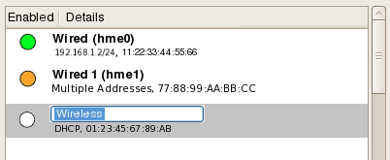
To change a connection's vanity name, select it and click Rename. This opens an embedded text field in the list, the contents of which are the current (possibly default) vanity name. Text is selected, ready for overtyping:
Specify a new vanity name by entering new text and pressing Return. Press Esc to dismiss the text field with no changes to the vanity name.

Network Preferences: Network Profile (cont'd.)
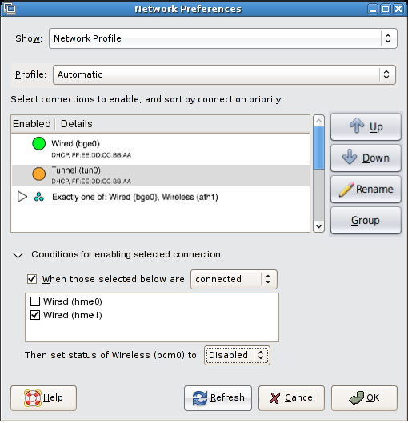
The Conditions for enabling selected connection expander is in the collapsed state by default when the dialog is opened. You can expand it manually by clicking the arrow, or automatically by selecting a connection that has associated rules (active or otherwise). If the arrow was last expanded automatically, and you select a different connection with no rules, it collapses automatically again. However, if you manually expanded it, then it stays expanded or collapsed regardless of the selection in the list, until the dialog is closed.
When expanded, the Conditions for enabling selected connection controls show any rules used to determine the enabled state of the selected connection in the current NCP. For example, if the NCP comprises a mixture of wired and wireless NICs, a rule is enabled by default for each wireless NIC that disables it should any wired NICs be connected.
When the Automatic NCP is selected (in the Name dropdown), all the following controls are disabled.
When those selected below checkbox: check or uncheck this to activate or disable the rules for the selected connection. A connection with an active rule is represented in the main connection list by its checkbox being in the indeterminate state (usually shown as a “-”, but depends on the GNOME theme). A connection with an inactive rule is represented in the main connection list by a checked or unchecked box, indicating that the connection is unconditionally enabled or disabled.
Connected/Disconnected dropdown: determines whether the rule is dependent on the selected connection being “connected” or “disconnected”. The dropdown is disabled if the When those selected below checkbox is unchecked.
Connection checkbox list: lists all connections (except the selected connection). The status of checked connections is taken into account when evaluating the rule. Unchecked connections are ignored when evaluating the rule. The list is disabled if the When those selected below checkbox is unchecked.
Set status dropdown: specifies whether the selected connection should be conditionally “enabled” or “disabled”. The dropdown is disabled if the When those selected below checkbox is unchecked.

Network Preferences: Connection Properties: IP Address
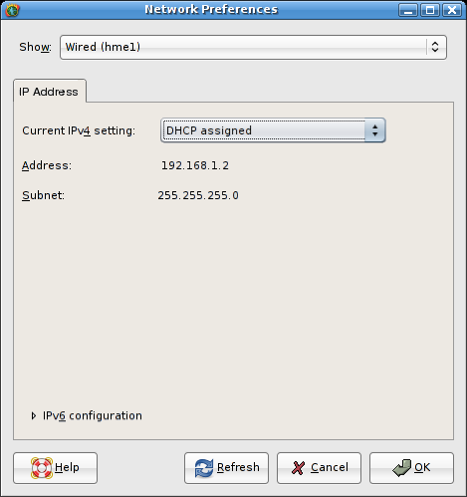
When you select a connection from the Show dropdown, a tabbed view appears allowing the user to edit the properties of that connection. The IP Address tab is one of those tabs, present for both wired and wireless NICs.
The Current Ipv4 Setting dropdown comprises the options DHCP assigned, Manually assigned, and Multiple addresses. The contents of the area between the dropdown list and the Configure Ipv6 expander change dynamically depending on the selection. See next page for details.
The Ipv6 configuration expander is collapsed by default if Ipv6 is disabled for this interface, and expanded by default if Ipv6 configuration is enabled. See pError: Reference source not found for details.

Connection Properties: IP Address: IPv4
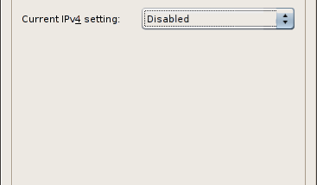
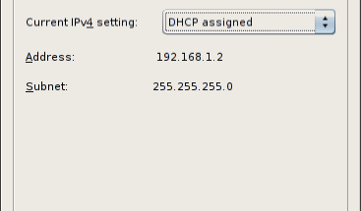
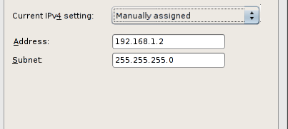
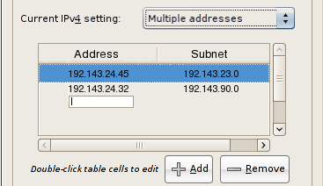
Disabled: No IPv4 address is assigned to this NIC.
DHCP assigned: when this option is selected, the Address and Subnet fields are provided by the router and shown as static labels.
Manually Assigned: when this option is selected, the Address and Subnet fields are editable. Their syntax is checked when you switch to a different tab, click OK, or select a different item from the Show dropdown at the top of the dialog. An appropriate alert is shown if any of the fields are invalid. Dismissing the alert focuses the offending field ready for input.
Multiple Addresses: This is an editable table as defined on p7. The overlaid control used for both the Address and Subnet cells in each rowis a text box.
When switching between DHCP assigned, Manually assigned and Multiple addresses views, any data entered is remembered in case you later switch back to that view. This data is also remembered between sessions.

Connection Properties: IP Address: IPv6
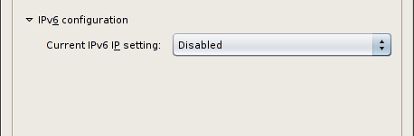
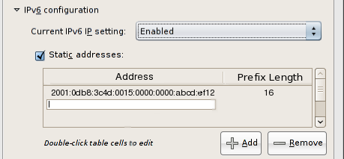
Disabled: No IPv6 address is assigned to this NIC.

Enabled: when this option is selected, the NIC attempts to obtain an Ipv6 address from the router.
Static Addresses: When checked, the table below is enabled to allow assignment of additional, manual IPv6 addresses to the NIC. The table is an editable table as defined on p7, with text fields used as the overlaid input controls for both the Address and Prefix Length fields.
When unchecked, the table is disabled but remains visible.

Connection Properties: Wireless
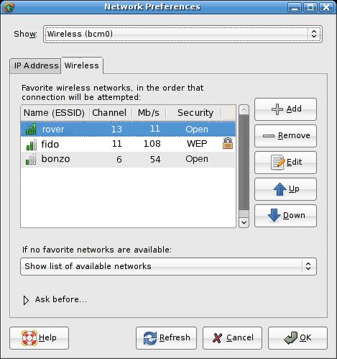
This tab only appears for wireless NICs.
The list shows your current favorite networks, in the order in which any automatic connection will be attempted. First column shows signal strength and name (ESSID). Second column shows wireless channel, third column shows speed, fourth column shows security type with right-aligned 'secure' icon for secure networks. List is re-orderable using drag and drop, or the Up and Down buttons.
If no favorite networks found dropdown gives choice of what to do if no preferred wireless networks are available:
- Show list of available networks: will open the wireless network chooser dialog (p33) to ask which other network to join.
- Join an open network: will attempt to join any available unsecured wireless network (strongest signal first?). If the Ask before joining a new open network preference is checked (see next page), you will be asked to confirm before joining.
- Remain offline: will not attempt to join any wireless network until any new networks are detected, or the location changes.
Add opens the Add Wireless Network dialog (p31), but with its Add to favorite networks checkbox hidden.
Remove deletes the selected network from the list, after confirmation alert.
Edit opens the Edit Wireless Network dialog (p31), retitled Edit Wireless Network, preloaded with the the selected network's details, and with its Add to favorite networks checkbox hidden. Disabled if no network is selected in the list.
Up/Down buttons move selected network up/down in the list. Up is disabled when selected network is at already at the top, likewise Down is disabled when selected network is already at the bottom.

Connection Properties: Wireless (cont'd)
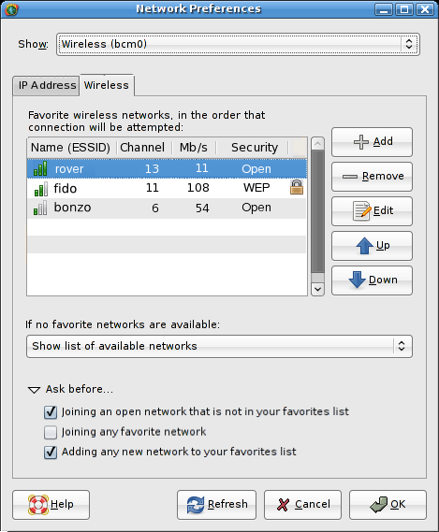
Ask Before expander is collapsed by default. Contains the following preferences:
- Joining an open network that is not in your favorites list: Ask before joining an open network that is not on the favorites list; default value=yes. If checked, causes the Join Wireless Network dialog (p31) to appear when such a connection is attempted, pre-filled with the network's name and security type (which is always “None” in this case). If unchecked, open networks are joined as required with no interaction necessary.
- Joining any favorite network: Ask before joining a network (open or secure) that is on the preferred list; default value=no. If checked, causes the Join Wireless Network dialog (p31) to appear when such a connection is attempted, pre-filled with the network's name, security type and any saved password information. If unchecked, favorite networks are joined automatically as required, provided any necessary credentials have previously been entered and saved.
- Adding any new network to your favorites list: If checked, causes the Add to favorite networks checkbox to appear in the Add Wireless Network (p31) and wireless network chooser dialogs (p33), whenever they are shown. If unchecked, new networks will be added to the favorites list automatically on first connection, with no interaction necessary (a notification balloon will tell you when this has happened). Default value=yes.

Location Preferences: Overview
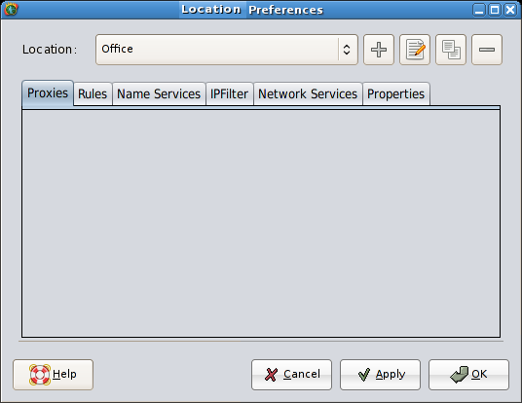
Open this window by choosing Location Preferences from the panel applet's right-click menu, or from Launch->Preferences->Locations.
When the window is opened, the Location dropdown indicates the currently active location. To force a switch to a different location, select it from the dropdown, and click OK. (How long will the delay be before the new location takes effect? If it's more than a second or two, may need some sort of progress indication while the switchover happens).
To edit the properties of a location, select it from the dropdown if required, and make the required changes on the tabs. Click Apply to submit all pending changes and leave the window open. Click OK to submit the changes and dismiss the dialog. (Note: clicking Apply or OK will also force a switch to the location selected on the Location dropdown. This is a bit ugly, but it's also how the Mac does it, and the alternatives I can think of aren't really any better: an alert when you click Apply/OK asking if you want to switch or not, or some sort of 'edit mode' checkbox in the dialog which , if checked, didn't do the switch when you clicked Apply/OK.)
The four buttons to the right of the dropdown are Add, Rename, Duplicate and Remove. All have tooltips.
To add a new location with default settings, click the Add button. A new location will be created with the name “Unnamed Location N”, where N is not shown for the first unnamed location, and is the lowest numerical value >=1 that would make the location name unique otherwise. The new location is selected in the dropdown, and the Rename dialog (see below) is popped up automatically to allow immediate renaming.
To rename the current location, click the Rename button. The rename dialog pops up, with the current name in the field, preselected to allow immediate overtyping:
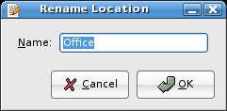
The Rename button is disabled when the default Automatic location is selected, because the Automatic location is not editable. You can duplicate it and rename the copy, however.
To duplicate the currently-active location, click the Duplicate button . A new location will be created with the name “Copy of $LOCATION” if that name is unique, otherwise “Copy of $LOCATION N” where N is the lowest numerical value >=1 that would make the location name unique). The new location is selected in the dropdown, and the Rename dialog (see above) is popped up automatically to allow immediate renaming.
To delete the current location, click the Remove button. A confirmation alert appears:
The Remove button is disabled when the Automatic location is selected, as the Automatic location cannot be deleted.
Remove location '$LOCATION'?

This operation cannot be undone.

[ Cancel ][ Delete ]
Tabs are Proxies, Rules, Name Services (TBD) and Network Services, covered on following pages.
You are not allowed to edit the system default location (called Automatic). Rather than disabling the majority of the dialog when this location is selected, however, the controls remain enabled and editable. When you click OK or Apply, an alert box is displayed explaining that the Automatic location is not editable:
Clicking Duplicate creates a new location with the default name “Copy of Automatic N” (see above for value of N).
Default location 'Automatic' is not editable
You can create a copy of this location that includes your
changes, or discard the changes you made to this location.

Pending changes to other location will still be applied.

[ Discard Changes ][ Duplicate]
Clicking Discard Changes discards any changes you attempted to make to the Automatic location. Any pending changes in other locations will still be applied, however.

Location Preferences: Proxies
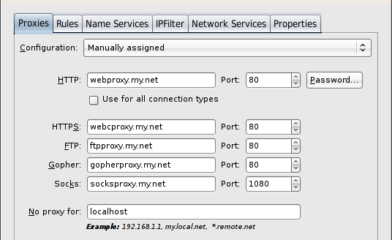
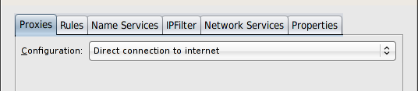
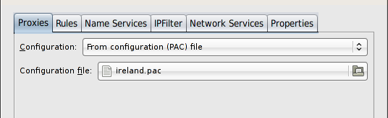
If no proxy is required for this location, select Direct connection to internet from the Configuration dropdown. This is the default setting for new locations. No other controls are visible on the tab when this setting is chosen.
If proxies are required, they can be configured manually or from a proxy configuration (.pac) file.
To manually assign a proxy:

- Choose Manually assigned from the Configuration dropdown, and fill in the HTTP proxy hostname (default is blank) in the HTTP field, and port number (default is 80) in the Port field.
- If the HTTP proxy requires authentication, click Password to open a dialog where you can enter a username and password:
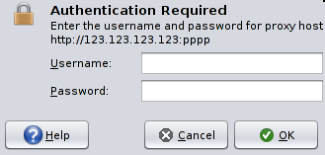
- To use the same proxy host and port number for all other services, check the Use for all connection types checkbox. The HTTPS, FTP, Gopher and Socks text fields and spinboxes are populated with the same information as in the HTTP field and spinbox, and are greyed out to disallow editing. Unchecking the box re-enables the controls, and replaces their contents with their last contents before Use for all connection types was checked. You can now enter a proxy host and port number for each connection type individually.
- To bypass the proxy for connections to certain hosts, enter their names or IP addresses in the No proxy for field, separated by spaces or commas. yntax as per equivalent Firefox dialog.
To use a proxy configuration file:
- Choose From configuration (PAC) file from the Configuration dropdown. The only other control now visible will be a file chooser button (default selection: the last-selected PAC file, or (None) if no file has previously been chosen). Clicking the button opens a standard gtk file chooser dialog, filtered on .pac files.

Location Preferences: Rules
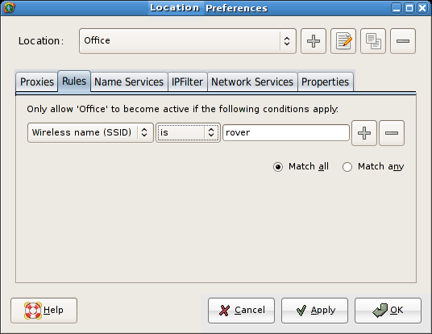
This tab allows the user to influence the conditions under which a particular location becomes active.
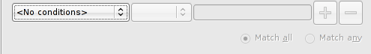
Initial state is:
Condition is added by selecting IP Address, Domain Name, Wireless Name (ESSID) or Wireless BSSID from the first dropdown. At this point, the second combo, text field, Add and Remove buttons become sensitive.
Contents of second combo depends on first:
- Connection: <VanityName(PhysName), selected from list of all available>: is active/is not active
- VPN: <list of defined ENMs>: is active/is not active
- IP Address: is, is not, is in range, is not range : <ipaddr>[/prefixlen]>
- Domain name: is, is not, contains, does not contain: <string>
- Wireless name: is, is not, contains, does not contain: <string>
- Wireless BSSID: is, is not: <string>
Add button adds a new row of condition controls. The first combo in the second and subsequent rows does not contain the <No conditions> entry; the default is IP Address. When more than one row is present, the Match All and Match Any radiobuttons become available.
Remove button removes the associated row of controls. When there is only one row left, its Remove button resets the dialog to the initial state shown above.

Location Preferences: Name Services
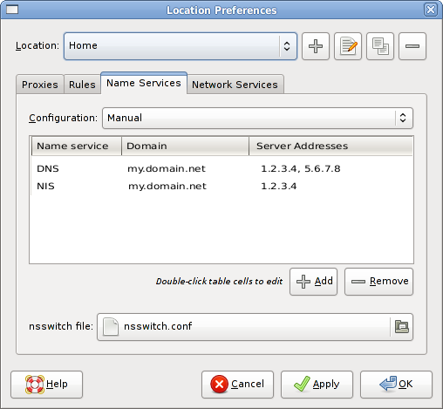
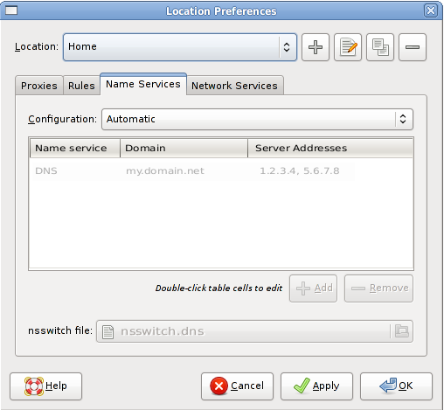
Allows you to configure name services in the specified location. Configuration dropdown allows you to choose between Automatic and Manual.
Automatic mode uses dhcpinfo to determine which name server/service is being used, and installs an appropriate nsswitch.conf file. When selected, the list, Add/Remove buttons, and nsswitch file selection button are disabled. The list, although inactive, shows the details of the automatically-detected configuration, for diagnostic purposes.
Manual mode allows you to add name service information manually. The list, Add/Remove buttons, and nsswitch file selection button are enabled.
The table is an editable table as defined on p7. The input type for each cell is as follows:
- Name Service: a popup menu containing the options DNS, NIS, NIS+, and LDAP.
- Domain: a text field into which a domain name is entered.
- Server Addresses: text field into which one or more IP addresses are entered, separated by commas or spaces.
- Search Domains: text field into which one or more DNS search domains are entered, separated by commas or spaces. Only editable if the Name Service on this row is “DNS”, otherwise blank.
Nsswitch File is a file selection button that allows you to choose the configuration file into which your manual name service configuration is stored. Default is /etc/nsswitch.conf.

Location Preferences: IPFilter
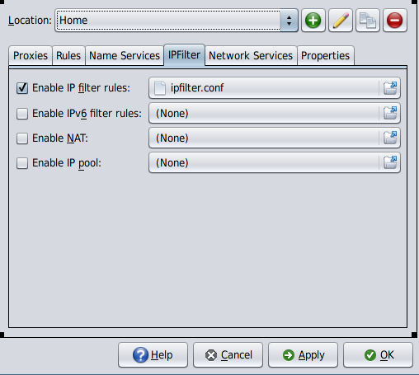
Allows you to enable various IP filter features in the selected location. A valid configuration file is required to enable each feature. All four features are disabled by default.
Each of the four features is enabled/disabled in the same way:
- When you check a box, the corresponding file chooser button is enabled. If no configuration file is currently associated, a file selection dialog is opened immediately, allowing you to choose the configuration file. Otherwise, the existing associated file will be used until you click the file chooser button.
- When you uncheck a box, the corresponding file chooser button is disabled, but the configuration file associated with the feature is remembered and remains visible in the disabled control.
No changes are made to running IP Filter services until you click the Apply or OK button.

Location Preferences: Network Services
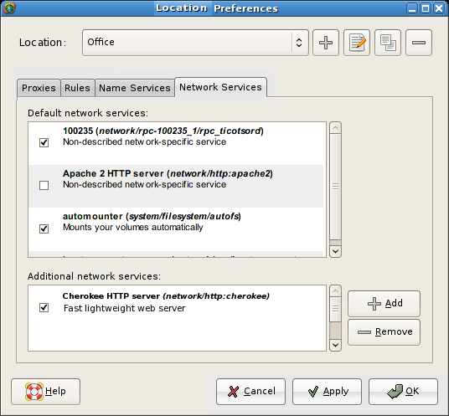
Default network services: list format is same as that in the existing GNOME Services preferences window, except that icons are not shown as we don't believe they're useful/feasible. Checkbox indicates whether each service is enabled.
List of default enabled/disabled services is TBD; the document specifying the final list will be referenced here.
Click Add to add a network service that is not on the default list to the Additional network services list. Dialog (TBD) opens presenting a list of network services that are available to be added.
Click Remove to remove a network service from the Additional network services list.

Location Preferences: Extensible Properties
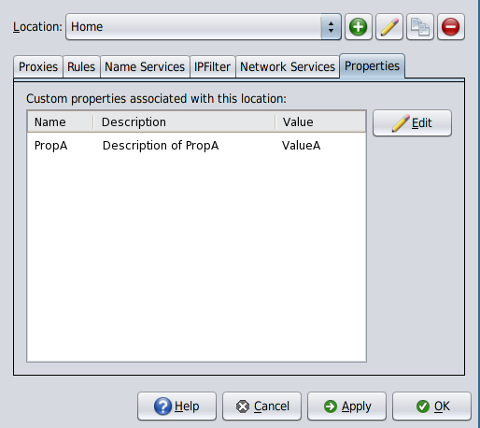
Allows you to edit the value of any extensible properties defined for this location. (It does not allow you to create or delete extensible properties, or to edit their name or description.)
To edit a property, either double-click its entry in the table, or select the table row and click Edit.
A text field will appear in the Value cell of the table, into which you can type the new value for the property. Press Enter to confirm the new value, or Esc to cancel the change.

Add/Join/Edit Wireless Network
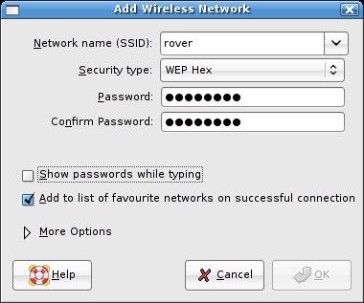
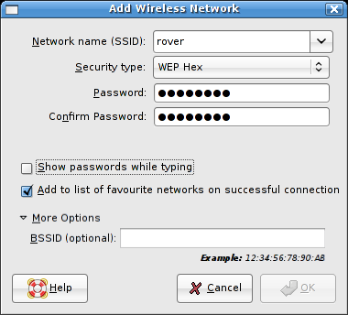
Manually opened by selecting Join Other Wireless Network..., or clicking Add or Edit in the wireless tab (p21). As much information as is already known about the network (its ESSID, and any previously-entered username and passwords that have been stored locally) will be pre-filled when the dialog appears. The titlebar text should be changed to “Join Wireless Network”, “Add Wireless Network” or “Edit Wireless Network” accordingly.
This dialog will also open automatically if any attempt is made to join a wireless network while any of the user's “Ask Before” criteria are satisfied (p21). The titlebar text should be changed to “Join Wireless Network” or “Add Wireless Network” accordingly.

Network Name (ESSID): The name of the wireless network to connect to. Editable combo box whose dropdown lists the currently available wireless networks.
Security Type: Dropdown list of supported security protocols. If connecting to an access point that is broadcasting its ESSID, its security type is pre-selected when the dialog opens or when the ESSID is entered in the field above. Password fields vary according to selection, see next page.
Show passwords while typing: If unchecked (default), typing will be masked in password fields. If checked, password field will be shown in plain text while it has focus, and revert to mask characters when focus is lost.
Add to favorite networks list: This checkbox is:
- Visible if the dialog is opened from the panel applet right-click menu, and the “Ask before adding any new network to favorites” checkbox in the connection's Wireless Connection Properties tab (p21) is also checked.
- Hidden if the dialog is opened from the panel applet right-click menu, and the “Ask before adding any new network to favorites” checkbox in the connection's Wireless Connection Properties tab is not checked.
- Hidden if the dialog is opened from the Add button on the Wireless Connection Properties tab
If the box is checked, the specified network is added to the user's preferred list once a successful connection is made.
More Options expander is initially collapsed. Expands to show:
- BSSID (optional): The MAC address of the access point to connect to. May be left blank.
OK button is disabled until a network name is entered.
When the user clicks OK, an alert is displayed if:
- The two passwords entered do not match
- The passwords match but are an invalid format/length
- A BSSID is provided but is an invalid format (should be MAC address format?)
When the alert is dismissed, the offending field is focused ready for input.

Add/Join/Edit Wireless Network (Cont'd.)
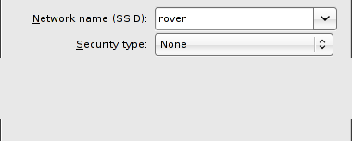
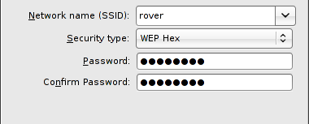
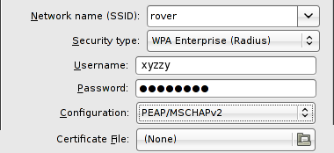
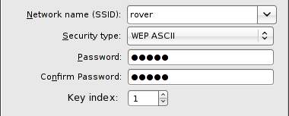
Security type None:
- Open network, no password fields displayed. Show passwords while typing field is disabled.
Security types WEP Hex and WPA Personal:
- Password: String required to join specified network, initially blank.
- Confirm Password: String required to join specified network, initially blank.(CFB: Not convinced the confirmation is useful, everyone's just going to copy and paste it anyway.)
Security type WEP ASCII:
- Password: 5- or 13-character passphrase required to join specified network, initially blank.
- Confirm Password: 5- or 13-character passphrase required to join specified network, initially blank.(CFB: Not convinced the confirmation is useful, everyone's just going to copy and paste it anyway.)
- Key Index: Which of the WEP keys generated from the passphrase should be used. Valid Range: 1-4.
Security type: WPA Enterprise:
- Username, Password: WPA username and password
- Configuration: LEAP or PEAP/MSCHAPv2
- Certificate File: Click to open a file chooser from which the certificate file can be selected (is there a file extension on which we could/should filter?). Only valid for PEAP/MSCHAPv2 configuration; button is disabled if LEAP configuration is selected.

Wireless Network Chooser
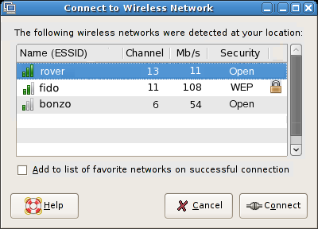
This dialog is shown if:
- A wireless connection is attempted when the user's favorite wireless networks list is empty
- No favorite networks have been found, and the Show available networks preference has been set on the wireless tab (p21).
The dialog is not shown if, in either case, no additional wireless networks are detected. (Unless we add a button for joining an unlisted network... might be useful.)
Wireless networks are listed in descending order of signal strength.
The Add to favorite networks list checkbox is shown only if the Ask before adding any networks to favorites preference is checked on the wireless tab (p21). If it is not checked, the network is not added to your favorites list upon connection.
Clicking Connect attempts to join the network immediately if no further input is required. Otherwise, the Join Wireless Network dialog (p31) is opened with the network's details pre-filled, to allow input of passwords etc.

VPN Preferences
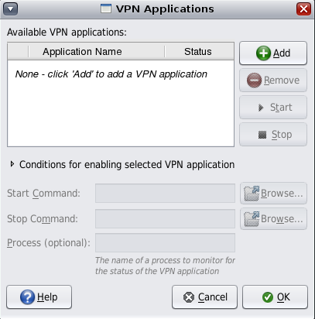
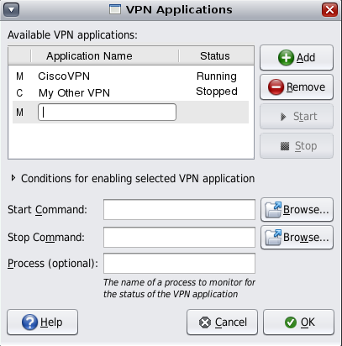
Open this dialog by clicking the VPN button on Connection Status tab (p14), or the VPN... menu item on the panel applet's right-click menu (p3). The main part of the dialog is a three column list, which shows, for each application:
- Activation state (manual or conditional) TBD: state shown by “M” and “C” here, may use icons instead
- User-defined name, e.g. “Cisco VPN”
- Current status, “Running” or “Stopped”
Default state is shown above left, when there no VPN applications have been added. Only the Add button is available.
Clicking Add switches focus to an embedded text field in the table, where the user can type a name for the new VPN application. At this point:
- Pressing Enter or Tab adds the new entry (of activation type Manual by default), enables the Start Command, Stop Command and Process fields, and moves focus directly to the Start Command field.
- Pressing Esc cancels the typing and no new application is added.
You can type the command that starts the VPN process into the Start Command text field, or look for it using the Browse button, which opens a file chooser dialog. The Start button remains disabled until a command has been typed into this text field.
You can type the command that starts the VPN process into the Stop Command text field, or look for it using the Browse button , which opens a file chooser dialog. The Stop button remains disabled until a command has been typed into this text field.
If the process given in the Start Command is not the one to be monitored for the status of the VPN application, you can enter the name of the process to be monitored here.
You can Remove any application from the list by selecting it, then clicking Remove.
You can start a VPN application manually by selecting it in the list, then clicking Start. The Start button is only enabled for applications that are not currently running, and whose activation type is Manual.
You can stop a VPN application manually by selecting it in the list, then clicking Stop. The Stop button is only enabled for applications that are not currently running, and whose activation type is Manual.
(Cont'd.)

VPN Preferences (Cont'd)
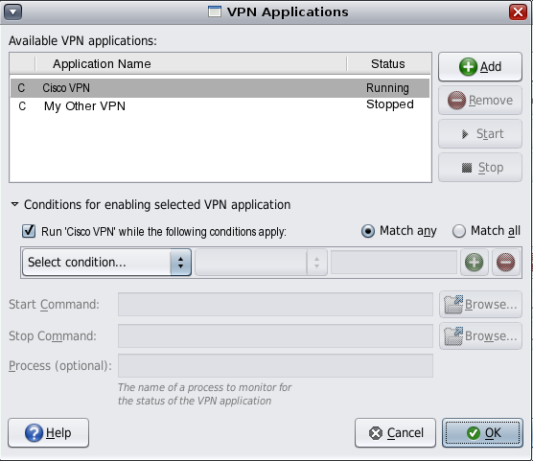
The Conditions for enabling selected VPN application expander is collapsed by default when the dialog is opened. You can expand it manually by clicking the arrow, or automatically by selecting a conditional VPN application in the list. If the arrow was last expanded by selecting a conditional VPN, it collapses again when you next select a manual VPN. However, if you manually expand the arrow, it remains expanded until you manually collapse it again, or until the dialog is closed.
When expanded, the Conditions for enabling selected VPN application panel shows the rules used to determine whether the application should run or not. This is a standard Rule Construction Component as described on p11. The available conditions are:
- Domain Name, [is|is not|contains|does not contain], <string>
- IP Address, [is | is not | is in range | is not in range ], <string>
- Location, [is|is not], [list of defined locations]
- Network Interface, [list of available network interfaces], [is active | is not active]
- VPN Application, [list of ENMs], [is running | is stopped ]
- Wireless ESSID, [is|is not|contains|does not contain], <string>
- Wireless BSSID, [is | is not], <string>
The Run <application> while the following conditions apply checkbox is checked by default. In this state, the selected VPN application will be started when the conditions are met, and stopped when the conditions are no longer met.
When the checkbox is unchecked, the VPN application is effectively disabled, and will never be run.

