Storyboards: Out of Box Experience – Wired
(Needs updating and expanding to reflect latest spec changes-- esp. Notification wording)
Plugs a cable into net0. The default Automatic location attempts a DHCP connection. Panel icon animates while connection is pending. If connection is successful, you are notified via panel notification area:
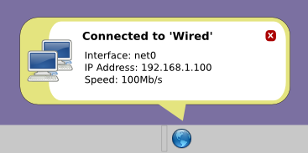
Unplug the cable from net0. Another notification message acknowledges:
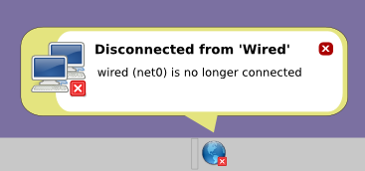
If the wired network to which you are connected becomes unavailable, another notification message acknowledges:
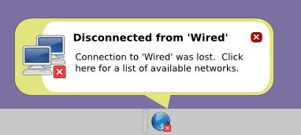

Storyboards: Out-of-box experience - Wireless
(Needs updating and expanding to reflect latest spec changes-- esp. Notification wording)
NWAM tries to connect to wireless access points in the order they appear on the preferred list (p). Since you have no favorite networks yet, by default you get to choose manually, via a popup window (p):
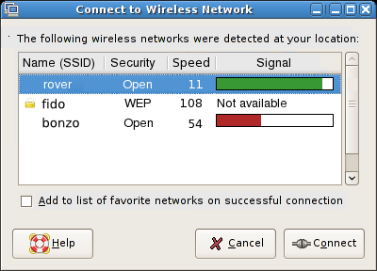
If you select a secured network to connect to, dialog pops up asking for authentication details.
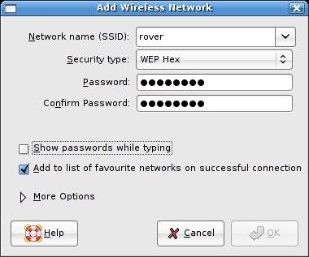
Once entered, password details are saved securely so they need not be entered again unless they change.
Panel icon animates while connection is pending. If connection is successful, you are notified via panel notification area:
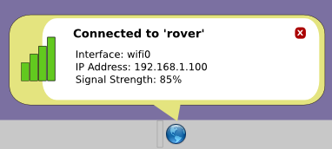
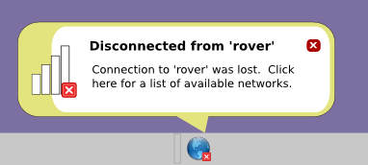
If the active wireless network becomes unavailable (e.g. signal is lost), you are notified via panel notification area:

Storyboards: Automatic Location Change
(Needs updating and expanding to reflect latest spec changes-- esp. Notification wording)
If you have defined more than one NWAM Location, you are informed whenever the location is automatically detected or changed.
The message indicates which location has been detected, and which connection(s) within that location NWAM is attempting to activate. Icon animates while connection is pending.
Clicking this balloon opens the Location Preferences dialog (p), with the current Location pre-selected.
