NWAM GUI Specification, Draft 1.5.1
Calum Benson
11/01/08

Table of Contents
Panel Icon 2
Panel Icon – Animation and Notifications 4
Changes required to GNOME Network Monitor Applet 5
Network Preferences Window : Overview 6
Network Preferences – Status View 7
Network Preferences: Network Configuration 8
Network Preferences : Network Configuration (cont'd.) 9
Network Preferences: Connection Properties: IP Address 10
Connection Properties: IP Address: IPv4 11
Connection Properties: IP Address: IPv6 12
Connection Properties: Wireless 13
Connection Properties: Wireless (cont'd) 14
Location Preferences: Overview 15
Location Preferences: Proxies 17
Location Preferences: Rules 18
Location Preferences: Name Services 19
Location Preferences: Network Services 20
Add/Join/Edit Wireless Network 21
Add/Join/Edit Wireless Network (Cont'd.) 22
Wireless Network Chooser 23
VPN Preferences 24

Panel Icon
The Location panel icon is shown inthe panel's status notification area at all times, and is the primary means by which you will interact with NWAM on a day-to-day basis. It is the focus for information messages about changes to your network status, and its menu allows quick access toessential network functionality.
The icon's appearance indicates the overall health of the network (problems indicated by an emblem overlaid on the icon)
 | All enabled connections in the current location are diconnected
 | One or more (but not all) enabled connections in the current location are connected; the others are disconnected or pending
 | All enabled connections in the current location are connected
When the mouse is over the icon, the tooltip shows the name of the currently active location and the status of enabled connections. Connection names are shown here (and elsewhere) in the format Vanity Name (Device Name). If no vanity name has been defined by the user, an appropriate default is used: “Wired N” for wired NICs (where N is not shown for the first wired NIC, and >=1 for susbequent NICs), or “Wireless N” for wireless NICs (again, N is either not shown or >=1). In later phases, “Tunnel”, “Bluetooth”, “Modem” etc. might be other possible default vanity names.
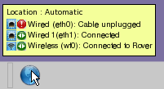
Clicking the panel icon opens the Location Preferences dialog (p15). Right clicking the icon pops up its context menu-- a rescan of available wireless networks is performed before posting. May need to reconsider if this typically takes longer than 1 second.

Panel Icon – Context Menu
This menu is posted by right-clicking the panel icon.
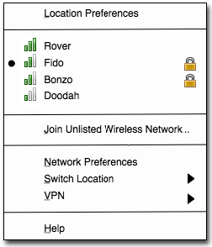
The function of the menu items is as follows:
- Location Preferences opens the Location Preferences dialog (p15).
- The next section of the menu is a combined list of available favorite networks (p13), and other currently available networks that are broadcasting their ESSID. The list is ordered by current signal strength, strongest first. Format is signal strength indicator, ESSID, secure/open indicator (right-aligned). Additionally, any network to which you are currently connected is indicated with a radio button indicator to the left of the signal strength indicator.
If no networks are available to be listed in this section, a single disabled menu item is shown: “No wireless networks detected”
Selecting the ESSID of a network to which you are not currently connected attempts to connect to that network. If connection fails, you are re-connected to your previous wireless network, if any. This manual switching of networks does not affect any stored network configuration, and lasts until the next manual or automatic switch of locations occurs. [CFB: If you have more than one wireless NIC available, a dialog should appear (TBD) asking you to choose which one to use for the new connection. Probably too much of a corner case for Phase 1, though]
Selecting the ESSID of a network to which you are already connected has no effect.
- Join Unlisted Wireless Network... opens the Join Wireless Network dialog (p21) with no details pre-filled, to allow you to connect to a network that is not broadcasting its ESSID. Once connected to any such network, it appears on this context menu in the list of favorite and available networks. If the network was not added to the list of favorites when connecting, it will disappear from this list again at the next disconnection.
- Network Preferences opens the Network Preferences dialog (p6).
- Switch Location submenu lists (with radio button menu items)the defined locations in alphabetical order, with the current location selected.
Select another location from the menu to switch to it.
* Automatic
Home
Office
- VPN submenu has one menu entry for each VPN application defined in the VPN Preferences dialog (p24) if any, in the same order as they are defined there, followed by a VPN Preferences menu item. E.g:
The entry for each script is Start <name> for VPN apps that are not running, and Stop <name> for those that are. The VPN Preferences menu item is always available and opens the VPN Preferences dialog (p24).
Start CiscoVPN
Stop Punchin

VPN Preferences
- Help opens the help browser at a page appropriate to this context menu.

Panel Icon – Animation and Notifications
As well as the panel icon's appearance and tooltip giving you a summary of the current status of the network location, notification messages will alert you when the status changes significantly:

Animation
The panel icon should animate (simply, perhaps 2or 4 frames/sec) when a status change is pending but not complete, in particular when:
- a scan for available wireless networks is in progress
- an attempted connection to a wired or wireless network is in progress but not yet established
This animation should be controlled by the /desktop/gnome/interface/enable_animations gconf key so that sysadmins can turn it off for thin clients etc.

Notification
A notification message balloon appears when a significant change of network status occurs. All balloons are shown for the system default length of time before disappearing again. (The examples below are not visually indicative of the final appearance of the balloons, which should include an icon and a close button, and be coloured according to the user's current theme).
- A wired or wireless connection is established. For wired networks, the primary text is “vanityname is connected”. For wireless networks, the primary text is “Connected to ESSID”. Secondary text shows the real device name, Ipv4 and/or Ipv6 address obtained, connection speed, and (for wireless networks) signal strength.
- A wired or wireless connection is disconnected. For wired networks, the primary text is “vanityname is disconnected”. For wireless networks, the primary text is “Disconnected from ESSID”. The secondary text gives the reason for the disconnection. For wireless networks, the message is clickable, which opens the wireless network chooser dialog (p23):
'Wired' is connected
Interface: net0
Address: 192.168.1.100
Speed: 100 Mb/s
Connected to 'Rover'
Interface: wifi0
Address: 192.168.1.100
Speed: 11 Mb/s
Signal Strength: 85%
- The location has changed. Primary text is “Switched to location Name”. The secondary text is “Now configuring your network”.
'Wired' is disconnected
Cable unplugged
Disconnected from 'Rover'
Wireless signal lost.
Click here to join another
wireless network.
- No wireless networks are detected. This is shown following a switch to a location with an enabled wireless NIC, when the initial scan reveals no available wireless networks for it to connect to. Clicking the balloon opens the Join Wireless Network dialog (p21), to allow the user to join a network that is not broadcasting is ESSID.
Switched to location 'Office'
Now configuring your network
- A wireless network has been automatically added to your favorites list. Automatic addition of networks can be over-ridden by the 'Ask before' preference in the Wireless tab (p13). Clicking the balloon opens this tab.
No wireless networks detected
Click here to join an unlisted
wireless network.
Wireless network 'Rover' added to favorites
Click here to view or edit your list of favorite
wireless networks.

Changes required to GNOME Network Monitor Applet
This NWAM design is largely independent of the exsiting Network Monitor (aka gnome-netstatus) panel applet, which has existed in GNOME and JDS for some time. Users are still free to add and remove netstatus applets as they wish in the usual way, to monitor individual connections:

One desirable change to the gnome-netstatus applet might be for its Properties menu item to open the appropriate connection properties view in NWAM's Network Preferences dialog (p6), rather than its own Properties dialog.
A desirable enhancement would be to get the applet's signal strength indicator working for wireless NICs; this currently only works on Linux:

Network Preferences Window : Overview
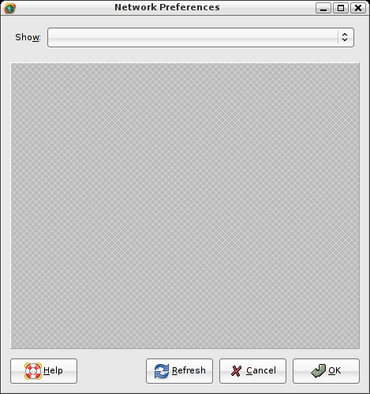
You open this dialog by either:
- Selecting Launch->Administration->Network (currently launches network-admin)
- Right-clicking the panel applet and selecting Network Preferences
The Show dropdown list comprises Connection Status, Network Configuration, and a list of all currently-defined connections. Connection names are shown in the format described on p2, e.g.:
Default view is Connection Status (p7)
Connection Status
Network Configuration

Wired (hme0)
Wired 1 (hme1)
Wireless (bcm0)
Selecting Connection Status from the dropdown list switches to the Connection Status View (p7)
Selecting Network Configuration switches to the Network Configuration View (p8)
Selecting a connection name from the dropdown list, or double-clicking it in connection status view, switches to the Connection Properties View (p10)
Refresh causes the NWAM subsystem to be refreshed, wireless networks rescanned, and the dialog updated if required.
Cancel closes the dialog without applying any pending changes.
OK closes the dialog and applies any pending changes, causing the NWAM subsystem to be refreshed.

Network Preferences – Status View
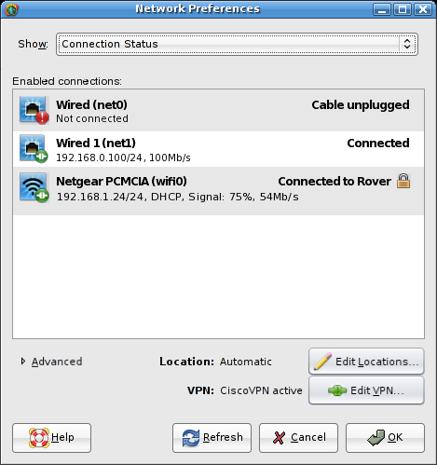
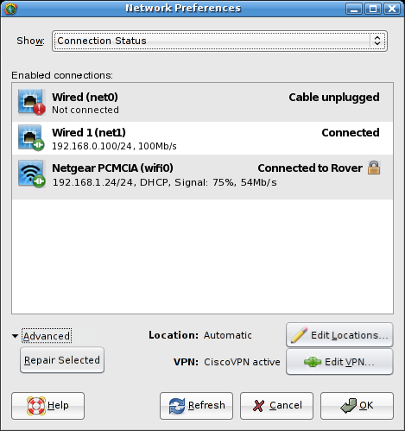
Show this view by selecting Connection Status in the dropdown list at the top. Shows information about each enabled connection in the NCP, as configured in the Network Configuration view (next page). Connections disabled there are not shown here.
Enabled Connections lists enabled connections in the same order as in the Network Configuration View (p8); that is, the order in which connections are attempted. The order cannot be changed here however, this functionality is only in the Network Configuration View.
Bold text for each connection shows vanity name, followed by the interface name in parentheses. Current status is shown on the same line, right-aligned. Suggested status messages (depends on exactly what statuses we can be informed about, but the more specific the better):
- Connecting... : A wired link is coming up but is not yet connected.
- Connected : A wired link is up and running.
- Connecting to ESSID... : A wireless link is attempting to connect to ESSID. ESSID should be followed by the 'secure' icon if the network employs WEP, WPA or other security.
- Connected to ESSID : Wireless link is up an running on network ESSID. ESSID should be followed by the 'secure' icon if the network employs WEP, WPA or other security.
- Network unavailable : E.g. if DHCP server or default gateway cannot be contacted.
- Cable unplugged : if wired link is enabled but cable is unplugged.
Secondary text for each active connection:
- “Not connected” for disconnected wired or wireless interfaces
- Address: [[Ipv4 address | Ipv6 link local address] / CIDR subnet mask], or “Multiple Addresses”; “DHCP” if applicable, “Signal: n%” for wireless NICs, connection speed.
Icon (final design TBD) indicates type of connection (wired or wireless; in later phases, tunnel, aggregation etc.) and current status (connected/disconnected for wired or wireless, plus signal strength and security type for wireless).
Double-clicking a connection switches the status view to that connection's properties view (p10)
Current Location shows the currently active location. Edit Locations... button opens the Location Preferences dialog (p15)
VPN lists any currently-running VPN applications, e.g. “CiscoVPN active”, “N active” (n>=2) if two or more applications are running, or “None active”. Edit VPN... button opens the VPN configuration dialog (p24) where such scripts can be configured, started and stopped.
Advanced expander, collpased by default, reveals a Repair Selected button that is enabled for interfaces that are reporting connectivity problems (except those for which the cause is physical, e.g. unplugged cable). Clicking the button attempts to re-establish the connection by whatever means available, e.g. renewing the DHCP lease.

Network Preferences: Network Configuration
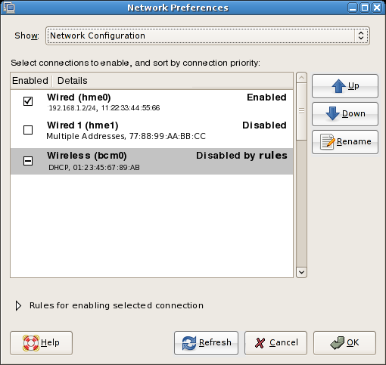
Show this view by selecting Network Configuration in the dropdown list at the top. View shows the current network configuration profile (of which there is only one per location, in Phase 1).
List is re-orderable by drag and drop, or by using the Up and Down buttons to move the selected item. The order reflects the order in which connection is attempted, when required.
Checkbox beside each connection is clickable, behaviour as follows:
- If no conditions are enabled for the connection (see next page), the checkbox simply toggles the enabled/disabled state of the connection, indicated by the presence or absence of a check mark).
- If conditions are enabled for the connection, clicking the checkbox cycles its state between “conditional” (indeterminate), “enabled” (checked) and “disabled” (unchecked).
Bold text for each connection shows vanity name of connection, followed by the interface name in parentheses, followed by current status. Status is “Enabled”, “Disabled”, “Enabled by rules”, or “Disabled by rules”.
Secondary text for each connection:
- Address: [[Ipv4 address | Ipv6 link local address] / CIDR subnet mask], or “Multiple Addresses” if static; “DHCP” if applicable; MAC address.
Double-clicking a connection switches the status view to that connection's properties view (p10).
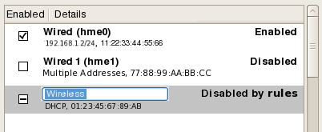
To change a connection's vanity name, select it and click Rename. This opens an embedded text field in the list, the contents of which are the current (possibly default) vanity name. Text is selected, ready for overtyping:
Specify a new vanity name by entering new text and pressing Return. Press Esc to dismiss the text field with no changes to the vanity name.

Network Preferences : Network Configuration (cont'd.)
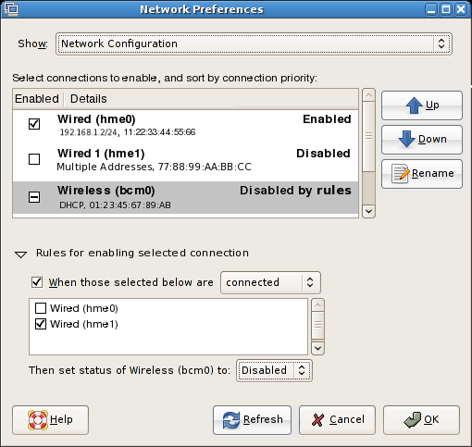
The Rules for enabling selected connection expander is in the collapsed state by default when the dialog is opened. You can expand it manually by clicking the arrow, or automatically by selecting a connection that has associated rules (active or otherwise). If the arrow was last expanded automatically, and you select a different connection with no rules, it collapses automatically again. However, if you manually expanded it, then it stays expanded or collapsed regardless of the selection in the list, until the dialog is closed.
When expanded, the Rules for enabling selected connection controls show any s used to determine the enabled state of the selected connection in the NCP. For example, if the NCP comprises a mixture of wired and wireless NICs, a rule is enabled by default for each wireless NIC that disables it should any wired NICs be connected.
When those selected below checkbox: check or uncheck this to activate or disable the rules for the selected connection. A connection with an active rule is represented in the main connection list by its checkbox being in the indeterminate state (usually shown as a “-”, but depends on the GNOME theme). A connection with an inactive rule is represented in the main connection list by a checked or unchecked box, indicating that the connection is unconditionally enabled or disabled.
Connected/Disconnected dropdown: determines whether the rule is dependent on the selected connection being “connected” or “disconnected”. The dropdown is disabled if the When those selected below checkbox is unchecked.
Connection checkbox list: lists all connections (except the selected connection). The status of checked connections is taken into account when evaluating the rule. Unchecked connections are ignored when evaluating the rule. The list is disabled if the When those selected below checkbox is unchecked.
Set status dropdown: specifies whether the selected connection should be conditionally “enabled” or “disabled”. The dropdown is disabled if the When those selected below checkbox is unchecked.

Network Preferences: Connection Properties: IP Address
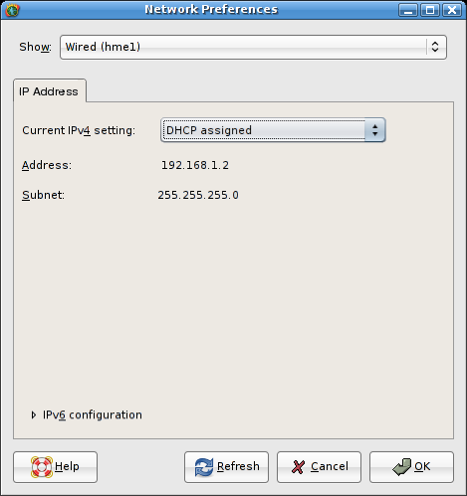
When you select a connection from the Show dropdown, a tabbed view appears allowing the user to edit the properties of that connection. The IP Address tab is one of those tabs, present for both wired and wireless NICs.
The Current Ipv4 Setting dropdown comprises the options DHCP assigned, Manually assigned, and Multiple addresses. The contents of the area between the dropdown list and the Configure Ipv6 expander change dynamically depending on the selection. See next page for details.
The Ipv6 configuration expander is collapsed by default if Ipv6 is disabled for this interface, and expanded by default if Ipv6 configuration is enabled. See p for details.

Connection Properties: IP Address: IPv4
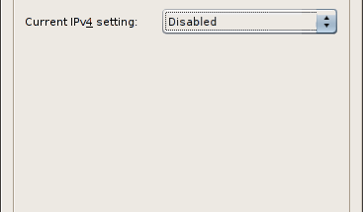
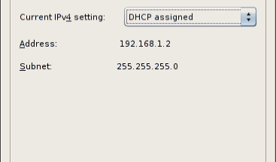
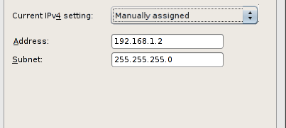
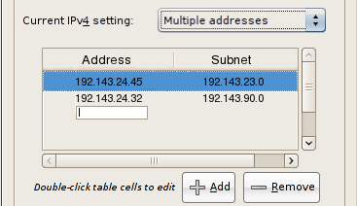
Disabled: No IPv4 address is assigned to this NIC.
DHCP assigned: when this option is selected, the Address and Subnet fields are provided by the router and shown as static labels.
Manually Assigned: when this option is selected, the Address and Subnet fields are editable. Their syntax is checked when you switch to a different tab, click OK, or select a different item from the Show dropdown at the top of the dialog. An appropriate alert is shown if any of the fields are invalid. Dismissing the alert focuses the offending field ready for input.
Multiple Addresses: When there are no existing addresses to display, the list shows “None – click Add to add an IP address”. When the user clicks Add, a text field is opened in the first row's Address column. Thereafter, the behaviour is as follows:
- Type an address and press Enter or Tab; the text field is replaced by its static text equivalent, and the embedded text field “moves” to the Subnet column. Alternatively, press Esc to cancel Address entry and restore the list to its previous state.
- Type a subnet and press Enter or Tab; the text field is replaced its static text equivalent, and the embedded text field “moves” to the Address column on the next row. Alternatively, press Esc to cancel subnet entry, and “move” the text field back to the Address column. The contents of the text field would be the existing address.
At any time, you can edit the contents of a cell containing static text by double-clicking to open an embedded text field. Only one embedded text field can be visible at once, however.
Delete an address by clicking once anywhere in the row to select/highlight, then clicking Delete button.
Address/subnet syntax is checked when you switch to a different tab, click OK, or select a different item from the Show dropdown at the top of the dialog. An appropriate alert is shown if any of the fields are invalid. Dismissing the alert focuses the offending field ready for input.
When switching between DHCP assigned, Manually assigned and Multiple addresses views, any data entered is remembered in case you later switch back to that view. This data is also remembered between sessions.

Connection Properties: IP Address: IPv6
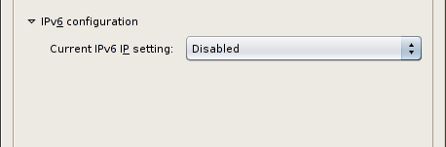
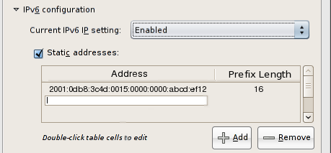
Disabled: No IPv6 address is assigned to this NIC.

Enabled: when this option is selected, the NIC attempts to obtain an Ipv6 address from the router.
Static Addresses: When checked, the table below is enabled to allow assignment of additional, manual Ipv6 addresses to the NIC. When unchecked, the table is disabled but remains visible. The editing behaviour is equivalent to that detailed on the previous page for multiple Ipv4 addresses.

Connection Properties: Wireless
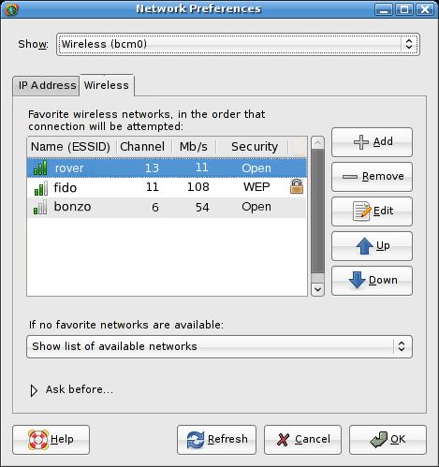
This tab only appears for wireless NICs.
The list shows your current favorite networks, in the order in which any automatic connection will be attempted. First column shows signal strength and name (ESSID). Second column shows wireless channel, third column shows speed, fourth column shows security type with right-aligned 'secure' icon for secure networks. List is re-orderable using drag and drop, or the Up and Down buttons.
If no favorite networks found dropdown gives choice of what to do if no preferred wireless networks are available:
- Show list of available networks: will open the wireless network chooser dialog (p23) to ask which other network to join.
- Join an open network: will attempt to join any available unsecured wireless network (strongest signal first?). If the Ask before joining a new open network preference is checked (see next page), you will be asked to confirm before joining.
- Remain offline: will not attempt to join any wireless network until any new networks are detected, or the location changes.
Add opens the Add Wireless Network dialog (p21), but with its Add to favorite networks checkbox hidden.
Remove deletes the selected network from the list, after confirmation alert.
Edit opens the Edit Wireless Network dialog (p21), retitled Edit Wireless Network, preloaded with the the selected network's details, and with its Add to favorite networks checkbox hidden. Disabled if no network is selected in the list.
Up/Down buttons move selected network up/down in the list. Up is disabled when selected network is at already at the top, likewise Down is disabled when selected network is already at the bottom.

Connection Properties: Wireless (cont'd)
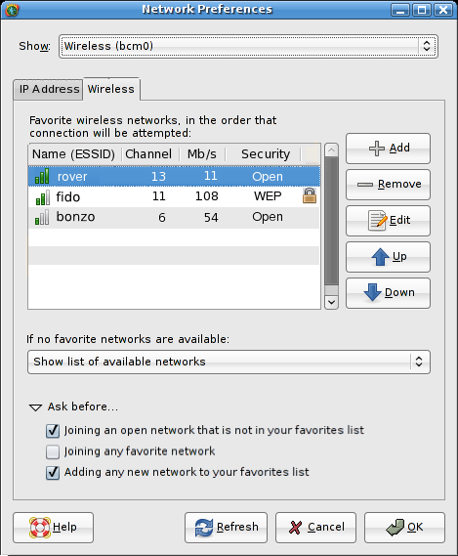
Ask Before expander is collapsed by default. Contains the following preferences:
- Joining an open network that is not in your favorites list: Ask before joining an open network that is not on the favorites list; default value=yes. If checked, causes the Join Wireless Network dialog (p21) to appear when such a connection is attempted, pre-filled with the network's name and security type (which is always “None” in this case). If unchecked, open networks are joined as required with no interaction necessary.
- Joining any favorite network: Ask before joining a network (open or secure) that is on the preferred list; default value=no. If checked, causes the Join Wireless Network dialog (p21) to appear when such a connection is attempted, pre-filled with the network's name, security type and any saved password information. If unchecked, favorite networks are joined automatically as required, provided any necessary credentials have previously been entered and saved.
- Adding any new network to your favorites list: If checked, causes the Add to favorite networks checkbox to appear in the Add Wireless Network (p21) and wireless network chooser dialogs (p23), whenever they are shown. If unchecked, new networks will be added to the favorites list automatically on first connection, with no interaction necessary (a notification balloon will tell you when this has happened). Default value=yes.

Location Preferences: Overview
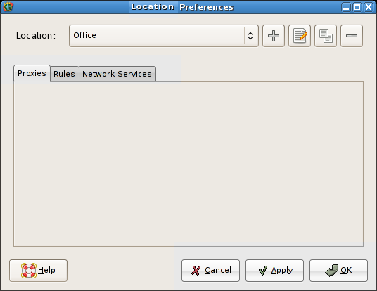
Open this window by choosing Location Preferences from the panel applet's right-click menu, or from Launch->Preferences->Locations.
When the window is opened, the Location dropdown indicates the currently active location. To force a switch to a different location, select it from the dropdown, and click OK. (How long will the delay be before the new location takes effect? If it's more than a second or two, may need some sort of progress indication while the switchover happens).
To edit the properties of a location, select it from the dropdown if required, and make the required changes on the tabs. Click Apply to submit all pending changes and leave the window open. Click OK to submit the changes and dismiss the dialog. (Note: clicking Apply or OK will also force a switch to the location selected on the Location dropdown. This is a bit ugly, but it's also how the Mac does it, and the alternatives I can think of aren't really any better: an alert when you click Apply/OK asking if you want to switch or not, or some sort of 'edit mode' checkbox in the dialog which , if checked, didn't do the switch when you clicked Apply/OK.)
The four buttons to the right of the dropdown are Add, Rename, Duplicate and Remove. All have tooltips.
To add a new location with default settings, click the Add button. A new location will be created with the name “Unnamed Location N”, where N is not shown for the first unnamed location, and is the lowest numerical value >=1 that would make the location name unique otherwise. The new location is selected in the dropdown, and the Rename dialog (see below) is popped up automatically to allow immediate renaming.
To rename the current location, click the Rename button. The rename dialog pops up, with the current name in the field, preselected to allow immediate overtyping:
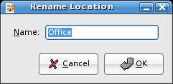
The Rename button is disabled when the default Automatic location is selected, because the Automatic location is not editable. You can duplicate it and rename the copy, however.
To duplicate the currently-active location, click the Duplicate button . A new location will be created with the name “Copy of $LOCATION” if that name is unique, otherwise “Copy of $LOCATION N” where N is the lowest numerical value >=1 that would make the location name unique). The new location is selected in the dropdown, and the Rename dialog (see above) is popped up automatically to allow immediate renaming.
To delete the current location, click the Remove button. A confirmation alert appears:
The Remove button is disabled when the Automatic location is selected, as the Automatic location cannot be deleted.
Remove location '$LOCATION'?

This operation cannot be undone.

[ Cancel ][ Delete ]
Tabs are Proxies, Rules, Name Services (TBD) and Network Services, covered on following pages.
You are not allowed to edit the system default location (called Automatic). Rather than disabling the majority of the dialog when this location is selected, however, the controls remain enabled and editable. When you click OK or Apply, an alert box is displayed explaining that the Automatic location is not editable:
Clicking Duplicate creates a new location with the default name “Copy of Automatic N” (see above for value of N).
Default location 'Automatic' is not editable
You can create a copy of this location that includes your
changes, or discard the changes you made to this location.

Pending changes to other location will still be applied.

[ Discard Changes ][ Duplicate]
Clicking Discard Changes discards any changes you attempted to make to the Automatic location. Any pending changes in other locations will still be applied, however.

Location Preferences: Proxies
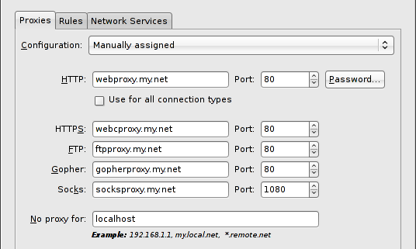
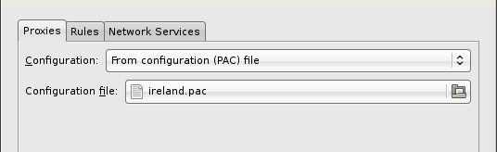
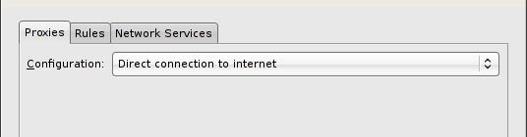
If no proxy is required for this location, select Direct connection to internet from the Configuration dropdown. This is the default setting for new locations. No other controls are visible on the tab when this setting is chosen.
If proxies are required, they can be configured manually or from a proxy configuration (.pac) file.
To manually assign a proxy:
- Choose Manually assigned from the Configuration dropdown, and fill in the HTTP proxy hostname (default is blank) in the HTTP field, and port number (default is 80) in the Port field.
- If the HTTP proxy requires authentication, click Password to open a dialog where you can enter a username and password:
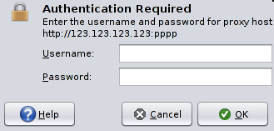
- To use the same proxy host and port number for all other services, check the Use for all connection types checkbox. The HTTPS, FTP, Gopher and Socks text fields and spinboxes are populated with the same information as in the HTTP field and spinbox, and are greyed out to disallow editing. Unchecking the box re-enables the controls, and replaces their contents with their last contents before Use for all connection types was checked. You can now enter a proxy host and port number for each connection type individually.
- To bypass the proxy for connections to certain hosts, enter their names or IP addresses in the No proxy for field, separated by spaces or commas. yntax as per equivalent Firefox dialog.
To use a proxy configuration file:
- Choose From configuration (PAC) file from the Configuration dropdown. The only other control now visible will be a file chooser button (default selection: the last-selected PAC file, or (None) if no file has previously been chosen). Clicking the button opens a standard gtk file chooser dialog, filtered on .pac files.

Location Preferences: Rules
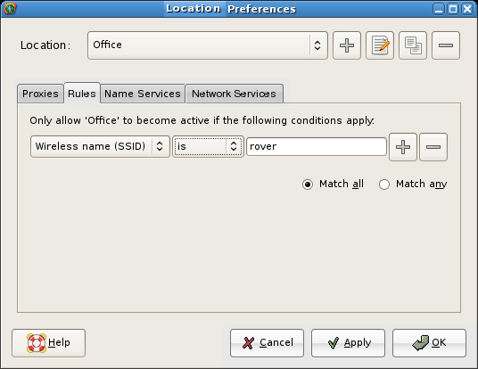
This tab allows the user to influence the conditions under which a particular location becomes active.
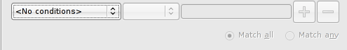
Initial state is:
Condition is added by selecting IP Address, Domain Name, Wireless Name (ESSID) or Wireless BSSID from the first dropdown. At this point, the second combo, text field, Add and Remove buttons become sensitive.
Contents of second combo depends on first:
- IP Address: is, is not, in range
- Domain name: is, is not, contains, does not contain
- Wireless name: is, is not, contains, does not contain
- Wireless BSSID: is, is not
Add button adds a new row of condition controls. The first combo in the second and subsequent rows does not contain the <No conditions> entry; the default is IP Address. When more than one row is present, the Match All and Match Any radiobuttons become available.
Remove button removes the associated row of controls. When there is only one row left, its Remove button resets the dialog to the initial state shown above.

Location Preferences: Name Services
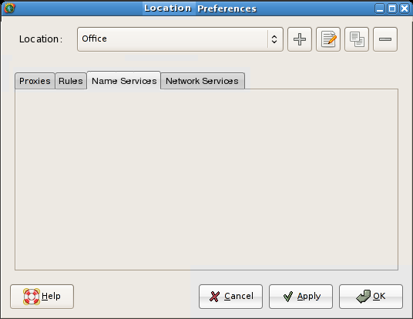
TBD: It's not currently clear what this tab needs to provide, to integrate with the Duckwater project.

Location Preferences: Network Services
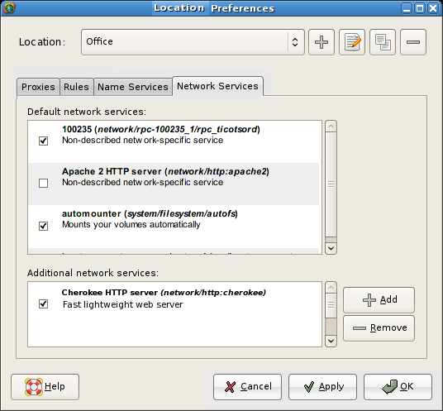
Default network services: list format is same as that in the existing GNOME Services preferences window, except that icons are not shown as we don't believe they're useful/feasible. Checkbox indicates whether each service is enabled.
List of default enabled/disabled services is TBD; the document specifying the final list will be referenced here.
Click Add to add a network service that is not on the default list to the Additional network services list. Dialog (TBD) opens presenting a list of network services that are available to be added.
Click Remove to remove a network service from the Additional network services list.

Add/Join/Edit Wireless Network
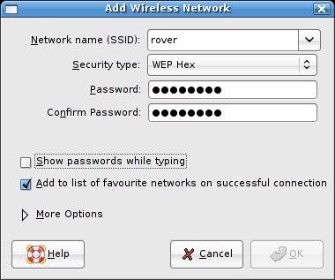
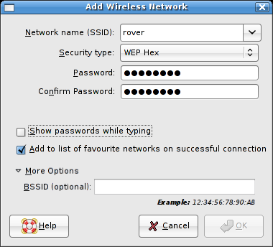
Manually opened by selecting Join Other Wireless Network..., or clicking Add or Edit in the wireless tab (p13). As much information as is already known about the network (its ESSID, and any previously-entered username and passwords that have been stored locally) will be pre-filled when the dialog appears. The titlebar text should be changed to “Join Wireless Network”, “Add Wireless Network” or “Edit Wireless Network” accordingly.
This dialog will also open automatically if any attempt is made to join a wireless network while any of the user's “Ask Before” criteria are satisfied (p13). The titlebar text should be changed to “Join Wireless Network” or “Add Wireless Network” accordingly.

Network Name (ESSID): The name of the wireless network to connect to. Editable combo box whose dropdown lists the currently available wireless networks.
Security Type: Dropdown list of supported security protocols. If connecting to an access point that is broadcasting its ESSID, its security type is pre-selected when the dialog opens or when the ESSID is entered in the field above. Password fields vary according to selection, see next page.
Show passwords while typing: If unchecked (default), typing will be masked in password fields. If checked, password field will be shown in plain text while it has focus, and revert to mask characters when focus is lost.
Add to favorite networks list: This checkbox is:
- Visible if the dialog is opened from the panel applet right-click menu, and the “Ask before adding any new network to favorites” checkbox in the connection's Wireless Connection Properties tab (p13) is also checked.
- Hidden if the dialog is opened from the panel applet right-click menu, and the “Ask before adding any new network to favorites” checkbox in the connection's Wireless Connection Properties tab is not checked.
- Hidden if the dialog is opened from the Add button on the Wireless Connection Properties tab
If the box is checked, the specified network is added to the user's preferred list once a successful connection is made.
More Options expander is initially collapsed. Expands to show:
- BSSID (optional): The MAC address of the access point to connect to. May be left blank.
OK button is disabled until a network name is entered.
When the user clicks OK, an alert is displayed if:
- The two passwords entered do not match
- The passwords match but are an invalid format/length
- A BSSID is provided but is an invalid format (should be MAC address format?)
When the alert is dismissed, the offending field is focused ready for input.

Add/Join/Edit Wireless Network (Cont'd.)
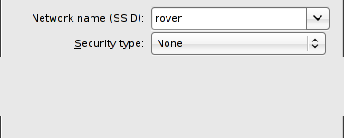
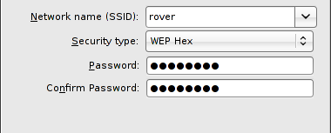
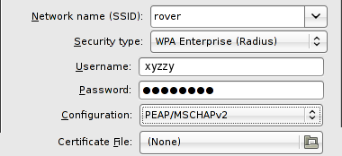
Security type None:
- Open network, no password fields displayed. Show passwords while typing field is disabled.
Security types WEP Hex, WEP ASCII and WPA Personal:
- Password: Password required to join specified network, initially blank.
- Confirm Password: Password required to join specified network, initially blank.(CFB: Not convinced this is useful, if the key is as long as it should be then everyone's just going to copy and paste it anyway.)
Security type: WPA Enterprise:
- Username, Password: WPA username and password
- Configuration: LEAP or PEAP/MSCHAPv2
- Certificate File: Click to open a file chooser from which the certificate file can be selected (is there a file extension on which we could/should filter?). Only valid for PEAP/MSCHAPv2 configuration; button is disabled if LEAP configuration is selected.

Wireless Network Chooser
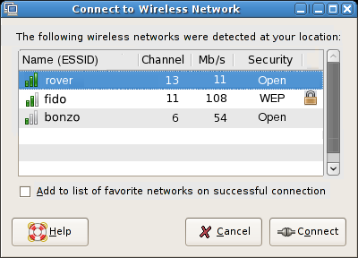
This dialog is shown if:
- A wireless connection is attempted when the user's favorite wireless networks list is empty
- No favorite networks have been found, and the Show available networks preference has been set on the wireless tab (p13).
The dialog is not shown if, in either case, no additional wireless networks are detected. (Unless we add a button for joining an unlisted network... might be useful.)
Wireless networks are listed in descending order of signal strength.
The Add to favorite networks list checkbox is shown only if the Ask before adding any networks to favorites preference is checked on the wireless tab (p13). If it is not checked, the network is not added to your favorites list upon connection.
Clicking Connect attempts to join the network immediately if no further input is required. Otherwise, the Join Wireless Network dialog (p21) is opened with the network's details pre-filled, to allow input of passwords etc.

VPN Preferences
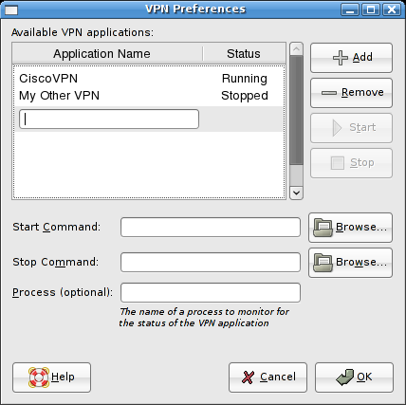
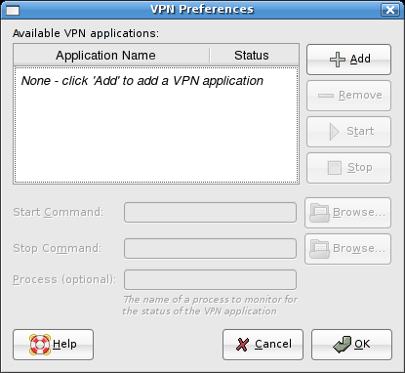
Open this dialog by clicking the VPN button on Connection Status tab (p7), or the VPN... menu item on the panel applet's right-click menu (p2).
Default state is shown left, when there no VPN applications have been added. Only the Add button is available.
Clicking Add switches focus to an embedded text field in the table, where the user can type a name for the VPN application. Pressing Enter adds the new entry, enables the Start Command, Stop Command and Process fields, and moves focus directly to the Start Command field. Esc cancels the typing and no new application is added.
You can type the command that starts the VPN process into the Start Command text field, or look for it using the Browse button, which opens a file chooser dialog. The Start button remains disabled until a command has been typed into this text field.
You can type the command that starts the VPN process into the Stop Command text field, or look for it using the Browse button , which opens a file chooser dialog. The Stop button remains disabled until a command has been typed into this text field.
If the process given in the Start Command is not the one to be monitored for the status of the VPN application, a process name can be entered here.
(CFB: How many scripts are allowed/allowed to run at the same time in Phase 1? Darren thought it might only be one; this design supports an unlimited amount.)
(CFB: This design only supports “on-demand” ENMs, will need some modification if conditional ENMs are supported in Phase 1)

