**SOFTWARE REQUIREMENTS SPECIFICATION**

**Sport Social Network**

Trương Văn Quốc Hoàng

Nguyễn Minh Hiếu

Văn Đức Dũng

Nguyễn Đình Kha

Date: **Oct 14 2017**

Version: **0.1**

Table of Contents

1 Revisions 4

2 Introduction 4

2.1 Purpose 4

2.2 Referenced documents 4

3 General description 5

3.1 Product scope 5

3.2 Product functions 5

3.3 Operating environments 5

3.3.1 Operating systems 5

3.4 Design and implementation constraints 5

4 Actor and usecase 5

4.1 Actors 5

4.2 System usecase 6

4.2.1 Manage matches detail 7

4.2.2 Manage tournament detail 7

4.2.3 User Profile Management detail 8

5 EXTERNAL INTERFACE FEATURES 8

5.1 Homepage 8

5.1.1 Homepage for guest 8

5.1.2 Homepage when logged in 10

5.2 Sign up screen 11

5.3 Login screen 13

5.4 Mange match 14

5.4.1 Create match 14

5.4.2 Update match 15

5.4.3 List matches 16

5.4.4 Show information of match 17

5.5 Manage tournament 18

5.5.1 Create tournament 18

5.5.2 Update tournament 20

5.5.3 List tournament 21

5.5.4 Show information of tournament 22

5.6 User profile management 23

5.6.1 Update Profile 23

5.6.2 Change password 25

5.7 Talent wanted 26

5.7.1 Create talent wanted new 26

5.7.2 Delete/update talent wanted new 27

6 Other requirements 28

6.1 Usability requirements 28

6.2 Security requirement 29

# Revisions

|  |  |  |  |
| --- | --- | --- | --- |
| **Version** | **Date** | **Author** | **Description** |
| 0.1 | Oct 14 2016 | Hoang Truong | Initial SRS |
|  |  |  |  |
|  |  |  |  |
|  |  |  |  |
|  |  |  |  |
|  |  |  |  |

# Introduction

## Purpose

A social network for soccer lover that help they create match, communicate to play together.

The document contains:

* Usecase for project.
* Detailed description of screens and functionalities

Technical considerations

## Referenced documents

# General description

## Product scope

The Sport Social Network includes web application and web service. It offers a solution for user who love soccer can create match, share match and invite other players to play together, or they can join any matches that are available.

## Product functions

Main functionalities:

* Manage match/tournament: create, assign, update and delete.
* Share match/tournament.
* Invite and join any match/tournament

## Operating environments

### Operating systems

The webapp is available on any mobile devices and any OSes with a web browser

The Web service can run on Window/Linux server.

## Design and implementation constraints

The Sport Social Network will be a web application to maximize the availability. User can access in any devices with a modern browser.

The web service will be host in a webserver and serve REST API for the web app, this can be extend for future for mobile app.

# Actor and usecase

## Actors

|  |  |
| --- | --- |
| **Actor** | **Description** |
| Administrator | * Login * Manage any matches * Manage any tournaments * Mange User Profiles |
| U User | * Login * Manage match this user created * Manage tournament this user created * Share matches/tournaments * Talent wanted: recruit good player |
| Guest | * View any matches/tournament * Register |

## System usecase

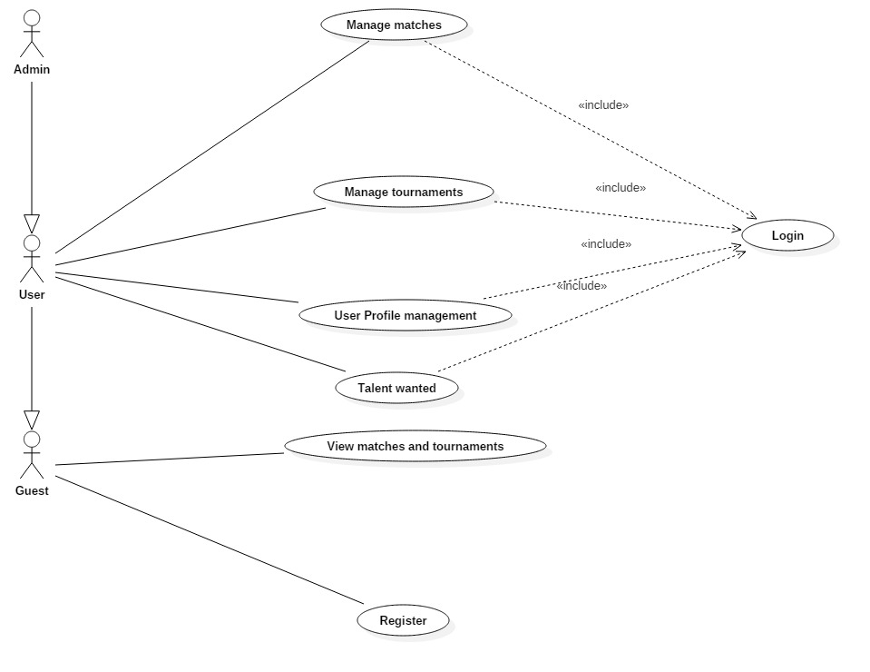

### Manage matches detail

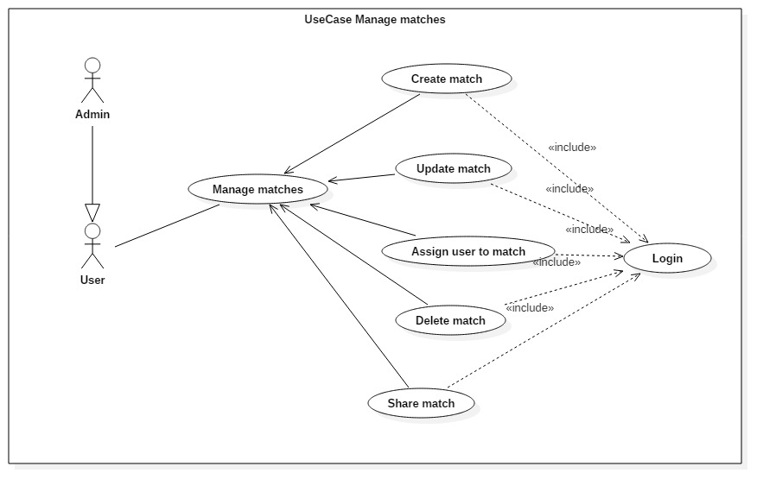

### Manage tournament detail

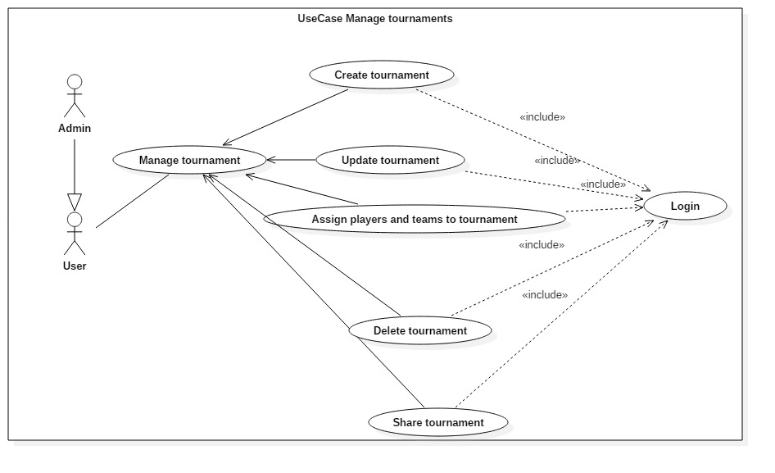

### User Profile Management detail

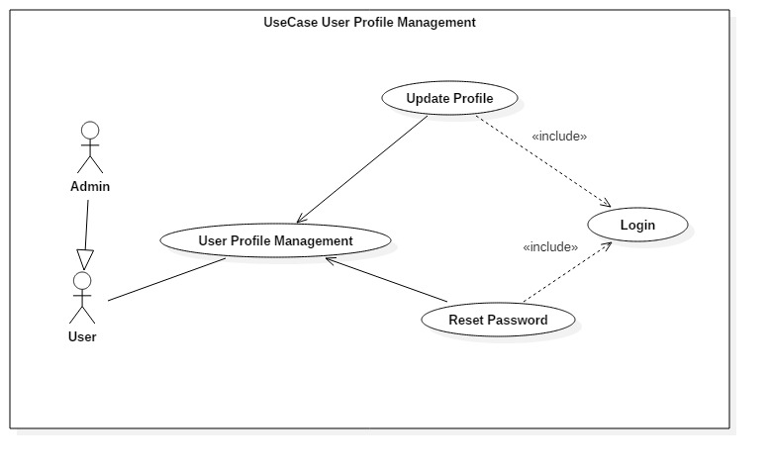

# EXTERNAL INTERFACE FEATURES

The user is able to use the App according to the flow of screens describe below.

## Homepage

### Homepage for guest

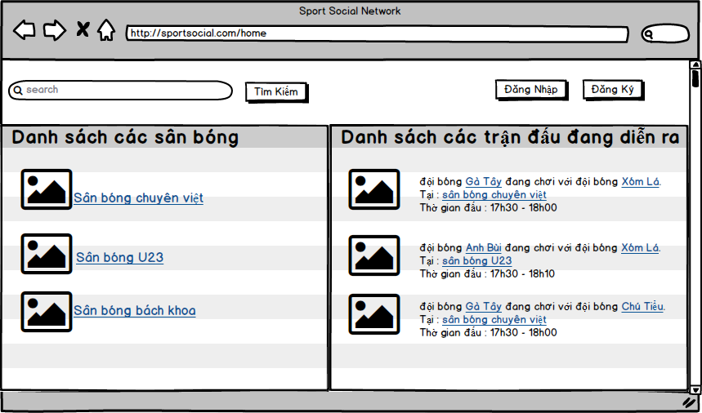

|  |  |  |  |  |  |  |
| --- | --- | --- | --- | --- | --- | --- |
| **Screen** | Homepage | | | | | |
| **Description** | | Homepage for guest (unregister user) | | | | |
| **Screen Access** | | Homepage | | | | |
| **Screen Content** | | | | | | |
| **Item** | | **Type** | **Data** | | **Description** | |
| Đăng nhập | | Button |  | | Navigate to login | |
| Tìm kiếm | | Text Field & Button |  | | Search match by name | |
| Đăng Ký | | Button |  | | Navigate to sign up | |
| Các trận đấu đang diễn ra | | Label – String |  | | List matches is happening | |
| Danh sách các Sân bóng | | Label – String |  | | List all football pitch | |
| **Screen Actions** | | | | | | |
| **Action Name** | | **Description** | | **Success** | | **Failure** |
| Login | | When “Đăng nhập” button is clicked, navigate to Login Page | | Login page is show | |  |
| Register | | When “Đăng Ký” is clicked, navigate to sign up page | | Sign up page is show | |  |
| Search | | When user type something in to input field and click search, it search matches/tournaments that match keyword | | List of results | |  |

### Homepage when logged in

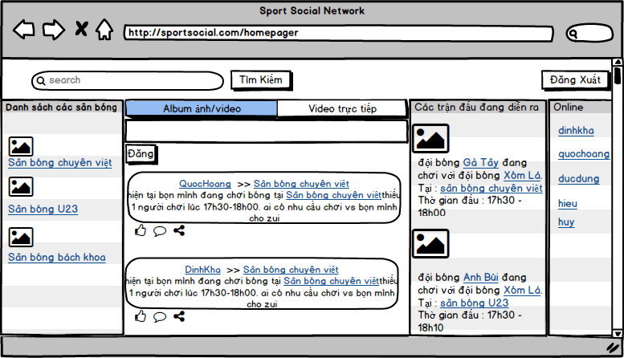

|  |  |  |  |  |  |  |
| --- | --- | --- | --- | --- | --- | --- |
| **Screen** | Homepage | | | | | |
| **Description** | | Homepage when user is logged in | | | | |
| **Screen Access** | | Homepage | | | | |
| **Screen Content** | | | | | | |
| **Item** | | **Type** | **Data** | | **Description** | |
| Đăng Xuất | | Button |  | | Log out | |
| Tìm kiếm | | Text Field & Button |  | | Search matches/tournament | |
| Album ảnh/video | | Button |  | | Post images/videos | |
| Video trực tuyến | | Button |  | | Livestream video | |
| Đăng | | Button |  | | Action post | |
| Các trận đấu đang diễn ra | | Label – String |  | | List all matches is happening | |
| Danh sách các Sân bóng | | Label – String |  | | List all football pitch | |
| Online | | Label – String |  | | List your friends is online | |
| **Screen Actions** | | | | | | |
| **Action Name** | | **Description** | | **Success** | | **Failure** |
| Log out | | Press “Đăng Xuất”, and navigate to homepage | | Homepage is show | |  |
| Search | | Search matches/tournament user typed in | | Show results | |  |
| Post iamges/videos | | When click on “Album ảnh/video”, user can browse images/videos on computer | | File pop-up show and user can choose file on computer | |  |
| Live stream video | | When click on “Video trực tuyến”, user can livestream video | | Live stream video | |  |
| Post a status | | When click on “Đăng”, content user typed in input field will be posted | | Status is show in their wall | |  |

## Sign up screen

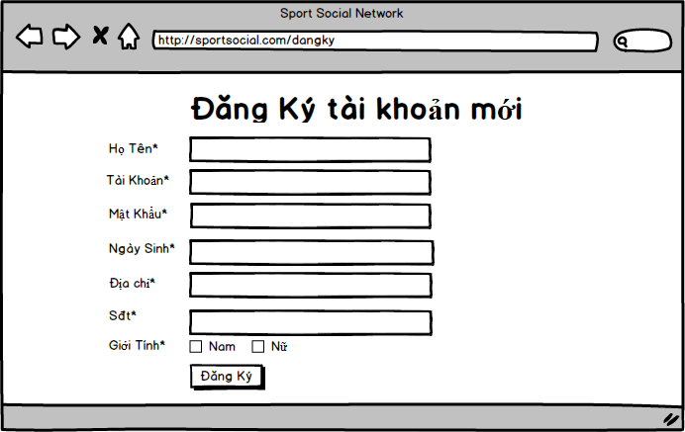

|  |  |  |  |  |  |  |
| --- | --- | --- | --- | --- | --- | --- |
| **Screen** | Register user - register | | | | | |
| **Description** | | Sign up | | | | |
| **Screen Access** | | Guest can sign up for website here | | | | |
| **Screen Content** | | | | | | |
| **Item** | | **Type** | **Data** | | **Description** | |
| Họ Tên | | Label - String |  | | Full name of user  This field is required | |
| Tài Khoản | | Text Field - String |  | | Account’s username  This field is required | |
| Mật khẩu | | Text Field - Password |  | | Password  This field is required | |
| Ngày sinh | | Text Field - Date |  | | User’s date of birth  This field is required | |
| Địa chỉ | | Text Field - String |  | | User’s address  This field is required | |
| Số điện thoại | | Text Field - String |  | | User’s phone number  This field is required | |
| Giới Tính | | checkbox |  | | Gender  This field is required | |
| Đăng Ký | | Button |  | | A button for submit | |
| **Screen Actions** | | | | | | |
| **Action Name** | | **Description** | | **Success** | | **Failure** |
| Sign up | | When click on “Đăng ký”, all date user have input will be send to server to register | | Sign up successful and redirect to homepage | | When any required field is missing -> Alert: “Hãy điền đầy đủ thông tin”  When username is not unique -> Alert: “tài khoản này đã tồn tại”  When password length is less than 8 -> Alert: “Mật khẩu không hợp lệ, ít nhất 8 ký tự, xin mời nhập lại”  When phone number is wrong -> Alert: “Số điện thoại phải đúng định dạng hoặc đã tồn tại” |

## Login screen

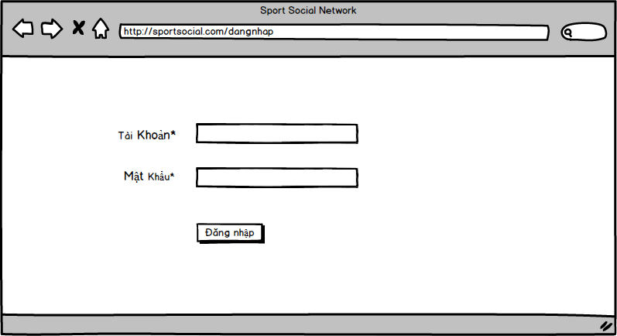

|  |  |  |  |  |  |  |
| --- | --- | --- | --- | --- | --- | --- |
| **Screen** | Login user - login | | | | | |
| **Description** | | Screen fo user to login | | | | |
| **Screen Access** | | User input info and press login | | | | |
| **Screen Content** | | | | | | |
| **Item** | | **Type** | **Data** | | **Description** | |
| Tài Khoản | | Text Field - String |  | | Username of user  This field is required | |
| Mật khẩu | | Text Field - Password |  | | Password  This field is required | |
| Đăng Nhập | | Button |  | | Perform login | |
| **Screen Actions** | | | | | | |
| **Action Name** | | **Description** | | **Success** | | **Failure** |
| Login | | When user input data and press “Đăng nhập”, data will be send to server and validate for login | | Login successful and redirect to homepage | | When any required field is missing -> Alert: “Hãy điền đầy đủ thông tin”  When usename doesn’t exist> Alert: “tài hoản không tồn tại”  When password is not correct -> Alert: “Mật khẩu của bạn không đúng” |

## Mange match

### Create match

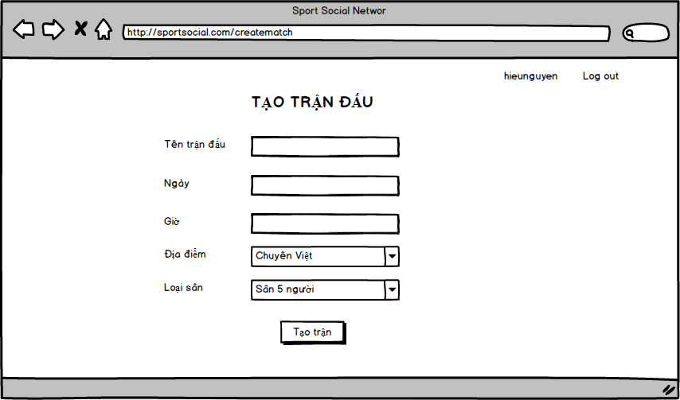

|  |  |  |  |  |  |
| --- | --- | --- | --- | --- | --- |
| **Screen** | Manage mathces – Create match | | | | |
| **Description** | | Allow user can create match | | | |
| **Screen Access** | | Press link “Create match” in navigation bar | | | |
| **Screen Content** | | | | | |
| **Item** | | **Type** | **Data** | **Description** | |
| Tên trân đấu | | TextField – String (50) |  | Input match name | |
| Ngày | | Datetime |  | Input date | |
| Giờ | | TextField – String (30) |  | Input time | |
| Địa điểm | | Combo Box |  | Choose location | |
| Loại sân | | Combo Box |  | Choose minimum of number of players for each team | |
| **Screen Actions** | | | | | |
| **Action Name** | | **Description** | | **Success** | **Failure** |
| Create match | | Add match to list of matches | | Display message “Tạo trận đấu thành công ” and redirect to list of matches | Show alerts “Không thể tạo trận đầu, mời nhập lại các thông tin chính xác”. |

### Update match

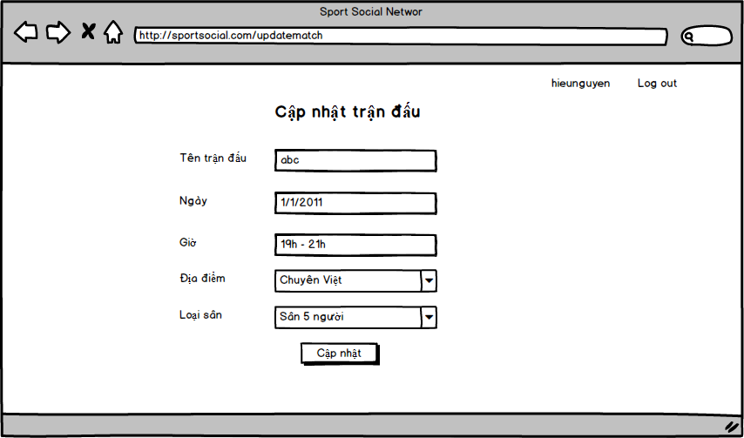

|  |  |  |  |  |  |
| --- | --- | --- | --- | --- | --- |
| **Screen** | Manage mathces – Update match | | | | |
| **Description** | | Allow user can update match | | | |
| **Screen Access** | | Press link “Create match” in navigation bar | | | |
| **Screen Content** | | | | | |
| **Item** | | **Type** | **Data** | **Description** | |
| Tên trân đấu | | TextField – String (50) |  | Change “Tên trận đấu” field if user want to change this field | |
| Ngày | | Datetime |  | Change “ Ngày” field if user want to change this field | |
| Giờ | | TextField – String (30) |  | Change “ Giờ” field if user want to change this field | |
| Địa điểm | | Combo Box |  | Change “ Địa điểm” field if user want to change this field | |
| Loại sân | | Combo Box |  | Change “ Loại sân” field if user want to change this field | |
| **Screen Actions** | | | | | |
| **Action Name** | | **Description** | | **Success** | **Failure** |
| Update match | | Add match to list of matches | | Display message “Cập nhật trận đấu thành công” and redirect to list of matches page | Show alerts “Cập nhật thất bại, vui lòng kiểm tra lại”. |

### List matches

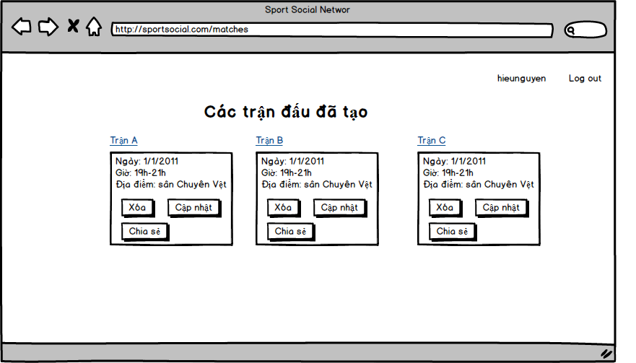

|  |  |  |  |  |
| --- | --- | --- | --- | --- |
| **Screen** | Manage match – List created matches | | | |
| **Description** | | User who created match can delete/update/share information matches | | |
| **Screen Access** | | Press link “List created matches” in navigation bar | | |
| **Screen Actions** | | | | |
| **Action Name** | | **Description** | **Success** | **Failure** |
| Delete match | | User click on “Xóa”, that match will be deleted. Admin can delete any matches, but user can only delete match which is they created | Display message “Đã xóa trận đấu thành công” | Show alert “Không thể xóa trận đấu, vui lòng kiểm tra lại” |
| Update match | | Update the detail of match | Navigate to update page |  |
| Share match | | User shares information of match onto the home page, and user can retrieve a link of match to share via facebook, gmail,… | Share to homepage, receive link of match |  |

### Show information of match

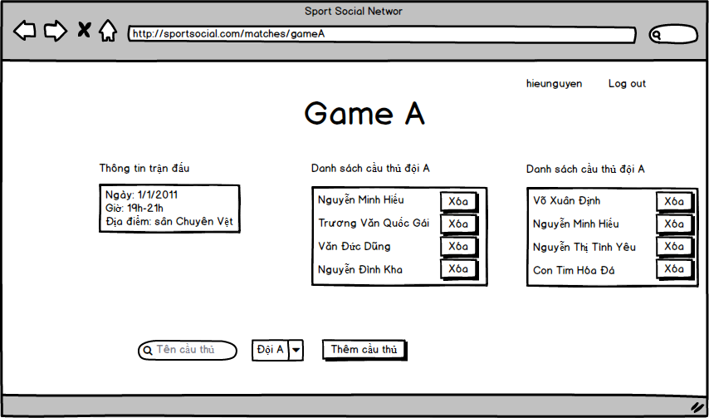

|  |  |  |  |  |  |
| --- | --- | --- | --- | --- | --- |
| **Screen** | Manage matches – Match Information | | | | |
| **Description** | | Allow user can view information of match | | | |
| **Screen Access** | | Press match name in “List matches” screen | | | |
| **Screen Content** | | | | | |
| **Item** | | **Type** | **Data** | **Description** | |
| Thông tin trận đấu | | Text | Match information: date, time, place | Display match infomation | |
| Danh sách cầu thủ đội A | | List | List of player in team A | List of player in team A | |
| Danh sách cầu thủ đội B | | List | List of player in team B | List of player in team B | |
| Thêm cầu thủ | | Button |  | Add player to team of match | |
| **Screen Actions** | | | | | |
| **Action Name** | | **Description** | | **Success** | **Failure** |
| Add player | | User input player name, select team then click “Thêm cầu thủ” will add player to the team of matches | | Show message “Thêm cầu thủ thành công” | Show alerts “Thêm cầu thủ không thành công” |
| Delete player from team | | Delete player from the team | | Show alerts “Xóa cầu thủ thành công” | Show alerts “Xóa không thành công” |

## Manage tournament

### Create tournament

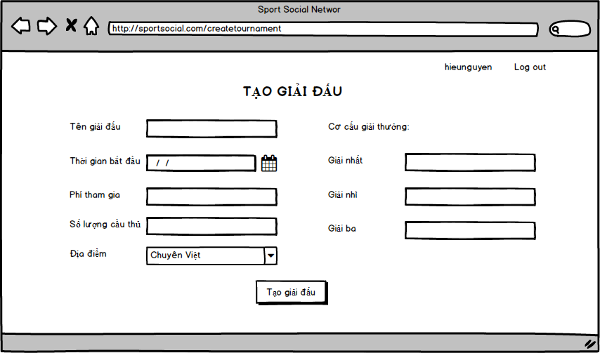

|  |  |  |  |  |  |
| --- | --- | --- | --- | --- | --- |
| **Screen** | Manage tournament – Create tournament | | | | |
| **Description** | | Allow user can create tournament | | | |
| **Screen Access** | | Press link “Create tournament” in navigation bar | | | |
| **Screen Content** | | | | | |
| **Item** | | **Type** | **Data** | **Description** | |
| Tên giải đấu | | TextField – String (50) |  | Input tournament name | |
| Thời gian bắt đầu | | Date time |  | Choose the time that tournament start | |
| Phí tham gia | | TextField – String (30) |  | Input the fee of each team to join tournament | |
| Số lượng cầu thủ | | TextField –String(100) |  | Choose minimum of number of player for each team | |
| Địa điểm | | Combo Box |  | Choose location | |
| Giải nhất | | TextField – String (100) |  | Input prize for best team | |
| Giải nhì | | TextField – String (100) |  | Input prize for second team | |
| Giải ba | | TextField – String (100) |  | Input prize for third team | |
| **Screen Actions** | | | | | |
| **Action Name** | | **Description** | | **Success** | **Failure** |
| Create tournament | | Create tournament and add tournament to list | | Display message “Tạo giải đấu thành công” | Display message “Tạo giải đấu thất bại, vui lòng kiểm tra lại thông tin”. |

### Update tournament

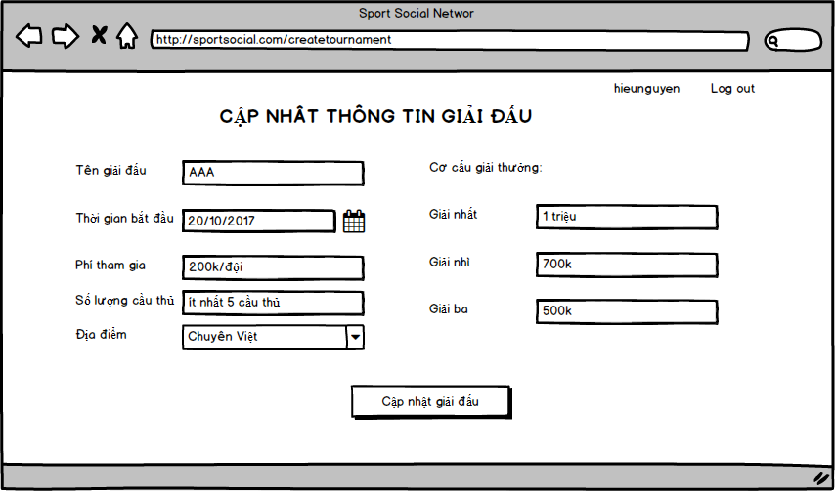

|  |  |  |  |  |  |
| --- | --- | --- | --- | --- | --- |
| **Screen** | Manage tournament – Update tournament | | | | |
| **Description** | | Allow user can create tournament | | | |
| **Screen Access** | | Press link “Update tournament” in navigation bar | | | |
| **Screen Content** | | | | | |
| **Item** | | **Type** | **Data** | **Description** | |
| Tên giải đấu | | TextField – String (50) |  | Change “Tên giải đấu” field if user want to change this field | |
| Thời gian bắt đầu | | Date time |  | Change “Thời gian bắt đầu” field if user want to change this field | |
| Phí tham gia | | TextField – String (30) |  | Change “Phí tham gia” field if user want to change this field | |
| Số lượng cầu thủ | | TextField –String(100) |  | Change “Số lượng cầu thủ” field if user want to change this field | |
| Địa điểm | | Combo Box |  | Change “Địa điểm” field if user want to change this field | |
| Giải nhất | | TextField – String (100) |  | Change “Giải nhất” field if user want to change this field | |
| Giải nhì | | TextField – String (100) |  | Change “Giải nhì” field if user want to change this field | |
| Giải ba | | TextField – String (100) |  | Change “Giải ba” field if user want to change this field | |
| **Screen Actions** | | | | | |
| **Action Name** | | **Description** | | **Success** | **Failure** |
| Update tournament | | Update information of the tournament | | Display message “Cập nhật thành công” | Display message “Cập nhật lỗi, vui lòng kiểm tra lại thông tin”. |

### List tournament

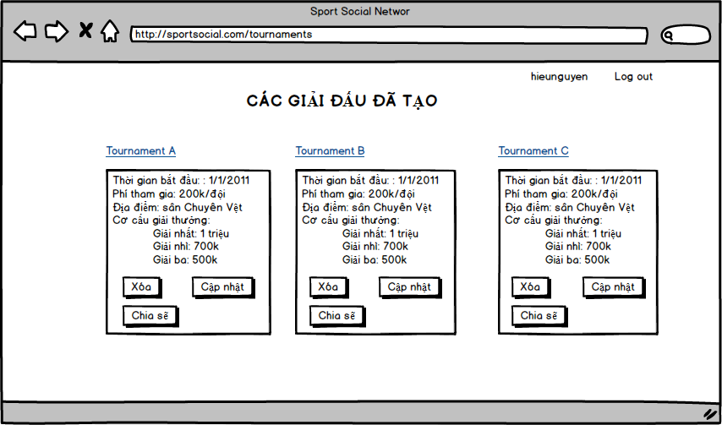

|  |  |  |  |  |
| --- | --- | --- | --- | --- |
| **Screen** | Manage tournament – Create tournament | | | |
| **Description** | | Allow user can create tournament | | |
| **Screen Access** | | Press link “List tournament” in navigation bar | | |
| **Screen Actions** | | | | |
| **Action Name** | | **Description** | **Success** | **Failure** |
| Delete | | Delete tournament from the list of tournament | Display message “Xóa giải đấu thành công” |  |
| Update | | Update information of the tournament | Navigate to Update tournament page |  |
| Share | | User shares information of match onto the home page, or share link via facebook,… |  |  |

### Show information of tournament

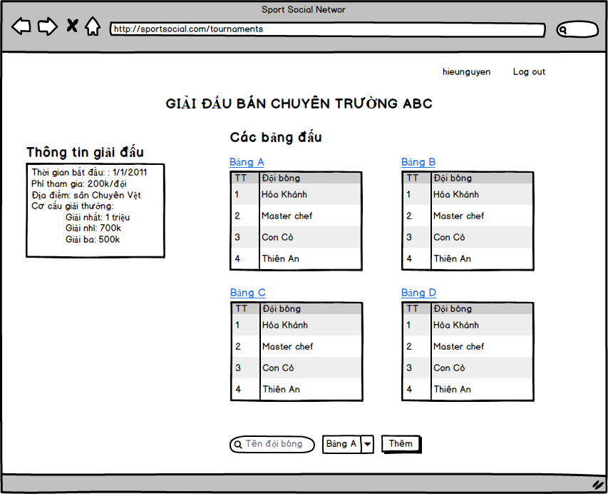

|  |  |  |  |  |  |
| --- | --- | --- | --- | --- | --- |
| **Screen** | Manage tournament – Show the tournament | | | | |
| **Description** | | Allow user can view information of the tournament | | | |
| **Screen Access** | | Press Tournament name in List tournament | | | |
| **Screen Content** | | | | | |
| **Item** | | **Type** | **Data** | **Description** | |
| Bảng A | | url |  | In order to show detail of group A | |
| Bảng B | | url |  | In order to show detail of group B | |
| Bảng C | | url |  | In order to show detail of group C | |
| Bảng D | | url |  | In order to show detail of group D | |
| Tên đội bóng | | TextField –String(100) |  | Input team name for search | |
| Bảng | | Combo box |  | Choose group for add the new team | |
| **Screen Actions** | | | | | |
| **Action Name** | | **Description** | | **Success** | **Failure** |
| Add | | Add the team to the group in the tournament | | Display message “Thêm đội thành công” | Display message “Thêm đội thất bại” |

## User profile management

### Update Profile

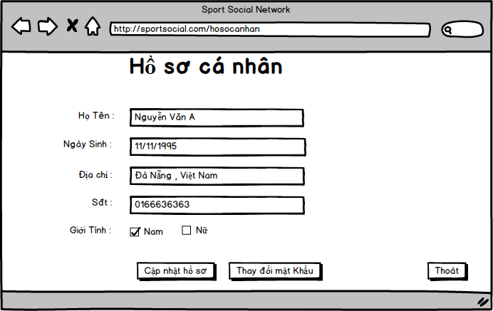

|  |  |  |  |  |  |  |
| --- | --- | --- | --- | --- | --- | --- |
| **Screen** | User profile management | | | | | |
| **Description** | | The page show user profile, allow to update user profile | | | | |
| **Screen Access** | | Access url /users/{username} or click username at top bar | | | | |
| **Screen Content** | | | | | | |
| **Item** | | **Type** | **Data** | | **Description** | |
| Họ Tên | | String(50) | full_name from Database | | Full name of user | |
| Ngày Sinh | | String(10) – format(dd/mm/yyyy) | birthday from Database | | user birthday | |
| Địa Chỉ | | String(255) | address from Database | | user address | |
| Sđt | | Number | phone_number from Database | | User phone number | |
| Giới tính | | check box | gender from Database | | If gender equals 1 then “Nam” is checked, otherwise “Nữ” is checked | |
| Cập nhật hồ sơ | | Button |  | | Update user profile when the profile form had changes | |
| Thay đồi mật khẩu | | Button |  | | Go to page change user password | |
| Thoát | | Button |  | | Go to home page | |
| **Screen Actions** | | | | | | |
| **Action Name** | | **Description** | | **Success** | | **Failure** |
| Update Profile | | After changes at least 1 input of user profile form, click button “Cập nhật hồ sơ” to request change user profile | | Notify update success | | - notify invalid format when validate fail  - notify update fail when get internal server error  - notify can not update user right now |
| Change password | | Click button “Thay đổi mật khẩu” to open page changes user password | | Open the change password page | |  |
| Exit | | Undo changes all of input user profile form has not updated yet and go to home page | | Go to home page | |  |

### Change password

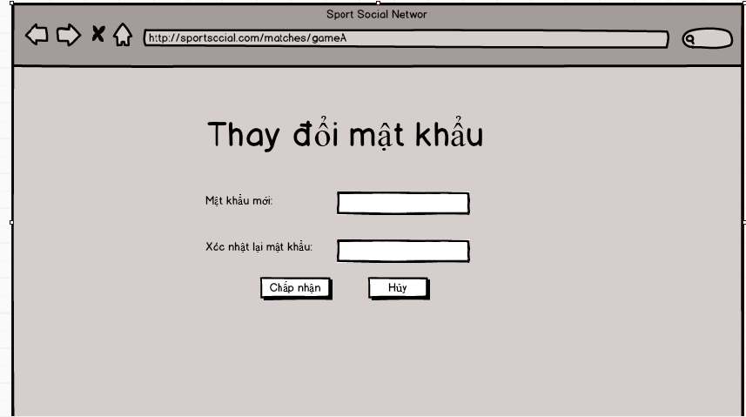

|  |  |  |  |  |  |  |
| --- | --- | --- | --- | --- | --- | --- |
| **Screen** | update user password | | | | | |
| **Description** | | update user password | | | | |
| **Screen Access** | | From user profile screen, click button “Thay đổi mật khẩu” | | | | |
| **Screen Content** | | | | | | |
| **Item** | | **Type** | **Data** | | **Description** | |
| Mật khẩu mới | | String(50) |  | | The new password that user want to update | |
| Xác nhận lại mật khẩu | | String(50) |  | | the password confirmation | |
| Chập nhận | | Button |  | | Accept change password | |
| Hủy | | Button |  | | Cancel update password | |
| **Screen Actions** | | | | | | |
| **Action Name** | | **Description** | | **Success** | | **Failure** |
| Change password | | After fill in field “Mật khẩu mới” and “xác nhận lại mật khẩu” with the same text, click button “Chấp nhận” | | Notify update password success and go to home user profile page | | - notify invalid password when validate fail  - notify update fail when get internal server error  - notify can not update password right now |
| Cancel | | Cancel update password | | Go to user profile page | |  |

## Talent wanted

### Create talent wanted news

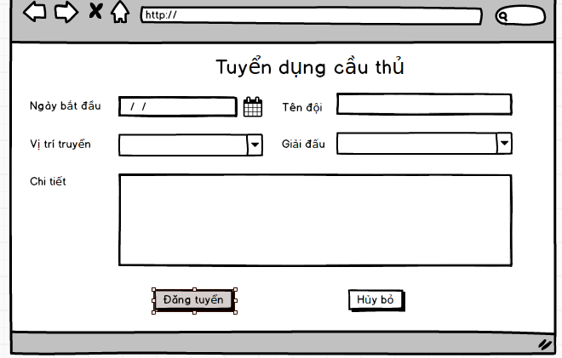

|  |  |  |  |  |  |  |
| --- | --- | --- | --- | --- | --- | --- |
| **Screen** | Create talent wanted | | | | | |
| **Description** | | Talent wanted for a team | | | | |
| **Screen Access** | |  | | | | |
| **Screen Content** | | | | | | |
| **Item** | | **Type** | **Data** | | **Description** | |
| Ngày bắt đầu | | String(10) |  | | The day start matches | |
| Tên Đội | | String(255) |  | | Team name | |
| Vị trí tuyển | | String(255) |  | | Position wanted | |
| Giải đấu | | String(255) |  | | Tournament Name | |
| Chi tiết | | text |  | | Description, content of the talent wanted | |
| Đăng Tuyển | | Button |  | | Public the talent wanted | |
| Hủy bỏ | | Button |  | | Cancel create talent wanted and go to home page | |
| **Screen Actions** | | | | | | |
| **Action Name** | | **Description** | | **Success** | | **Failure** |
| Create new | | After fill in all input form and click button “Đăng Tuyển”. | | Notify create talent wanted success | | - notify invalid format when validate fail  - notify update fail when get internal server error  - notify can not create the post right now |
| Hủy bỏ | | Cancel create talent wanted and go to home page | | Go to home page | |  |

### Delete/update talent wanted news

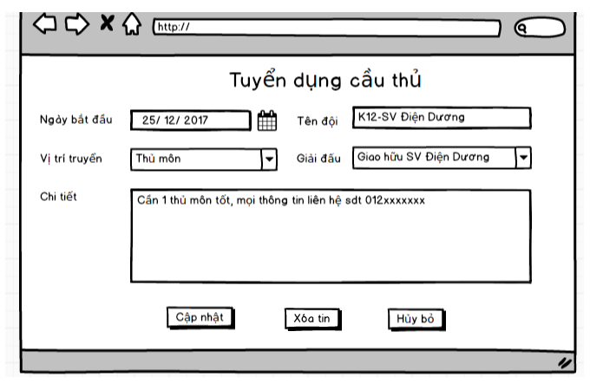

|  |  |  |  |  |  |  |
| --- | --- | --- | --- | --- | --- | --- |
| **Screen** | update talent wanted | | | | | |
| **Description** | | update talent wanted | | | | |
| **Screen Access** | |  | | | | |
| **Screen Content** | | | | | | |
| **Item** | | **Type** | **Data** | | **Description** | |
| Ngày bắt đầu | | String(10) | start_at from DB | | The day start matches | |
| Tên Đội | | String(255) | team_name from DB | | Team name | |
| Vị trí tuyển | | String(255) | Position from DB | | Position wanted | |
| Giải đấu | | String(255) | tournament_name from DB | | Tournament Name | |
| Chi tiết | | text | Description from DB | | Description, content of the talent wanted | |
| Cập nhật | | Button |  | | Accept the changes and public the talent wanted | |
| Xóa tin | | Button |  | | Delete the talent wanted post | |
| Hủy bỏ | | Button |  | | Undo changes, cancel update talent wanted and go to home page | |
| **Screen Actions** | | | | | | |
| **Action Name** | | **Description** | | **Success** | | **Failure** |
| Update | | After changes at least 1 field of the form, click button “Cập nhật”. | | Notify update success and go to hom page | | - notify invalid input format when validate fail  - notify update fail when get internal server error  - notify can not update right now |
| Delete | | Click button “Xóa tin” | | Notify delete post success | | - notify delete fail when get internal server error |
| Hủy bỏ | | Cancel update talent wanted | | Go to home page | |  |

# Other requirements

## Usability requirements

Very important for the product will be the usability, can be connected and display in any devices with a web browser.

A secondary aspect is the look & feel of the application

## Security requirement

Web API part must be secure and have fully role management.

Admin can manage all matches/tournaments. User can only manage matches/tournaments that they created