Report on Laboratory Work No. 8
DEVELOPMENT OF TECHNICAL SPECIFICATION
Project topic: Pre-order System for a Cafeteria
(Cafeteria Pre-order System)
The report is prepared according to the structure of a technical specification for an automated system and summarizes the results of the previous laboratory works on the same project.
Bishkek, 2026

Contents
1. Introduction
2. Problem Statement for Software Development
3. Review of Existing Analogues
4. Justification of Development Necessity
5. Technical Specification for the Automated System
6. AS-IS, Use Case and TO-BE Models
7. Glossary
8. Conclusion
9. Sources of Development

1. Introduction
This laboratory work is devoted to the preparation of a technical specification for an automated meal pre-order system for a cafeteria. The technical specification defines the system purpose, development goals, automation area, functional and non-functional requirements, data requirements, system requirements, development stages and acceptance procedure.
The Cafeteria Pre-order System is considered as a web-oriented system for students and university employees. It allows users to view the daily menu, select dishes in advance, reserve a pick-up time slot and reduce waiting time in the cafeteria. The specification is based on the artifacts prepared in the previous laboratory works: analysis of the domain, business requirements, user requirements, prioritization, functional and non-functional requirements, data requirements and system requirements.
The aim of Laboratory Work No. 8 is to combine the previous requirements engineering results into a single technical specification that can be used for further design, implementation and verification of the software product.

2. Problem Statement for Software Development
In the current cafeteria service process, queues appear during peak hours, and clients do not have a guarantee that the desired meal will still be available when they arrive. Cafeteria staff have to plan cooking volume based on approximate estimates, which may lead either to shortage of popular meals or to excessive leftovers and food waste.
It is necessary to develop an automated system that publishes an actual daily menu, accepts pre-orders, distributes customer flow by time slots, supports order payment and pick-up, and forms management reports for the cafeteria.
Element | Description
Problem | High cafeteria load during peak hours, queues of 10-20 minutes, and no guaranteed availability of selected dishes.
Affected stakeholders | Students and university employees, cashiers, kitchen staff, cafeteria manager and administration.
Causes | No digital pre-ordering, manual update of stock, no time-slot capacity control, and limited demand analytics.
Target state | The client selects meals and a pick-up time slot in advance; the system reserves portions and capacity in the slot; cafeteria staff can see the expected order flow.
Expected effect | Reduced queues, better user convenience, fewer pick-up errors, and more accurate planning of purchases and cooking volume.

3. Review of Existing Analogues
To evaluate the domain, several existing approaches and analogues were considered. They partially solve the food ordering problem, but they do not fully match the conditions of a university cafeteria with scheduled self-pick-up.
Analogue | Purpose | Advantages | Disadvantages | Conclusion for the project
Glovo / Wolt | Online food ordering and delivery | Convenient interface, catalog of dishes, payment, order statuses | Focused on delivery rather than internal cafeteria pick-up; no cafeteria time-slot management; dependence on an external platform | Use UX ideas, order statuses and meal cards
Cafeteria Telegram bot | Fast pre-ordering through a messenger | Low development cost, quick launch, familiar communication channel | Limited analytics; difficult role model, reports, stock validation and admin panel | Useful as a simplified MVP, but insufficient for a full system
Google Forms / spreadsheets | Manual collection of requests | Very easy to start and does not require software development | No real-time statuses, weak data protection, manual processing, no automatic stock and slot control | Suitable only for temporary hypothesis testing
Internal cafeteria web application | Specialized system for university cafeteria process | Can include roles, slots, stock, stop-list, payment, reports and data rules | Requires design, development, testing and support | Selected solution for development

Conclusion: a custom automated system is the most appropriate solution because it can take into account cafeteria-specific features: pick-up slot limits, menu management, stop-list, stock control, staff roles and reporting. Ready-made analogues solve only a part of the problem and do not provide the required process control.

4. Justification of Development Necessity
The Cafeteria Pre-order System is necessary because the current process does not provide predictable load, up-to-date information for clients or convenient order pick-up control. The system creates a single digital environment for clients, kitchen staff, cashiers and the cafeteria manager.
Reason for development | How the system solves the problem | Expected result
Queues during peak hours | Orders are distributed by time slots and created before the client comes to the cafeteria. | Average waiting time is reduced by the target value of up to 70%.
Outdated menu information | The manager publishes the daily menu, stock and stop-list; the system updates availability of menu items. | The client sees only actual dishes and available portions.
Unpredictable kitchen load | A summary of orders by slots and dishes is created in advance. | The kitchen plans cooking based on real demand.
Pick-up errors | The cashier finds the order by number, client ID or QR code and sees the payment status. | The number of duplicate or incorrect pick-ups decreases.
Lack of management analytics | Reports on sales, popular dishes and slot load are generated. | The manager makes data-based decisions.

5. Technical Specification for the Automated System

5.1. General Information
Parameter | Content
Full name of the system | Automated Meal Pre-order System for a Cafeteria
Short name | Cafeteria Pre-order System
Type of system | Web application / adaptive mobile web application for clients and cafeteria staff
Customer | Administration of the educational institution / cafeteria administration
Users | Students, university employees, cashier, cafeteria manager, administrator
Basis for development | Results of Laboratory Works No. 1-7 and the task of Laboratory Work No. 8 on technical specification development
Reference documents | GOST 34.602-2020, ISO/IEC/IEEE 29148-2018, course materials on Software Requirements Engineering

5.2. Purpose and Objectives of System Creation
The purpose of the system is to automate the process of meal selection, pre-ordering, payment and pick-up in the cafeteria, and to provide cafeteria staff with tools for menu, time-slot, stock and report management.
ID | Objective | Achievement criterion
O-1 | Reduce cafeteria queues | Average waiting time after implementation is reduced to the target level, not less than 70% compared with the initial process.
O-2 | Ensure actual menu information | The client sees a published daily menu with actual stock, price, nutrition values and allergens.
O-3 | Distribute client flow | Every order is linked to a time slot, and the system does not allow exceeding slot capacity.
O-4 | Improve kitchen controllability | Manager and kitchen staff can see order summaries by slots and dishes.
O-5 | Reduce food waste | The manager receives demand and sales analytics to adjust purchase and cooking volume.

5.3. Characteristics of the Automation Object
The automation object is the process of serving clients in a cafeteria of an educational institution: menu publication, dish selection, pre-order creation, payment, preparation, pick-up and order accounting. The process includes interaction between several roles: client, cashier, kitchen staff, cafeteria manager and payment system. The system must support peak periods, when the cafeteria receives the highest number of visitors within a short time interval.
Process area | Current state | Automated target state
Menu publication | Menu and stock are updated manually or shown only at the counter. | The daily menu is published in the system with price, stock, nutrition values and stop-list.
Order creation | The client selects dishes only after coming to the cafeteria. | The client creates a pre-order in advance and reserves dishes and a time slot.
Load planning | The kitchen forecasts demand approximately. | The kitchen receives a summary by dishes and time slots.
Pick-up | Orders are paid and received in a common queue. | The cashier finds the order by number or QR code and confirms pick-up.
Analytics | Sales and demand are analyzed manually or irregularly. | The system forms reports on sales, popular dishes and slot load.

5.4. Requirements for the Automated System

5.4.1. Business Requirements
ID | Business requirement
BR-001 | The system shall reduce waiting time in the cafeteria during peak hours.
BR-002 | The system shall increase predictability of demand for the kitchen and cafeteria manager.
BR-003 | The system shall decrease the number of unavailable dishes selected by clients.
BR-004 | The system shall support transparent accounting of orders, payments and pick-up statuses.
BR-005 | The system shall provide management data for menu planning and purchase planning.

5.4.2. User Requirements
ID | User requirement
UR-001 | As a client, I want to view the daily menu so that I can choose meals before coming to the cafeteria.
UR-002 | As a client, I want to select a time slot so that I can receive my order without standing in the common queue.
UR-003 | As a client, I want to see the order status so that I know whether it is created, paid, ready or picked up.
UR-004 | As a cashier, I want to find an order by number or QR code so that I can quickly confirm pick-up.
UR-005 | As a cafeteria manager, I want to update the menu and stock so that clients see only available meals.
UR-006 | As a manager, I want to view reports so that I can plan future menu and cooking volume.

5.4.3. Business Rules
ID | Business rule
BRL-001 | An order can be created only for a published daily menu.
BRL-002 | The number of reserved portions of a dish must not exceed available stock.
BRL-003 | A time slot becomes unavailable when its order limit is reached.
BRL-004 | A paid order cannot be cancelled by the client after the selected slot has started.
BRL-005 | A dish included in the stop-list must not be available for new orders.
BRL-006 | Only authorized staff members can change menu, stock, stop-list and order status.

5.4.4. Functional Requirements
ID | Functional requirement
FR-001 | The system shall allow user registration and authentication by email and password.
FR-002 | The system shall support roles: client, cashier, cafeteria manager and administrator.
FR-003 | The system shall show the daily menu with name, description, price, available quantity, nutrition values and allergens.
FR-004 | The system shall allow the client to add dishes to the cart and change quantity before order confirmation.
FR-005 | The system shall show available time slots with remaining capacity.
FR-006 | The system shall allow the client to create a pre-order for a selected time slot.
FR-007 | The system shall reserve selected portions after order creation and reduce available stock.
FR-008 | The system shall generate a unique order number and optionally a QR code.
FR-009 | The system shall support online payment or payment at the cashier.
FR-010 | The system shall store order statuses: created, awaiting payment, paid, preparing, ready, picked up, cancelled.
FR-011 | The system shall allow the client to view order history and current order status.
FR-012 | The system shall allow the client to cancel an unpaid order before the selected slot starts.
FR-013 | The system shall allow the cashier to search an order by number, client name/ID or QR code.
FR-014 | The system shall allow the cashier to confirm payment at the cashier and confirm order pick-up.
FR-015 | The system shall allow the manager to create and publish the daily menu.
FR-016 | The system shall allow the manager to change stock, prices and stop-list values.
FR-017 | The system shall allow the manager to create and configure time slots and capacity limits.
FR-018 | The system shall form reports on sales, popular dishes and time-slot load.
FR-019 | The system shall record critical staff actions in the audit log.
FR-020 | The system shall send notifications about order status changes.

5.4.5. Non-functional Requirements
ID | Category | Requirement
NFR-PF-01 | Performance | 95% of menu view requests shall be processed within 2 seconds under normal load.
NFR-PF-02 | Performance | Order creation and portion reservation shall be completed within 3 seconds under peak load.
NFR-RL-01 | Reliability | The system shall prevent double reservation of portions and loss of order status during a failure.
NFR-AV-01 | Availability | Target system availability during cafeteria working hours shall be not less than 99.5%.
NFR-SE-01 | Security | Access to functions shall be restricted by roles: client, cashier, manager and administrator.
NFR-SE-02 | Payment security | The system shall not store full bank card details; only transaction statuses and provider references may be stored.
NFR-US-01 | Usability | The user interface shall be responsive and understandable for clients without special training.
NFR-CP-01 | Compatibility | The client side shall work in current versions of Chrome, Edge, Firefox, Safari and on iOS/Android devices.
NFR-SC-01 | Scalability | The system shall support growth of users and orders without changing the core data logic.
NFR-OB-01 | Observability | Critical staff actions and status changes shall be recorded in AuditLog.

5.5. Data Requirements
The system shall store data about users, dishes, daily menus, menu items, time slots, orders, payments, notifications, audit logs and reports. Key entities must have primary keys, relationships, integrity constraints and storage rules.
Entity | Purpose | Related entities
User | A system user: client, cashier, manager or administrator | Order, Payment, Notification, AuditLog
Dish | A meal with price, description, nutrition values and allergens | MenuItem
DailyMenu | Menu for a specific date with draft, published or closed status | MenuItem
MenuItem | A daily menu position: dish, price, available quantity and stop-list status | Dish, DailyMenu, OrderItem
TimeSlot | Pick-up interval with a capacity limit | Order
Order | Client pre-order with number, status, total amount and selected time slot | User, TimeSlot, OrderItem, Payment
Payment | Information about payment method and result | Order
AuditLog | Record of staff actions and critical data changes | User

ID | Data rule
DV-01 | User email shall be unique and shall match the email format.
DV-02 | Passwords shall be stored only as strong hashes; original passwords shall not be stored.
DV-03 | Dish price and order total amount shall be non-negative and stored with two decimal places.
DV-04 | reserved_qty shall not exceed available_qty; negative stock values are prohibited.
DV-05 | reserved_count shall not exceed order_limit; a closed slot is unavailable for new orders.
DV-06 | Each order shall contain at least one OrderItem row.
DV-07 | The client may cancel only an unpaid order before the selected time slot starts.
DV-08 | Successful payment amount shall match the order total_amount.
DV-09 | A menu item with stop_list_flag=true shall not be shown for new orders.
DV-10 | AuditLog records are append-only and shall not be deleted by users.

5.6. System Requirements
Component | Minimum | Recommended | Justification
Application server | CPU 2 cores, RAM 8 GB | CPU 4-8 cores, RAM 16 GB+ | Processing orders and reports during peak hours
Database storage | 100 GB SSD | 500 GB NVMe SSD | Storage of orders, reports, logs and indexes
DBMS | PostgreSQL 14 | PostgreSQL 16+ | Relational data model, transactions and integrity constraints
Backend runtime | Node.js 20 LTS or Java 17 LTS | Node.js 22 LTS or Java 21 LTS | API support and long-term maintenance
Deployment | Docker 24+ | Docker 25+ / Kubernetes | Simplified delivery and scalability
Network | 100 Mbps, TLS 1.2 | 1 Gbps, TLS 1.3 | Protection of personal and payment-related data
Client browser | Last 3 major versions of Chrome/Edge/Firefox/Safari | Last 2 major versions | Compatibility with common devices
Mobile devices | iOS 14+ / Android 10+ | iOS 16+ / Android 13+ | Access to menu and orders from smartphone

5.7. Development Procedure for the Automated System
Stage | Name | Work content | Duration | Result
1 | Requirements clarification and TS approval | Interviews, review of requirements, agreement on MVP boundaries | 1 week | Approved technical specification
2 | Design | Data model, architecture, interface prototype, use scenarios | 1 week | Prototype, database scheme, API description
3 | MVP development | Daily menu, cart, time slots, order creation, client and manager roles | 3 weeks | Working MVP version
4 | Staff functions and payment | Cashier order search, pick-up confirmation, online payment, stop-list, notifications | 2 weeks | Integration version
5 | Reports, audit and system functions | Reports, audit log, backup and monitoring | 1 week | Testing version
6 | Testing and acceptance | Functional, integration and load testing, defect fixing | 1 week | Acceptance act / list of remarks
7 | Pilot implementation | Launch for a limited user group and feedback collection | 1 week | Recommendations for production launch

5.8. Control and Acceptance Procedure
Control type | What is checked | Acceptance criterion
Functional testing | FR-001 - FR-020 are checked by client, cashier and manager scenarios. | All Must Have functions are implemented and pass tests.
Data validation testing | Stock, slots, statuses, payments and audit log restrictions are checked. | Negative stock, capacity overflow and loss of action history are not allowed.
Integration testing | Connection with payment provider and notification service is checked. | Transaction statuses are returned and stored correctly.
Load testing | System behavior is checked under peak user load. | Response time complies with NFR-PF-01 and NFR-PF-02.
User acceptance | Key scenarios are demonstrated to the customer and cafeteria representatives. | Remarks are fixed or moved to later iterations.

5.9. Documentation Requirements
- Technical specification for the system development.
- Description of the data model and validation rules.
- User guide for the client.
- Staff guide for the cashier and cafeteria manager.
- Test program and test methodology.
- Short deployment, backup and recovery instruction.

6. AS-IS, Use Case and TO-BE Models

6.1. AS-IS Model
The AS-IS model shows the current process without automated pre-ordering: the client comes to the cafeteria, waits in line, chooses a dish from the available stock, pays at the cashier and receives the meal. The main problems are queues, outdated information, no preliminary load distribution and manual kitchen planning.
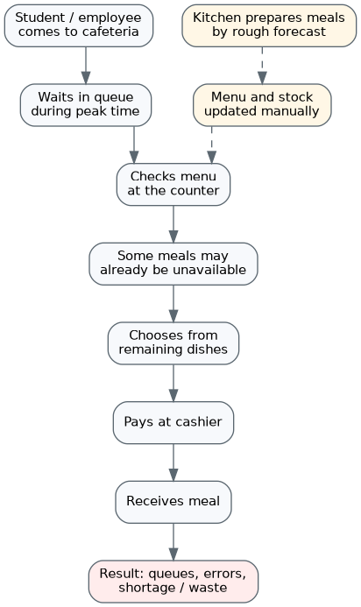
Figure 1 - AS-IS model of the current cafeteria service process

6.2. Conceptual Use Case Model
The Use Case model shows the system boundary and interaction of main actors with the system functions. The main actor is the client; supporting actors are the cashier, cafeteria manager and external payment system.
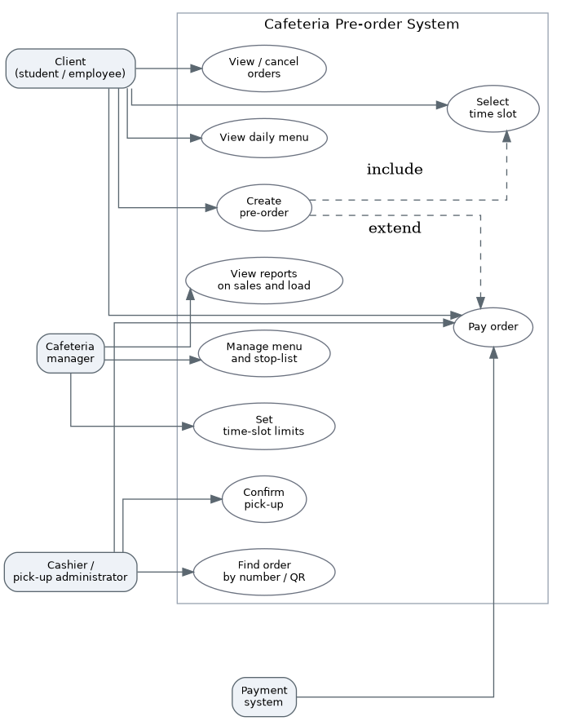
Figure 2 - Conceptual use case model

6.3. TO-BE Model
The TO-BE model describes the target process after implementation: the manager publishes the menu and slots, the client creates a pre-order, the system reserves resources, the kitchen sees the queue by time slots, and the cashier quickly finds and confirms the order. After pick-up, data is used for reports and demand analysis.
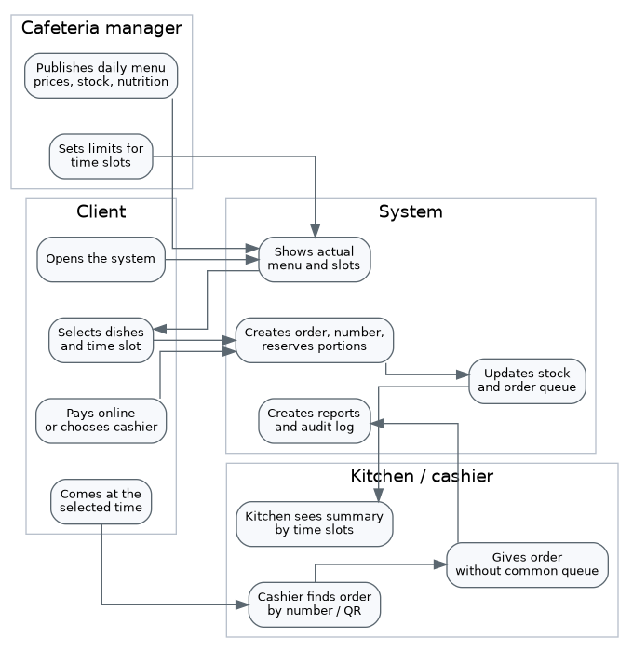
Figure 3 - TO-BE model of the target process

7. Glossary
Term | Definition | Source
Automated System (AS) | A system including personnel, software and technical means intended for automation of activity. | GOST 34.602-2020
Technical Specification (TS) | An initial document that defines system goals, requirements, work content and acceptance procedure. | GOST 34.602-2020; ISO/IEC/IEEE 29148
Business Requirement | A high-level goal or expected business benefit of system creation. | BABOK Guide
User Requirement | A description of a task that a user must be able to perform with the system. | IEEE 830 / SRS practice
Functional Requirement | A requirement that describes specific behavior of the system under defined conditions. | ISO/IEC/IEEE 29148
Non-functional Requirement | A requirement for quality attributes such as performance, security, reliability and usability. | ISO/IEC/IEEE 29148
Pre-order | Preliminary selection and reservation of a meal before physical pick-up in the cafeteria. | Project definition
Time Slot | A fixed time interval for order pick-up used to distribute cafeteria load. | Project definition
Stop-list | A list of meals temporarily hidden from the menu due to absence or impossibility of pick-up. | Food service practice
Nutrition Values | Calories, proteins, fats and carbohydrates that describe meal nutritional value. | Food service practice
MVP | Minimum viable product version with enough functions to launch and test the core hypothesis. | Lean Startup
AuditLog | A journal of critical user actions and system data changes. | Project definition
Use Case | A description of interaction between actors and the system to achieve a particular goal. | UML 2.5
AS-IS / TO-BE | Models of current and target process states used for change analysis. | Business analysis practice

8. Conclusion
In Laboratory Work No. 8, a technical specification for the Cafeteria Pre-order System was developed. The document combines the results of previous laboratory works: problem and domain analysis, business requirements, user requirements, business rules, functional and non-functional requirements, data requirements and system requirements.
The prepared technical specification shows that the system must provide the full pre-order cycle: from menu publication and time-slot selection to payment, pick-up, accounting and reporting. The most critical requirements are actual menu information, order creation, time-slot limit control, portion reservation, cashier order search and menu management. These functions form the MVP of the product.
The resulting document can be used as a basis for architecture design, database design, interface development, test scenarios and software development planning.

9. Sources of Development
- Laboratory Work No. 1: problem definition and domain analysis for the Cafeteria Pre-order System project.
- Laboratory Work No. 2: collection and analysis of business requirements.
- Laboratory Work No. 3: user requirements, scenarios, user stories and use cases.
- Laboratory Work No. 4: requirements prioritization using Kano, MoSCoW, RICE and WSJF.
- Laboratory Work No. 5: functional requirements and traceability matrices.
- Laboratory Work No. 7: data requirements and system requirements.
- GOST 34.602-2020: Information technology. Set of standards for automated systems. Technical specification for automated system creation.
- ISO/IEC/IEEE 29148-2018: Systems and software engineering - Life cycle processes - Requirements engineering.
- BABOK Guide: Business Analysis Body of Knowledge.
- IEEE 830: Software Requirements Specification.

