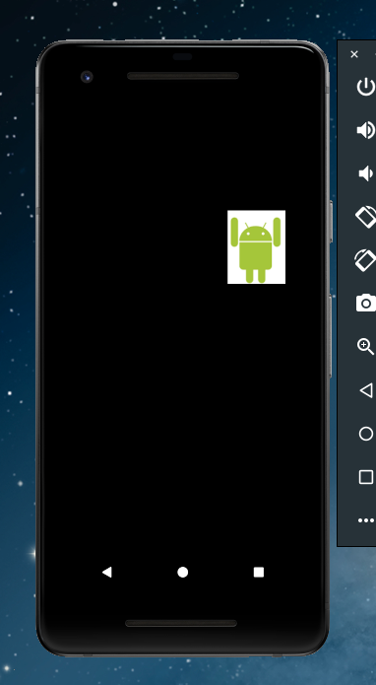

1. My second application using loops actually developed into a screen where the image/character moves around the screen constantly. I have changed it to move a bit slower because it disappears at some point.

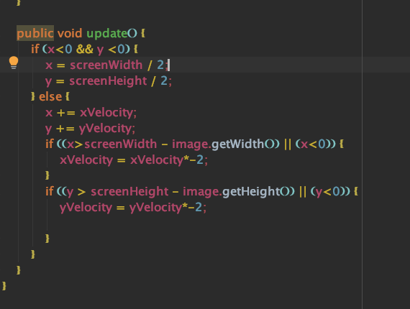

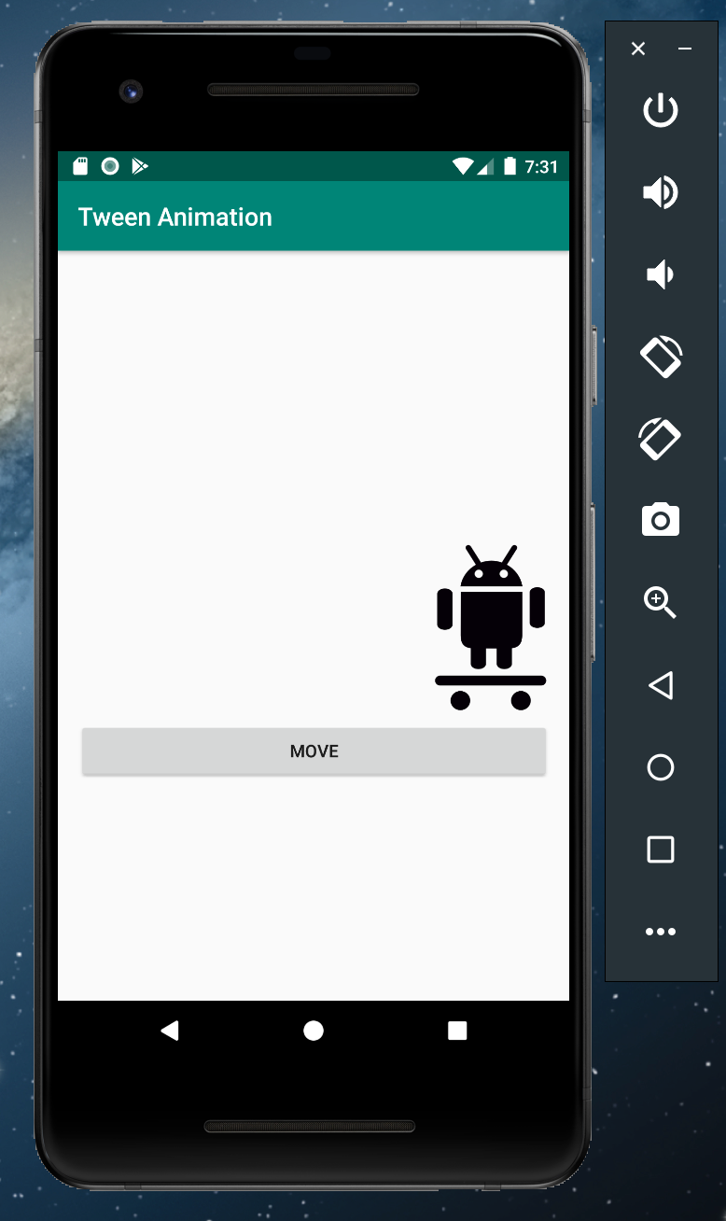

1. Tween Animation – I was only able to move the image to the right of the screen, but it works!