**View Sample Output**

*1. MenuItem_v:*

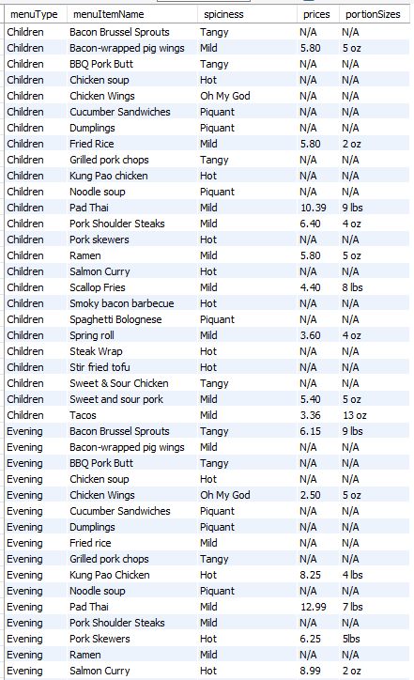

*2. Customer_addresses_v:*

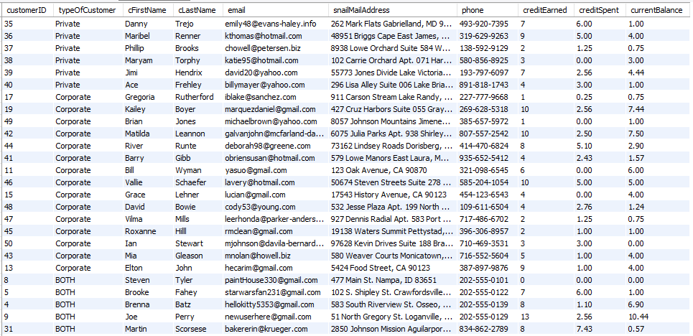

*3. Sous_mentor_v:*

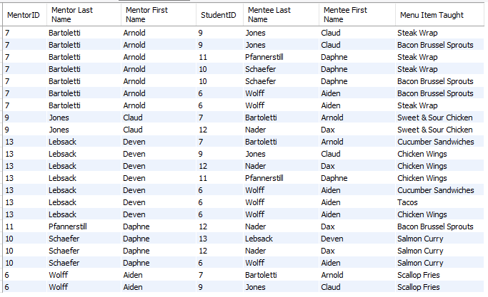

*4. Customer_Sales_v:*

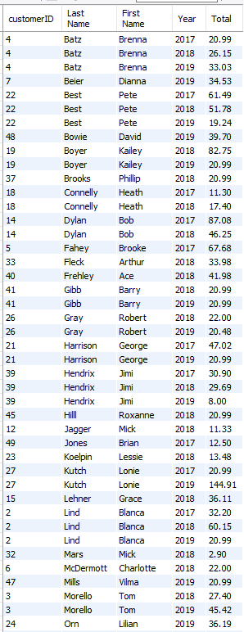

*5. Customer_Value_v:*

