<https://docs.microsoft.com/en-us/powershell/module/microsoft.powershell.core/about/about_comparison_operators?view=powershell-7>

Get-Service | Sort-Object status | Format-Wide Name -Column 8 -GroupBy Status

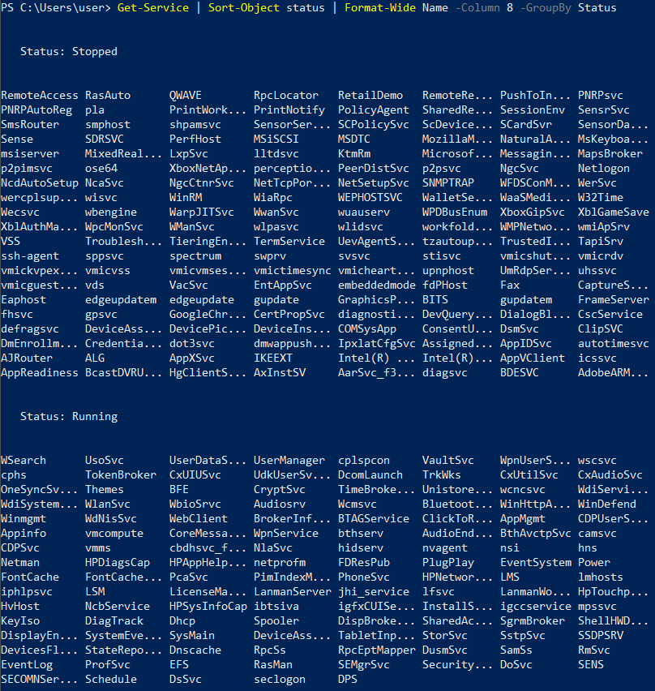

ConvertTo

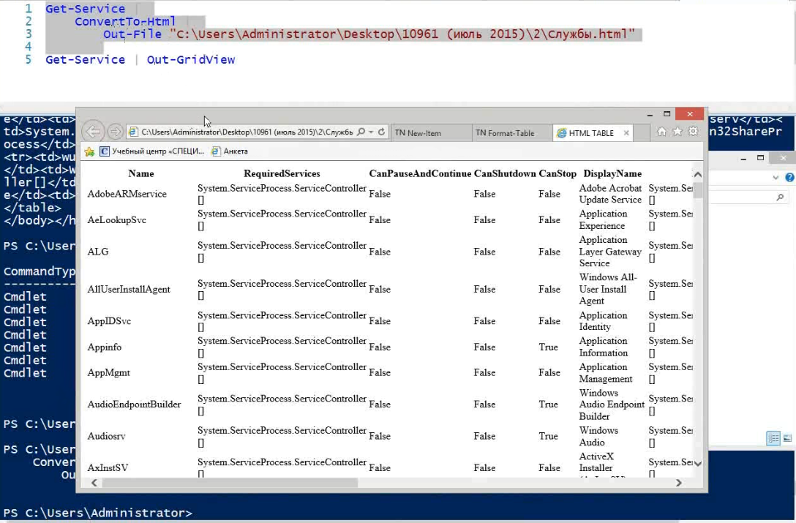

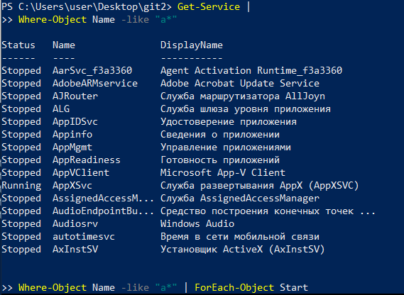

New-Variable -Name test3 -Value "powershell learning"

OR $test3 = "powershell learning"

Get-Variable

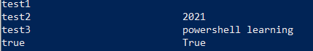

while

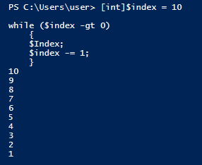

for ($indx = 20; $indx -GT 0; $indx -= 1){

$indx;

}

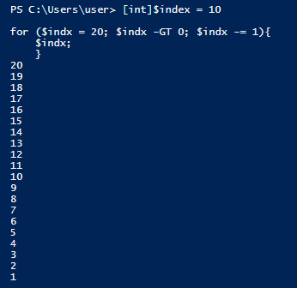

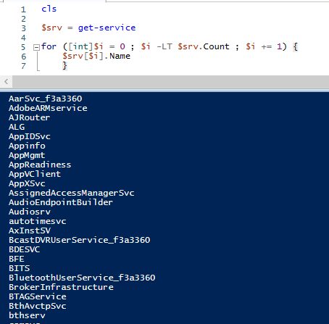

Another Variant

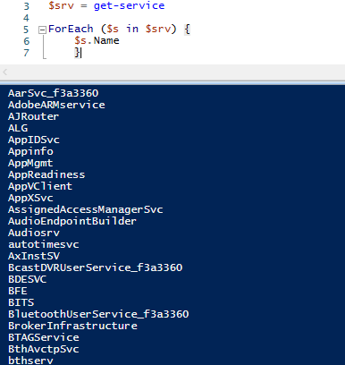

$num = 3

if ($num -GT 3) {

Write-Host "Greater than 3"

}

ElseIf ($num -LT 3) {

Write-Host "Less than 3"

}

Else {

Write-Host "Equals to 3"

}

Показать название каталога в корневой папке диска C: , в котором больше всего вложенных подкаталогов

$diskC = Dir "C:\" -directory #-directory only folders

$diskC

ForEach ($folder in $DiskC)

{

Dir -Directory $folder | Measure-Object

}

----------------------------------------------------------------------------------------

$diskC = Dir "C:\" -directory #-directory only folders

#$diskC

$MaxCount = 0

$MaxName = ""

ForEach ($folder in $DiskC)

{

$insidefolder = Dir -Directory $folder

if ($insidefolder.count -gt $MaxCount)

{

$MaxCount = $insidefolder.count

$MaxName = $folder.FullName

}

}

echo "result: "

$MaxName

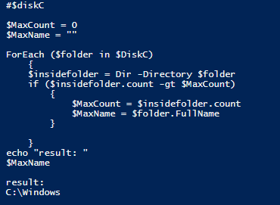

Чтобы запустить файл со скриптом powershell, для начала нужно убрать ограничения:

PS C:\> Set-ExecutionPolicy Unrestricted

PS C:\> powershell.exe .\script.ps1

result:

C:\Windows

PS C:\> .\script.ps1

result:

C:\Windows

[CmdletBinding()] #select some parameters for param

Param(

[parameter(Mandatory)] # to input $foldername is mandatory

[string]$foldername,

[string]$Ext = "\*" # $Ext is not mandatory, but if not input, value will be default

)

Write-Host ("Каталог: " + $foldername)

Write-Host ("Расширение: " + $Ext)

$diskC = Dir $foldername -directory #-directory only folders

#$diskC

$MaxCount = 0

$MaxName = ""

ForEach ($folder in $diskC)

{

$insidefolder = Dir -File ($folder.FullName + "\\*." + $Ext)

if ($insidefolder.count -gt $MaxCount)

{

$MaxCount = $insidefolder.count

$MaxName = $folder.FullName

}

}

echo "result: "

$MaxName

PS C:\> C:\script.ps1

Командлет script.ps1 в конвейере команд в позиции 1

Укажите значения для следующих параметров:

foldername: c:\windows

Каталог: c:\windows

Расширение: \*

result:

C:\windows\System32

PS C:\>

Создать папки с именем "PowershellFolder" в указанной директории

[string]$Froot = "C:\"

$Directory = Dir $Froot -Directory

ForEach ($folder in $Directory)

{

New-Item -Name "PowershellFolder" -ItemType Directory -Path $folder.FullName

}

Через конвейер

Dir C:\ -Directory | ForEach-Object CreateSubdirectory “PowershellFolder”