BHUK
SINGLE-CHAIN FOOD DELIVERY SYSTEM
MINI PROJECT REPORT
Prepared in accordance with the prescribed FA1 and FA2 formative assessment guidelines

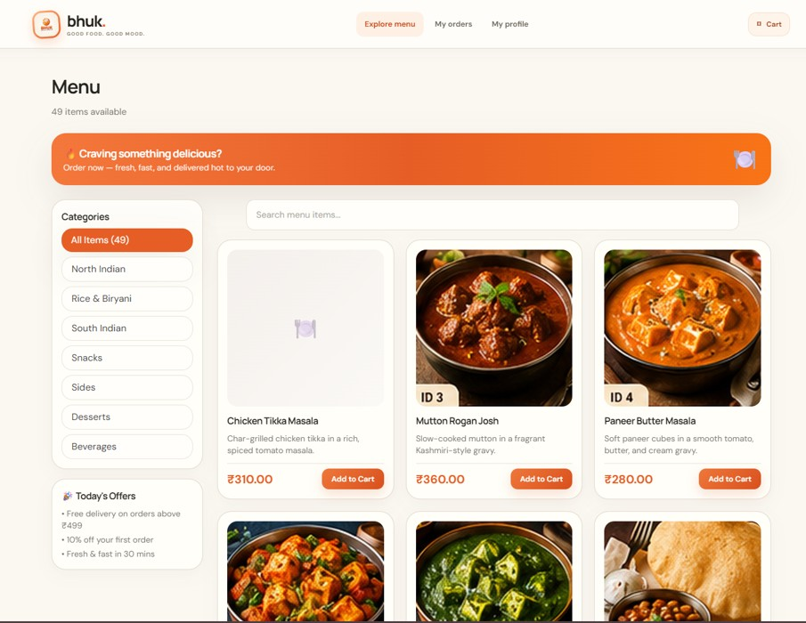

Particular | Details
Student | Abhishek Vishwakarma
Project | Bhuk — Single-Chain Food Delivery System
Repository | https://github.com/atabhishekx/bhuk
Programme / Department | ________________________________
Institute | ________________________________
Semester / Academic Year | ________________________________
Project Guide | ________________________________
Submission Date | ________________________________

Submitted for academic assessment. Complete the blank institutional fields before submission.

ABSTRACT
Bhuk is a web-based food delivery application designed for a single restaurant chain. It brings menu discovery, cart management, checkout, order creation, restaurant order processing, delivery assignment, order tracking and administrative operations into a coordinated digital workflow. The customer-facing interface is built with React and TypeScript using Vite, while the backend uses Java 17 and Spring Boot to expose REST APIs. MySQL stores operational data and Flyway manages database schema migrations. The architecture separates the presentation layer, API controllers, business services, repositories and persistence entities.
The project is developed in two formative assessment stages. FA1 covers problem analysis, objectives and scope, actor identification, functional and non-functional requirements, architecture, UML-style diagrams, database design, technology selection, development setup and the initial implementation. FA2 builds on that foundation through integration of major modules, object-oriented implementation, validation, exception handling, database verification, test execution and defect documentation.
The supplied project verification material records a successful backend compile and application startup, successful database migrations, menu and authentication endpoint checks, and order creation with related records. The supplied FA2 report records 31 passing backend integration tests, a successful frontend build with no TypeScript errors, and 22 of 23 functional requirements marked fully implemented. Payment processing is identified as the primary incomplete area. This report combines the FA1 and FA2 work, includes screenshots supplied by the project team, and provides separate diagram assets for reuse.
Keywords: Food delivery, React, TypeScript, Spring Boot, Java, MySQL, REST API, JWT, order management, database, testing.

1. INTRODUCTION

1.1 Background
Digital ordering platforms improve convenience for customers and help restaurant teams coordinate preparation and delivery. A complete food delivery workflow needs more than a menu page: it must manage cart contents, validate availability and pricing, record an order, provide status updates, support delivery operations and give authorized administrators operational visibility. If these activities are handled separately, duplicate orders, incorrect totals and unclear order states can occur.
Bhuk is designed as a single-chain restaurant ordering system rather than an open marketplace for unrelated vendors. It provides customer-facing ordering functions and operational interfaces for staff, delivery partners and administrators. The supplied screenshots demonstrate a menu page, sign-in page, administrator overview, order management, order detail history and menu management.

1.2 Problem Statement
The problem addressed by Bhuk is the lack of a unified digital workflow for menu browsing, order placement and fulfilment within a restaurant chain. The project aims to centralize customer ordering and operational processing while maintaining reliable data persistence, controlled access, validated state transitions and clear status visibility.

1.3 Objectives
- Provide an intuitive interface to browse menu items by category and search available items.
- Allow customers to manage a cart and proceed through checkout.
- Calculate trusted item prices, taxes and delivery fees on the server.
- Create persistent orders with item snapshots and status history.
- Support restaurant-side order review and preparation updates.
- Support delivery assignment and delivery status updates.
- Provide administrative visibility over orders and menu operations.
- Protect sensitive operations using authentication and role-based authorization.
- Maintain schema changes through versioned database migrations.
- Validate the implementation using tests and recorded evidence.

1.4 Scope and Assumptions
In Scope | Assumptions / Boundaries
Customer menu, categories, search and cart | The chain owns the menu; availability may be outlet-specific.
Checkout and order creation | Backend recalculates totals; client-submitted totals are not trusted.
Restaurant order processing | Only authorized staff can perform permitted state transitions.
Delivery assignment and tracking | Partner actions must be limited to assigned deliveries.
Admin overview, orders and menu management | Administrative functions require privileged roles.
Database persistence and API security | Existing Spring Boot/MySQL architecture is retained.
Payment gateway | The documented integration is partial; production payments require completion and testing.

1.5 Report Organization
Section 2 describes the system, actors, requirements, architecture, diagrams, database, technology stack and development setup. Section 3 presents results and discussion, including the supplied screenshots and recorded verification outcomes. Sections 4 and 5 present conclusions, future scope and references. The annexure provides representative code and endpoint examples. The FA1/FA2 mapping is provided separately so that the combined report can later be partitioned.

2. PROJECT DESCRIPTION

2.1 System Overview
The application follows a layered full-stack architecture. The browser-based frontend presents customer and operational pages and sends requests to the REST API. The backend authenticates requests, validates payloads, applies business rules, interacts with repositories and stores data in MySQL. Flyway migrations version database changes. External payment processing is represented as a separate integration boundary.
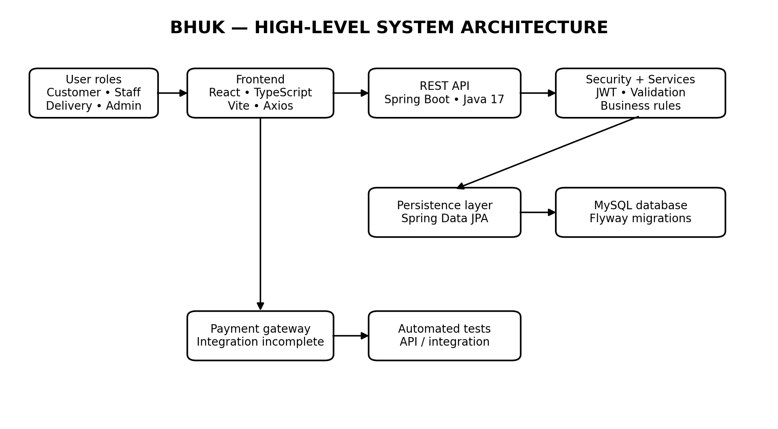
Figure 1. High-level architecture of the Bhuk Food Delivery System.

2.2 User Roles / Actors
Actor | Main responsibilities
Customer | Sign in, browse categories and dishes, manage cart, submit orders and review order status.
Restaurant staff | View incoming orders, accept/reject orders and update preparation status.
Delivery partner | Receive assigned delivery work and update pickup/delivery progress.
Administrator | View chain-wide operational summary, manage menu/categories and oversee orders.
Payment gateway | Process payment requests and deliver verified status events when fully configured.
Application backend | Enforce authentication, authorization, pricing rules, order lifecycle and persistence.

2.3 Functional Requirements
ID | Requirement
FR-01 | The application supports user authentication and protected API access.
FR-02 | Customers can view menu categories and menu item information.
FR-03 | Customers can add, update and remove items from their cart.
FR-04 | The backend calculates checkout pricing using trusted menu data.
FR-05 | The system creates orders and persists order-item details.
FR-06 | Order creation records a status event and supports duplicate-request protection where configured.
FR-07 | Restaurant staff can update order status through allowed transitions.
FR-08 | Delivery partners can view and update eligible delivery assignments.
FR-09 | Administrators can review orders and manage menu data.
FR-10 | Protected functions enforce user roles and relevant ownership restrictions.
FR-11 | Database changes are versioned and applied through migrations.
FR-12 | Payment initiation and reconciliation are supported to the extent implemented; full gateway integration remains pending.

2.4 Non-Functional Requirements
Category | Requirement
Security | Use secure password hashing, JWT validation, role checks and environment-based secrets.
Integrity | Validate prices and status transitions on the server; preserve order-item price snapshots.
Maintainability | Separate controllers, services, repositories, DTOs and entities.
Usability | Provide clear labels, readable status badges, responsive cards and useful validation messages.
Reliability | Handle errors consistently and avoid duplicate orders on supported retry paths.
Testability | Provide repeatable build, API and backend test commands.
Compatibility | Support modern browsers and the documented Java backend runtime.

2.5 Use-Case Diagram
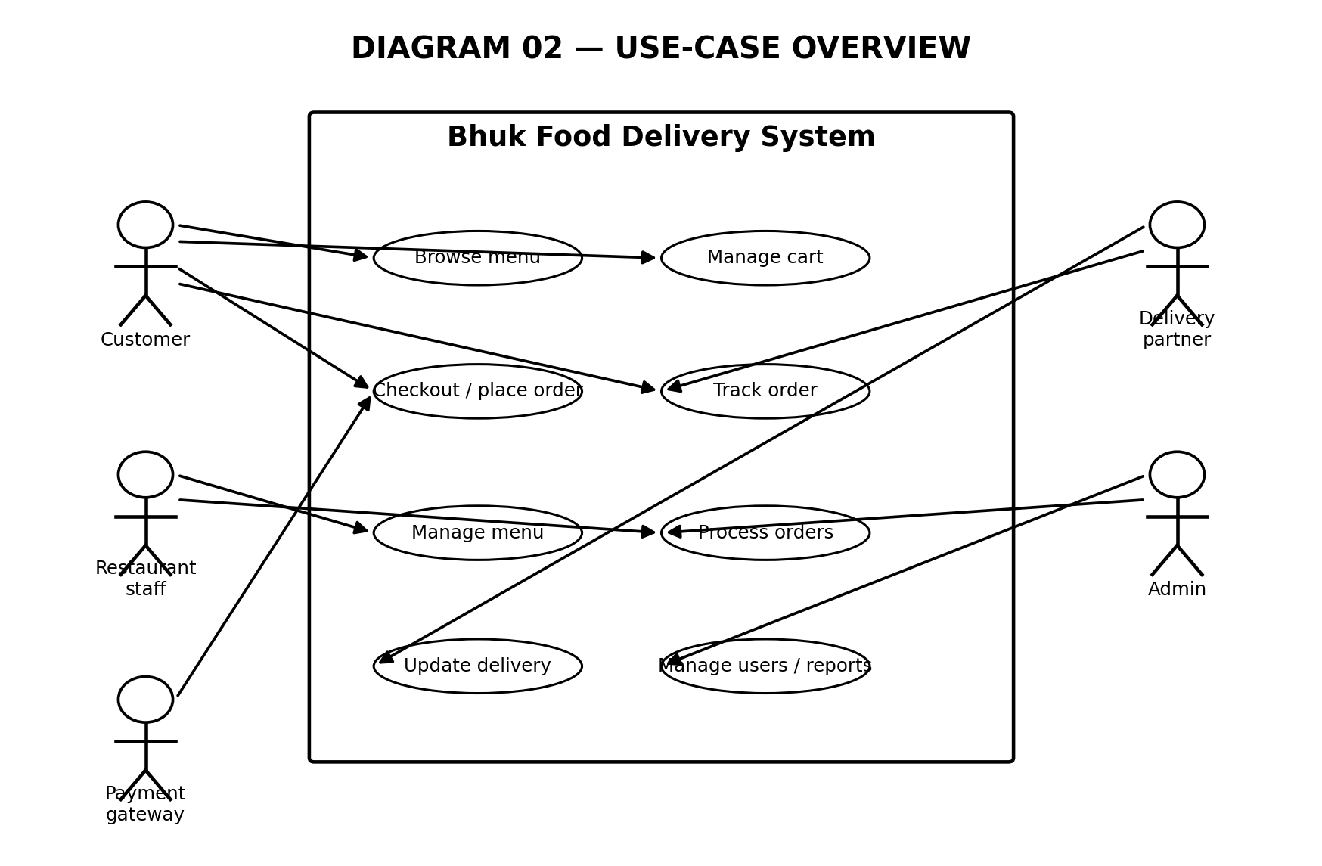
Figure 2. Use-case overview showing the primary actors and their system interactions.

2.6 Customer Order Activity Flow
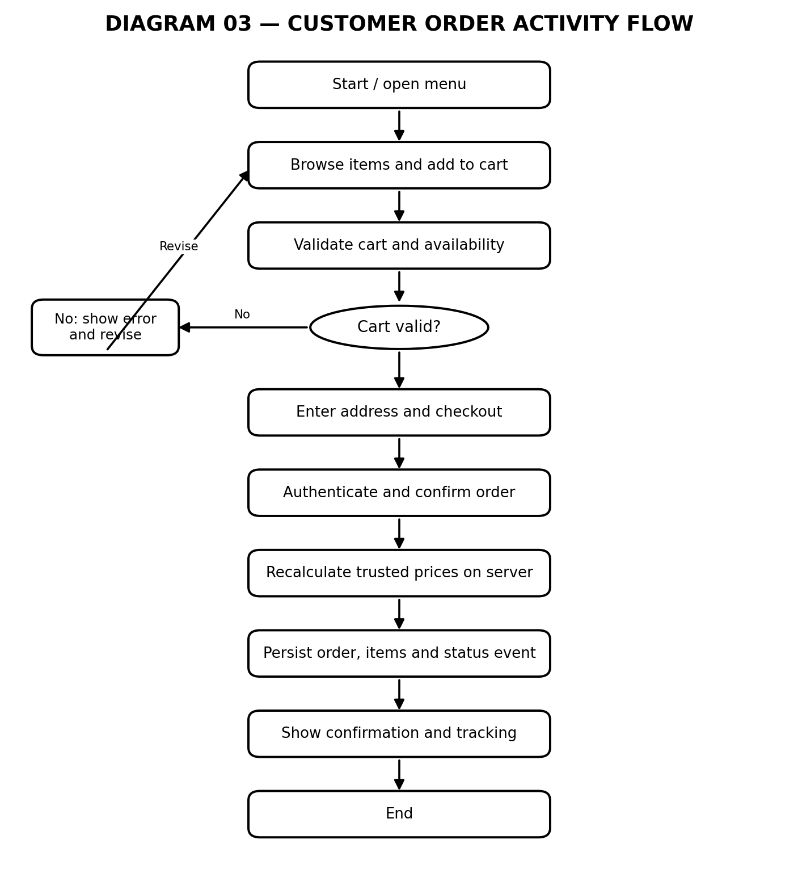
Figure 3. Customer ordering flow from menu discovery through confirmation.

2.7 Order State Machine
The expected order lifecycle moves from PLACED to ACCEPTED, PREPARING, READY FOR PICKUP, PICKED UP, OUT FOR DELIVERY and DELIVERED. A restaurant may reject a newly placed order. The backend must validate each transition and confirm that the acting user is authorized. The exact transition rules should match the state machine implemented in the submitted source.
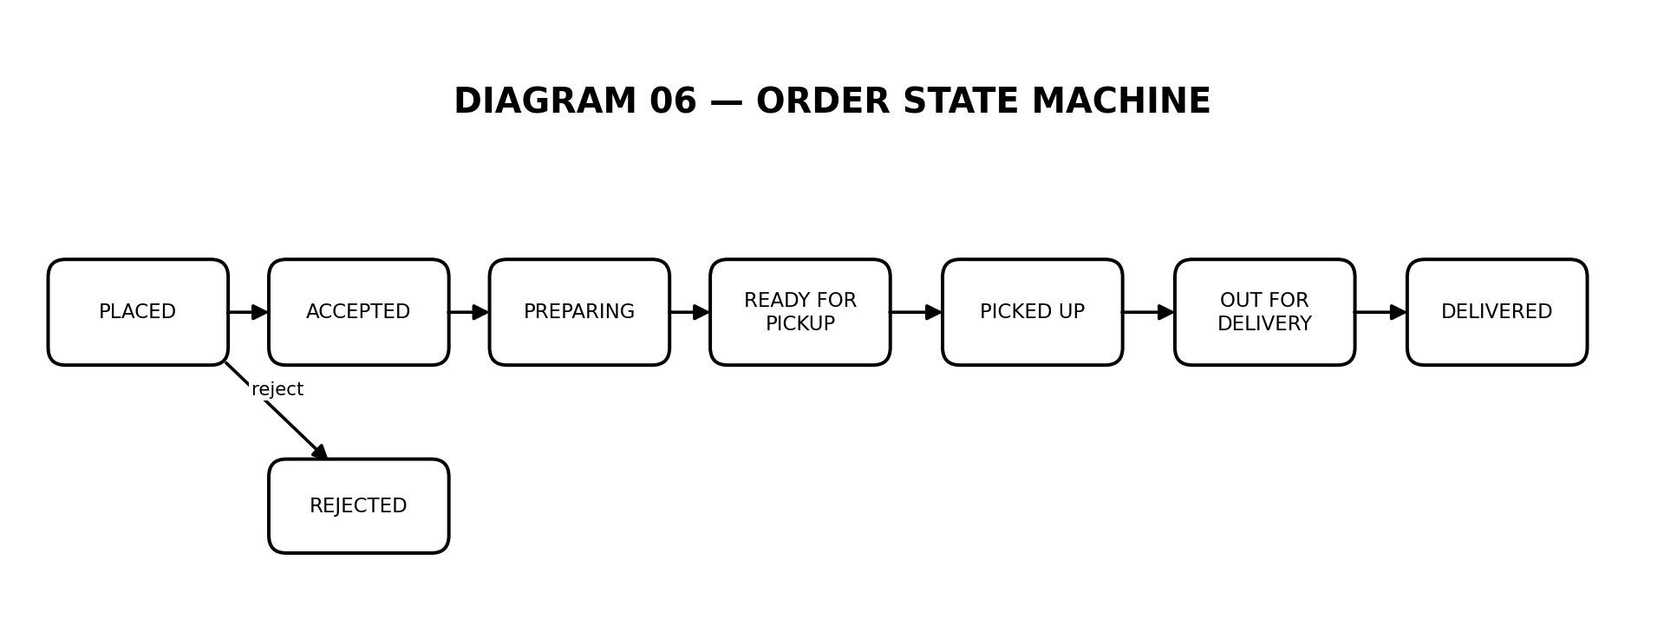
Figure 4. Simplified order lifecycle; actual transitions must match backend rules.

2. PROJECT DESCRIPTION (CONTINUED)

2.8 Database Design and ER Diagram
The conceptual data model includes users, addresses, carts, cart items, menu categories, menu items, outlets, orders, order items, payments and delivery assignments. These entities support the core ordering journey. User and order relationships establish ownership; menu categories group menu items; carts associate customers with selected items; orders contain item snapshots; and payment/delivery records connect operational outcomes to the order.
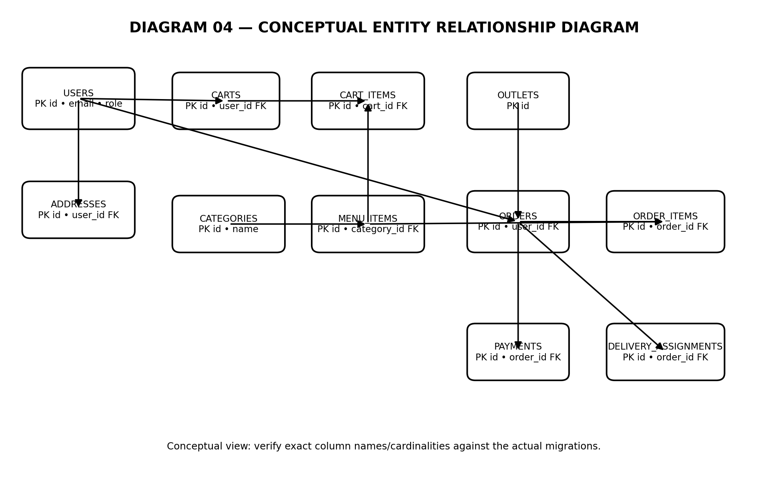
Figure 5. Conceptual ER diagram for the core Bhuk data model. Verify exact columns and cardinalities against the migrations.
The FA1 verification material reports nine Flyway migrations and 22 tables, while the audit's table listing appears to name additional tables. This inconsistency must be reconciled against the actual database schema before the report is treated as final evidence. The data model in Figure 5 is deliberately conceptual rather than a claim that every column shown matches the database verbatim.

2.9 Class Design and Object-Oriented Principles
The documented backend uses controllers for HTTP request handling, services for business logic, repositories for persistence, entities for domain data and DTOs for API contracts. This separation improves testability and limits coupling between transport, business rules and database operations. Typical OOP principles include encapsulation of domain state, abstraction through service/repository interfaces, composition between orders and order items, and controlled state transitions.
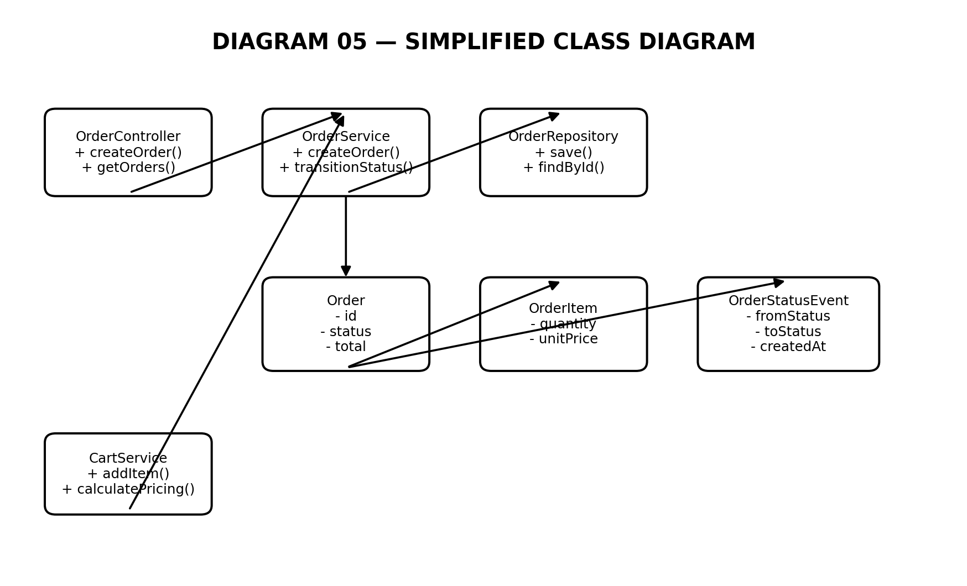
Figure 6. Simplified class diagram; representative names and operations should be checked against the source code.

2.10 Technology Stack
Layer | Technology | Purpose
Frontend | React 19, TypeScript, Vite | Component-driven UI and build tooling.
Routing / HTTP | React Router DOM, Axios | Client-side navigation and API calls.
Styling | Tailwind CSS | Responsive utility-first styling.
Backend | Java 17, Spring Boot | REST APIs and business logic.
Security | Spring Security, JWT | Authentication and role-based authorization.
Persistence | Spring Data JPA | Mapping domain entities and database operations.
Database | MySQL | Relational application storage.
Migrations | Flyway | Versioned schema changes.
Build / test | Maven and npm | Dependency management, build and test commands.
Payments | Gateway integration (partial) | Payment processing boundary; production flow remains incomplete.

2.11 Development Environment and Project Structure
The project uses a separate frontend and backend development workflow. Install the dependencies in the directory containing the relevant package.json and run the backend from the directory containing the Maven wrapper or pom.xml. The environment should supply database connection values, server port and JWT secret without committing credentials.
Backend: ./mvnw clean test
Backend: ./mvnw spring-boot:run
Frontend: npm install
Frontend: npm run dev
Frontend: npm run build

2.12 Security, Validation and Exception Handling
- Authenticate protected requests and validate JWTs on the backend.
- Apply role checks to administrator, staff and delivery operations.
- Validate required fields, email formats, quantities and identifiers.
- Recalculate totals using trusted database prices rather than browser-supplied totals.
- Reject invalid order-state transitions and unauthorized access to another user's order.
- Return consistent API error responses and avoid exposing secrets or stack traces.
- Use transactions for operations that must persist an order and its related records consistently.

2.13 Payment Integration Status
The supplied FA2 material identifies payment processing as the principal incomplete functional area. A production implementation should create payment orders securely, verify gateway signatures, authenticate webhooks, process duplicate events idempotently, reconcile payment status and handle failure/refund paths. The system should not display payment success solely because the browser reports it.

3. RESULTS AND DISCUSSIONS

3.1 Customer Menu Interface
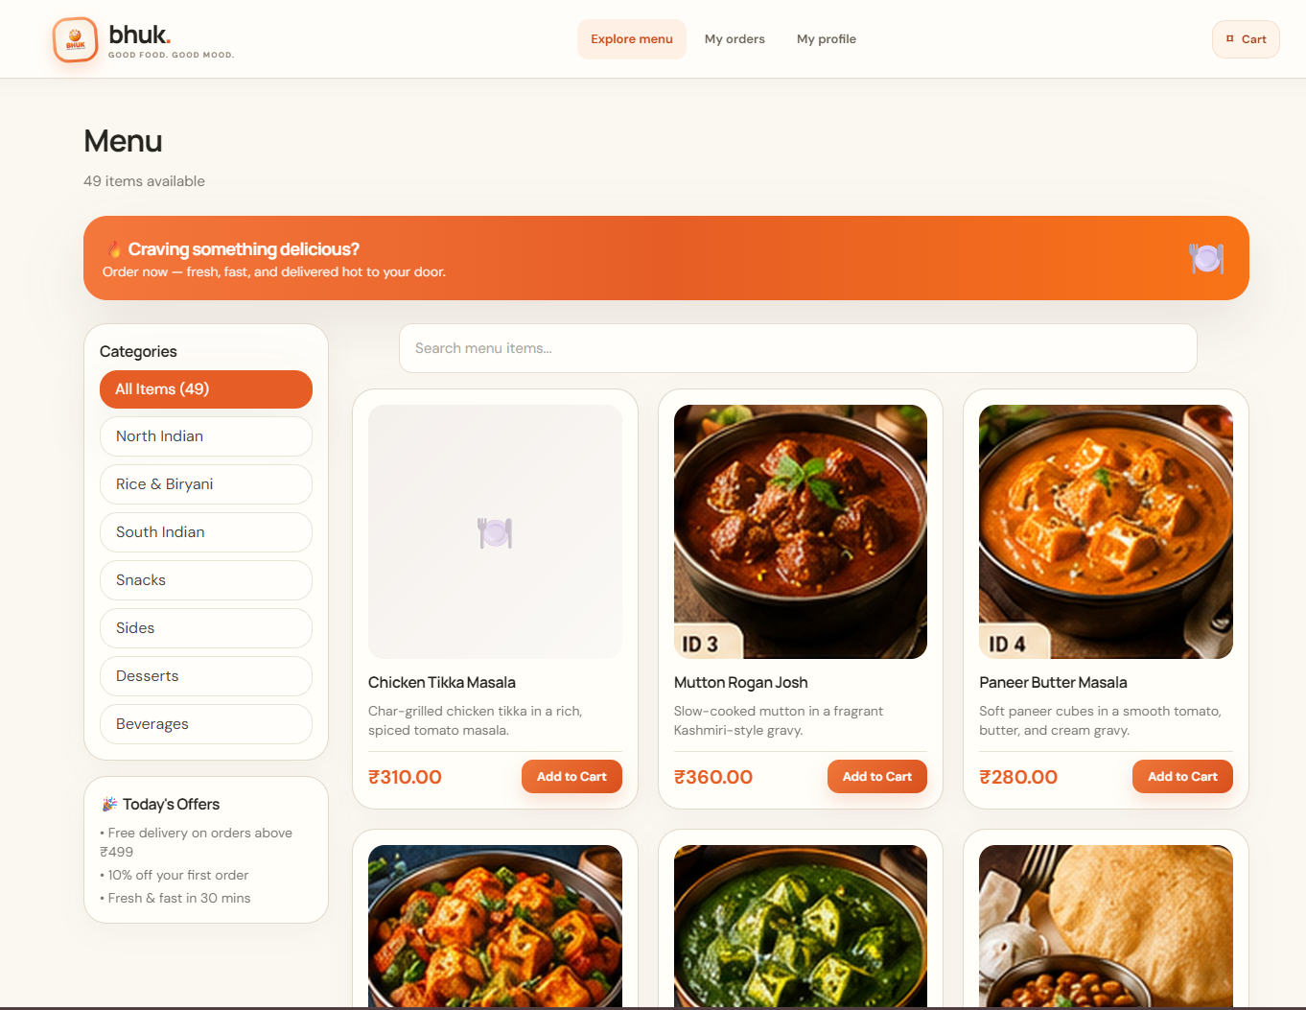
Figure 7. Customer menu page showing categories, search, dish cards, descriptions, prices and add-to-cart controls.
The menu page presents a category sidebar, search field, promotional banner and food cards with descriptions, prices and add-to-cart actions. The interface uses a warm neutral background and orange accent color to establish a consistent restaurant identity. The supplied screenshot shows 49 available items in the current view; this is a screenshot-specific count and may differ from seeded or later menu data.

3.2 Customer Authentication
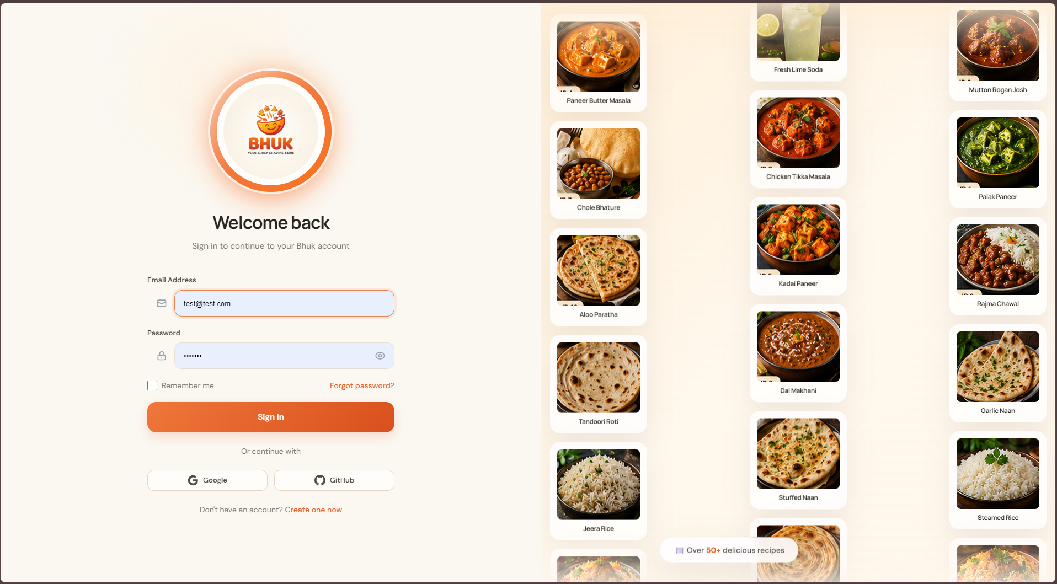
Figure 8. Sign-in interface with email/password fields, password visibility control and account options.
The login page provides a branded sign-in experience with input labels, password visibility, remember-me option and account navigation. Authentication must still be enforced by the backend, and any third-party sign-in buttons should be treated as enabled only if their provider integrations are configured.

3.3 Administrator Dashboard
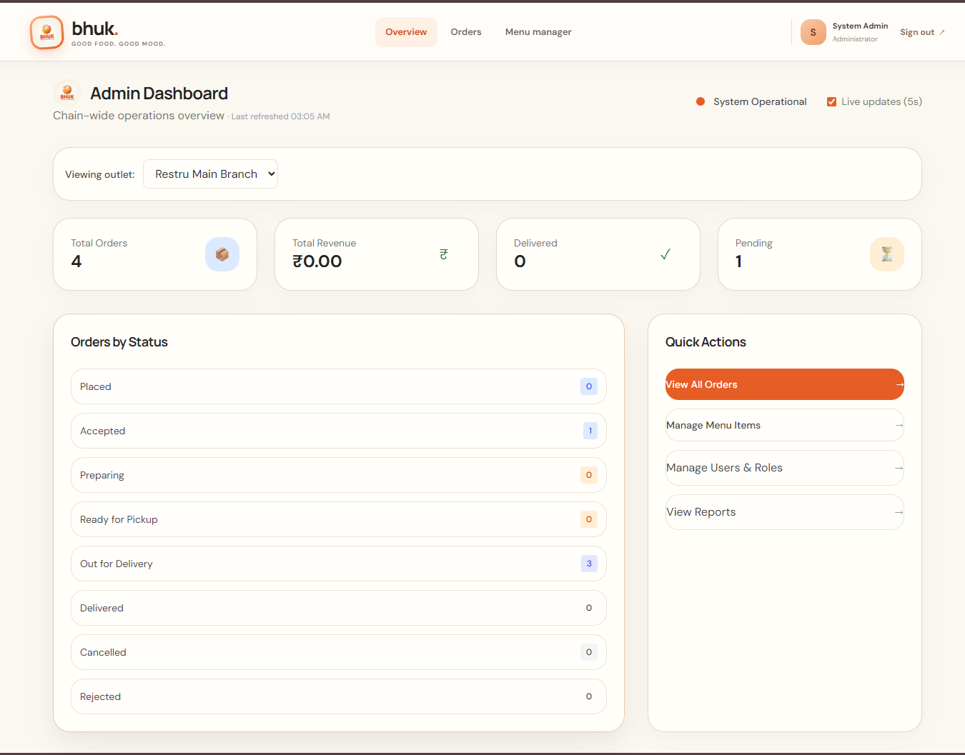
Figure 9. Administrator dashboard showing order and revenue summaries, status counts and quick actions.
The administrator dashboard summarizes operational activity and offers shortcuts to order management, menu management, user/role management and reports. The shown figures represent the captured test environment at that moment and should not be interpreted as production business metrics.

3. RESULTS AND DISCUSSIONS (CONTINUED)

3.4 Order Management
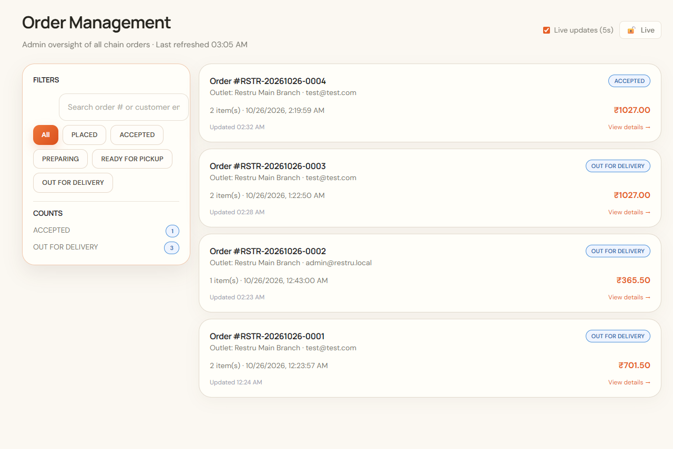
Figure 10. Order management screen with search, status filters, order summaries and detail navigation.
The order management screen gives administrators a consolidated view of orders, customer/outlet details, item counts, timestamps, status and totals. Filters and search help narrow the displayed orders. Role restrictions and server-side status validation remain essential even when the interface presents controls conditionally.

3.5 Order Detail, Pricing and Status History
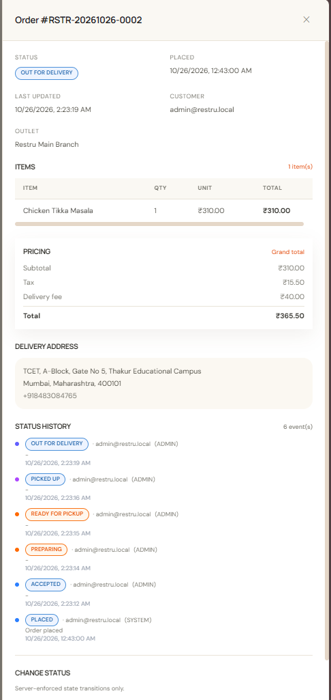
Figure 11. Order detail panel showing status, line items, subtotal, tax, delivery fee, total, address and status history.
The order detail view exposes the item breakdown and pricing components as well as delivery address and status history. This supports operational traceability and helps users understand how the displayed total is composed. The values shown are illustrative records from the captured environment; sensitive customer data should be masked in publicly shared reports.

3.6 Menu and Category Management
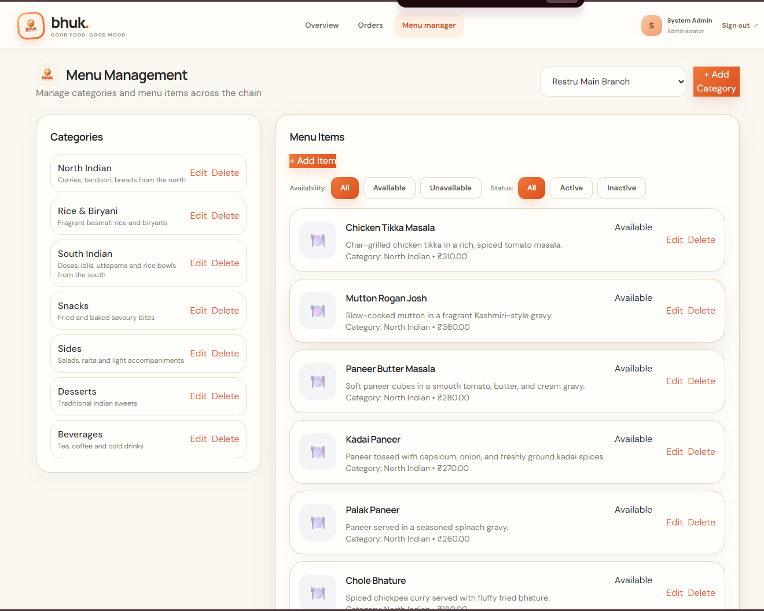
Figure 12. Administrator menu manager with category management, item availability filters and edit/delete actions.
The menu management page allows authorized staff to view categories and menu items, filter by availability/status, and access create/edit/delete controls. Destructive operations should require appropriate authorization and, where necessary, confirmation. Server validation must prevent invalid prices, missing categories and accidental changes to items referenced by historical orders.

3.7 FA1 Results — Initial Implementation
Verification activity | Evidence reported in supplied FA1 material
Backend compile | Maven clean compile completed successfully.
Database migration | Nine Flyway migrations reported as applied.
Application startup | Spring Boot application started on port 8080.
Health endpoint | GET /api/v1/health returned HTTP 200 and status UP.
Menu API | Category, item-list and item-detail endpoints returned data.
Authentication | Login returned a JWT and a protected cart request accepted the token.
Order creation | Test order, order items, status event and idempotency record were reported as persisted.

These results support the FA1 claim that the project foundation and a major ordering module were established. The screenshots in Figures 7–12 provide visual evidence of the customer menu, authentication and administrative workflows.

3. RESULTS AND DISCUSSIONS (CONTINUED)

3.8 FA2 Results — Integration and Testing
Metric | Recorded result | Interpretation
Backend integration tests | 31 passed | As recorded in the supplied FA2 report; retain the test log as evidence.
Frontend build | Successful; zero TypeScript errors | Indicates a successful recorded build, not proof of deployment readiness.
Functional requirements | 22/23 marked fully implemented (95.7%) | Payment integration is identified as partially implemented.
Non-functional requirements | 15/15 reported met | Use the detailed verification checklist to substantiate each item.
Payment integration | Partial | Live gateway processing and reconciliation remain incomplete.

3.9 Order Creation Sequence
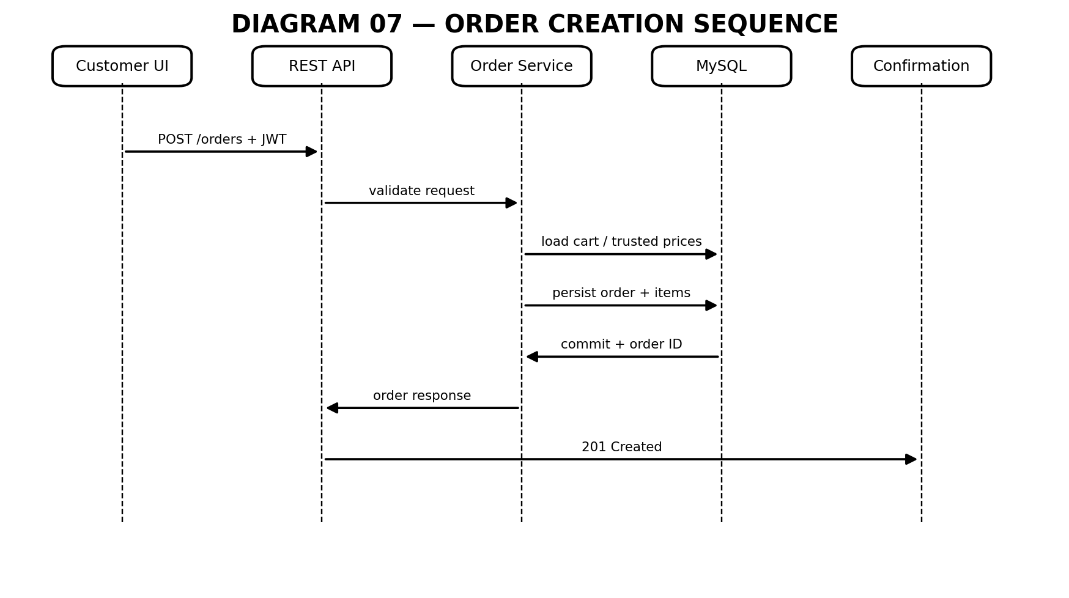
Figure 13. Sequence overview of order creation across the user interface, REST API, service and database.
The expected order creation path begins when the customer confirms checkout. The API authenticates the request, the service validates cart contents and trusted prices, and the database persists the order and associated records. A successful response returns the order identifier and status. Repeated requests should be handled according to the application's idempotency implementation.

3.10 Discussion and Limitations
The supplied materials indicate that the project has moved beyond a static UI into a layered full-stack application with ordering and operational interfaces. The role-oriented screens make the intended workflow visible, while the database and API checks provide evidence of persistence and access control. The most significant outstanding area is payment gateway completion. Additional verification is also needed to reconcile the reported database table count and to retain actual test logs with the final submission.
- Do not present the test environment's dashboard totals as live business results.
- Replace or mask any personally identifying data in screenshots before public distribution.
- Attach backend test output and frontend build logs to the submission evidence.
- Verify the exact database schema and migration count before finalizing the report.
- Confirm that all role-specific operations are enforced by backend authorization.

4. CONCLUSION AND FUTURE SCOPE

4.1 Conclusion
Bhuk demonstrates the design and implementation of a single-chain food delivery application using React, TypeScript, Java, Spring Boot and MySQL. FA1 established the problem definition, objectives, scope, actors, requirements, architecture, diagrams, database design, development environment and initial module implementation. FA2 focused on completing and integrating core workflows, documenting OOP design, validating inputs, handling exceptions, verifying persistence, executing tests and recording defects.
The supplied project evidence reports successful backend compilation and startup, working menu and authentication endpoints, a tested order-creation path, 31 passing backend integration tests and a successful frontend build. The captured screenshots show the customer menu, login page, administrator overview, order management, order detail history and menu manager. The payment gateway remains incomplete, so production readiness should not be claimed until the integration and reconciliation path is fully implemented and tested.

4.2 Future Scope
- Complete payment gateway order creation, signature verification, webhook handling and reconciliation.
- Add automated end-to-end tests for customer checkout and the restaurant-to-delivery lifecycle.
- Implement customer notifications through email, SMS or push services where appropriate.
- Add operational logging, metrics, backup and recovery procedures.
- Conduct security review, load testing, accessibility checks and responsive-device testing.
- Improve delivery tracking and estimated delivery time where location services are available.
- Add reporting for popular dishes, order fulfilment time, cancellations and outlet performance.
- Prepare deployment hardening and monitoring before accepting real customer orders.

5. REFERENCES
[1] Bhuk project repository, “Bhuk — Single-Chain Food Delivery System,” GitHub. Available: https://github.com/atabhishekx/bhuk. Accessed: 26 October 2026.
[2] Bhuk FA1 project documentation, including implementation audit, requirements specification, system architecture, database design and verification results, supplied project files, 2026.
[3] Bhuk FA2 project documentation, including gap analysis, OOP implementation, validation and exception handling, test execution results, database verification, bug/fix log and functional completion status, supplied project files, 2026.
[4] React, “React Documentation.” Available: https://react.dev/.
[5] Spring, “Spring Boot Reference Documentation.” Available: https://docs.spring.io/spring-boot/.
[6] Oracle, “Java Documentation.” Available: https://docs.oracle.com/en/java/.
[7] MySQL, “MySQL Reference Manual.” Available: https://dev.mysql.com/doc/.
[8] Redgate, “Flyway Documentation.” Available: https://documentation.red-gate.com/flyway/.
[9] OWASP Foundation, “OWASP Cheat Sheet Series.” Available: https://cheatsheetseries.owasp.org/.
[10] M. Jones, J. Bradley and N. Sakimura, “JSON Web Token (JWT),” RFC 7519, IETF, May 2015. Available: https://www.rfc-editor.org/rfc/rfc7519.

6. ANNEXURE (CODE)
This annexure gives concise representative examples of the application structure and workflow. These are explanatory excerpts, not a substitute for the actual source. The submitted GitHub repository remains authoritative; ensure the excerpts match the final commit before submission.

Annexure A — Representative REST endpoints
Method | Endpoint family | Purpose
GET | /api/v1/health | Check application health.
GET | /api/v1/menu/categories | List menu categories.
GET | /api/v1/menu/items | List/search menu items.
POST | /api/v1/auth/login | Authenticate and issue a JWT.
GET | /api/v1/cart | Read the authenticated customer's cart.
POST | /api/v1/orders | Create an order from validated cart data.

Annexure B — Illustrative order service flow
// Illustrative pseudocode: confirm names and implementation in the repository.
@Transactional
public OrderResponse createOrder(CreateOrderRequest request, User user) {
validateRequest(request);
checkIdempotencyKey(request.idempotencyKey(), user);

Cart cart = cartRepository.findByUser(user)
.orElseThrow(() -> new ResourceNotFoundException("Cart not found"));

PricingResult pricing = calculateServerSidePricing(cart);
validateAvailability(cart);

Order order = createOrderFromTrustedCart(user, cart, pricing);
orderRepository.save(order);
recordInitialStatusEvent(order);
saveIdempotencyRecord(request.idempotencyKey(), order);

return mapToResponse(order);
}

Annexure C — Illustrative request validation
// Illustrative DTO: compare with the actual request class/record.
public record RegisterRequest(
@NotBlank String name,
@NotBlank @Email String email,
@NotBlank @Size(min = 8) String password
) {}

Annexure D — FA1 and FA2 partition map
FA1 — Requirement analysis, design and initial implementation | FA2 — Core implementation, integration and testing
Problem statement, objectives and scope | Completion of approved functional modules
Actors and functional/non-functional requirements | Frontend, backend and database integration
Use-case, activity, ER and class diagrams | Java/OOP evidence from actual source
Database design and technology stack | Input validation and exception handling
Development environment and project structure | Database operations and persistence verification
Initial implementation of one major module | Test cases, execution results and defect fixes
Initial implementation screenshots | Updated progress, final screenshots and completion status

Annexure E — Submission checklist
- Complete the college, programme, semester, guide and date fields on the cover page.
- Verify all statements against the final GitHub commit and FA1/FA2 evidence archives.
- Keep all six provided application screenshots and seven diagrams in the accompanying folders.
- Attach actual test logs and build output if the instructor requires them.
- Reconcile database table/migration counts against the live schema.
- Document the payment gateway as incomplete until end-to-end sandbox verification passes.
- Review screenshot privacy and redact sensitive data where required.
Repository: https://github.com/atabhishekx/bhuk
End of report.

