UML Diagram

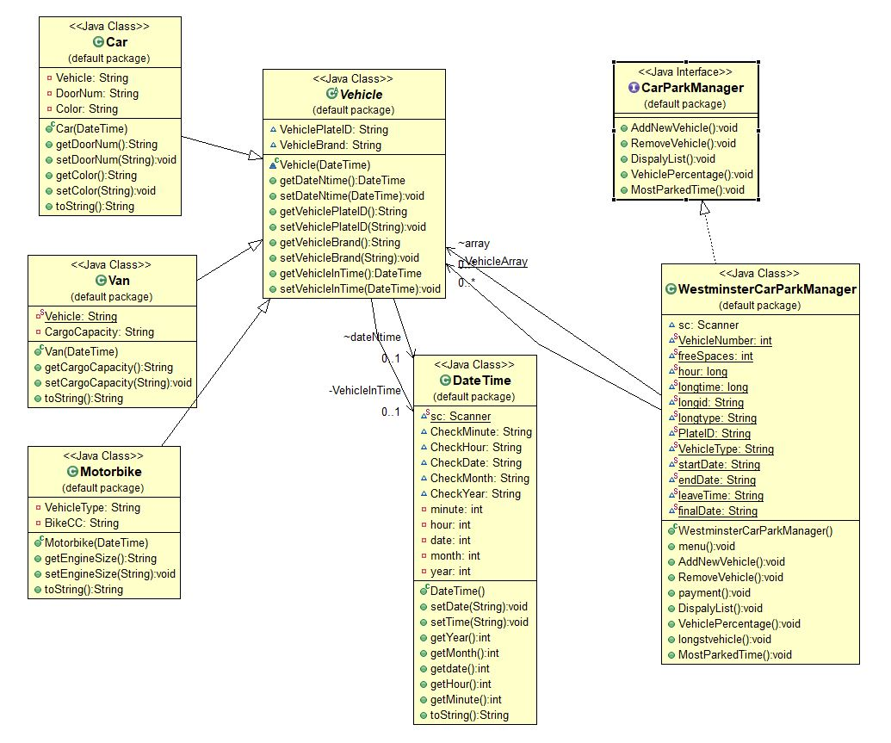

Use Case Diagram

Use Case Diagram