Task Passport Project Report
  - Purpose Goals Architecture and Hackathon Delivery
Prepared for the Task Passport hackathon team
Goldman Sachs AI Control Layer challenge HackYeah 2026
3 October 2026 Version 1.0 Design baseline
Task Passport gives an AI agent permission to complete one bounded job. We define the permitted tools, records, destinations, approvals, and usage limits in a trusted task grant, then check proposed actions before they produce effects. The first demonstration uses synthetic invoices and a simulated report outbox.
Our goal is a useful task completing under visible controls. The report brings the product definition, technical architecture, demonstration, team plan, and evidence requirements into one editable reference.
Status Proposed design and delivery plan. A running implementation has not been reviewed for this report. Example limits are illustrative; validation targets are not test results.

Contents
Use the linked section titles to navigate the report. Page references reflect the reviewed report layout.
Report purpose and design status 3
Project definition purpose and intended outcome 3
Mapping the proposal to the Goldman Sachs challenge 4
Users operating model and proposed user journeys 6
Functional requirements MVP boundary and deferred scope 7
Architecture and chart reading guide 9
Technical architecture and service ownership 18
Data ownership and the transition from starter to product 19
Trusted authority and passport invariants 20
The enforcement loop and data minimization 21
Exact action approval versioning and execution rechecks 21
Atomic allowances hard limits and estimated cost 22
Durable state idempotency audit and uncertain outcomes 23
Threat model limits and unresolved design choices 24
Positioning differentiation and credible product claims 24
Illustrative invoice scenario and future domain adaptations 26
Delivery scope and six person ownership 27
Relative implementation milestones and critical dependencies 28
Live demonstration storyboard and proof checks 29
Validation plan and evidence matrix 31
Research documentation and submission workflow 32
Risk register and scope controls 33
Phased roadmap beyond the prototype 34
Illustrative passport and interface contracts 34
Design decision record 37
Terminology for developers and presenters 38
Sources and evidence register 39

Report purpose and design status
We are building Task Passport as a proposed entry for the Goldman Sachs AI Control Layer challenge at HackYeah. Our goal is to demonstrate that an AI agent can complete a useful business task while the application retains control over the data it may access, the actions it may take, and the resources it may consume. The initial use case is invoice reconciliation using synthetic records and a simulated message outbox.
This report is the team’s shared product and engineering reference. It explains what we want to build, why the controls belong in the execution path, how the selected services should cooperate, what evidence the demonstration must produce, and how a six-person team can deliver a coherent prototype. It also gives the research and presentation owner enough context to explain the design without relying on undocumented developer knowledge.
The report records a proposed design rather than measured implementation results. The artifacts reviewed for this report are the architecture specification, the architecture and execution-flow Mermaid diagrams, the generic starter prompt, and the decisions recorded in our project discussion. A running application or any work completed elsewhere has not been reviewed. Statements about behavior are requirements or expected outcomes until the team records verification evidence.
Our immediate delivery decision is to use Next.js, NestJS, Go, and PostgreSQL, with TypeORM as the migration and application persistence toolchain on the NestJS side. We should demonstrate one workflow, one model provider, and four registered tools. The full architecture describes a target boundary; it is not a requirement to implement every administrative screen or operational refinement during the hackathon.

How to read the report
Product sections explain the problem, users, and desired outcome. The architecture figures and technical sections explain where authority resides and how the controls work. Delivery sections identify the minimum build, team ownership, demonstration, evidence, and risks. The appendices provide illustrative contracts, decision records, terminology, and sources for later reference.
Source identifiers such as [S1] refer to the source register at the end. External sources establish challenge framing or existing technical capabilities. Our proposed architecture and acceptance criteria are team design decisions. Numerical limits and example records in the appendices are illustrative configuration values, not sponsor requirements or measured performance.

Project definition purpose and intended outcome
Task Passport is a proposed control layer for delegating a bounded business job to an AI agent. Its purpose is to make the delegation understandable to the operator and enforceable by the software that executes the agent’s actions. The central promise is simple: the agent receives authority to complete this job, with these resources and these limits. It does not receive unrestricted authority merely because a tool is available.
The proposed hackathon product is one complete invoice reconciliation workflow, supported by a task setup interface, a governed agent runtime, exact-action approvals, spending and usage limits, and a readable activity timeline. The architecture specification defines intended behavior; implementation and security properties require verification against the final application. The design should be evaluated as a prototype proposal, with actual results recorded separately.

The problem the product would solve
An organization may want an agent to read selected invoices, compare them with vendor records, prepare an internal report, and queue a reviewed message. Those capabilities can become dangerous when the agent reads an adversarial document, mistakes an instruction for evidence, chooses an unrelated record, changes the recipient, or repeatedly retries an unsuccessful operation. A general permission to read invoices or send reports is too broad to express the limits of one delegated task.
Task Passport would place a decision point before every governed model request and tool effect. The model could propose an action, but the runtime would decide whether the action fits authenticated user authority, organization policy, and the task’s narrower scope. This would make the execution boundary responsible for enforcing permissions, rather than relying on the model to remember and obey a paragraph of instructions.

What a passport would contain
A passport would be an immutable grant tied to an organization, operator, task version, policy version, and expiry. It would identify the permitted tools, records, destinations, field-handling rules, and usage limits. Admission would derive the grant from trusted application records and authenticated operator context. The agent would not be permitted to invent a user identity, expand its own scope, or approve its own operation.
The task setup screen would expose these choices in business language: which invoices to reconcile, which vendor is involved, where a report may go, which action needs review, and how long the run may continue. The operator would see the issued passport before or alongside execution. If requested scope exceeds available authority, admission rejects it with an explanation; the operator can submit an explicitly narrowed task.

The intended outcome
- A legitimate invoice task would finish and leave an inspectable report in application state.
- An out-of-scope request would produce a recorded denial and no corresponding business effect.
- A reviewed action would execute only with its approved content, destination, and current record preconditions.
- A blocked proposal could receive bounded correction feedback, allowing useful work to continue where a permitted alternative exists.
- Usage limits, uncertain outcomes, cancellation, and approval waits would remain visible and durable across worker restarts.

Mapping the proposal to the Goldman Sachs challenge
The official AI Control Layer brief asks how organizations can retain control as agents access resources and automate workflows [S1]. The three named concerns are sensitive data exposure, unauthorized actions, and unpredictable costs, alongside the need to preserve innovation and developer productivity. Task Passport would address those concerns through the actual execution path of one useful business workflow.
This mapping is a proposed product interpretation, not a Goldman Sachs feature specification or judging rubric. The team should reconcile the report with the final official task description released for the event. Any additional requirements, submission instructions, or organizer clarifications should be recorded separately and incorporated without presenting the team’s design choices as sponsor mandates.

Why successful work matters as much as blocked work
A control layer that stops every interesting action could appear safe while failing the business objective. The proposed demonstration would therefore begin and end with successful reconciliation. The protected run should still produce a useful result, while the injected or out-of-scope branch would be denied. The team would distinguish inability to complete the task from a justified interruption that preserves a permitted path forward.
Exact-action review would be reserved for a meaningful effect such as queuing an outbound report. Reading a scoped invoice and preparing an internal report would normally proceed automatically. This selective intervention would make the product easier to assess: the organization decides where approval is required, and the agent remains productive within that boundary.

Claims the prototype should avoid
- Do not claim universal prompt-injection detection; demonstrate specific attempted actions being constrained regardless of how the model reached them.
- Do not equate a spending estimate with a precise provider invoice, especially when reported usage is incomplete.
- Do not describe a simulated outbox as live email delivery or an invoice report as a real payment operation.
- Do not imply that routing selected tools through the gateway controls credentials or tools that remain accessible elsewhere.
Challenge concern, proposed control and evidence
Concern | Proposed response | Evidence to demonstrate
Sensitive data exposure | Restrict records and returned fields; use opaque references for selected protected values; constrain report content; show exact outbound effects only to authorized reviewers. | Inspect what reaches the model, the simulated outbox, and the general activity feed. Confirm that a forbidden record or destination does not produce an effect.
Unauthorized actions | Validate typed tool arguments against task scope, organization policy, current revocations, record versions, and any required exact-action approval. | Attempt a different invoice, changed recipient, expired approval, and edited payload. Show denied decisions and unchanged business state.
Unpredictable costs | Reserve allowance before dispatch; impose model-call, token, tool-attempt, correction, and time limits; retain unresolved cost reservations. | Run a bounded retry scenario and show execution stopping at the configured limit, with usage and uncertainty recorded.
Developer productivity | Offer a stable tool contract and reusable task template; keep ordinary permitted work automatic; provide structured denial reasons and a focused rehearsal suite. | Show a valid task completing and a recoverable blocked proposal continuing without an operator manually approving every step.

Users operating model and proposed user journeys
The proposed product would serve the people who define a job, the people who approve its consequential effects, and the developers who make business tools available. These responsibilities should remain distinct even if one hackathon demonstrator plays several roles. The organization boundary would be enforced in the application and runtime, not inferred from a record identifier supplied by the browser or agent.

Journey 1 create and delegate a task
The operations user would choose an invoice reconciliation template, identify the vendor and invoice set, request an allowed destination, and choose available limits. NestJS would authenticate the user and verify organization membership. Go would validate the authoritative task and policy versions, derive the permitted grant, and create the passport, run, and durable job together.
The run page would then show the task goal, issued scope, current state, usage, and chronological activity. A denied admission would explain which requested authority was unavailable. The user should not need to understand service boundaries or database schemas to recognize what the agent is allowed to do.

Journey 2 review an exact outbound effect
When the agent proposed queuing a report, the runtime would store a fixed action and pause the job. The reviewer would see the recipient, rendered content, referenced records, and reason review is required. A decision would travel through the authenticated application API to Go, which would verify reviewer authority and persist the grant.
Approval would apply to the original stored action. A changed recipient, changed content, expired grant, revoked permission, or changed relevant record version would require renewed checks and potentially a new review. The interface would clearly distinguish approval waiting, rejection, expiry, execution success, and an uncertain result.

Journey 3 recover cancel or investigate
A blocked proposal would show a concrete rule and a bounded correction route where appropriate. If no permitted alternative remained, the run would stop with an explanation. The operator could cancel future dispatches, while the interface would retain already committed effects and explain that cancellation is not a reversal mechanism.
An audit reader would trace the passport, action, rule version, reviewer decision, and resulting effect through sanitized events. A tool operation with an unknown outcome would pause for reconciliation; the product would not quietly convert a timeout into permission to repeat a potentially completed action.
Proposed user responsibilities
User | Need | Authority in the proposed product
Operations user | Complete a scoped reconciliation task and understand its progress. | Create tasks within their organizational authority; inspect permitted run details; request cancellation.
Authorized reviewer | Know exactly what an agent intends to send or change. | Approve or reject a stored action after viewing its precise effects; approval does not grant general agent permission.
Policy administrator | Define reusable organizational boundaries and emergency revocations. | Maintain versioned policies and permitted task templates; reduce or revoke authority through trusted configuration.
Tool developer | Connect a business capability without rewriting every agent workflow. | Implement registered typed adapters, idempotency behavior, and data minimization rules; arbitrary code is outside policy configuration.
Audit reader | Understand why a run proceeded, paused, or stopped. | Read authorized, sanitized decisions and evidence; access to full sensitive payloads would require separate authority.

Functional requirements MVP boundary and deferred scope
The proposed MVP would use Next.js for task setup and review, NestJS for identity and configuration, Go as the sole agent execution authority, and PostgreSQL for application, runtime, and synthetic business state. It would use one model provider and four registered tools: read_invoice, read_vendor, create_report, and queue_report. The objective would be a complete and reviewable workflow, rather than a large catalog of partial integrations.

Product decisions that keep the MVP coherent
Only registered adapters would be executable. An administrator could configure permissions for those adapters, but a policy edit would not introduce arbitrary code, URLs, or tools. The agent would propose one action per model step, keeping policy decisions, approvals, and replay behavior inspectable. PostgreSQL-backed jobs would avoid introducing a separate message broker for the prototype.
Outbound reports would use constrained templates and authorized references. The model could select and summarize permitted business information, but sensitive values could be resolved inside the adapter. A recipient allowlist would be one check among several; it would not prove that arbitrary free-text content is safe. Monetary usage would be labeled estimated when provider pricing or response usage is uncertain.

Deferred features
- Broad enterprise identity federation, complex organizational hierarchies, and production onboarding.
- Multiple model providers, arbitrary agent frameworks, dynamic executable tool installation, and general browser or shell control.
- Real payments, production email delivery, live bank records, and connectors requiring access to customer systems.
- General natural-language policy compilation, comprehensive content-loss prevention, and automated classification of every possible leak.
- Multi-agent delegation chains, cross-region deployment, advanced observability, and organization-wide financial chargeback.
- A formal security certification, universal attack coverage, or a claim that the prototype can control independently accessible credentials.
Proposed MVP requirements and acceptance evidence
Requirement | Expected behavior | Acceptance evidence
Trusted admission | Issue a passport only when requested scope fits verified user and organization authority. | Reject an unauthorized task and prevent passport creation.
Task-scoped actions | Check typed arguments, tools, records, destinations, and field rules before execution. | A forbidden action leaves no report or outbox effect.
Exact-action approval | Bind review to immutable arguments, content, record versions, expiry, and a single action. | Edited and expired proposals do not execute under the original grant.
Durable execution | Persist jobs, continuations, approvals, and execution state. | A worker restart preserves an approval wait and does not replay a successful operation.
Bounded usage | Reserve allowance atomically before dispatch and count model calls, tool attempts, and corrections. | Competing requests cannot each spend the same remaining allowance.
Safe outcomes and retries | Use stable action identifiers; retry only known-safe operations; reconcile unknown effects. | A repeated request does not create a second outbox message; uncertainty pauses the run.
Data minimization | Return scoped fields and safe references; constrain generated outbound content. | Inspect model context and output channels for the defined protected fields.
Authorized visibility | Expose organization-scoped run state and sanitized ordered events. | A user outside the organization cannot read another organization’s run or approval.
Bounded recovery | Return structured denial feedback while limiting correction attempts. | A recoverable branch continues; repeated forbidden proposals terminate at the limit.
Cancellation and revocation | Observe current revocations and cancellation before new execution. | Future dispatches stop while committed effects remain correctly recorded.

Architecture and chart reading guide
The architecture has three application processes and one PostgreSQL instance. Next.js presents the operator’s task and review experience. NestJS owns the public application API, identity checks, and authoritative task and policy configuration. Go owns the runtime boundary: admission, model dispatch, proposed actions, approval consumption, usage reservations, registered tool execution, and runtime audit state.
The system architecture and execution-flow charts below reproduce the components and transitions from the diagrams already agreed by the team. They have been laid out for print, with shorter labels where necessary. The execution flow is presented in five connected panels so that its decisions remain readable in the Word report. Continuation labels connect panels; the accompanying technical sections preserve the detailed conditions from the original diagram.
Colored service groups identify ownership rather than separate microservices. The modules inside the Go group run in one Go service. The database groups are schemas in one PostgreSQL instance. An arrow describes a request or dependency; it does not by itself imply that the caller has unrestricted database access. Credentials and database roles must enforce the intended boundary.
The important path is operator to Next.js to NestJS to Go to a registered adapter. Go also governs requests to the model provider. Tool results are minimized before they return to the agent. Sanitized events return through the authorized NestJS activity API. The browser must never receive provider credentials, tool credentials, internal service secrets, or an unrestricted runtime command interface.

Interpreting the full architecture
The full service chart includes future administration and durable recovery capabilities because they explain the intended ownership model. For the hackathon, a fixed reviewed policy and a small task form can stand in for a general policy editor. One seeded operator can replace enterprise onboarding only within a clearly labeled development demonstration. Authentication placeholders in the starter must not be presented as implemented production identity controls.
The implementation should preserve the execution boundary even when the interface is simplified. Approval must still refer to an exact stored action; budget checks must still precede dispatch; task and organization scope must still be checked by Go; and a denied action must still leave no corresponding business effect. A simpler interface should not turn the control layer into a display of decisions made elsewhere.

System architecture
Figure 1 Task Passport service architecture
The overview preserves all twenty components and their dependencies from the agreed architecture. Next.js is the interface, NestJS owns the application boundary, Go owns execution, and three schemas reside in one PostgreSQL instance. Detailed arrow meanings are explained in the ownership and interface sections.

Application boundary detail
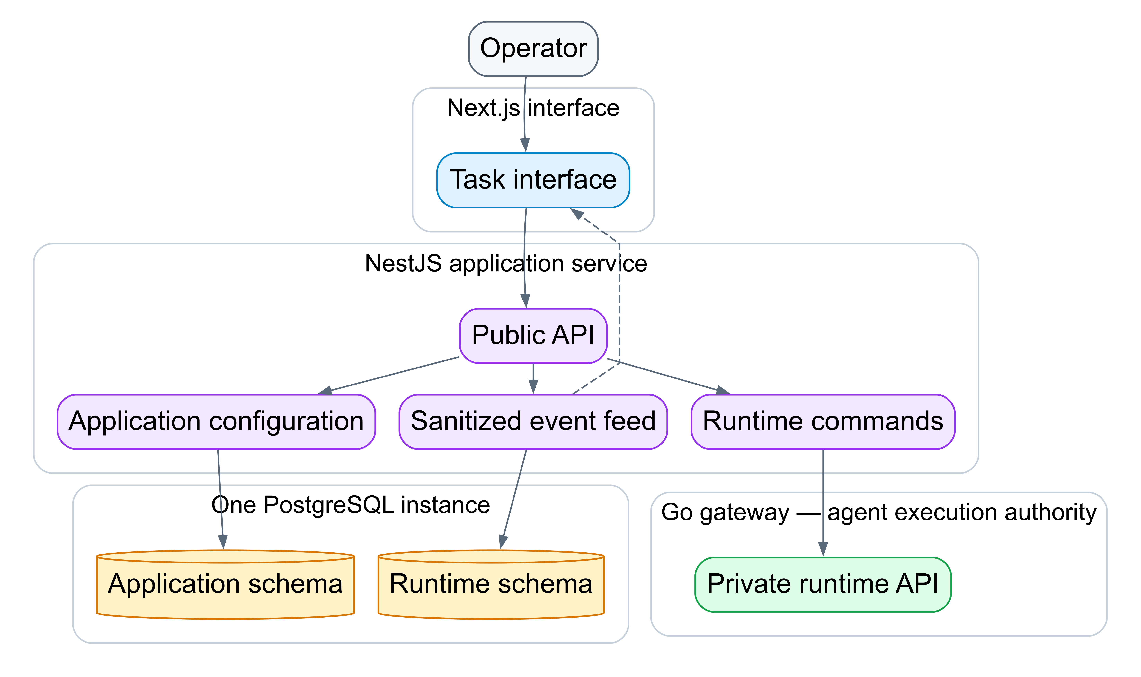
Figure 2 Interface application API and runtime commands
The operator uses the public NestJS API through Next.js. NestJS owns configuration and sends private authenticated runtime commands. The activity feed exposes sanitized authorized reads. Go runtime authority and database write permissions remain separate from UI visibility.

Go runtime detail
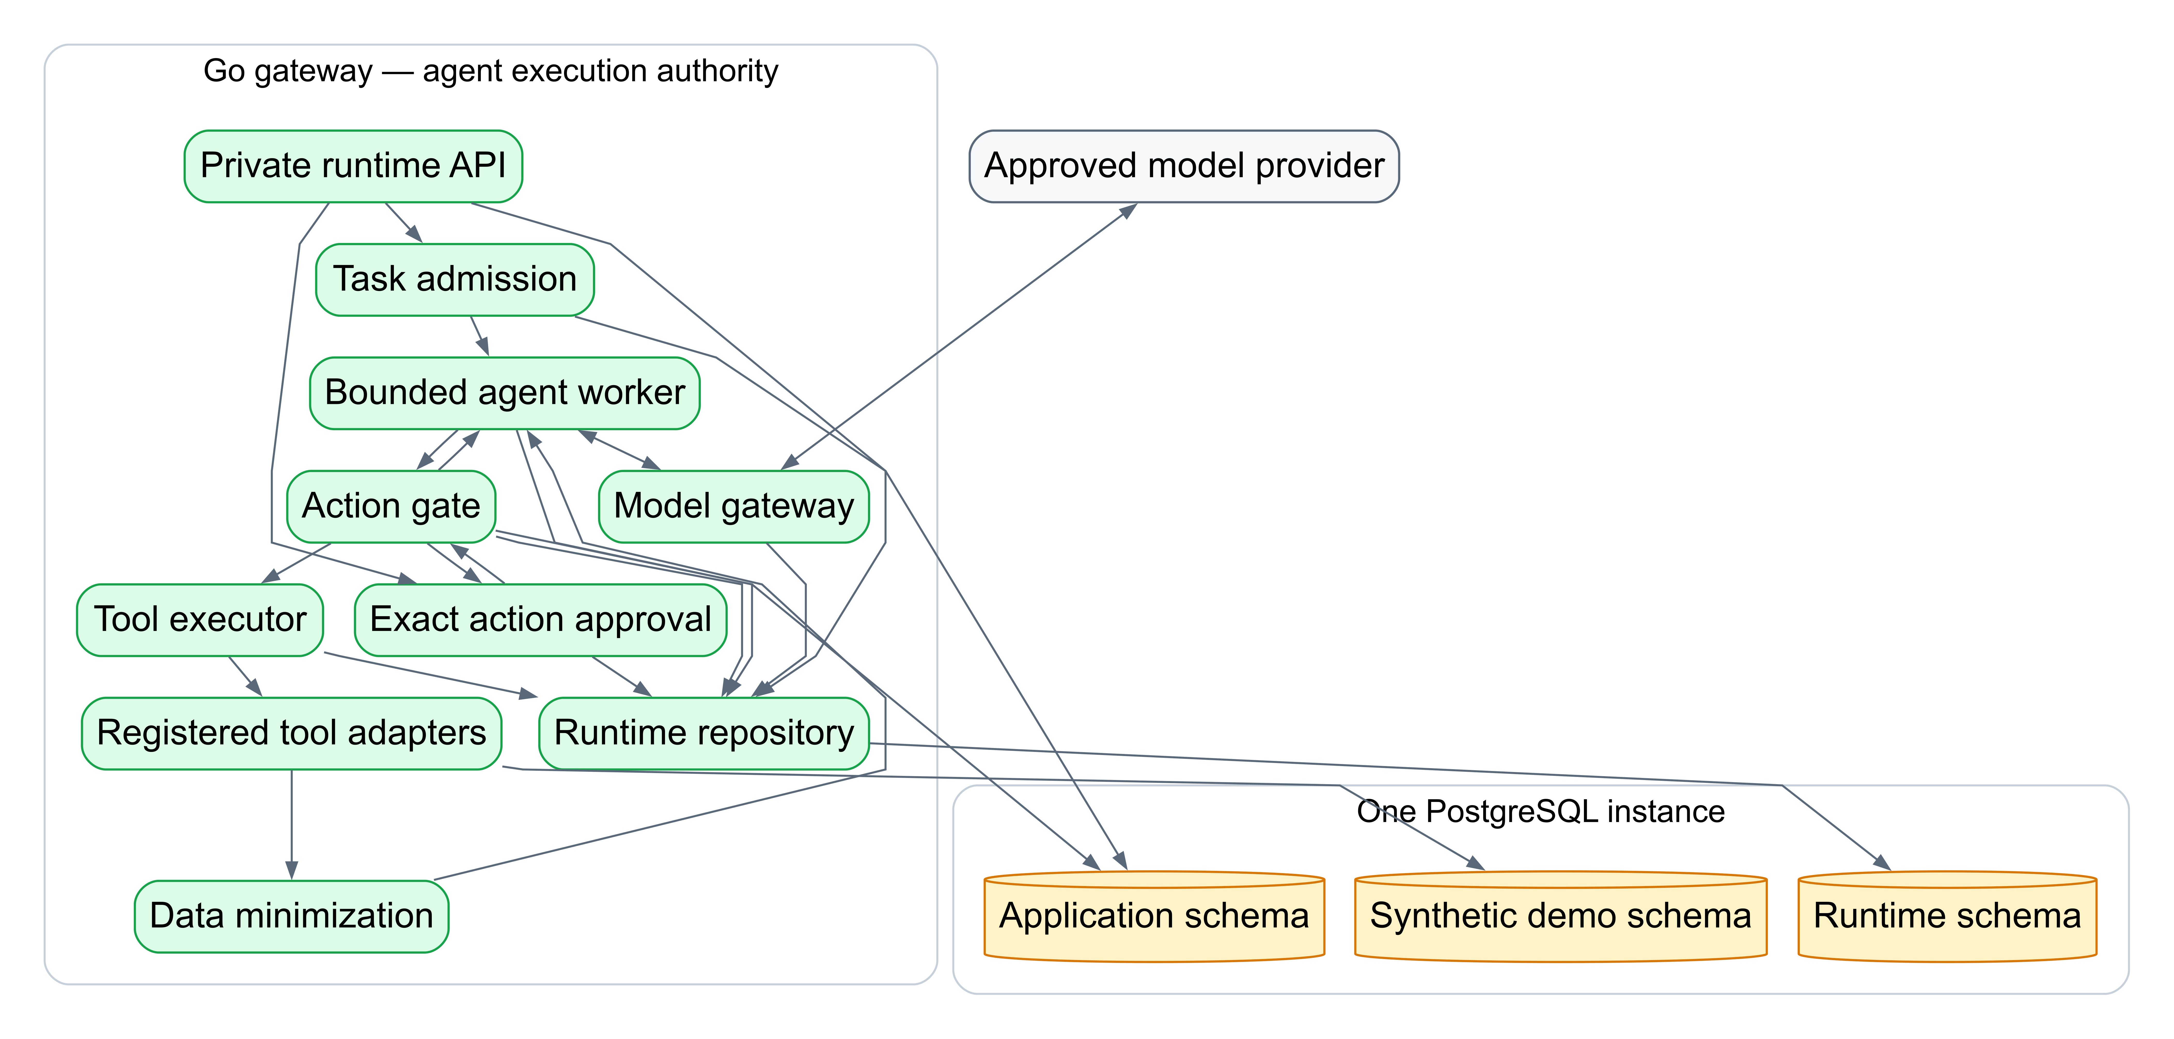
Figure 3 Agent execution authority and data ownership
Admission creates the grant; the worker proposes work; the action gate enforces scope; approval and the executor govern effects. The model gateway controls provider dispatch. The runtime repository persists state, while typed adapters operate on synthetic records and minimize results.

Task admission and allowance
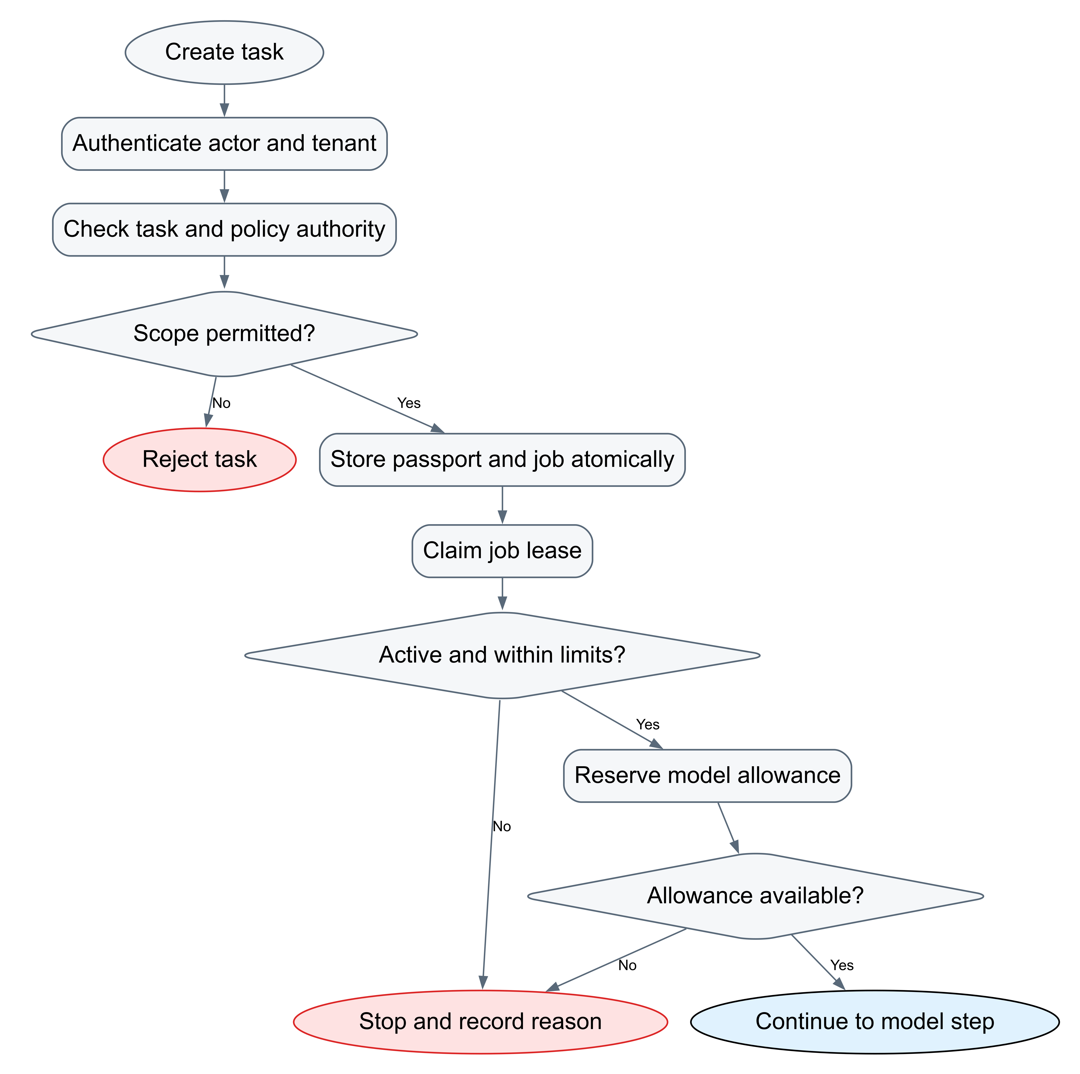
Figure 4 Admission and pre dispatch model allowance
Scope is derived from trusted authority. The passport, run, and job are stored together. Before model dispatch the worker checks the current run and reserves allowance atomically. A denied task or depleted allowance produces no model dispatch.

Model step and proposed action
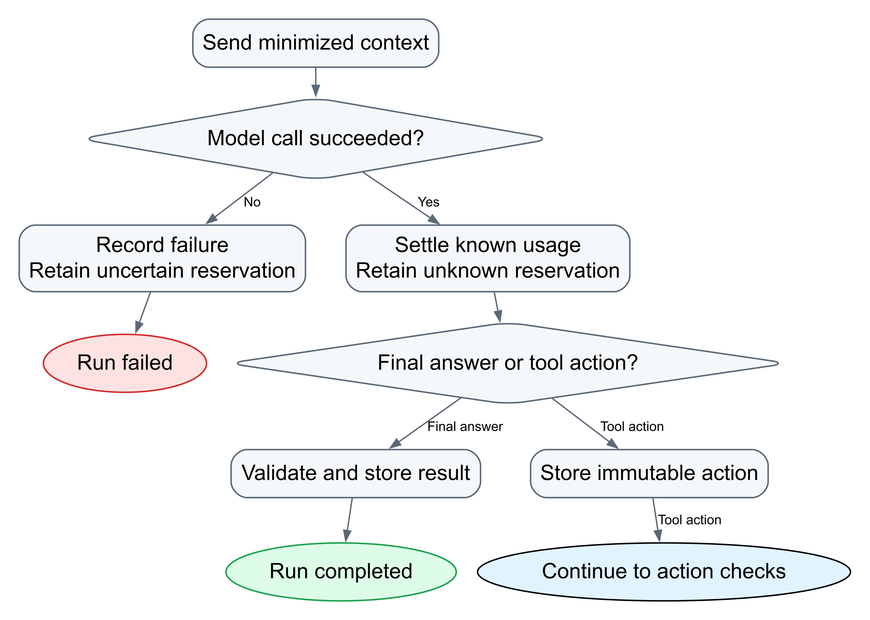
Figure 5 Model usage and action classification
Successful provider usage is reconciled; uncertain usage retains its reservation. The model can propose an action or a final answer. A final answer remains subject to the defined output boundary, and proposed actions become immutable records before policy checks.

Action checks and exact review
Figure 6 Authorization and durable approval
The gate can allow, deny, or require review. Approval pauses the durable job and applies to the original action. Rejected or stale proposals receive bounded handling. Current integrity, record versions, revocation, and cancellation are checked again before execution.

Execution claim and tool effect
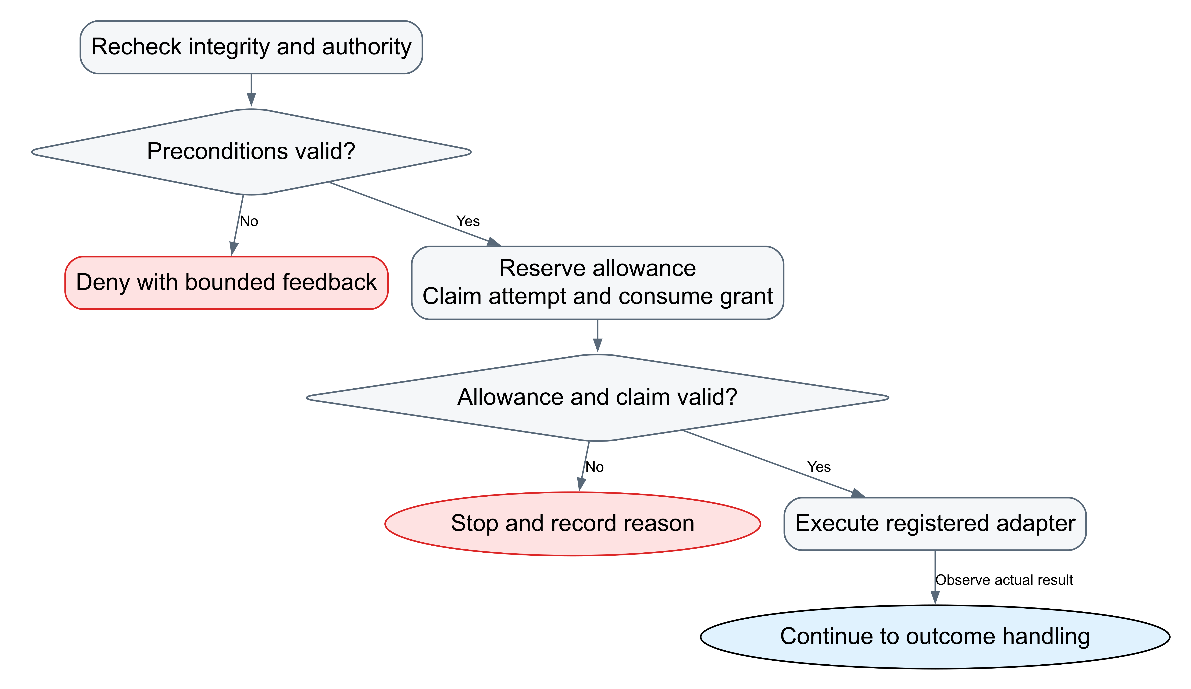
Figure 7 Execution admission and attempt claim
A valid policy result is followed by a fresh execution check. The runtime reserves tool allowance and atomically claims the attempt and bound approval. Only a registered adapter can execute the effect, using the stable action identity.

Success failure and uncertainty
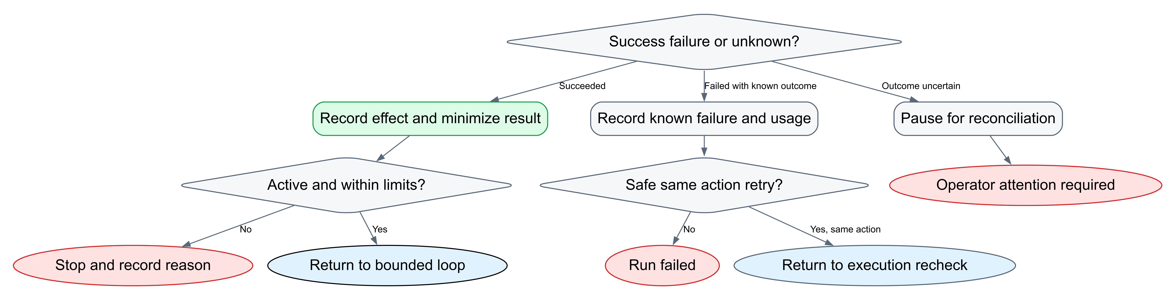
Figure 8 Execution outcomes and safe retry behavior
Successful effects return minimized results to the bounded loop. A known failure can retry only when the operation is safe and limits remain. An uncertain external outcome pauses for reconciliation. Local database demo effects can instead commit with their runtime success record in one transaction.

Technical architecture and service ownership
Task Passport is proposed as a control layer around one finance-operations agent. The planned stack is Next.js, NestJS, Go and PostgreSQL. The current artifacts specify architecture and a reusable starter prompt; they do not establish that the application, enforcement logic or security checks have been implemented. The diagrams should therefore be read as intended responsibilities and execution paths, rather than evidence of working behavior.
Next.js would provide the operator interface. NestJS would own application identity, organization access, task definitions and policy configuration. Go would own admission, agent execution, model calls, action authorization, approvals, limits and tool effects. PostgreSQL would hold both business configuration and durable runtime state. The modules shown inside NestJS and Go are parts of those services; the proposal does not require a separate deployment for every box.
The principal security boundary is the Go execution path. An agent may propose an operation, but it must not possess independent model or tool credentials that let it bypass the gateway. NestJS forwards authenticated commands rather than performing agent effects itself. The browser receives neither provider credentials nor the development service token. Resource-owning services must still enforce their own authorization; an upstream check does not justify giving a downstream adapter unrestricted access. This separation follows the runtime responsibility described in the NVIDIA guidance. [S3]

Interfaces and repository strategy
The proposed public operations are starting or cancelling a run, reviewing an action, reading a run and reading its events. NestJS would expose these operations and call corresponding private Go endpoints. Go must verify service identity and authenticated operator context, then authorize the command against its organization and run. A signed user identifier alone is insufficient if the user lacks permission to review the particular action.
The repository separates apps/web, apps/api and services/gateway, with shared UI, configuration and contract packages. HTTP and JSON are sufficient for the prototype. Shared schemas should define supported requests and errors, while Go remains the authority for action canonicalization and execution. One migration owner should coordinate database changes. The starter specification stops at health, configuration, connections, UI primitives and empty migration tooling; product modules and domain records would be added only during authorized implementation.
Proposed ownership
Component | Responsibilities | Boundary to preserve
Next.js | Task setup, run detail, exact-action review and activity presentation | Calls NestJS; cannot grant scope or execute tools
NestJS | Operator identity, memberships, versioned configuration and public APIs | Authenticates and forwards commands; does not write runtime decisions
Go | Passport admission, bounded agent loop, policy checks, approvals, accounting and execution | Final authority for every agent operation
PostgreSQL | Configuration, runtime records and synthetic demo effects | Explicit service privileges and transactions; no assumed tenant isolation

Data ownership and the transition from starter to product
The future product architecture proposes app, runtime and demo schemas inside one PostgreSQL instance. NestJS would own application writes such as task versions, memberships, policies and explicit revocations. Go would own passports, runs, actions, jobs, approvals, reservations and execution records. Typed tool adapters would access synthetic invoices, vendors, reports and outbox messages through narrow database permissions.
Schemas organize data; they do not automatically isolate tenants or contain a compromised service. Every query must use verified organization context and check the relationship between the requested record and the permitted task. An invoice ID or action ID is a reference, not authorization. NestJS should receive only the runtime views necessary for the interface, and should not directly edit approval grants, execution states or budget balances.
The starter prompt intentionally differs from the product architecture. It requests one development database using the default public schema, no business entities, no seed data and no product tables. Authentication is represented only by extension points, not working login or fabricated users. Its protected internal ping demonstrates generic service connectivity; it does not establish the future operator identity or Task Passport trust boundary. These differences are preparation boundaries, rather than features already delivered.
TypeORM is the agreed migration toolchain. The starter specifies entities as an empty list, with synchronization, automatic migration execution and schema dropping disabled. Application startup should therefore not create business tables. Explicit migration tooling may create its own bookkeeping when invoked. Configuration loading and an empty migration list should work, while generation with no entities may correctly report no changes. These settings need to be preserved when the first product migrations are added. [S7]
Proposed database ownership
Schema | Main records | Write authority
app | Memberships, task versions, policy versions, tool definitions and revocations | NestJS
runtime | Passports, runs, jobs, actions, approvals, usage and decision events | Go
demo | Synthetic invoices, vendors, reports and simulated outbox | Go tool adapters through restricted access

Trusted authority and passport invariants
A passport would be an immutable, server-issued grant for a particular run. It records what the agent may do while carrying out the authorized task. The grant must be derived from authenticated operator authority, an approved task definition, organization policy and the requested scope. The model, a retrieved document or a tool result cannot supply identity, enlarge permissions or declare itself approved.
Admission should reject a request that exceeds available authority and explain which scope or limit must change. The operator can then submit a revised request. Silently reducing the scope would make the accepted task differ from the user's request and obscure why the agent later cannot finish. Once admitted, the passport remains fixed. Broader authority requires a newly admitted run; retrying or correcting an action must not mutate the existing grant.
The passport is an upper bound, not an instruction that every allowed operation should occur. An action must both fit the grant and satisfy current execution checks. A valid approval may satisfy a review requirement for an otherwise permitted action, but it cannot convert a denied resource or destination into an authorized one. Emergency revocation and cancellation can stop further dispatch even though the original passport and policy version remain available for explanation.

Task relationships matter
In the invoice workflow, read_vendor should not accept an arbitrary vendor identifier simply because the tool name is allowed. The vendor must belong to the organization and be associated with a passport-scoped invoice. Similarly, creating a report must use authorized record references, and queuing it must use an authorized report and recipient. These argument-level relationships make the passport more precise than a list of tool names.
Passport fields and their purpose
Field group | Proposed contents | Required invariant
Identity | Organization, initiating actor and run reference | Derived from verified context; never from model arguments
Versions | Task version and policy version | Immutable references to authoritative definitions
Capabilities | Registered tools and permitted resources | Every action remains inside the admitted set
Data and destinations | Field rules, recipient rules and opaque references | Read and outbound access are checked independently
Limits | Calls, steps, attempts, token ceilings and estimated spending allowance | Validated before dispatch; retries also consume allowance
Lifetime | Issue time, expiry and applicable revocation checks | Expiry and cancellation are checked on resume and execution

The enforcement loop and data minimization
The proposed worker would process one tool action per model step. Before requesting another model response, it checks whether the run remains active, unexpired and within its limits. It reserves the model allowance, sends minimized context, records reported usage and interprets the response as either a final result or one proposed action. Unsupported multiple-action responses should be rejected or handled by an explicitly defined policy; the worker should not silently execute an arbitrary subset.
Each proposed action is stored before evaluation. The gate checks the registered tool name, argument schema, organization, resource relationships, destinations, field rules and applicable limits. Malformed or unsupported inputs receive a denial. Missing policy data or an unavailable authorization dependency must not become an automatic allow. The three principal outcomes are allow, deny and require approval. A bounded correction message can let the model propose a permitted alternative, but correction attempts count toward the run limits.
The four planned adapters are read_invoice, read_vendor, create_report and queue_report. They expose narrow operations against synthetic records. The agent should not receive unrestricted SQL, shell execution, arbitrary HTTP access or a general-purpose extension capable of recreating those operations outside the gate. Model and tool credentials remain with Go, which also determines which supported adapter is invoked.

Minimize information before it enters the model
Data rules should determine approved fields before model access. Opaque references can identify protected records without exposing their raw contents; adapters resolve those references only after authorization. The same principle applies to initial task input, retrieved documents, tool results and stored conversation state. The diagram's filter after tool execution is useful, but that location alone would not cover every source of model context.
Outbound reports should use constrained templates and authorized references, with exact-content review where required. A recipient allowlist does not prove that arbitrary free text is safe. If the model already possesses a sensitive value, it might repeat, transform or encode it in an allowed channel. The prototype should therefore describe the fields and output forms it controls, without claiming universal detection of personally identifiable information or encoded disclosure.
The final-answer path needs the same care. The flowchart's instruction to validate output scope is a proposed requirement, not a complete mechanism for proving arbitrary prose harmless. A narrow result schema and minimized inputs would make the demonstration more defensible. General activity events should contain masked metadata, while authorized reviewers may see the specific content necessary to make a decision.

Exact action approval versioning and execution rechecks
Approval would authorize one immutable action, rather than an agent or a broad class of future behavior. Before requesting review, Go stores the tool, canonical arguments, recipient, affected resources, relevant versions, exact outbound content, passport reference, policy version and expiry. The review screen presents the actual intended effect. The command sent back to Go identifies that stored action; it does not replace it with a new browser-supplied payload.
Canonicalization must be defined deliberately. Go can own a stable representation of supported argument types, rejecting ambiguous or unsupported values. Money, if later introduced, should use an explicitly defined decimal or minor-unit representation rather than relying on cross-language floating-point equality. A digest can identify the stored action and detect changes, but hashing a request does not authenticate its author or make its contents authorized. The database record, trusted identity and policy checks remain necessary.
The action must include the exact material reviewed. If an approved report is regenerated from mutable invoice data after review, the operator may receive a different effect from the one shown. Freeze the payload, or bind its source records to versions and require a new proposal when they change. A changed recipient, content, resource version or other material argument invalidates the previous approval.
When the reviewer approves, Go checks the reviewer's authority and persists the decision with a durable continuation. Immediately before execution, it rechecks integrity, expiry, current revocations, cancellation, resource preconditions and allowance. An atomic execution claim consumes the approval once. Safe retries may reuse the same frozen action and its consumed grant, subject to fresh checks; they must not create a second effect under a new identifier.

Versioned policy and current revocation
The design combines immutable policy versions with current revocation. Historical versions explain why the run was admitted, while revocation prevents future effects when authority is withdrawn. The implementation must make that distinction explicit. Ordinary policy editing must not silently broaden existing passports, and emergency revocation must remain effective even while a run waits for review.
The architecture also needs one clear revocation owner. NestJS owns application configuration and app-schema revocations; Go owns runtime cancellation and enforces current revocation checks. The diagram's internal cancel-or-revoke path should not imply that Go can directly edit every NestJS-owned policy record. Rejecting or expiring a proposal should close that approval; any replacement must be a new bounded proposal rather than repeatedly reusing the denied grant.

Atomic allowances hard limits and estimated cost
The cost-control design has two layers. Hard operational limits bound the number of model calls, model steps, tool attempts, correction attempts and permitted output size. Estimated monetary allowances provide an additional admission rule. These are related but different claims. A tool-call limit alone cannot bound model spending, and a price estimate should not be presented as an exact provider invoice.
Before dispatching a model request, Go would atomically reserve allowance based on the configured model, estimated input and the permitted output ceiling. After the request, it records available provider usage and settles the reservation. Retries are separate attempts and consume allowance. When usage is missing or a timeout leaves billing uncertain, the reservation remains unresolved rather than being released as though nothing happened.
Money values may remain uncertain because token estimation, reasoning usage, caching, provider price changes or incomplete response metadata affect the bill. The selected provider and model should have a documented accounting rule, and the interface should distinguish reported usage, reserved allowance and estimated cost. The defensible promise is bounded dispatch under specified limits, with conservative estimates and visible uncertainty; it is not universal prevention of every possible charge.
Parallel requests must not each observe the same remaining balance and both spend it. PostgreSQL transactions and row locks can protect reservation updates and execution claims. Keep these transactions short, and do not hold a database lock throughout a model or remote-tool request. Commit the reservation first, perform the request, then settle it in a later transaction. PostgreSQL's locking behavior supports this coordination, but the application must choose and verify the appropriate transaction boundaries. [S5]

Cancellation and time limits
Cancellation should stop future model and tool dispatches and request interruption of active work where supported. It cannot reverse a committed effect or guarantee that a provider stops billing an in-flight request. The same limitation applies to a runtime deadline. The worker checks the current run state before each dispatch, including after an approval wait, and records why execution stopped.

Durable state idempotency audit and uncertain outcomes
Waiting approvals and queued work must survive the browser closing or a worker restarting. The proposal uses PostgreSQL records rather than a separate broker. A state change and the continuation or event it produces should be committed together. A worker claims a durable job with a lease, persists progress and releases the lease during a review wait. Lease expiry indicates that ownership needs recovery; it does not prove a previously dispatched operation failed.
Each action needs a stable identifier and a defined idempotency rule. Successful actions must not be re-executed merely because a response was lost. For an operation supported by an external service, reuse the same idempotency key when a safe retry is permitted. If the external service does not support a suitable guarantee, the adapter must not invent exactly-once behavior from a local status field.
The synthetic prototype has a simpler opportunity: reports and outbox messages are local PostgreSQL effects. Where permissions and connection design allow it, the effect, execution result and event can be committed in the same short database transaction, with a uniqueness constraint tied to the action ID. This produces evidence that a blocked action created no outbox record and that a repeated approved action did not create duplicates.
For the local prototype, the recommended transaction uses one Go executor connection with explicit permissions for the necessary runtime writes and limited demo report and outbox operations. The effect, completion record, and event then share one database transaction. Separate connections with different credentials would not provide that atomicity automatically. NestJS retains separate application privileges; logical module separation inside the trusted Go process does not claim containment of a compromised process.
External effects introduce different uncertainty. A remote system may complete an operation before the connection times out. Such an attempt enters an unknown state and pauses for reconciliation; it must not be blindly returned to the queue. Known failures can follow documented retry rules, with the same action and fresh authorization checks. The simulated outbox does not demonstrate remote delivery, provider-side idempotency or recovery from a real financial transaction.

Evidence without creating a second disclosure channel
Decision events should connect the run, action, policy version, matched rule, outcome and actual effect. Masked summaries support the timeline without copying confidential arguments into general logs. Review payloads need their own access rules. Request IDs help connect NestJS and Go diagnostics, but are not authorization tokens.
The proposed audit stream is application evidence. It should not be called tamper-proof, independently verified or legally sufficient unless additional controls are designed and tested. The useful demonstration is narrower: a permitted report exists, a denied export has no effect, the reviewed payload matches the queued message, and repeated attempts respect action identity and limits.

Threat model limits and unresolved design choices
The central threat is an untrusted model response or retrieved instruction causing the agent to attempt an operation outside its task. This includes an injected invoice instruction, incorrect reasoning, malformed arguments, unauthorized record references, altered approval payloads and repeated requests. The intended defense is independent enforcement at execution time. The model may misunderstand the task while the gateway still prevents a prohibited effect.
This threat model trusts the configured services, database and authorized administrators to enforce their responsibilities. It does not establish containment after Go, NestJS, PostgreSQL, the host or a privileged account is compromised. It also does not establish total protection from provider-side exposure or leakage through a permitted free-text channel. Any claim about the product should state the integrated tools, data rules and limits to which it applies.
Several diagram labels need concrete definitions before implementation. Final-output validation requires an output format and a data rule. Record-version rechecks require versions and comparison semantics. Durable worker recovery requires identifiable dispatched attempts. Current revocation requires a single owner and reliable reads. The service token in the starter requires replacement or extension for authenticated operator context. These are unresolved implementation choices, not completed protections.
For the hackathon, the smallest credible vertical slice is one authorized invoice/report workflow, one denied out-of-scope operation, one exact-action approval and one limit-triggered stop. All effects should use synthetic data, with truthful labels for simulated delivery and captured-action replay. The broader architecture remains a useful direction, but generic policy editing, configurable tools, complex recovery and organizational administration should not displace a complete demonstrable enforcement path.

Verification priorities
- Verify that scope rejection is explicit and the revised request must be resubmitted.
- Verify that every adapter checks arguments and resource relationships, not only the tool name.
- Verify that approval cannot enlarge the passport and changed content requires new review.
- Verify that two concurrent attempts cannot consume one approval or allowance twice.
- Verify that cancellation and revocation prevent future dispatch after a review wait.
- Verify that blocked operations create no synthetic outbox effect and successful retries do not duplicate it.
- Verify that spending uncertainty, simulated effects and unimplemented features remain visible in the report and demonstration.

Positioning differentiation and credible product claims
Task Passport should not be presented as the invention of tool authorization, approvals, or audit logging. Official Cerbos Aperture documentation already describes tool-parameter authorization and decision logging [S2]; NVIDIA documents tool and execution rails [S3]. The proposed differentiation would be the product experience around a specific delegated business task: a clear grant, understandable limits, review of exact effects, and safe continuation after a denied proposal. The architecture would support that experience through ordinary, inspectable enforcement mechanisms.
The most useful positioning statement is: delegate the job while retaining control over its actions, data, and allowance. This would give judges a business outcome to evaluate and a concrete boundary to inspect. A polished dashboard could help explain the result, but it would not substitute for proving that a disallowed action failed to reach the executor or create application state.

What would make the presentation persuasive
The audience should see the same task objective throughout the demonstration. If poisoned input produces a forbidden proposal, the gateway should deny its execution and the reconciliation should continue where a permitted route remains. A labeled action replay can demonstrate the gate if the live model ignores the injected instruction. The reviewer would inspect an exact outbound report rather than approve an abstract label such as send email.
The team should explain the boundary candidly. All demonstrated model and tool operations would pass through Go, with provider credentials held there. A separately accessible tool or credential would fall outside that guarantee. The prototype would demonstrate enforcement for its registered workflow and defined data rules, not a complete enterprise security platform.
How the proposed product would be distinguished
Common approach | Task Passport emphasis | Qualification
General tool permissions | Narrow permission to the records, destination, and limits of one authenticated job. | Implement deterministic task contracts first; do not imply that the model reliably infers authority from prose.
Prompt or response filtering | Authorize proposed effects at the execution boundary, even when the model follows a hostile instruction. | This is complementary to content defenses and does not promise detection of every attack.
Generic approval buttons | Show and bind permission to one stored payload and its current preconditions. | Approval still requires an authorized reviewer and a trustworthy rendering of the exact effect.
Usage dashboards | Reserve allowance before dispatch and stop further work at defined limits. | Estimated monetary usage and unresolved reservations must remain visibly uncertain.
Security demonstrations that only block | Show the useful task completing, with a denied branch corrected within limits. | Recovery is allowed only when a permitted alternative exists; safety is not measured by completion alone.
Transcript-only attack scoring | Connect decisions to actual report and simulated outbox state. | A finite rehearsal suite provides evidence for tested scenarios, not a universal guarantee.

Illustrative invoice scenario and future domain adaptations
The proposed demonstration would use fictional vendor Atlas and synthetic invoices stored in the demo schema. The operator’s task would be to reconcile a selected invoice set, produce an internal discrepancy report, and queue that report to the vendor’s registered demonstration address after review. The task would not authorize payments, unrelated customer records, arbitrary message destinations, or unlimited execution.
The four tools would provide the complete business path. read_invoice would return permitted invoice fields, read_vendor would return scoped vendor information, create_report would persist a structured reconciliation result, and queue_report would create an entry in a simulated outbox. The resulting database records would provide concrete evidence of useful work and prohibited effects. No message would be delivered to a real recipient.

Scene 1 a legitimate reconciliation
The operator would select Atlas and the permitted invoices. The runtime would issue a passport and show its limits. The agent would read the relevant records and propose an internal report containing authorized discrepancies. The demonstration would inspect the saved report, establishing that the control layer permits the intended workflow rather than merely rejecting requests.

Scene 2 a hostile instruction in a business document
A synthetic invoice note would contain an instruction attempting to redirect the report or obtain an invoice outside the task. This follows the indirect prompt-injection pattern studied in InjecAgent [S4]. In a live agent run, the model might follow or ignore that instruction. The team should retain a clearly labeled deterministic rehearsal that submits the same forbidden action through the actual gate, so enforcement can be demonstrated without pretending the model’s attack response is guaranteed.
When the forbidden proposal occurs, the action gate would record its denial before the tool effect. The demonstration would inspect the outbox and report state to confirm the prohibited operation did not occur. A safe structured reason could steer the agent back to the registered vendor or permitted record set, while the correction limit would prevent endless attempts.

Scene 3 precise human review
The agent would propose queuing the allowed report. The reviewer would see its exact recipient, rendered content, and referenced report version. Approval would resume the stored action, with current authorization and record preconditions rechecked. A separate rehearsal would modify the payload or relevant record version and show that the original approval no longer permits the changed operation.

Scene 4 cost limits and uncertain execution
A bounded retry scenario would exercise model or tool-attempt limits and show the run stopping before another dispatch. Usage would distinguish measured units, estimated spending, and unresolved reservations. An optional failure rehearsal would simulate an unknown external result, placing the action into an attention-required state instead of automatically repeating an effect that might already have succeeded.

Future adaptations beyond invoices
The same task-contract idea could later support municipal incident handling or defensive cyber-response workflows. These are illustrative adaptations, not additional MVP commitments or verified eligibility for another challenge. Their value would depend on a genuine domain workflow, appropriate resource ownership, and final event requirements. The team should not assume that a single project can be submitted across categories.
Optional domain examples
Domain | Bounded task example | Consequential effect requiring control
Smart City | Read incident reports for one district and create internal maintenance tickets. | Publishing a public alert or sending resident data would require a separate authorized scope and appropriate exact-effect review.
Defence or defensive cyber operations | Read selected synthetic security alerts and prepare a remediation recommendation. | Executing a containment action or sharing sensitive infrastructure information would need explicit authority, current preconditions, and review.
Financial operations | Reconcile one vendor’s invoices and prepare a reviewed report. | Queuing the report would be constrained to the registered recipient; payments would remain outside the prototype.

Delivery scope and six person ownership
Task Passport should be delivered as one complete finance workflow: an operator delegates invoice reconciliation; a Go-controlled agent reads permitted records, prepares a report, requests any required review, and queues approved content in a simulated outbox. The proposed architecture is a target design, not evidence that these capabilities exist. The implementation plan assumes a 24-hour coding window; the organizers' confirmed rules and actual submission deadline take precedence.
The prototype needs four deployed components: Next.js, NestJS, Go, and PostgreSQL. Modules inside Go are not independent services. One model provider, one task template, four registered tools, and synthetic records form the practical boundary. A policy editor, arbitrary tool registration, multiple model providers, real email, complex organization administration, and a C++ worker are outside the initial delivery scope.

Starter work versus task specific implementation
The planned generic starter contains service scaffolding, health checks, empty TypeORM configuration, authentication interfaces and placeholders, local database setup, verification commands, and reusable UI primitives. It does not include a working login flow or Task Passport entities. Passport issuance, business tools, enforcement rules, approval binding, usage reservations, synthetic challenge fixtures, and demo behavior are task-specific work. Do not presume that pre-event code or prepared assets are eligible; the document owner should resolve this from official rules before those materials are used.
Freeze the small set of shared contracts before parallel development: start-run request, passport representation, action proposal, approval decision, run state, and safe event. Record one owner per contract and per Go module. A mocked response can unblock interface development, but it must be replaced or clearly labeled before any result is presented as a working capability.
Proposed team ownership
Role | Primary responsibility | First integrated deliverable
Implementer 1: interface | Next.js task form, passport summary, run timeline, approval preview, and terminal states. | Start a run and display a real persisted event through the NestJS API.
Implementer 2: application API | NestJS authentication, membership checks, task configuration, runtime facade, and authorized event feed. Coordinate shared contracts. | An authenticated command reaches Go with verifiable actor and organization context.
Implementer 3: agent runtime | Go worker, provider integration, bounded agent loop, model reservations, usage accounting, and cancellation checks. | A live model proposes a typed tool action within a recorded allowance.
Implementer 4: enforcement | Go admission, immutable passport, argument checks, exact-action approvals, execution claims, and denial feedback. | An out-of-scope proposal is denied before the tool adapter runs.
Implementer 5: data and integration | Migrations, service database roles, four tool adapters, synthetic fixtures, transactional effects, reset procedure, and deployment integration. | A permitted action produces one inspectable database effect and its matching execution record.
Researcher, document owner, and presenter | Official requirements, sponsor clarification, source register, demo specification, claim-to-proof tracking, presentation, and submission checklist. | A verified brief and a storyboard with observable evidence for every claimed protection.

Relative implementation milestones and critical dependencies
Progress should be measured by integrated behavior rather than completed screens or isolated modules. The early checkpoint is a complete authenticated path from the interface to a live model, through one governed tool, back to a persisted effect and visible event. If that path is late, remove optional breadth before adding more features.

Critical path and sensible reductions
The enforcement developer depends on authoritative task and policy data, not client-supplied grants. The runtime developer depends on the action schema and tool-result contract. Approval UI depends on a frozen server-held action, and evidence collection depends on inspectable business effects. Schema changes and event names therefore require a quick shared review rather than independent invention.
If time becomes tight, keep a fixed server-owned task template instead of a general policy editor, use one worker process with durable jobs instead of distributed scheduling, and use authenticated polling before adding SSE if necessary. Keep service-side authorization, scope enforcement, pre-dispatch limits, and exact-action approval intact. A missing protection must become an explicit limitation, not a silently mocked success.
Proposed 24-hour implementation sequence
Relative window | Team focus | Exit condition
Hours 0-2 | Confirm rules and sponsor expectations; freeze task, contracts, tool arguments, policy fixture, and schema ownership. Bring up the starter and provider connection. | A single documented workflow, working service connectivity, and an agreed contract example for each command and event.
Hours 2-6 | Build the vertical path in parallel: task form, authenticated facade, admission, worker, live model call, one read tool, and event feed. | A real operator starts a run; Go executes a permitted tool; the interface displays the actual persisted result.
Hours 6-10 | Complete four adapters, scoped reads, structured report creation, destination checks, and bounded correction feedback. | A permitted reconciliation succeeds; an explicit prohibited proposal produces no business effect.
Hours 10-14 | Add frozen action previews, authorized approval decisions, approval consumption, model/tool reservations, and controlled stopping. | The reviewed action executes once; changed content and depleted allowance cannot dispatch an operation.
Hours 14-18 | Exercise concurrency and waiting-state recovery; inspect context and safe events; finish reset and deployment procedures. | Critical checks have recorded outcomes, and the team can reset fixtures and repeat the workflow.
Hours 18-21 | Polish comprehension and error states; rehearse the complete story; capture evidence from the final build. | A reviewer can understand the task boundary, attempted action, decision, actual effect, and limitation without narration filling gaps.
Hours 21-24 | Freeze features, fix critical faults, finalize documentation and artifacts, and submit using the confirmed organizer requirements. | Submission checklist is complete; the demonstration matches the submitted build and its documented limitations.

Live demonstration storyboard and proof checks
The demonstration should establish productive delegation and enforceable boundaries through the same execution path. Use only synthetic invoices, vendors, recipient addresses, and reports. Label the outbox as simulated: a queued database message is a real prototype effect, but it is not evidence of email delivery. Rehearsal timing should be adapted to the organizer's confirmed presentation format rather than assuming a particular pitch duration.
Keep the passport visible beside the activity timeline: permitted invoices, associated vendors, allowed recipient, approval requirement, expiry, and remaining allowance. Show attempted operations separately from completed effects. A red event alone does not prove that a tool was prevented from changing state.

Reliable demonstrations without invented behavior
A live model may refuse a malicious document itself. That is a useful observation, but it does not establish gateway enforcement. Prepare a clearly labeled adversarial action replay that submits a prohibited proposal to the same validation and execution path. Explain when the replay is being used; never present a scripted proposal as a model-generated action.
Record a successful rehearsal from the final implementation and retain its evidence as a fallback if permitted. A recording, deterministic replay, or screenshot should be labeled accordingly. On provider failure, show the actual failure state and distinguish the working gateway demonstration from unavailable live model behavior.
Proposed demo sequence
Beat | Visible action | Required observable proof
1. Establish the job | Operator selects the fixed reconciliation task and designated synthetic invoices. | Persisted passport matches authorized task scope; unrelated records and other recipients are visibly excluded.
2. Establish the baseline | Open the relevant business records and outbox before execution. | Capture starting record versions, report count, and outbox count so later effects can be compared.
3. Show useful work | Agent reads allowed invoice/vendor fields and identifies the seeded discrepancy. | Returned fields obey policy; the report references authorized records and contains the expected discrepancy.
4. Introduce hostile input | A synthetic invoice contains instructions to use an unrelated record or an unapproved destination. | The document's text is treated as data; it does not amend the stored passport or operator identity.
5. Prove the boundary | An attempted prohibited action receives a specific denial. | Tool execution was not entered; no prohibited report or outbox row appears; the denial identifies the applicable rule.
6. Continue productively | The agent receives bounded feedback and resumes permitted reconciliation. | The original useful output is completed within the same run and allowance; correction attempts are counted.
7. Review exact effects | Operator sees the stored report content and recipient, then approves the outgoing action. | Approval binds to the displayed action ID and content; one approved outbox row is created, with no broader grant.
8. Show controlled stopping | A separate run or clearly labeled runtime test exhausts a small configured allowance. | The next request is rejected before dispatch; a terminal reason is visible and the ledger does not record an unaccounted call.

Validation plan and evidence matrix
The following entries are acceptance targets, not completed test results. Maintain status, build identifier, fixture, observed outcome, and evidence reference for each check. Prioritize boundaries where an error could produce unauthorized effects or misleading budget balances. Happy-path screenshots alone are insufficient.

Interpreting results honestly
Test identity and authorization through the public path and the internal service boundary; a hidden URL is not a protection. Exercise malformed tool arguments and invalid state transitions as well as valid ones. Bound all corrective loops and retries, including rejected attempts where the configured policy counts them.
Display request and token limits separately from estimated monetary spending. Report a small synthetic evaluation with its fixture count and limitations; do not extrapolate to universal prompt-injection prevention, production reliability, or financial savings. Cancellation can prevent future dispatches but cannot retract information already sent or undo committed effects.
Proposed critical checks
Check | Target behavior | Evidence to retain
Legitimate task | Reconciliation finishes and the approved report is queued once. | Report references, expected discrepancy, one outbox row, and completed run events.
Resource boundary | A supplied invoice/vendor ID outside the passport is rejected before adapter execution. | Denial record plus unchanged excluded records and absence of an execution attempt.
Destination boundary | An unapproved recipient cannot receive a queued report. | Stored proposal, rule decision, and outbox comparison.
Field minimization | Protected fields are omitted from model-facing results and safe activity views. | Inspected serialized tool result, model request fixture, and event payload.
Approval integrity | Changing content, recipient, or resource versions invalidates the prior grant. | Tampered proposal outcome and no matching business effect.
Approval replay | Concurrent approval or execution requests cannot create a second effect. | Concurrent request results, one consumed grant, and one outbox row.
Budget concurrency | Simultaneous reservations cannot overspend configured call/token/tool allowance. | Reservation and usage rows with reconciled totals and denied competing request.
Unknown usage | Missing provider usage does not free unresolved spending allowance as though cost were zero. | Retained reservation and visibly uncertain estimated-cost state.
Waiting-state restart | An awaiting-approval run survives a worker restart and resumes the original stored action. | State before/after restart and exactly one resulting effect.
Cancellation and expiry | After the applicable check, no new operation dispatches for a cancelled or expired run. | Cancellation/expiry timestamp, subsequent denial, and dispatch records.
Organization access | Another organization cannot inspect the run, approve its action, or claim its resources. | Rejected read/command requests and absence of runtime mutation.
Database execution transaction | Prototype business effect and successful execution record commit together or neither commits. | Fault-injection outcome and consistent action/business state.

Research documentation and submission workflow
The researcher should own a concise official requirements sheet, a source register, a focused comparison of existing controls, a storyboard, and a submission checklist. Conceptual preparation should be distinguished from challenge-specific implementation and from completed evidence. Use official rules and sponsor statements to resolve eligibility; do not infer that a preparation practice is permitted because it is common elsewhere.
Compare a small number of relevant authorization and agent-control products using primary documentation. Record supported features, unavailable information, and overlap. Position Task Passport around bounded delegation and useful continuation after intervention, subject to what is actually delivered; do not claim a first-of-its-kind mechanism or invent market statistics.

Questions to resolve with organizers and sponsor mentors
- What preparation, existing starter code, third-party libraries, datasets, and generated assets may be reused, and how must they be disclosed?
- Which submission artifacts, language, presentation format, demonstration environment, and deadline apply to this task?
- Is a synthetic finance workflow with a simulated outbox an acceptable demonstration of the control-layer concept?
- Which agent risks or developer-integration expectations should the team prioritize beyond the public brief?
- What evidence would make cost controls and exact-action approvals convincing, and are any sponsor-specific evaluation requirements available?
- If considering another track, what are the exact rules for cross-track submissions, reuse, and eligibility?

From requirements to verified presentation
During implementation, translate mentor feedback into a short requirements update, not uncontrolled feature additions. Maintain a claim-to-proof list: each presentation claim names a demo step, observed record, or completed check. At feature freeze, replace placeholders with final-build screenshots and results, remove unsupported language, and explain remaining limitations.
The final technical handoff should include setup instructions, architecture and boundaries, synthetic-data reset, tool contracts, policy fixture, known limitations, dependency disclosures where required, and the critical-check outcomes. The presentation should explain the delegated job, why the attempted action was unsafe, how enforcement prevented its effect, and how legitimate work continued.

Risk register and scope controls
The non-negotiable quality threshold is a truthful account of the implemented boundary. A smaller prototype with working enforcement and inspectable effects is more credible than a wider interface backed by simulated protections. If a critical check fails, either fix it or narrow the supported behavior and the claims.
Principal delivery risks
Risk | Early signal | Response
NestJS/Go contract drift | Identity fields, action states, or event formats differ across services. | Freeze examples and ownership early; integrate frequently and validate serialized contracts.
Feature breadth exceeds time | Policy administration and generic integrations displace the first working workflow. | Keep fixed templates and four adapters; protect the integrated path before optional breadth.
Provider instability or unsuitable output | Rate limits, malformed proposals, or intermittent calls interrupt the loop. | Use bounded validation/retries and transparent failure states; prepare a labeled enforcement replay.
Budget display implies certainty | Unknown usage is shown as zero or estimated currency is described as an exact bill. | Retain unresolved reservations and label estimates; emphasize hard dispatch and token ceilings.
Approval grants are too broad | Approval references a run generally or content changes after review. | Bind to immutable action content, resource versions, reviewer authority, and expiry.
Demo proves logs, not prevention | Only an error banner is shown after a prohibited proposal. | Compare business state and execution records before and after every denied action.
Data leakage through secondary views | Raw tool output appears in timeline, logs, or broad run-detail endpoints. | Inspect model context and safe event serialization; apply organization and reviewer access checks.
Final build diverges from presentation | Screenshots, feature claims, or recordings come from different revisions. | Freeze features, record the build identifier, and recapture evidence after material fixes.
Rules remain unresolved | Preparation or submission assumptions are accepted without official confirmation. | Assign the researcher to resolve them and document any remaining uncertainty before reuse or submission.

Phased roadmap beyond the prototype

Phase 1 focused hackathon prototype
Deliver one task, one provider, four typed tools, immutable scope, exact-action review, bounded usage, and evidence from synthetic records. Use PostgreSQL transactions for the controlled business effects. Record what remains unsupported.

Phase 2 integration pilot
Only after validating the prototype, add a documented tool-adapter interface, more task templates, usability research, deployment controls, and a limited real integration. External tools require explicit idempotency and uncertain-outcome reconciliation rather than assuming database transaction guarantees extend across services.

Phase 3 production hardening
Evaluate stronger isolation, secrets rotation, policy administration, operational monitoring, retention controls, adversarial testing, independent security review, and organization-scale reservations. Multiple workers and providers should follow demonstrated need. Production readiness is a future validation effort, not a property established by the architecture diagram or hackathon demonstration.

Illustrative passport and interface contracts
The following examples make the proposal concrete without defining a final wire format. Shared contracts should be versioned and agreed before parallel implementation. The TypeScript applications and Go runtime should describe the same identifiers, enum values, timestamps, error semantics, and action integrity rules. The authenticated actor and organization must be supplied through verified context rather than trusted from agent arguments.
The example passport belongs to an imaginary organization and the Atlas invoice task. All identifiers and limits are synthetic. A stored passport is an immutable grant derived by admission. Changes to the task, destination, or scope create a new grant; they do not silently alter the authority of an existing run. Revocation remains a separate current-state check.

Concrete synthetic business example
An illustrative fixture can contain invoice_A01 and invoice_A02 for vendor Atlas, both carrying the same external invoice reference INV104. The task asks the agent to identify possible duplicate references in the selected records and prepare a review report. The expected result is a report that identifies the two authorized record IDs and the repeated reference. It does not determine fraud or authorize payment.
A separate invoice_B01 belongs outside the permitted task. The hostile note may ask the agent to read that record or change the reporting recipient. The gate should deny either proposal. The agent can still complete the duplicate-reference report using A01 and A02. The reviewed report then creates one simulated outbox message to the trusted Atlas recipient.
Reports created during the run are derived task objects. Their tenant, run, source references, template, and version must be checked before they can be queued. A generated report ID is not permission to queue an unrelated report, and permission to create a report does not expand the original invoice scope.

Narrow final result and context boundary
The recommended prototype final result is a structured status with authorized report references. The interface renders its substantive content from the stored report and registered template, rather than displaying unrestricted model prose as the authoritative deliverable. This turns final-output validation into a defined check of identifiers, ownership, and supported fields.
Initial context should come from the fixed task template and authorized parameters. Each tool returns an explicit field allowlist; protected values remain opaque references. The hostile invoice note is synthetic untrusted content used for the demonstration. These controls define which application data enters the model; they do not establish that arbitrary text or information already known to a provider is universally safe.

Decision and error semantics
A successful policy decision should distinguish allow, deny, and approval required. A transport or configuration error is not an allow decision. Responses should include a stable reason code, a safe operator message, and relevant action or run references. Detailed sensitive payloads belong in restricted review storage rather than general error text.
Useful reasons include resource_out_of_scope, destination_not_allowed, approval_required, approval_expired, action_changed, resource_version_changed, allowance_exhausted, run_cancelled, and outcome_unknown. These names are proposed contract vocabulary. The final implementation should keep the vocabulary stable across the UI, runtime, tests, and evidence rather than allow each service to invent a different interpretation.
Illustrative passport fields
Field | Example value | Meaning
passport_id | passport_atlas_001 | Stable reference to the issued immutable grant.
organization_id and actor_id | demo_org and operator_01 | Trusted tenant and delegating user; not selected by the agent.
task_version and policy_version | reconcile_atlas_v1 and policy_v1 | Authoritative versions used at admission.
allowed_tools | read_invoice read_vendor create_report queue_report | Only these registered adapters are available.
allowed_resources | invoice_A01 invoice_A02 vendor_Atlas | Resource scope checked independently of the tool name.
allowed_destination | Registered Atlas reporting address | Trusted directory lookup rather than a destination found in invoice prose.
field_rules | Invoice totals and status allowed; protected values remain references | Defined data handling for this workflow, with no universal free-text classification claim.
approval_rule | Review every queue_report effect | Approve the exact rendered report and recipient.
model_call_limit | 8 calls | Illustrative hard dispatch count; retries consume allowance.
tool_attempt_limit | 12 attempts | Illustrative limit on governed attempts, including safe retries.
correction_limit | 2 corrections | Bounded feedback after a denied proposal.
expires_at | 15 minutes after admission | Illustrative deadline checked before future dispatches.
cost_reservation | Conservative estimate under configured provider pricing | Display estimated usage and retain unresolved reservations.

Proposed tool argument boundaries
Tool | Constrained arguments | Required check and effect
read_invoice | invoice_id | Verify tenant and passport membership; return only authorized fields.
read_vendor | vendor_id | Verify the vendor belongs to the task; resolve selected values as safe references.
create_report | Authorized invoice references and a registered template | Verify every reference; store a structured report with a stable ID and version.
queue_report | Stored report reference and trusted recipient reference | Render and freeze exact content; require bound review; insert a single simulated outbox effect.

Proposed browser and runtime operations
Browser operation through NestJS | Runtime or read behavior | Authority
POST /api/runs | POST /internal/runs issues the passport and durable job | Verified actor and organization; authoritative task and policy versions.
POST /api/runs/{id}/cancel | Persist cancellation before future dispatches | Actor may manage this run within this organization.
POST /api/actions/{id}/approval | Approve or reject the stored action | Authorized reviewer; exact action integrity and expiry.
GET /api/runs/{id} | Read authorized run and usage view | Organization and object access checked on every read.
GET /api/runs/{id}/events | Read sanitized events with cursor or SSE | Authorized subscription; no unrestricted raw payload stream.

Design decision record
These decisions preserve the scope agreed in the planning discussion. A change should record its reason and update the architecture, interface contracts, demonstration, and claim-to-proof checklist together. The team should first remove optional breadth when delivery is at risk, while keeping the checks required to substantiate the control-layer proposition.
Agreed and proposed design decisions
Decision | Reason | Consequence
Next.js and NestJS | Matches the main application stack and separates interface from public application API. | Keep UI and identity/configuration ownership clear.
Go runtime gateway | Provides one explicit owner for admission, execution, usage, and credentials. | NestJS forwards commands; Go remains the final runtime authority.
One PostgreSQL instance | Reduces deployment and coordination work for a short prototype. | Use app runtime and demo schema ownership with narrow roles.
TypeORM migration toolchain | Matches the selected NestJS starter and avoids competing schema owners. | One migration history; Go consumes the resulting schema.
No C++ execution layer | The selected workflow does not need native performance or additional language boundaries. | Avoid extra build and integration work.
Four registered tools | Enough to show reading, transformation, and a consequential reviewed effect. | No arbitrary shell browser or dynamic code execution.
One action per model step | Makes decisions and approval continuations easier to inspect. | Every proposed effect has a clear stored action boundary.
Synthetic data and simulated outbox | Produces real inspectable application effects without production systems. | Explain the simulation accurately in the demo.
Deterministic permission checks | Authority can be checked against defined records and typed parameters. | Model explanations or another model verdict cannot expand scope.
Constrained outbound content | Recipient checks alone do not constrain arbitrary disclosure. | Use approved fields references templates and exact content review.
Evidence before broad claims | A finite prototype can demonstrate specific properties and useful work. | Report targets separately from actual test results.

Terminology for developers and presenters
Working glossary
Term | Meaning in Task Passport
Agent | The bounded loop that uses a model to propose work and receives permitted tool results.
Task Passport | An immutable grant of authority for one delegated task.
Admission | The trusted process that checks requested scope and issues a permitted passport.
Tool adapter | Registered application code that performs a defined business operation.
Action | One stored proposed effect with fixed arguments and a stable identity.
Exact action approval | Review permission bound to the specific stored effect rather than the agent generally.
Canonical arguments | A normalized representation used consistently to compare and hash the same intended arguments.
Idempotency key | A stable identifier used to prevent a repeated request from creating a fresh duplicate effect.
Reservation | Allowance held before dispatch so concurrent operations cannot each spend the same remaining capacity.
Lease | A temporary claim allowing a worker to process a durable job; expiry does not prove an external action failed.
Opaque reference | An identifier the model can use without receiving the protected value it refers to.
Revocation | A trusted current-state reduction or removal of authority checked before further execution.
Simulated outbox | A real database record representing a queued report without sending real email.
Unknown outcome | A request whose external effect cannot yet be established; it requires reconciliation rather than blind replay.
Indirect prompt injection | Instructions embedded in external content that try to redirect the agent away from the trusted task.
Claim to proof | A mapping from a presentation statement to the specific demonstration or test result that supports it.

Sources and evidence register
External sources were consulted on 3 October 2026. The official challenge page was available through indexed official content; final task rules and organizer clarifications should be checked at the event. The sources below support narrow factual statements. They do not establish implementation, sponsor endorsement, complete security, or production readiness for Task Passport.

S1 HackYeah 2026 Tasks and Prizes
HackYeah 2026 Tasks and Prizes
The published Goldman Sachs AI Control Layer brief names sensitive data exposure, unauthorized actions, and unpredictable costs while asking to preserve innovation and developer productivity. The page lists English submission for this task. Detailed judging criteria, presentation timing, and dual-category eligibility have not been established by this report.

S2 Cerbos Hub integration with Aperture
Cerbos Hub integration with Aperture
Official documentation describes evaluation of agent tool calls with identity, tool parameters, and policy context, together with enforcement and audit decisions. This establishes that parameter-aware tool authorization is an existing capability; Task Passport must explain its task delegation experience without claiming the underlying mechanism is new.

S3 NVIDIA NeMo Guardrails AI Runtime Security FAQ
NVIDIA NeMo Guardrails AI Runtime Security FAQ
Official guidance describes tool and execution rails, advises validating model output and keeping resource authorization in the owning application, and warns that no individual rail guarantees protection against every adversarial prompt. This informs the execution boundary and limited claims in this design.

S4 InjecAgent Benchmarking Indirect Prompt Injections in Tool Integrated Large Language Model Agents
InjecAgent Benchmarking Indirect Prompt Injections in Tool Integrated Large Language Model Agents
Zhan and colleagues study malicious instructions in content handled by tool-integrated agents. The paper motivates the hostile-document scenario. Its historical model-specific attack rates are not used as estimates for the selected prototype or current models.

S5 PostgreSQL Explicit Locking
PostgreSQL Explicit Locking
Official documentation explains row-level locking and transaction behavior. The report proposes short atomic reservation and execution-claim transactions, while avoiding database locks across model or external network requests.

S6 NestJS Health checks with Terminus
NestJS Health checks with Terminus
Official guidance supports the generic starter health module and dependency health indicators. The actual starter and its health results still require implementation verification.

S7 TypeORM Data Source Options
TypeORM Data Source Options
Official options distinguish synchronization and automatic migration behavior. The starter design uses empty entity configuration with synchronization, automatic migrations, and schema dropping disabled; later schema changes use the agreed migration history.

Internal design sources
The internal baseline consists of project-architecture.md, project-architecture.mmd, task-execution-flow.mmd, and CLAUDE_SETUP_PROMPT.md prepared in this project discussion. The report incorporates the selected stack, TypeORM choice, authentication placeholders for the generic starter, team instructions and focused agents, and the research and presentation role. No application build or external implementation was inspected.

Evidence to add after implementation
For each acceptance check, record the build identifier, fixture, observed outcome, timestamp, and evidence location. Replace presentation placeholders with actual interface captures. Keep failed or unverified checks visible. Update this report when the chosen model, contracts, policy, or implementation scope changes, so that the submission describes the final product accurately.

