2.2 Cell selector

Create a Swing application that initially draws a grid with cells. Each cell should have a number. For a 20x10 board the application should look like this:

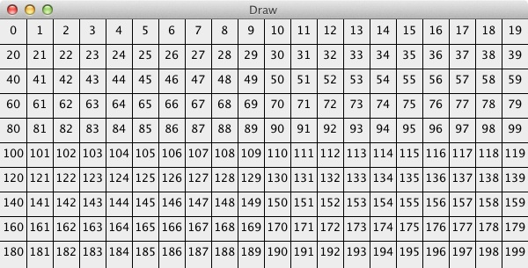

Add a mouse listener that detects the cell where the user has pressed and marks it. Example of pressing cell 92:

