**Title: Lesional and non-lesional device-based neuromodulatory treatments for movement disorders: A comprehensive survey of the clinical trial landscape**

Alaa Taha BMSc1, Brendan Santyr MD MSc1, David Gwun BSc1*, Aaron Loh MB BCh BAO1*, Regina Annirood BSc, Michelle Beyn BSc BScN, Alexandre Boutet MD PhD1,2, Can Sarica MD1, Artur Vetkas MD PhD1*, Clement T. Chow MSc1, Jurgen Germann PhD1, Andres M. Lozano MD, PhD1,3†

1 Division of Neurosurgery, Toronto Western Hospital, University of Toronto, Canada.

2 Joint Department of Medical Imaging, University of Toronto, Toronto, Canada.

3 GE Global Research Center, Niskayuna, NY

* these authors contributed equally

†Corresponding author:

Andres M. Lozano

399 Bathurst St.,

WW 4-431 Toronto Western Hospital

Toronto, ON M5T 2S8, Canada

E-mail: lozano@uhnresearch.ca

phone: +1-416-603-6200

**Abstract (250-word limit max)**

**Background:** Numerous neuromodulatory therapies are currently under investigation for the treatment of movement disorders. We aim to survey and characterize these studies to examine past and current trends in the clinical trial landscape and elucidate the direction of the field.

**Methods:** Using the Clinical Trials registry ([clinicaltrials.gov](http://clinicaltrials.gov)) and the International Clinical Trials Registry Platform (<https://www.who.int/ictrp/en/>), we conducted a broad and comprehensive search for global clinical trials investigating 15 neuromodulation modalities as a treatment for 14 movement disorders. We performed a descriptive analysis of trial characteristics using variables such as neuromodulation modality, country, brain target, publication status, design, and funding source.

**Results:** Our dual-database search strategy identified 2129 trials, of which 721 were included in this review. DBS represented over 50% of all trials. While DBS was represented across all study phases, TMS dominated phase II trials. In sequential order, Parkinson’s Disease, dystonia, and essential tremor were the most common movement disorders investigated by trials. In the last decade, there has been a growing focus on imaging and neurophysiological outcomes. Cerebral palsy studies stand out amongst the rest as the favoured non-invasive non-lesional modalities. By country, the US contributed considerably to the field of neuromodulation and movement disorders. Notably, China demonstrates impressive growth, doubling the number of clinical trials registered by China since 2018.

**Conclusions:** As the field of neurosurgery continues to expand internationally, our findings suggest the possibility of a shift away from DBS and PD towards non-invasive neuromodulation modalities and less common movement disorders.

**Keywords:** Movement disorder, neuromodulation, clinical trials, review, DBS

**Introduction**

Movement disorders are neurological conditions that affect the speed, fluency, and quality of movement. [(1)](https://paperpile.com/c/OlAMRO/ApBay) Symptoms can range from mild movement disturbances to severe physical and psychological debilitation that considerably reduce quality of life. While most movement disorders can be initially managed with pharmacological treatments, as they progress, they become challenging to treat with medications alone. In such cases, neuromodulation can be a promising treatment option. [(5)](https://paperpile.com/c/OlAMRO/9VPC9)

Device-based neuromodulation techniques for movement disorders can range from invasive lesional surgeries, such as radiofrequency ablation (RFA), gamma knife radiosurgery (GKRS), or MR-guided focus ultrasound (MRgFUS), to various forms of invasive and non-invasive modalities that utilize electrical, magnetic, and sonic techniques. [(1,6,7)](https://paperpile.com/c/OlAMRO/8nWp5+ApBay+UyfFz) Today, deep brain stimulation (DBS) is the most common neuromodulatory intervention utilized to treat movement disorders. [(8)](https://paperpile.com/c/OlAMRO/zHiyj) While, DBS is FDA approved for Parkinson’s Disease (PD), essential tremor (ET), and dystonia, its efficacy for less common disorders is still under investigation. [(9–11)](https://paperpile.com/c/OlAMRO/KCbp6+4x6y1+A3hE5) Unlike lesional neuromodulatory interventions, DBS is reversible and titratable. Despite its net benefits, however, certain symptoms can be poorly managed – or even exacerbated – by DBS. [(12–14)](https://paperpile.com/c/OlAMRO/Dny3j+od2zo+l18uz) Additionally, DBS is an invasive and resource-intensive intervention, precluding many potential candidates from undergoing the treatment. [(8,15)](https://paperpile.com/c/OlAMRO/zHiyj+wVOko) In light of these challenges, there may be a growing demand for non-invasive neuromodulation modalities such as transcranial magnetic stimulation, (TMS) transcranial electrical stimulation (tES), and lesional or non-lesional focused ultrasound therapy (FUS).

As the field of neuromodulation continues to grow, well-designed and executed clinical trials are necessary to improve the treatment of movement disorders. Furthermore, clinical trials investigating non-invasive and readily accessible neuromodulatory modalities may help address symptoms and disorders not adequately treated by existing treatments. Previous studies of this kind have examined past and current trends of the clinical trial landscape to elucidate where specific fields are heading and serve to complement existing systematic reviews and meta-analyses. However, no such review has evaluated the field of neuromodulation as it applies to movement disorders. [(16–18)](https://paperpile.com/c/OlAMRO/FcJRl+sRdEo+JlCrh) Here, we aim to survey and characterize all clinical trials involving device-based neuromodulation of the central nervous system as a treatment for movement disorders registered on clinicaltrials.gov and the World Health Organization (WHO) International Clinical Trials Registry Platform (ICTRP).

**Methods**

A detailed description of the search strategy, screening, variable extraction, and publication retrieval is provided in the Supplementary Methods. [(16,17,19)](https://paperpile.com/c/OlAMRO/sRdEo+FcJRl+NEJdF) In brief, a comprehensive search for past and ongoing clinical trials pertaining to lesional and non-lesional device-based neuromodulation for movement disorders was conducted in August 2021. The search was conducted using two publicly available trial registries, Clinicaltrials.gov (<https://clinicaltrials>.gov/) and the International Clinical Trials Registry Platform (ICTRP, <https://trialsearch.who.int/>). We searched for clinical trials investigating neuromodulation for movement disorders. Our list of movement disorders was informed by the International Classification of Diseases (11th edition) (<https://icd.who.int/>) and included: dyskinesis, Meige syndrome, ballism, myoclonus, TS and tics, chorea, palsy, dyskinesia, PD, dystonia, ET, HD, Parkinson’s plus syndrome (PPS), corticobasal degeneration. [(2,20,21)](https://paperpile.com/c/OlAMRO/JFYlR+RSWtv+QiZ10) We considered trials investigating device-based lesional and non-lesional neuromodulation of the central nervous system. Informed by the literature and previous clinical trials of this kind, the specific neuromodulation modalities we examined were: deep brain stimulation (DBS), electroconvulsive therapy (ECT), transcranial magnetic stimulation (TMS), transcranial electrical stimulation (tES), transcranial alternating current stimulation (tACS), transcranial direct current stimulation (tDCS), transcranial random noise stimulation (tRNS), low-field magnetic stimulation (LFMS), transcranial focused ultrasound (FUS), transcranial ultrasound (tUS), cortical stimulation (ECS), magnetic seizure therapy (MST), GKRS, RFA, MRgFUS, spinal cord stimulation (SCS). [(1,16,17,22–26)](https://paperpile.com/c/OlAMRO/ApBay+nf6IW+VxWyS+WJuDA+jYNet+FcJRl+sRdEo+MW8rq) To overcome the limitations of the specific search engines (i.e.: receiving an error message when too many search terms are included), a separate search was conducted for each neuromodulation modality with a combined list of movement disorders (a total of 45 searches – see Supplementary Table 1 for full search syntaxes). A broad search was conducted over a highly specific search (e.g.: a search for each neuromodulation and condition pairing) to avoid missing relevant trials (50). The search results were screened for duplicates and relevance by two independent reviewers (D.G. and C.C.) and disagreements were settled by a third reviewer (A.L.).

Relevant trials were retained for further extraction, characterization, and analysis. Study details and recruitment information such as – study type, study phase, randomization, interventional model, masking, condition, study arms, recruitment status, reasons for withdrawal or termination, actual and estimated enrollment size, study start date, eligibility criteria (minimum and maximum age, gender, condition, and inclusion and exclusion criteria), neuromodulatory intervention, outcomes, and follow-up period were extracted. Additionally, administrative information including clinical trial id, study location and institution, study sponsors and collaborators, funding type, and presence of a data monitoring committee were recorded. When accessible, information regarding the specific neuromodulation target and treatment parameters (i.e.: frequency, pulse width, voltage, TMS pulse repetitions) were extracted. Publications were extracted in a stepwise fashion involving extracting automatically indexed publications and searching the clinical trial IDs in the PubMed and google scholar databases.

**Results**

Our initial search identified 1339 clinical trials from the ClinicalTrials.gov database and 790 from the ICTRP database. After screening for duplicates and relevance, 721 clinical trial entries remained (Fig. 1). Of these, 18% and 33% of clinical trials came from the clinicaltrials.gov and ICTRP databases, respectively, and 49% were common to both.

*Studies by indication, neuromodulation intervention, outcomes, and brain targets*

PD was by far the most common movement disorder, investigated by over half of the trials included in this review (58%), followed by dystonia (14%) and ET (13%) (Fig. 2A). The average number of new clinical trials registered per year for PD, ET, and dystonia has increased from 4.9, 2.6, and 0.3 (1997-2010) to 32, 5.6, and 7.8 (2011-2022), respectively (Figure 2B). Novel movement disorders investigated by neuromodulation trials include Meige syndrome, PPS, and HD. Overall, 18% of trials included more than one indication. In recent years, a growing number of these trials are investigating neuropsychiatric comorbidities, the most common being cognitive impairment (15%), depression (9%), pain (7%), and OCD (5%).

55% of identified movement disorder neuromodulation trials investigated invasive neuromodulation techniques (DBS, MCS, SCS). In comparison, 36% of trials examined non-lesional non-invasive modalities (TMS, tES, tUS), and 7% of trials involved lesional modalities (MRgFUS, GKRS, RFA). The percentage breakdown of trials by specific intervention is provided in Fig. 3A. MRgFUS and SCS represent relatively novel but rapidly growing interventions considering their earliest movement disorder trials were registered in 2011 and 2014, respectively, and over 50% of these trials started within the last five years (Fig. 3B). Overall, less than one percent of trials examined more than one neuromodulation modality (n=3). Different neuromodulation modalities present different movement disorder profiles (Fig. 4). PD was the indication of focus across all neuromodulation modalities. DBS for PD represents the largest single modality-disorder pairing, accounting for 40% of all trial entries identified. A smaller, albeit substantial proportion of DBS studies also investigated ET, dystonia, and TS. TMS and tES studies research spanned all of the indications queried here, with a heavy focus on PD. TMS and tES focused less on ET and more on cerebral palsy, whereas MRgFUS concentrated heavily on PD and ET.

Approximately half (52%) of trials evaluated the efficacy of neuromodulation modalities to treat or change movement-related symptoms of movement disorders as a primary outcome (Fig. 5). Changes in gait, balance and postural instability were of particular interest which were measured in 21.8% of the trials in this review. Other outcomes of interest included changes in voice and sleep disturbances, which were investigated by 5% and 3% of trials, respectively.

72% of trials (n=521) specified brain targets, identifying 45 unique brain targets. (Supplementary Table 2) DBS trials present the most variety of targets, followed by TMS and tDCS. STN was the most common, accounting for 30% of all discrete targets. Among DBS trials, STN was targeted 55% of the time, followed by globus pallidus (21%) and thalamus (15%). The most novel DBS targets include thalamic ventral-oralis complex (VO) and dentatothalamic tract, both investigated for the treatment of ET, and the superior cerebellar peduncle, which is being investigated for dystonia. For TMS and tES trials, cortical motor regions (primary motor cortex, supplementary motor area, and premotor area) were targeted 38% and 50% of the time, respectively. The proportion of targets according to broad CNS sub-divisions was as follows: 62% deep brain structures, 30% cortical areas, 5% cerebellum, and 3% spinal cord. Overall, 17% of trials investigated more than one target.

*Studies by start date and status of completion*

Since the creation of the ClinicalTrials.gov and ICTRP databases, the number of clinical trials investigating neuromodulation modalities for movement disorders has trended upwards (Fig. 6A). Between 1997 and 2004, the maximum number of trials started each year was 10. From 2005 onwards, the number of clinical trials started each year grew rapidly, with approximately a quarter of all clinical trials starting in the last five years. All trials that began before 2006 have been completed, or their status is unknown. 621 trials provided a known study status. Of the 298 active trials, 112 were not recruiting, 16 were enrolling by invitation, and 177 were recruiting. Reasons for termination, withdrawal, and suspension are shown in Fig. 6B.

*Studies by study type, design, projected enrollment, phase, and funding*

Information regarding the clinical trial arms, blinding, phase, and randomization of interventional and non-interventional studies are summarized in table 1. Overall, the study phase was reported inconsistently, with only 16.2% of trial entries providing this information. Fig. 7A shows the relationship between phase and projected enrollment numbers for the 106 trials that provided information for both phase and projected enrollment, while Fig. 7B categorizes study phases by neuromodulation modality. Across modalities, only DBS, TMS, tDCS, GKRS, and MRgFUS had trials beyond the phase 2 stage. 137 (n=17%) clinical trials identified in this review were either fully or partially funded by the industry. A third of these studies were sponsored by Medtronic, followed by Insightec and Boston Scientific which sponsored 20% and 14% of trials, respectively. The remaining 83% of trials were funded by non-industry sources such as academic institutions and university-affiliated hospitals (79%), governments such as NIH (17%), and private foundations (10%).

*Studies by publication status and country* 26% (n=184) of trials published their results in peer-reviewed journals for a total of 98 publications. Except for myoclonus, all indications identified in our search were represented in the literature (65% PD, 24% Dystonia, 14% ET, 7% Tourette’s syndrome, 5% cerebral palsy, 2% PPS, 2% HD, 1% dyskinesis, 1% Meige, 1% MS). Across neuromodulation modalities, DBS led with the greatest number of trials with published results (62%) followed by TMS (14%), tES (11%), MRgFUS (6%), SCS (2%), RFA (0.5%), MCS (0.5%). Overall, the majority of trials with published results were complete (55%), 29% remained active, 4% were terminated or withdrawn, and 13% were unknown. Finally, 82% and 22% of published trials were either partially or fully funded by academic institutions and industry, respectively.

Movement disorder neuromodulation clinical trials were found to span 6 continents and 36 countries. North America accounted for 36% of trials, followed closely by Europe (35%) and Asia (21%), then South America (5%), Oceania (2%), and Africa (1%). By country, the United States leads with the highest number of registered clinical trials (36%). Following the USA, the countries with the highest percentage of trials are, in turn, France (12%), China (10%), Germany (8%) and Japan (5%) (Fig.8A). Cumulatively, these countries contributed over 70% of all entries. In terms of growth, the USA also leads with the highest number of new trials registered per year. Notably, China demonstrates impressive growth, doubling the number of clinical trials registered by China since 2018 (Fig. 8B).

**Discussion**

Here, we conducted a comprehensive search and survey of global clinical trials investigating neuromodulation as a treatment for movement disorders. DBS stood out with respect to the number of trials, representing over 50% included in this review. While DBS was represented across all study phases, TMS dominated phase II trials. In sequential order, PD, dystonia, and ET were the most common movement disorders investigated by trials. In the last decade, there has been a growing focus on imaging and neurophysiological outcomes. CP studies stand out amongst the rest as it was favoured by trials investigating non-invasive non-lesional modalities. Trials spanned 6 continents and 37 countries, with significant contributions from the US and China. Overall, our results highlight neuromodulation for movement disorder as a rapidly growing field.

The large representation of DBS in the clinical trial landscape can be explained by the long-established efficacy of DBS to provide therapeutic benefits for movement disorder patients. [(9–11)](https://paperpile.com/c/OlAMRO/KCbp6+4x6y1+A3hE5) In keeping with previous findings, we found that DBS trials for movement disorders trended towards investigating novel brain targets (e.g., VO) and DBS hardware (i.e., rechargeable IPGs and directional leads). [(27,28)](https://paperpile.com/c/OlAMRO/sVza6+mvxvy) Interestingly, electrophysiological and neuroimaging outcomes were the second most common metric measured by DBS studies suggesting a shift away from assessing motor-related effects and towards understanding the underlying mechanism of DBS and disease. [(29,30)](https://paperpile.com/c/OlAMRO/Ls35d+AMv71) These trials may also serve to improve DBS by identifying biomarkers to better guide stimulation programming and to be used in adaptive DBS systems as opposed to establishing clinical safety and efficacy. [(29,31)](https://paperpile.com/c/OlAMRO/Ls35d+w2lJQ) Despite the preeminence of DBS in the clinical trial landscape, utilization of non-invasive non-lesional modalities continues to expand. Cumulatively, trials investigating non-invasive neuromodulation modalities tended to increase at a similar rate as DBS, despite the large discrepancy in the total number of trials by individual neuromodulation modality. Two modalities of interest are TMS and tES trials. These studies were most often classified as phase II studies, the phase in which treatments may offer preliminary evidence of efficacy. [(32)](https://paperpile.com/c/OlAMRO/76pCW) The limited number of TMS and tES trials beyond the phase II stage may suggest that we are still investigating the ideal application of these modalities for movement disorders. [(33,34)](https://paperpile.com/c/OlAMRO/SZCxl+4mbIh) This contrasts with neuromodulation interventions that are FDA-approved such as DBS and MRgFUS, which are represented in phase III and IV trials. [(35,36)](https://paperpile.com/c/OlAMRO/rjSEx+vhzHs) Nevertheless, it is important to consider that these non-invasive neuromodulation modalities have been applied to treat neuropsychiatric disorders successfully. [(17)](https://paperpile.com/c/OlAMRO/sRdEo) As such, TMS and other non-invasive modalities may have the potential to alleviate some of the non-motor-related symptoms associated with movement disorders, such as depression and cognitive decline, as well as symptoms inadequate addressed by DBS such as speech disturbances or disease-associated pain. [(37–42)](https://paperpile.com/c/OlAMRO/IRdJX+TiSuE+JmvvR+waSNm+yyHpY+SFuUf)

While the field of neuromodulation spans numerous movement disorders, PD was the dominant clinical indication of focus. Other notable indications include dystonia and ET, which, along with PD, accounted for 85% of indications investigated by trials. This finding may be attributable to the fact that PD, dystonia, and ET are the only movement disorders for DBS that are currently approved by the FDA, Health Canada, and European Medicines Agency. [(8)](https://paperpile.com/c/OlAMRO/zHiyj) Additionally, the overrepresentation of these indications may be related to disease prevalence considering that they are the three most common movement disorders globally. [(2–4,43)](https://paperpile.com/c/OlAMRO/RSWtv+MzZKL+aD6Y2+6f6dc) However, the proportion of disease-specific clinical trials did not follow global prevalence as ET is the more common movement disorder, followed by PD, then dystonia. Notably, the number of ET studies lagged behind both dystonia and PD until 2012, when there was a sudden increase in ET studies. This rapid increase was primarily driven by the advent of MRgFUS, which soon received FDA approval for ET in 2016. [(35,44)](https://paperpile.com/c/OlAMRO/rjSEx+NlvER). By contrast, only a handful of studies investigated less common indications, which constituted less than one-fifth of total clinical trials, highlighting considerable gaps within the clinical trial landscape. However, nearly 70% of these trials started in the past 10 years, suggesting that there is a growing trend toward assessing neuromodulation for these indications. One movement disorder of interest is CP, which showed consistent growth over the last decade, doubling the number of trials within the last five years. Unlike other movement disorders that predominantly preferred DBS, trials investigating CP favoured non-invasive neuromodulation modalities, such as TMS and tES. The preference for non-invasive modalities may relate to the fact that CP develops during infancy, making invasive brain or spine surgery that requires multiple follow-up procedures to replace hardware (i.e.: batteries) a suboptimal treatment option for children. [(45,46)](https://paperpile.com/c/OlAMRO/9AA5h+e1NUd) Though the factors that affect the preference for invasive and non-invasive modalities are unclear, the disease seems to be an important consideration. For example, the disorder profile of neuromodulation modalities for movement disorders is drastically different from that of neuropsychiatric disorders, which highly favoured nonconvulsive non-invasive modalities such as TMS and tES over conclusive and invasive modalities like DBS. [(17)](https://paperpile.com/c/OlAMRO/sRdEo) Other variables include patient age, disease mechanism, brain targets, and preserved risk associated with the neuromodulation modality.

Along with the ClincicalTrails.gov, this review surveyed the ICTRP database, which accumulates data from 16 different databases. This has allowed us to decrease a bias towards the USA and western countries and present a better representation of the field of neuromodulation for movement disorders. In doing so, we identified 313 unique clinical trials (16%) not registered on ClinicalTrials.gov, mainly from countries outside of the USA. Though the USA has and continues to be the greatest contributor in this field, a sizable number of trials came from Asian countries, such as Japan and China. Most impressively, China has shown rapid growth – registering its first clinical trial in 2011 and doubling the number of trials registered in the last 5 years. The notable increase may be attributable to the establishment of local manufacturers of neuromodulation devices.

*Limitations*

Unlike previous works of this kind, we conducted a broad search across two international trial registries, with over 420 000 trials registered from over 200 countries and data acquired from 16 different databases. However, we are ultimately limited by the consistency and reliability in which clinical trials are registered, reported, updated, and monitored. Additionally, this review only includes surveyed trials registered after the inception of Clinicaltrials.gov and ICTRP databases, precluding early neuromodulation studies before 1999. This greatly biases our findings to modern neuromodulation modalities as opposed to early lesional techniques. [(6,47–49)](https://paperpile.com/c/OlAMRO/LesZi+6oILY+jIlpc+8nWp5) Finally, for practical reasons, we limited our search to 12 movement disorder indications and 15 neuromodulation modalities.

**Conclusion**

We used a dual-database methodology to provide an overview of past and current clinical trials researching neuromodulation as a treatment for movement disorders revealing global trends in subject matter, areas of interest, and study design. As the field of neurosurgery continues to expand internationally, our findings suggest the possibility of a shift away from DBS and PD towards non-invasive neuromodulation modalities and less common movement disorders. Future neuromodulation research will likely be driven by the prevalence of movement disorders as well as new techniques that may dramatically improve the treatment of these conditions.

**References**

1. [Shipton EA. Movement disorders and neuromodulation. Neurol Res Int. 2012 Sep 19;2012:309431.](http://paperpile.com/b/OlAMRO/ApBay)

2. [Ostrem JL, Galifianakis NB. Overview of common movement disorders. Continuum . 2010 Feb;16(1 Movement Disorders):13–48.](http://paperpile.com/b/OlAMRO/RSWtv)

3. [Louis ED, Ferreira JJ. How common is the most common adult movement disorder? Update on the worldwide prevalence of essential tremor. Mov Disord. 2010 Apr 15;25(5):534–41.](http://paperpile.com/b/OlAMRO/MzZKL)

4. [Wenning GK, Kiechl S, Seppi K, Müller J, Högl B, Saletu M, et al. Prevalence of movement disorders in men and women aged 50-89 years (Bruneck Study cohort): a population-based study. Lancet Neurol. 2005 Dec;4(12):815–20.](http://paperpile.com/b/OlAMRO/aD6Y2)

5. [Williams A, Gill S, Varma T, Jenkinson C, Quinn N, Mitchell R, et al. Deep brain stimulation plus best medical therapy versus best medical therapy alone for advanced Parkinson’s disease (PD SURG trial): a randomised, open-label trial. Lancet Neurol. 2010 Jun;9(6):581–91.](http://paperpile.com/b/OlAMRO/9VPC9)

6. [Benabid AL, Pollak P, Louveau A, Henry S, de Rougemont J. Combined (thalamotomy and stimulation) stereotactic surgery of the VIM thalamic nucleus for bilateral Parkinson disease. Appl Neurophysiol. 1987;50(1-6):344–6.](http://paperpile.com/b/OlAMRO/8nWp5)

7. [Walters H, Shah BB. Focused Ultrasound and Other Lesioning Therapies in Movement Disorders. Curr Neurol Neurosci Rep. 2019 Aug 3;19(9):66.](http://paperpile.com/b/OlAMRO/UyfFz)

8. [Lozano AM, Lipsman N, Bergman H, Brown P, Chabardes S, Chang JW, et al. Deep brain stimulation: current challenges and future directions. Nat Rev Neurol. 2019 Mar;15(3):148–60.](http://paperpile.com/b/OlAMRO/zHiyj)

9. [Koller W, Pahwa R, Busenbark K, Hubble J, Wilkinson S, Lang A, et al. High-frequency unilateral thalamic stimulation in the treatment of essential and parkinsonian tremor. Ann Neurol. 1997 Sep;42(3):292–9.](http://paperpile.com/b/OlAMRO/KCbp6)

10. [Zhang K, Bhatia S, Oh MY, Cohen D, Angle C, Whiting D. Long-term results of thalamic deep brain stimulation for essential tremor. J Neurosurg. 2010 Jun;112(6):1271–6.](http://paperpile.com/b/OlAMRO/4x6y1)

11. [Limousin P, Krack P, Pollak P, Benazzouz A, Ardouin C, Hoffmann D, et al. Electrical stimulation of the subthalamic nucleus in advanced Parkinson’s disease. N Engl J Med. 1998 Oct 15;339(16):1105–11.](http://paperpile.com/b/OlAMRO/A3hE5)

12. [Eisenstein SA, Dewispelaere WB, Campbell MC, Lugar HM, Perlmutter JS, Black KJ, et al. Acute changes in mood induced by subthalamic deep brain stimulation in Parkinson disease are modulated by psychiatric diagnosis. Brain Stimul. 2014 Sep;7(5):701–8.](http://paperpile.com/b/OlAMRO/Dny3j)

13. [Merola A, Romagnolo A, Rizzi L, Rizzone MG, Zibetti M, Lanotte M, et al. Impulse control behaviors and subthalamic deep brain stimulation in Parkinson disease. J Neurol. 2017 Jan;264(1):40–8.](http://paperpile.com/b/OlAMRO/od2zo)

14. [Schuepbach WMM, Rau J, Knudsen K, Volkmann J, Krack P, Timmermann L, et al. Neurostimulation for Parkinson’s disease with early motor complications. N Engl J Med. 2013 Feb 14;368(7):610–22.](http://paperpile.com/b/OlAMRO/l18uz)

15. [Jourdain VA, Schechtmann G. Health economics and surgical treatment for Parkinson’s disease in a world perspective: results from an international survey. Stereotact Funct Neurosurg. 2014 Jan 30;92(2):71–9.](http://paperpile.com/b/OlAMRO/wVOko)

16. [Harmsen IE, Elias GJB, Beyn ME, Boutet A, Pancholi A, Germann J, et al. Clinical trials for deep brain stimulation: Current state of affairs. Brain Stimul. 2020 Mar;13(2):378–85.](http://paperpile.com/b/OlAMRO/FcJRl)

17. [Elias GJB, Boutet A, Parmar R, Wong EHY, Germann J, Loh A, et al. Neuromodulatory treatments for psychiatric disease: A comprehensive survey of the clinical trial landscape. Brain Stimul. 2021 Sep;14(5):1393–403.](http://paperpile.com/b/OlAMRO/sRdEo)

18. [Mansouri A, Beyn ME, Pancholi A, Chow CT, Wang R, Boutet A, et al. Evolution of the Neurosurgeon’s Role in Clinical Trials for Glioblastoma: A Systematic Overview of the Clinicaltrials.Gov Database. Neurosurgery. 2021 Jul 15;89(2):196–203.](http://paperpile.com/b/OlAMRO/JlCrh)

19. [Turner BE, Magnani CJ, Frolov A, Weeks BT, Steinberg JR, Huda N, et al. Neurology trial registrations on ClinicalTrials.gov between 2007 and 2018: A cross-sectional analysis of characteristics, early discontinuation, and results reporting. J Neurol Sci. 2021 Sep 15;428:117579.](http://paperpile.com/b/OlAMRO/NEJdF)

20. [Fahn S. Classification of movement disorders. Mov Disord. 2011 May;26(6):947–57.](http://paperpile.com/b/OlAMRO/JFYlR)

21. [Carlos PF. About Movement Disorders. J dairy vet sci [Internet]. 2019 Feb 20 [cited 2022 Apr 24];10(2). Available from:](http://paperpile.com/b/OlAMRO/QiZ10) <https://www.movementdisorders.org/MDS/About/Movement-Disorder-Overviews.htm>

22. [Régis J, Bartolomei F, Hayashi M, Chauvel P. Gamma Knife surgery, a neuromodulation therapy in epilepsy surgery! Acta Neurochir Suppl. 2002;84:37–47.](http://paperpile.com/b/OlAMRO/nf6IW)

23. [Abejón D, Reig E. Is pulsed radiofrequency a neuromodulation technique? Neuromodulation. 2003 Jan;6(1):1–3.](http://paperpile.com/b/OlAMRO/VxWyS)

24. [Li Y, Lee J, Long X, Qiao Y, Ma T, He Q, et al. A Magnetic Resonance-Guided Focused Ultrasound Neuromodulation System With a Whole Brain Coil Array for Nonhuman Primates at 3 T. IEEE Trans Med Imaging. 2020 Dec;39(12):4401–12.](http://paperpile.com/b/OlAMRO/WJuDA)

25. [Ranjan M, Boutet A, Bhatia S, Wilfong A, Hader W, Lee MR, et al. Neuromodulation beyond neurostimulation for epilepsy: scope for focused ultrasound. Expert Rev Neurother. 2019 Oct;19(10):937–43.](http://paperpile.com/b/OlAMRO/jYNet)

26. [Harmsen IE, Hasanova D, Elias GJB, Boutet A, Neudorfer C, Loh A, et al. Trends in Clinical Trials for Spinal Cord Stimulation. Stereotact Funct Neurosurg. 2021;99(2):123–34.](http://paperpile.com/b/OlAMRO/MW8rq)

27. [Center for Devices, Radiological Health. VerciseTM PC and Vercise GeviaTM DBS system - P150031/S028 [Internet]. U.S. Food and Drug Administration. 2021 [cited 2022 May 4]. Available from:](http://paperpile.com/b/OlAMRO/sVza6) <https://www.fda.gov/medical-devices/recently-approved-devices/vercisetm-pc-and-vercise-geviatm-deep-brain-stimulation-dbs-system-p150031s028>

28. [Frey J, Cagle J, Johnson KA, Wong JK, Hilliard JD, Butson CR, et al. Past, Present, and Future of Deep Brain Stimulation: Hardware, Software, Imaging, Physiology and Novel Approaches. Front Neurol. 2022 Mar 9;13:825178.](http://paperpile.com/b/OlAMRO/mvxvy)

29. [Boutet A, Madhavan R, Elias GJB, Joel SE, Gramer R, Ranjan M, et al. Predicting optimal deep brain stimulation parameters for Parkinson’s disease using functional MRI and machine learning. Nat Commun. 2021 May 24;12(1):3043.](http://paperpile.com/b/OlAMRO/Ls35d)

30. [Loh A, Gwun D, Chow CT, Boutet A, Tasserie J, Germann J, et al. Probing responses to deep brain stimulation with functional magnetic resonance imaging. Brain Stimul. 2022 Apr 18;15(3):683–94.](http://paperpile.com/b/OlAMRO/AMv71)

31. [Wårdell K, Nordin T, Vogel D, Zsigmond P, Westin C-F, Hariz M, et al. Deep Brain Stimulation: Emerging Tools for Simulation, Data Analysis, and Visualization. Front Neurosci. 2022 Apr 11;16:834026.](http://paperpile.com/b/OlAMRO/w2lJQ)

32. [Umscheid CA, Margolis DJ, Grossman CE. Key concepts of clinical trials: a narrative review. Postgrad Med. 2011 Sep;123(5):194–204.](http://paperpile.com/b/OlAMRO/76pCW)

33. [Obeso I, Cerasa A, Quattrone A. The Effectiveness of Transcranial Brain Stimulation in Improving Clinical Signs of Hyperkinetic Movement Disorders. Front Neurosci. 2015;9:486.](http://paperpile.com/b/OlAMRO/SZCxl)

34. [Latorre A, Rocchi L, Berardelli A, Bhatia KP, Rothwell JC. The use of transcranial magnetic stimulation as a treatment for movement disorders: A critical review. Mov Disord. 2019 Jun;34(6):769–82.](http://paperpile.com/b/OlAMRO/4mbIh)

35. [FDA approves focused ultrasound treatment for Parkinson’s disease [Internet]. Focused Ultrasound Foundation. 2021 [cited 2022 Apr 24]. Available from:](http://paperpile.com/b/OlAMRO/rjSEx) <https://www.fusfoundation.org/news/fda-approves-focused-ultrasound-treatment-for-parkinsons-disease>

36. [Office of the Commissioner. FDA approves first MRI-guided focused ultrasound device to treat essential tremor [Internet]. U.S. Food and Drug Administration. 2016 [cited 2022 May 4]. Available from:](http://paperpile.com/b/OlAMRO/vhzHs) <https://www.fda.gov/news-events/press-announcements/fda-approves-first-mri-guided-focused-ultrasound-device-treat-essential-tremor>

37. [Weintraub D, Burn DJ. Parkinson’s disease: the quintessential neuropsychiatric disorder. Mov Disord. 2011 May;26(6):1022–31.](http://paperpile.com/b/OlAMRO/IRdJX)

38. [Kamble N, Netravathi M, Pal PK. Therapeutic applications of repetitive transcranial magnetic stimulation (rTMS) in movement disorders: a review. Parkinsonism Relat Disord. 2014 Jul;20(7):695–707.](http://paperpile.com/b/OlAMRO/TiSuE)

39. [Potrebić A, Dragasević N, Svetel M, Kostić VS. [Effect of slow repetitive transcranial magnetic stimulation on depression in patients with Parkinson ’s disease]. Srp Arh Celok Lek. 2001 Sep;129(9-10):235–8.](http://paperpile.com/b/OlAMRO/JmvvR)

40. [Benninger DH, Berman BD, Houdayer E, Pal N, Luckenbaugh DA, Schneider L, et al. Intermittent theta-burst transcranial magnetic stimulation for treatment of Parkinson disease. Neurology. 2011 Feb 15;76(7):601–9.](http://paperpile.com/b/OlAMRO/waSNm)

41. [Srovnalova H, Marecek R, Rektorova I. The role of the inferior frontal gyri in cognitive processing of patients with Parkinson’s disease: a pilot rTMS study. Mov Disord. 2011 Jul;26(8):1545–8.](http://paperpile.com/b/OlAMRO/yyHpY)

42. [Brabenec L, Klobusiakova P, Simko P, Kostalova M, Mekyska J, Rektorova I. Non-invasive brain stimulation for speech in Parkinson’s disease: A randomized controlled trial. Brain Stimul. 2021 May;14(3):571–8.](http://paperpile.com/b/OlAMRO/SFuUf)

43. [Thenganatt MA, Louis ED. Distinguishing essential tremor from Parkinson’s disease: bedside tests and laboratory evaluations. Expert Rev Neurother. 2012 Jun;12(6):687–96.](http://paperpile.com/b/OlAMRO/6f6dc)

44. [Elias WJ, Huss D, Voss T, Loomba J, Khaled M, Zadicario E, et al. A pilot study of focused ultrasound thalamotomy for essential tremor. N Engl J Med. 2013 Aug 15;369(7):640–8.](http://paperpile.com/b/OlAMRO/NlvER)

45. [Sanger TD. Deep brain stimulation for cerebral palsy: where are we now? Dev Med Child Neurol. 2020 Jan;62(1):28–33.](http://paperpile.com/b/OlAMRO/9AA5h)

46. [Patel DR, Neelakantan M, Pandher K, Merrick J. Cerebral palsy in children: a clinical overview. Transl Pediatr. 2020 Feb;9(Suppl 1):S125–35.](http://paperpile.com/b/OlAMRO/e1NUd)

47. [Lozano AM, Lang AE, Galvez-Jimenez N, Miyasaki J, Duff J, Hutchinson WD, et al. Effect of GPi pallidotomy on motor function in Parkinson’s disease. Lancet. 1995 Nov 25;346(8987):1383–7.](http://paperpile.com/b/OlAMRO/LesZi)

48. [Riechert T. The stereotactic technique and its application in extrapyramidal hyperkinesia. Confin Neurol. 1972;34(5):325–30.](http://paperpile.com/b/OlAMRO/6oILY)

49. [Lunsford LD, Niranjan A. The History of Movement Disorder Brain Surgery. Prog Neurol Surg. 2018 Jan 12;33:1–12.](http://paperpile.com/b/OlAMRO/jIlpc)

50. Glanville JM, Duffy S, McCool R, Varley D. Searching clinicaltrials.gov and the International Clinical Trials Registry Platform to inform systematic reviews: What are the optimal search approaches? [Internet]. Journal of the Medical Library Association : JMLA. Medical Library Association; 2014 [cited 2022May25]. Available from: https://www.ncbi.nlm.nih.gov/pmc/articles/PMC4076126/

**Table 1. Trial characteristics**

|  | **All studies (n=721)** | **Interventional (n=487)** | **Observational (n=230)** |
| --- | --- | --- | --- |
| **Projected enrollment size** |  |  |  |
| 0 | 13 | 12 | 1 |
| 1-10 | 155 | 115 | 39 |
| 11-50 | 382 | 256 | 124 |
| 51-100 | 100 | 68 | 32 |
| 101-500 | 55 | 26 | 28 |
| 500+ | 6 | 1 | 5 |
| Not specified | 10 | 9 | 1 |
| **Arms** |  |  |  |
| 1 | 235 | 159 | 76 |
| 2 | 302 | 238 | 64 |
| 3 | 58 | 34 | 22 |
| 4+ | 41 | 27 | 14 |
| Not specified | 85 | 29 | 54 |
| **Blinding** |  |  |  |
| None | 246 | 196 | 48 |
| Single | 74 | 62 | 12 |
| Double | 159 | 127 | 32 |
| Triple | 54 | 46 | 8 |
| Quadruple | 37 | 33 | 4 |
| Not specified | 151 | 23 | 126 |
| **Randomization** |  |  |  |
| Yes | 346 | 297 | 48 |
| No | 104 | 62 | 31 |
| Not specified | 271 | 121 | 151 |
| **Funding\*** |  |  |  |
| Industry | 571 | 399 | 170 |
| Accademic | 119 | 64 | 54 |
| Government | 137 | 91 | 45 |
| Private grants | 73 | 59 | 13 |
| Not specified | 4 | 4 | 0 |

*The cumulative number of trials does not add up to 721 because trials funded by more than funding category were counted in each respective category.

**Figure 1. Consort diagram of clinical trials included in the analysis.** The number of trials obtained at each stage is shown. Abbreviations: ICTRP=International Clinical Trials Registry Platform.

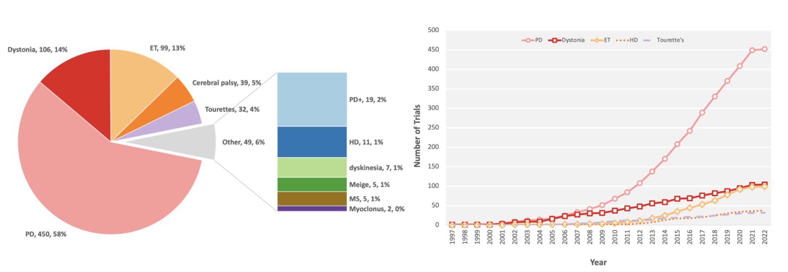**Figure 2. Trials by clinical disorder.** 721 trials (100%) included in this study provided information on the clinical disorders being studied. (**A**) Pie chart representing the percentage of clinical trials categorized by clinical disorder.* (**B**) Line plot of the five most common movement disorders investigated by trials (PD, dystonia, ET, HD, and TS) between 1997 and 2022. Abbreviations: PD=Parkinson’s disease; ET=essential tremor; PD+=Parkinson’s plus syndrome; HD=Huntington’s disease; MS=multiple sclerosis.

*The cumulative number of trials does not add up to 721 because trials investigating more than one indication were counted in each respective category.

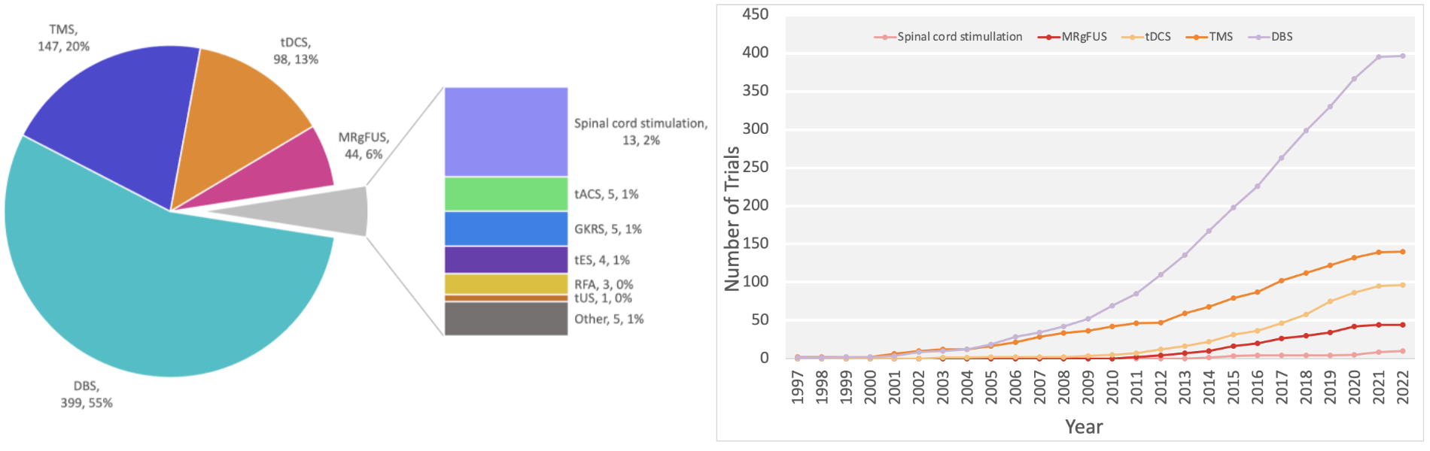

**Figure 3. Trials by neuromodulation modality.** All trials included in this study provided information on the neuromodulation modality being investigated. (**A**) Pie chart representing the percentage of clinical trials categorized by neuromodulation modality. In sequential order, 399 (55%) investigated DBS, followed by 147 (20%) TMS, 98 (13%) tDCS, 44 (6%) MRgFUS, 13 (2%) SCS. The remaining modalities contributed less than 5% of the total number of discrete neuromodulation modalities investigated.* (**B**) Line plot of the five most common neuromodulation modalities investigated by trials (DBS, TMS, tDCS, MRgFUS, and SCS) between 1997 and 2022. Abbreviations: DBS=deep brain stimulation; TMS=transcranial magnetic stimulation; tDCS=transcranial direct current stimulation; MRgFUS=MR-guided focused ultrasound; tACS=transcranial alternating current stimulation; tUS=transcranial ultrasound; GKRS=gamma knife radiosurgery, RFA=radiofrequency ablation; tES=transcranial electrical stimulation.

*The cumulative number of trials does not add up to 721 because trials investigating more than one indication were counted in each respective category.

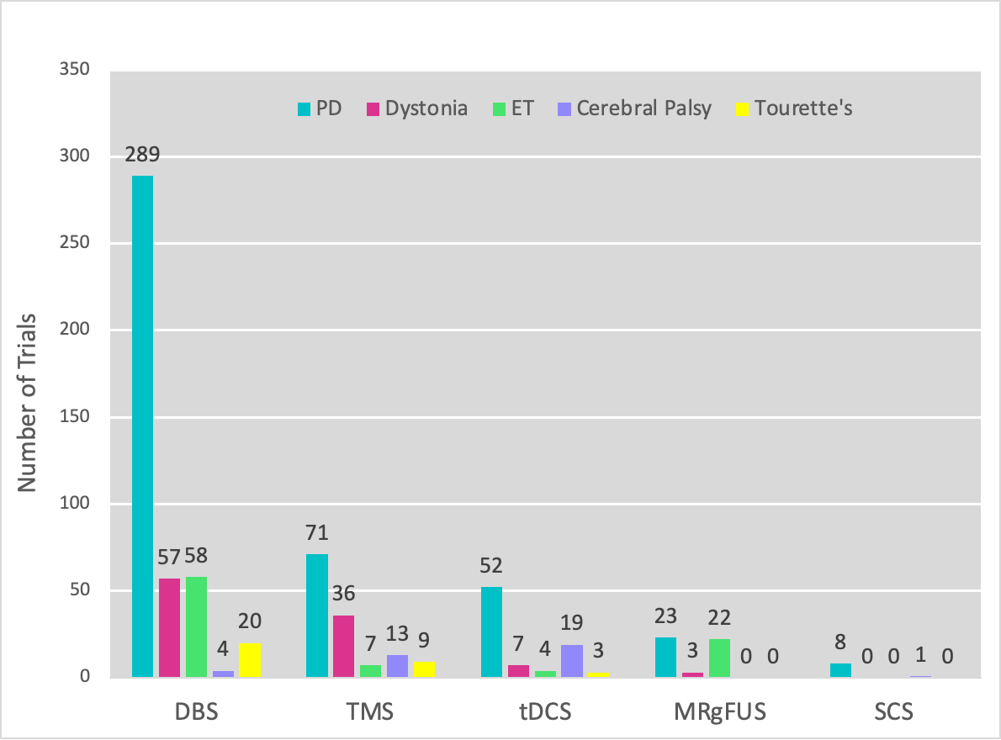

**Figure 4. Trials by neuromodulation modality and disorder.** Bar chart showing the interaction between the five most common neuromodulation modalities and indications. Abbreviations: Abbreviations: DBS=deep brain stimulation; TMS=transcranial magnetic stimulation; MRgFUS=MR-guided focus ultrasound; GKRS=gamma knife radiosurgery; RFA=radiofrequency ablation; SCS=spinal cord stimulation; tPCS=transcranial pulsed-current stimulation, PD=Parkinson’s Disease; ET=essential tremor.

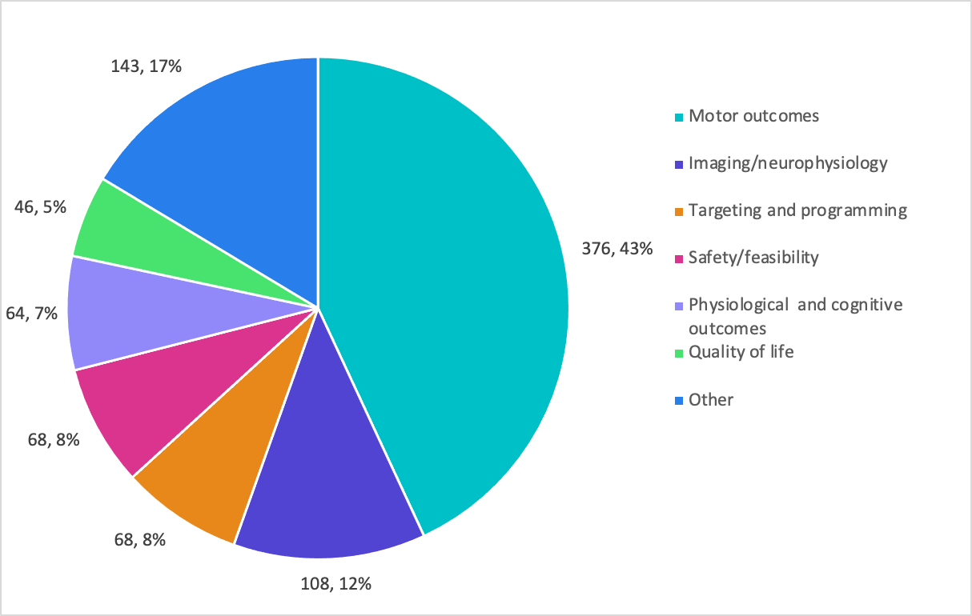

**Figure 5. Trials by primary outcomes.\*** 697 trials (97%) included in this study provided information regarding primary outcomes. The number of trials and the percentage for each category is provided. Abbreviations: PI=primary investigator.

*Total number of trials does not add up to 721 because trials that measured more than one outcome were counted in each respective category.

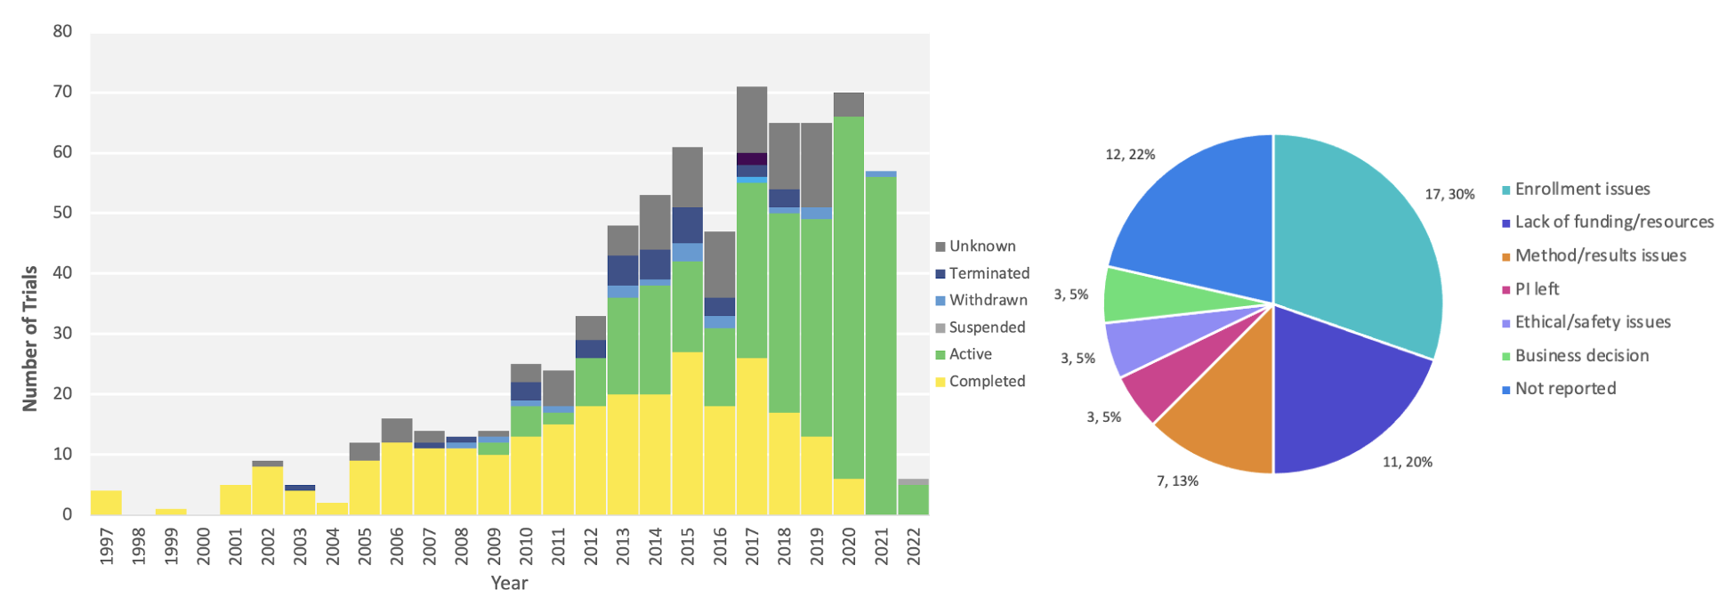

**Figure 6. Trials by status completion.** 621 trials (86% of all trials) included in this study reported a known study status. (**A**) the number of studies by start date between 1997 and 2022 categorized by study status. 298 (48%) were active, 270 (43%) were completed, 33 (5%) were terminated, 18 (3%) were withdrawn and 2 (<0.5%) were suspended. (**B**) Pie chart representing the percentage of terminated, withdrawn, and suspended clinical trials and their reason for abandonment. The most common reason was enrollment issues (30%), followed by lack of funding or resources (20%), issues with methods or results (13%), PI departure (5%), ethical or safety issues (5%), and business-related decisions (5%). Abbreviation=PI=primary investigator.

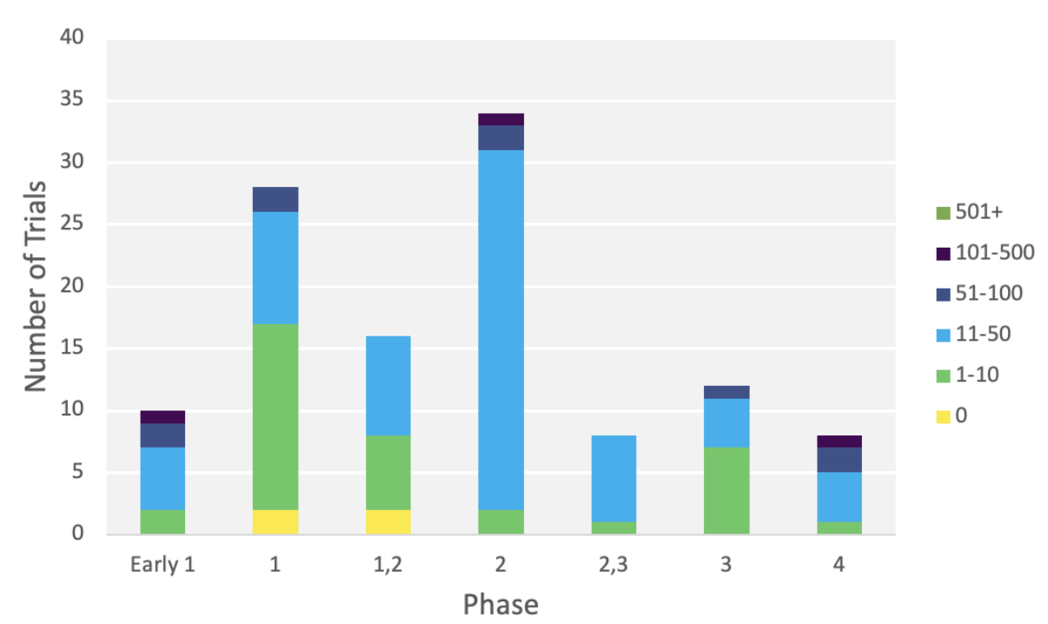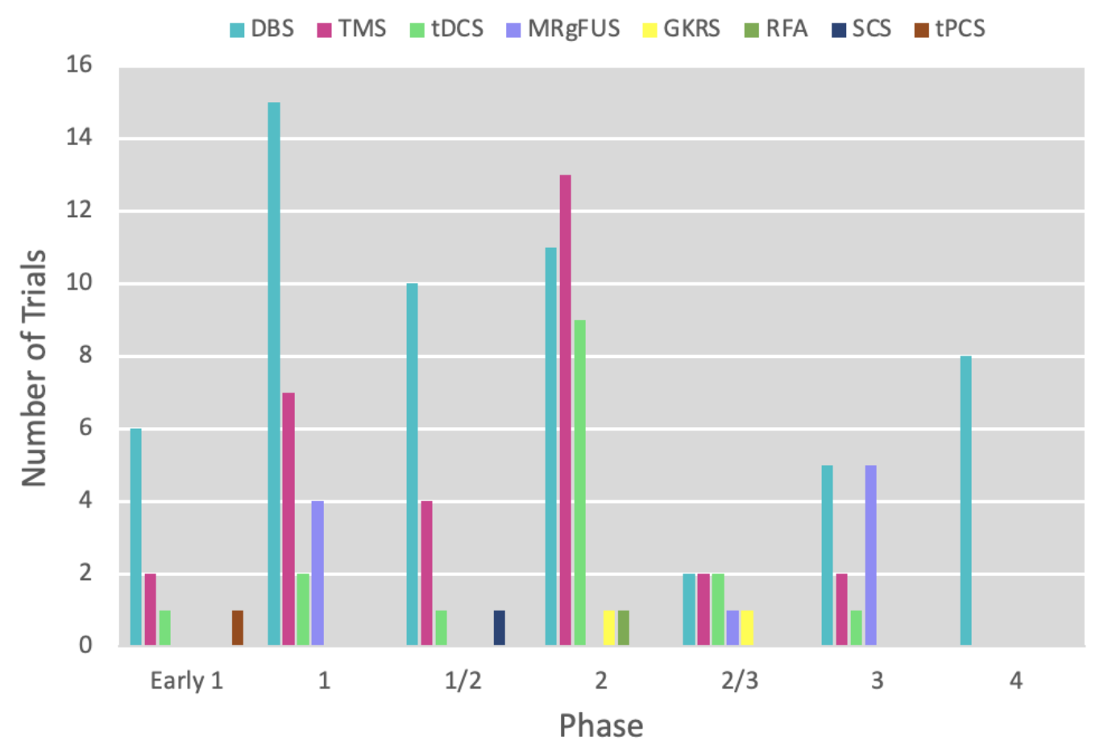

**Figure 7. The number of trials by phase categorized by projected enrollment of subjects.** (**A**) 117 trials (16% of all trials) included in this study provided information on the study phase and projected enrollment. Phase II studies were the most common (29% of trials), followed sequentially by phase I (24%), phase I/II (14%), phase III (11%), early phase I (8%), phase II/III (7%) and phase IV (7%). Of the studies that specified phase, projected enrollment ranged from 1 to 10 subjects (29%) to 101-500subjects (3%), with an enrollment of 11-50 subjects being most common (56%). (**B**) Bar chart showing the interaction between the five most common neuromodulation modalities and movement disorder clinical disorders. Abbreviations: DBS=deep brain stimulation; TMS=transcranial magnetic stimulation; MRgFUS=MR-guided focus ultrasound; GKRS=gamma knife radiosurgery; RFA=radiofrequency ablation; SCS=spinal cord stimulation; tPCS=transcranial pulsed-current stimulation.

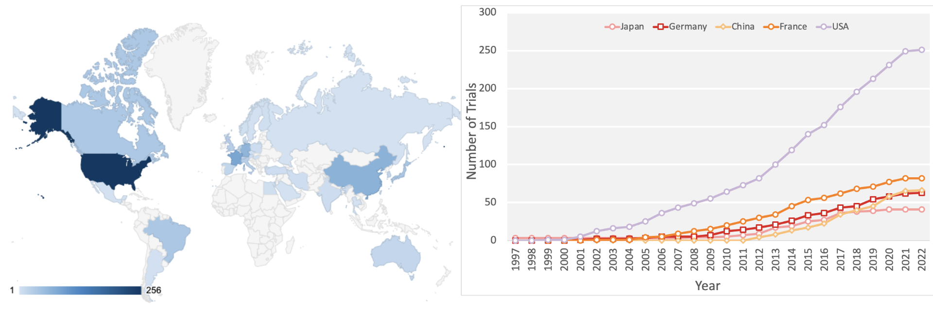

**Figure 8. Trials by country.** (**A**) Geomap illustrating the distribution of clinical trials by country of their responsible institution. Corresponding percentage values are provided in Supplementary Table 3. (**B**) Line plot tracking the cumulative number of trials attributable to the top five countries (Japan, Germany, China, France, USA) in terms of trial count to date. Abbreviations: USA=United States of America.