Zero-Shot Reboot-State Detection Across Android Malware Families

Inspired by the research paper:

Detecting New Obfuscated Malware Variants: A Lightweight and Interpretable Machine Learning Approach

Oladipo A. Madamidola, Felix Ngobigha, Adnane Ez-zizi

University of Suffolk, Waterfront Building, IP4 1QJ Ipswich, UK

Abdullah Atahan Türk N24120222

# Introduction

Android’s open ecosystem and rapid app-release cycle have made it the primary target for malware authors, who routinely ship new families or obfuscate existing ones to evade static and session-based sandboxing. Traditional dynamic analysis often runs each sample only once, missing behaviors that only trigger after a device reboot (e.g. persistence routines, payload activation). As tens of thousands of new APKs appear daily and many variants lie dormant until after reboot, there is a critical need for models that can distinguish “pre-reboot” vs. “post-reboot” behavior and, crucially, that generalize to never-before-seen families.

This project first extends the study “Detecting New Obfuscated Malware Variants: A Lightweight and Interpretable Machine Learning Approach” by evaluating gradient-boosted learners for feature selection and classification, improving the results achieved by the previous study. In light of these improvements, it was envisaged that a similar study could be conducted on a different dataset.

The main aim of this project is performing dynamic analysis on Android malware, using a reboot state labeled feature extraction dataset to distinguish pre-reboot and post-reboot behavior while ensuring the models remain lightweight and interpretable.

# Related Work

The primary reference for this project is the recent study titled "Detecting New Obfuscated Malware Variants: A Lightweight and Interpretable Machine Learning Approach." The authors addressed the detection of previously unseen (zero-day) malware using memory analysis from the CIC-MalMem-2022 dataset. Initially evaluating various algorithms (Random Forest, Naive Bayes, Logistic Regression, K-Nearest Neighbors, Decision Trees), they identified Random Forest as the most accurate and interpretable. Training exclusively on a single malware subtype (Transponder spyware), they achieved excellent detection accuracy (99.84%) against 14 entirely different and previously unseen malware subtypes. Their methodology significantly emphasized interpretability through SHAP (Shapley Additive Explanation) and computational efficiency with a minimal feature set which contains only five features, resulting in a lightweight and real-time deployable solution.

# Methodology

The methodology for this project begins with working on the related work. It was tested whether LightGBM and XGBoost gradient-boosted learners would achieve better results compared to the random forest algorithm used in the related work.

For this purpose, the same dataset, CIC-MalMem-2022, used in the related work was used. The dataset includes memory dumps of benign files and 3 main types of malware: trojan, spyware and ransomware. These main types are divided into 15 different subtypes. The dataset contains 29298 benign memory dumps and 29298 malware memory dumps. The distribution of subtypes can be seen in the figure below.

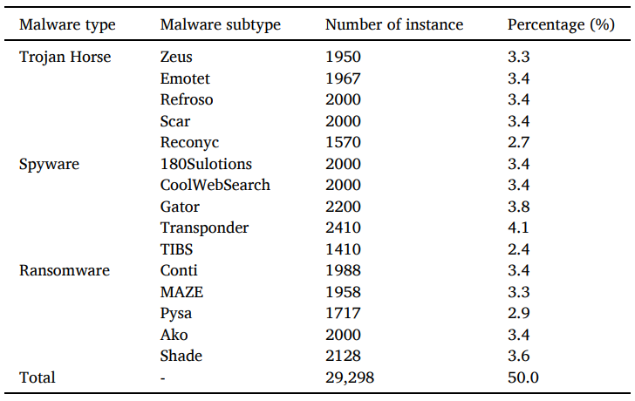

Figure 1: Distribution of malware subtype

Based on the improvements made in related work, zero-shot reboot state detection across Android malware families was performed using the dataset CCCS-CIC-AndMal-2020’s dynamic analysis part. The dataset contains 53439 rows of 14 malware families and their behavioral feature changes before and after system reboots. In the dataset, six categories of features are extracted after executing the malware in an emulated environment: Memory, API, Network, Battery, Logcat and Process.

The distribution of malware states (before and after) and malware category distribution can be seen in the figures below.

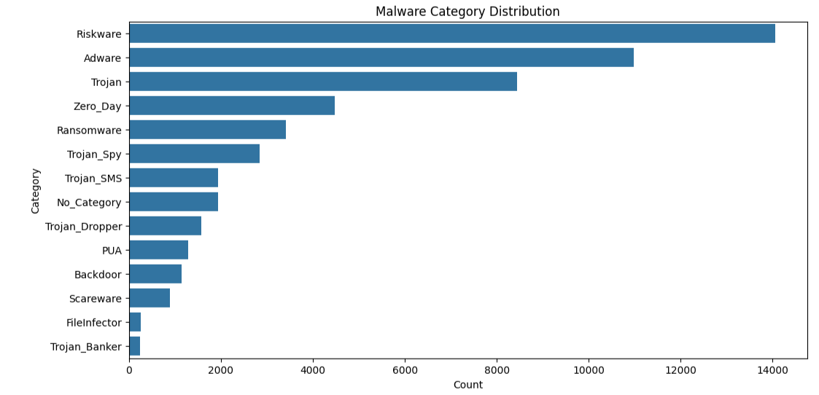

Figure 2: Dıstribution of Malware categories

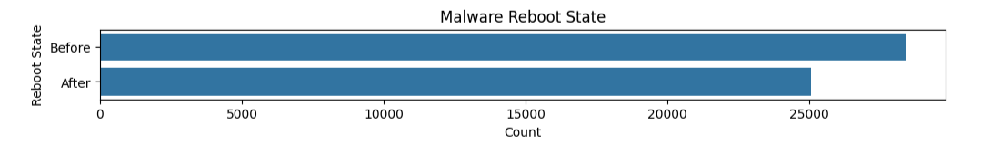

Figure 3: Distribution of Malware States

To prevent unequal distribution of before and after states in the dataset, SMOTE used.

First, binary classification was performed using LightGBM, XGBoost, Random Forest, Logistic Regression and Decision Tree to see which algorithm would give better results. Based on the results obtained, it was decided to use XGBoost in the study.

Afterwards, in order to find the most effective reboot-predictive features, the 5 most important features were found in all malware categories one by one and their total frequency was examined.

Finally, the top-5 most important features per category from from feature extraction process collected and used in zero-shot learning. To enforce zero-shot learning, each model trained on %80 of a single malware category’s samples and then tested it on the remaining %20 of that category plus all samples from every other category. The model trained with XGBoost. The results obtained were documented and analyzed.

# Results

With the improvements made in the related work, XGBoost and LightGBM outperformed Random Forest in 14 out of 15 malware subtype categories. Only in “Transponder” subtype RF achieved better result. LightGBM achieved the highest accuracy in 10 out of 15 malware subtypes, while XGBoost had the best results in 4 subtypes. LightGBM achieved the highest accuracy, with a score of 99.88% on the Coolwebsearch subtype, narrowly surpassing the highest accuracy reported in the paper %99.84, which was obtained using Random Forest on the Transponder subtype. Comparison across Random Forest, LightGBM and XGBoost can be seen in the figure below.

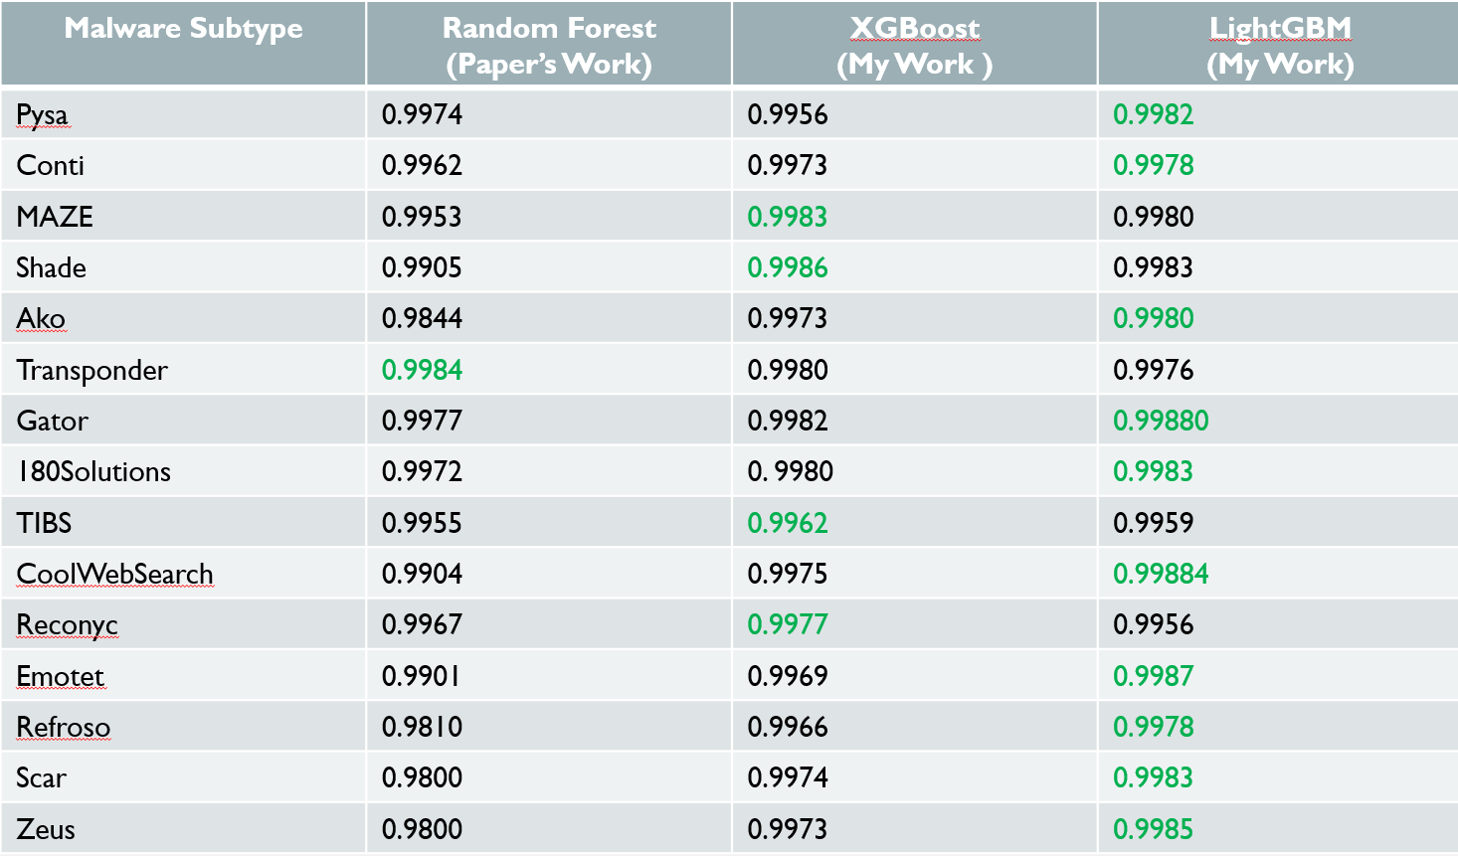

Figure 4: Comparison of Accuracy: RF(Paper) vs. XGBoost and LightGBM

These results motivated me to apply XGBoost and LightGBM in my work inspired by this paper.

The best result in binary classification for zero-shot reboot state detection across Android malware families was obtained with XGBoost. Confusion matrices of RF, LightGBM and XGBoost can be seen in figures below.

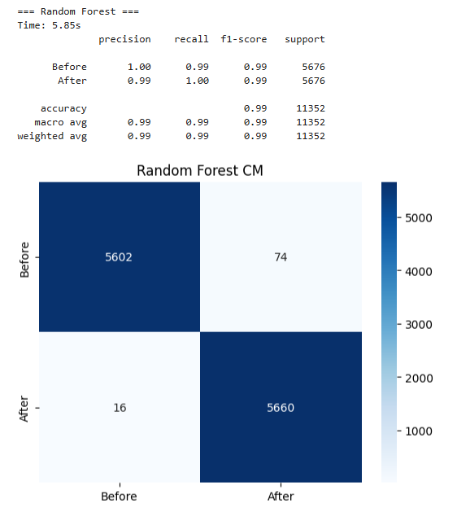

Figure 5: Binary classification results of RF

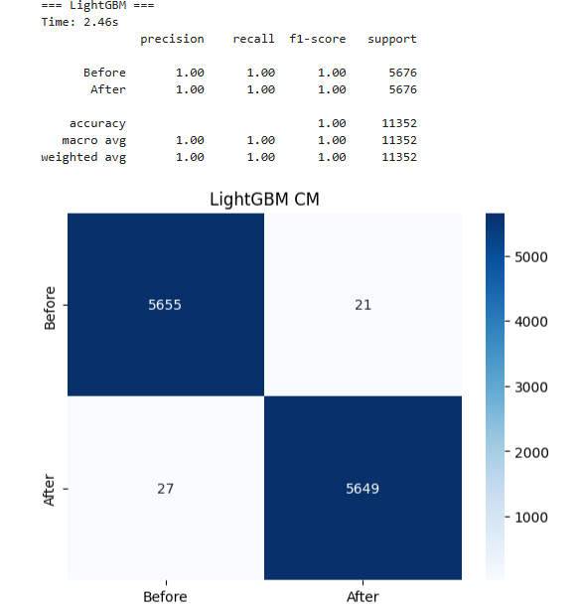

Figure 6: Binary classification results of LightGBM

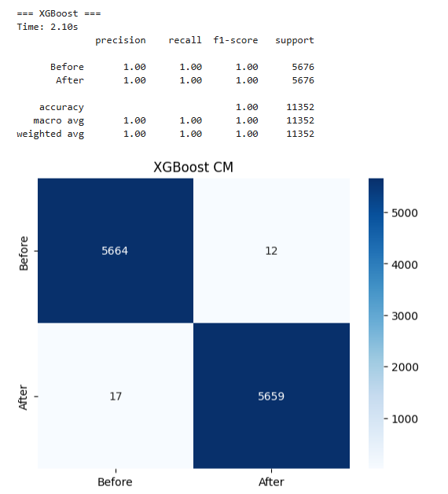

Figure 7: Binary classification results of XGBoost

The features with the highest frequency in all categories in feature extraction using XGBoost can be seen in the figure below.

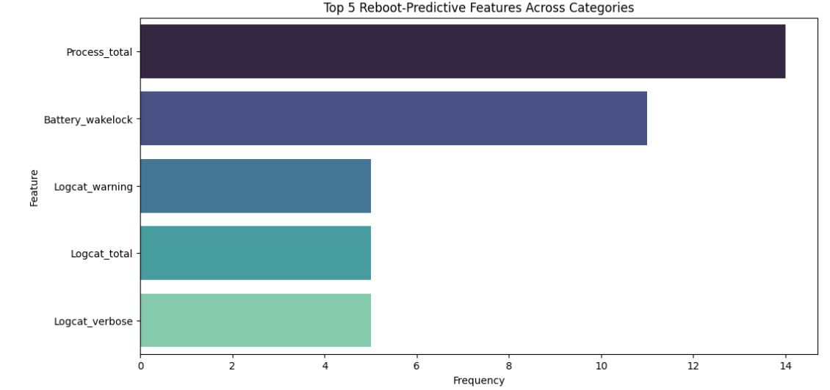

Figure 8: Most effective reboot-predictive 5 features

According to the results obtained at the end of the training using the 5 most important features of each category and using XGBoost, the best result was obtained by Trojan malware with 92.64%. Statistics and confusion matrix of the Trojan malware subtype’s can be seen in the figure below.

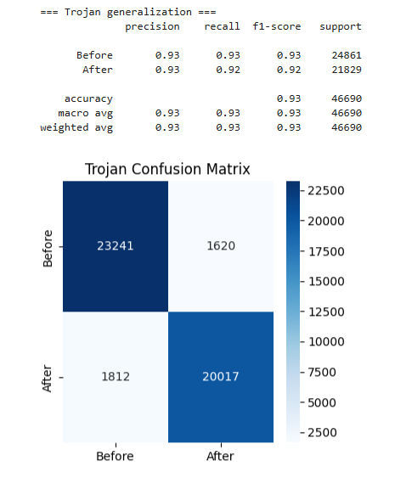

Figure 9: Trojan Trained Model statistics and confusion matrix

SHAP analysis of top-5 features of Trojan-trained model can be seen in the figure below.

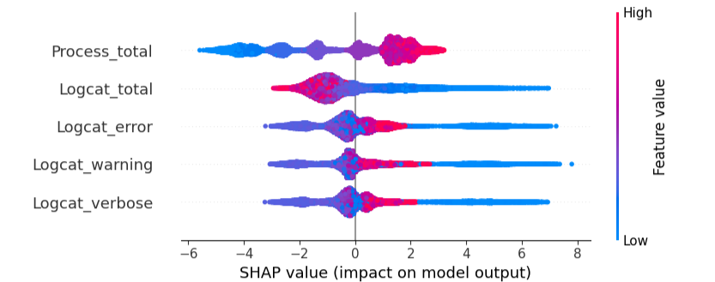

Figure 10: SHAP analysis of top-5 features of Trojan-trained model

SHAP analysis confirmed that total process count and logcat activity drive the model’s reboot-state decisions, building trust in predictions.

The repository of this project can be accessed at the following address: <https://github.com/atahanturk/CMP656/>

# Conclusion

The results obtained in related work were improved using XGBoost and LightGBM, and it was found that using gradient boosted learners gave better results.

Demonstrated that a model trained on just one Android family (e.g. Trojans) can predict pre- vs post-execution with high accuracy (92.64 %) on 13 completely unseen families.

Discovered five dynamic metrics that generalize across all malware categories.

SHAP analysis confirmed that higher process activity and log output reliably indicate “After” execution, making the detection interpretable for security analysts.

# References

[Oladipo A. Madamidola, Felix Ngobigha, Adnane Ez-zizi (2025). Detecting new obfuscated malware variants: A](https://www.researchgate.net/publication/387449355_Detecting_new_obfuscated_malware_variants_A_lightweight_and_interpretable_machine_learning_approach)

[lightweight and interpretable machine learning approach. Intelligent Systems with Applications, 25, 200472](https://www.researchgate.net/publication/387449355_Detecting_new_obfuscated_malware_variants_A_lightweight_and_interpretable_machine_learning_approach)

[CIC-MalMem-2022](https://www.kaggle.com/datasets/luccagodoy/obfuscated-malware-memory-2022-cic)

[CCCS-CIC-AndMal-2020](https://www.unb.ca/cic/datasets/andmal2020.html)