Multiple Inheritance

In C++, a class may have multiple base classes. That is, it may inherit the members and methods of multiple base classes. As an example of this, I will walk you through some recent design I have done for my top secret Jet-Car project. Over the last year, tired of both endless construction on the roads and increased time to pass through tightened airport security, I have embarked on producing the only reasonable solution to my commuting nightmares, a homemade Jet-Car.
As I started on my Jet-Car design, I began with two existing classes I developed for earlier lessons, the Vehicle and Car classes.
#include <iostream>
using namespace std;
class Vehicle {
public:
Vehicle() {cout << "Vehicle Constructor" << endl;}
virtual ~Vehicle() {cout << "Vehicle Destructor" << endl;}
virtual void accelerate() const {cout << "Vehicle Accelerating" << endl;}
void setAcceleration(double a) {acceleration = a;}
double getAcceleration() const {return acceleration;}
private:
double acceleration;
};
class Car: public Vehicle {
public:
Car() {cout << "Car Constructor" << endl;}
virtual ~Car() {cout << "Car Destructor" << endl;}
virtual void accelerate() const {cout << "Car Accelerating" << endl;}
void drive() const {cout << "Car Driving" << endl;}
private:
// Car inherits acceleration accessors, member
};
int main() {
Car myCar;
myCar.setAcceleration(9.81);
//One "G"
cout << "Accelerating at " << myCar.getAcceleration() << " m/(s*s)";
cout << endl;
myCar.Accelerate();
myCar.Drive();
}
Analysis of Car Class
First, here is the output of the program.
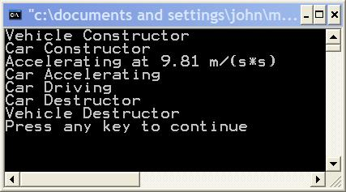
Let's go through this example in detail as it reviews many concepts from the previous two lessons, and then continue with our design. First, the Car class inherits from the Vehicle class. I put a simple print statement in each constructor and destructor. Notice the order of construction and destruction of the Car object, myCar.
- The Vehicle part of myCar is constructed.
- The Car part of myCar is constructed
- The Car part of myCar is destructed
- The Vehicle part of myCar is destructed
This order of construction and destruction is followed by all subclasses. First, a base class object is formed, then the subclass "part" is added on. This allows the base class to be properly constructed and initialized, before the additional subclass parts are formed. On destruction the order is opposite. First, the subclass "part" is destroyed, followed by base classes. Next, notice that the destructor is declared as virtual. As described in the last lesson, this allows the proper destructor to be called if a subclass is referenced thought a pointer or reference. If any methods in a class are virtual, the destructor should be virtual.
Next, notice that the Accelerate method is declared as virtual. Any method that will be overridden in a subclass should be declared as virtual. Why? This allows the C++ polymorphism mechanism to operate properly when accessing subclass objects via base class pointers and references. Review the last lesson for more details on this. Notice that in the Car class I have used the keyword virtual as a specifier on the Accelerate method. This is optional. Once a method is declared as virtual, it is automatically virtual in all subclasses. But by using the keyword "virtual" in Car, it is clearer that Accelerate() is a virtual method. Another programmer, looking only at the Car class, would know that the method was virtual.
Notice that the Car class has added functionality. A Drive method has been added. It is virtual because it is likely that the Car class will be extended. That is, subclasses will probably be derived from the Car class as we continue this design.
Finally, notice that the acceleration data member and its accessor methods, setAcceleration and getAcceleration, are non virtual. Why? I don't expect to override them in any subclasses, but rather just inherit them. Notice that the Car class has indeed inherited these methods. I called them in the main program on the Car object, myCar. They are defined only in the Vehicle class and not in the Car class.

JetCar, First Attempt
As a first design, I have decided to derive JetCar from Car using single inheritance. After all, a JetCar "is a" Car. Here are the classes and a simple test function. The test function needs to work on both Cars and JetCars, so I am passing a pointer to the base class Car with the hope that polymorphism will produce proper behavior. When testing a Car, I want Car behavior. When testing a JetCar, I want JetCar behavior.
class Vehicle {
public:
Vehicle() {}
virtual ~Vehicle() {}
virtual void accelerate() const {cout << "Vehicle Accelerating" << endl;}
void setAcceleration(double a) {acceleration = a;}
double getAcceleration() const {return acceleration;}
protected:
double acceleration;
};
class Car: public Vehicle {
public:
Car() {}
virtual ~Car() {}
virtual void accelerate() const {cout << "Car Accelerating" << endl;}
virtual void drive() const {cout << "Car Driving" << endl;}
private:
// Car inherits acceleration accessors, member
};
class JetCar: public Car {
public:
JetCar() {}
virtual ~JetCar() {}
virtual void drive() const {cout << "JetCar driving" << endl;}
virtual void fly() const {cout << "JetCar flying" << endl;}
};
void analyzePerformance(Car *testVehicle)
{
testVehicle->drive();
testVehicle->fly();
}
Notice that I have overridden the drive method in Jetcar. JetCars probably would drive differently than ordinary Cars. Additionally, I have added a "fly" method. So far, so good? When compiling this code, an error was detected in analyzePerformance. Car does not have a "fly" method; only JetCar does. I am passing a pointer of type Car into the function. How can this be fixed? Let's try adding a "fly" method into Car.

Percolating Up
class Car: public Vehicle {
public:
Car() {}
virtual ~Car() {}
virtual void accelerate() const {cout << "Car Accelerating" << endl;}
virtual void drive() const {cout << "Car Driving" << endl;}
virtual void fly() const {cout << "Cars can only fall" << endl;}
private:
// Car inherits acceleration accessors, member
};
class JetCar: public Car {
public:
JetCar() {}
virtual ~JetCar() {}
virtual void drive() const {cout << "JetCar driving" << endl;}
virtual void fly() const {cout << "JetCar flying" << endl;}
};
Here is a simple main program and output.
int main() {
Car myCar;
JetCar myJetCar;
analyzePerformance(&myCar);
// The & operator is the address of operator.
// The address of myCar is passed into the function.
// A pointer holds the address of a variable.
analyzePerformance(&myJetCar);
return 0;
}
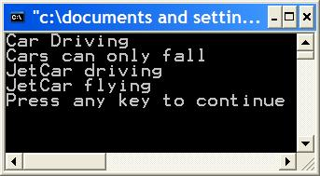
We get the right results. But there is still a problem. The Car class has a "fly" method. Surely, Cars don't fly. We added the fly method to Car so that a base class pointer could be used on either. This is known as percolating upward. The fly method was moved up into a base class, but the base class Car should not have that functionality. If we percolated up more methods as we built these classes, Car becomes bloated and confused. Generally, only functionality common to all subclasses belongs in a base class.
Casting Down
We have seen that moving functionality upward, percolating up, works, but really is not the correct design solution. As another approach let's not move the fly method into the Car class, but instead modify the analyzePerformance function. Let's see if we can make it smarter, so that it can detect whether we are testing a Car or a JetCar. C++ has a built in mechanism for Runtime Type Identification, RTTI. This means that as a program is running it is possible to determine the exact type of object a pointer or reference refers to. We can tell if a base class pointer holds the address of a base class object or a subclass object. RTTI is achieved in C++ via the dynamic_cast operator, the typeid operator and the type_info class. Let's look at the dynamic_cast operator here, and examine the others in another article. Here's our example. I am showing only the code that has changed from previous examples.
class Car: public Vehicle {
public:
Car() {}
virtual ~Car() {}
virtual void accelerate() const {cout << "Car Accelerating" << endl;}
virtual void drive() const {cout << "Car Driving" << endl;}
private:
// Car inherits acceleration accessors, member
};
class JetCar: public Car {
public:
JetCar() {}
virtual ~JetCar() {}
virtual void drive() const {cout << "JetCar driving" << endl;}
virtual void fly() const {cout << "JetCar flying" << endl;}
};
void analyzePerformance(Car *testVehicle)
{
JetCar *ptr;
//A pointer of subclass type, JetCar
testVehicle->drive();
//drive() exists for both base and sub class
ptr = dynamic_cast<JetCar *> (testVehicle);
if (ptr) {
ptr->fly();
}
else {
cout << "Car being tested" << endl;
}
}
int main() {
Car myCar;
JetCar myJetCar;
analyzePerformance(&myCar);
analyzePerformance(&myJetCar);
return 0;
}

Casting Down, Continued
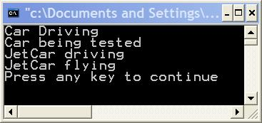
The dynamic_cast operator returns a pointer to type JetCar if have the address of a JetCar object in the original pointer, testVehicle. Otherwise, the dynamic_cast operator returns NULL. In analyzePerformance, I am checking "ptr" to see whether it contains an address, which indicates that testVehicle addresses a JetCar, or NULL. The dynamic_cast works at runtime, as your program executes. C++ also allows static casts, implemented via the static_cast operator, or via C-style casting. Static casting occurs at compile time. No checking is done at runtime. The compiler trusts you, the programmer, to check that the casted object is of the necessary type. If you statically cast a pointer into some type that it is not, for instance, a pointer to a Car object into a JetCar pointer, a runtime error may occur. Static casting is fine for most uses; I have used it extensively in code. It is inappropriate only when using the type of an object cannot be known until execution.
Dynamic casting used in this manner is referred to as "casting down". We have casted a base class pointer down its hierarchy into a subclass pointer. Now, here's the punch line. Explicitly checking an objects type is usually indicative of bad design. Generally, you should avoid explicitly testing the type of an object in your code. Why? As additional classes are formed, every point in the code that makes explicit checks on object type may need modification. If you forget to modify code somewhere, you may not find out until your program fails and your JetCar careens off into the sun. For practice, consider what modifications would be needed to support my next project, the BoatCar.
To conclude this section, let's review the syntax for dynamic and static casting.
ptr = dynamic_cast<JetCar *> (testVehicle); //Dynamic Cast
ptr = static_cast<JetCar *> (testVehicle); //Static Cast
ptr = (JetCar *) testVehicle; //C style static cast
Important Note: In Visual C++, RTTI is not turned on by default, if you run this code without turning on RTTI, you will get a cryptic error message saying something like "'dynamic_cast' used on polymorphic type 'Car' with /GR-; unpredictable behavior may result". Turning on RTTI allows the compiler to insert additional code to support RTTI as it forms object files.

Turning on RTTI in Visual C++ 6.0
Runtime Type Identification allows identification of the type of object referred to by a pointer or reference at runtime. This feature may be turned off for your project in Visual C++ 6.0. Here are instructions on how to check and turn on this feature.
1) Select project, then settings from the main menu.
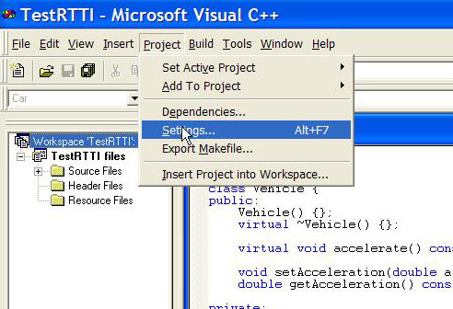
2) Click on the C++ Tab.
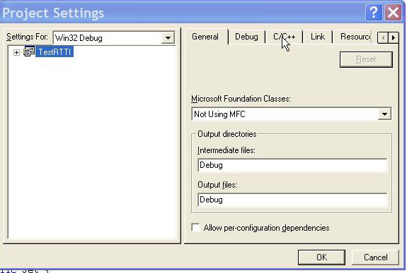
3) Select C++ Language.
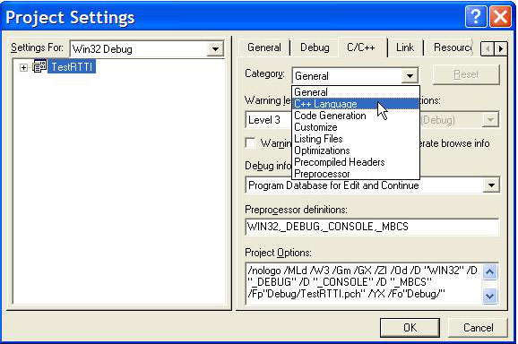
Multiple Inheritance
Here's the basic problem with our design. A JetCar is really both a Jet and a Car. We have tried inheriting from Car alone, but this isn't really satisfactory. Our JetCar may need many properties (members) and abilities (methods) of a Jet. We need to inherit those as well. First, here is the syntax for multiple inheritance.
class SubClass : public BaseClass1, public BaseClass2
{
.....
}
Also, note that the base classes need to be defined before the subclass. Actually, a forward declaration of base classes will also work.
Here is the complete program. Notice that JetCar inherits from both Car and Jet. JetCar is inheriting all the public and protected members and methods of both the Car and Jet classes. Also, notice that I have changed the test function. There are now two test functions. One tests Car abilities, such as drive. The second tests Jet abilities, such as fly. Problem. JetCar is both a car and a jet. Two performance functions. Base classes have only common functionality.
#include <iostream>
using namespace std;
class Vehicle {
public:
Vehicle() {cout << "Vehicle Constructor" << endl;}
virtual ~Vehicle() {cout << "Vehicle Destructor" << endl;}
virtual void accelerate() const {cout << "Vehicle Accelerating" << endl;}
void setAcceleration(double a) {acceleration = a;}
double getAcceleration() const {return acceleration;}
protected:
double acceleration;
};
class Car: public Vehicle {
public:
Car() {cout << "Car Constructor" << endl;}
virtual ~Car() {cout << "Car Destructor" << endl;}
virtual void accelerate() const {cout << "Car Accelerating" << endl;}
virtual void drive() const {cout << "Car Driving" << endl;}
private:
// Car inherits acceleration accessors, member
};
class Jet: public Vehicle {
public:
Jet() {cout << "Jet Constructor" << endl;}
virtual ~Jet() {cout << "Jet Destructor" << endl;}
virtual void fly() const {cout << "Jet flying" << endl;}
};
class JetCar: public Car, public Jet {
public:
JetCar() {cout << "JetCar Constructor" << endl;}
virtual ~JetCar() {cout << "JetCar Destructor" << endl;}
virtual void drive() const {cout << "JetCar driving" << endl;}
virtual void fly() const {cout << "JetCar flying" << endl;}
};
void analyzeCarPerformance(Car *testVehicle)
{
testVehicle->drive();
//drive() exists for both base and sub class
}
void analyzeJetPerformance(Jet *testVehicle)
{
testVehicle->fly();
//fly() exists for both base and sub class
}
int main() {
Car myCar;
Jet myJet;
JetCar myJetCar;
cout << endl << endl;
cout << "Car testing in progress" << endl;
analyzeCarPerformance(&myCar);
analyzeCarPerformance(&myJetCar);
cout << "Jet testing in progress" << endl;
analyzeJetPerformance(&myJet);
analyzeJetPerformance(&myJetCar);
cout << endl << endl;
return 0;
}
Output and Analysis
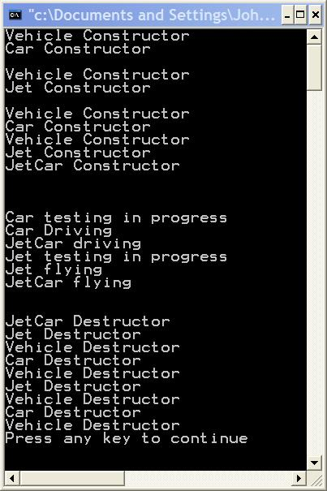
First let's look at the construction of the Car, Jet and JetCar objects. The Car object, myCar, is constructed by calling its base class constructor, Vehicle(), then its subclass constructor, Car(). The Vehicle part is built first, followed by the Car part. Similarly, for the Jet object, myJet, first the Vehicle part is constructed followed by the Jet part. Visually, Jet and Car objects could be depicted as follows using standard UML, Unified Modeling Language, diagrams. These diagrams indicate that both Jet and Car inherit from Vehicle.
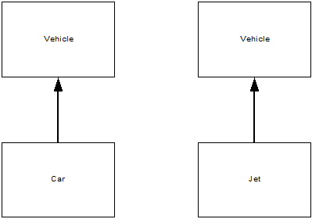

Output and Analysis, Continued
The next thing to look at is how the JetCar object, myJetCar, is constructed. The constructors that form it are executed in the same order as in the classes following the colon in the class definition. First, the Car parts are formed, then the Jet. Let's look at the UML depiction.
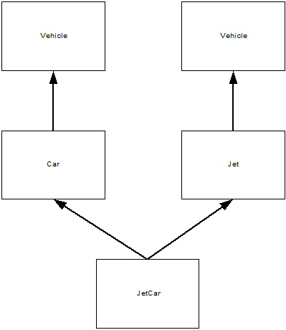
We see that JetCar inherits from both Car and Jet. That Car inherits from Vehicle. And that Jet inherits from Vehicle. JetCar inherits two Vehicle parts. This means that when calling a method that is in Vehicle, but not overridden in the subclass JetCar, or when we access a variable that exists only in Vehicle, we must explicit specify which Vehicle part we are accessing: Car's Vehicle or Jet's Vehicle. This ambiguity and how to correct for it are the topic of the next lesson: Virtual Inheritance. For now, there are two important things to take away from this example. First, a subclass such as JetCar can inherit from multiple base classes. This may not seem that significant given the small size of the classes in the example. But suppose, Jet had 50 methods and Car had 60 methods. Without multiple inheritance, we would be forced to duplicate a great deal of code. Additionally, we or other programmers would be forced to maintain this duplicate code. Eventually, errors would happen with this maintenance nightmare. The second important point to notice is that with multiple inheritance a subclass is a kind of each of its base classes. JetCar is a Car and it is a Jet. It may be used in places that expect a Car object, such as analyzeCarPerformance. It can also be used in places that expect a Jet, such as analyzeJetPerformance.

