Virtual Inheritance

This lesson covers some ambiguities that can arise with multiple inheritance, and their solutions, including virtual inheritance. We will begin this lesson where we left off in the lesson on multiple inheritance, designing the JetCar class. As you may recall, we were designing a JetCar class to support development of a prototype of my new line of JetCars. We decided that the JetCar, having properties of both Cars and Jets needed to inherit from both classes. Here are the classes for your reference.
class Vehicle {
public:
Vehicle() {cout << "Vehicle Constructor" << endl;}
virtual ~Vehicle() {cout << "Vehicle Destructor" << endl;}
virtual void accelerate() const {cout << "Vehicle Accelerating" << endl;}
void setAcceleration(double a) {acceleration = a;}
double getAcceleration() const {return acceleration;}
protected:
double acceleration;
};
class Car: public Vehicle {
public:
Car() {cout << "Car Constructor" << endl;}
virtual ~Car() {cout << "Car Destructor" << endl;}
virtual void accelerate() const {cout << "Car Accelerating" << endl;}
virtual void drive() const {cout << "Car Driving" << endl;}
private:
// Car inherits acceleration accessors, member
};
class Jet: public Vehicle {
public:
Jet() {cout << "Jet Constructor" << endl;}
virtual ~Jet() {cout << "Jet Destructor" << endl;}
virtual void fly() const {cout << "Jet flying" << endl;}
};
class JetCar: public Car, public Jet {
public:
JetCar() {cout << "JetCar Constructor" << endl;}
virtual ~JetCar() {cout << "JetCar Destructor" << endl;}
virtual void drive() const {cout << "JetCar driving" << endl;}
virtual void fly() const {cout << "JetCar flying" << endl;}
};
Problems with Multiple Inheritance
Here is a Unified Modeling Language, UML, diagram showing the relationships between our classes.
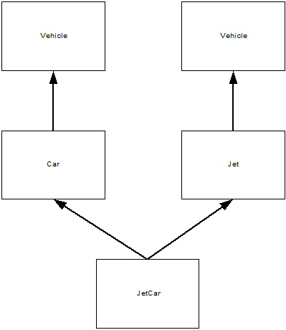
Notice that both Car and Jet inherit from Vehicle. JetCar inherits two Vehicle parts, one via Car and one via Jet. This means that if we access members and methods that exist within Vehicle, but are not overridden in JetCar, there is an ambiguity. Are we trying to access the method (or member) from Car's Vehicle or from Jet's Vehicle? With the classes as they are, if we don't explicitly specify which, the compiler will flag an error. The following programs demonstrate how to explicitly specify which Vehicle part of JetCar we want to access. For this example, we will use the acceleration accessors to access the acceleration member from Vehicle.
int main() {
JetCar myJetCar;
myJetCar.setAcceleration(39.2);
//Compilation Error // 4 G's
return 0;
}
This code does not compile. Why? The use of setAcceleration is ambiguous. Which Vehicle? Here's the error the compile gave.
"ambiguous access of 'setAcceleration' in 'JetCar'"
Explicitly Specifying Base Classes
Here's how to explicitly specify a "Vehicle".
int main() {
JetCar myJetCar;
JetCar *jetCarPtr;
jetCarPtr = &myJetCar;
myJetCar.Car::setAcceleration(39.2);
cout << "Accelerating at " << myJetCar.Car::getAcceleration() << endl;
// 4 G's
jetCarPtr->Car::setAcceleration(-19.62);
cout << "Braking at " << jetCarPtr->Car::getAcceleration() << endl;
// 2 G breaking, hold on.
return 0;
}
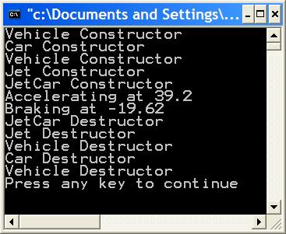
Notice that this example presents the syntax for both objects and pointers. Simply prepend the method name with the desired base class and two colons. What is shown in this example will work, but it does have a lacking. We must remember in which Vehicle we have updated the acceleration, Car's Vehicle or Jet's Vehicle. Look what happens when if we forget.
int main() {
JetCar myJetCar;
myJetCar.Car::setAcceleration(39.2);
cout << "Accelerating at " << myJetCar.Jet::getAcceleration() << endl;
return 0;
}
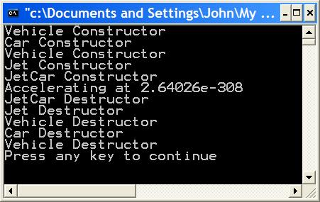
What happened? We set the acceleration member in Car's Vehicle and the retrieved the acceleration member in Jet's Variable, which was never initialized. With this simple program the error is obvious, but it more detailed code it might be hidden. The technique show in this section is used, but you must be careful.

Chaining Up
Another technique used to resolve ambiguities is called chaining up. A method that is ambiguous in a subclass is overridden in that subclass to call a particular base class's method. Lets see how it's done.
#include <iostream>
using namespace std;
class Vehicle {
public:
Vehicle() {cout << "Vehicle Constructor" << endl;}
virtual ~Vehicle() {cout << "Vehicle Destructor" << endl;}
virtual void accelerate() const {cout << "Vehicle Accelerating" << endl;}
virtual void setAcceleration(double a) {acceleration = a;}
virtual double getAcceleration() const {return acceleration;}
protected:
double acceleration;
};
class Car: public Vehicle {
public:
Car() {cout << "Car Constructor" << endl;}
virtual ~Car() {cout << "Car Destructor" << endl;}
virtual void accelerate() const {cout << "Car Accelerating" << endl;}
virtual void drive() const {cout << "Car Driving" << endl;}
};
class Jet: public Vehicle {
public:
Jet() {cout << "Jet Constructor" << endl;}
virtual ~Jet() {cout << "Jet Destructor" << endl;}
virtual void fly() const {cout << "Jet flying" << endl;}
};
class JetCar: public Car, public Jet {
public:
JetCar() {cout << "JetCar Constructor" << endl;}
virtual ~JetCar() {cout << "JetCar Destructor" << endl;}
virtual void drive() const {cout << "JetCar driving" << endl;}
virtual void fly() const {cout << "JetCar flying" << endl;}
virtual void setAcceleration(double a)
{
Jet::setAcceleration(a);
}
virtual double getAcceleration() const
{
return Jet::getAcceleration();
}
};
int main() {
JetCar myJetCar;
myJetCar.setAcceleration(39.2);
cout << "Accelerating at " << myJetCar.getAcceleration() << endl;
return 0;
}
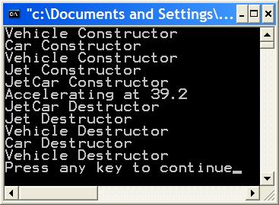
First, notice that I have made setAcceleration and getAcceleration virtual methods. Any base class method that will be overridden should be virtual so that polymorphism will work through pointers and references to objects of that class and its subtypes. Now, look at the JetCar class. I have overridden getAcceleration and setAcceleration. These methods call the methods they override. That is, they call the methods with the same signature, name and arguments, in a base class. This is chaining up. It resolves the ambiguity issue. Note that these methods could also perform some unique JetCar related work and then call the corresponding base class function. This is also considered "chaining up". Here's an example.
class JetCar: public Car, public Jet {
public:
JetCar() {cout << "JetCar Constructor" << endl;}
virtual ~JetCar() {cout << "JetCar Destructor" << endl;}
virtual void drive() const {cout << "JetCar driving" << endl;}
virtual void fly() const {cout << "JetCar flying" << endl;}
virtual void setAcceleration(double a)
{
cout << "Could be doing anything here" << endl;
Jet::setAcceleration(a);
cout << "Here, too." << endl;
}
virtual double getAcceleration() const
{
cout << "Could be doing anything here" << endl;
return Jet::getAcceleration();
}
};

Virtual Inheritance
Virtual inheritance in C++ provides a way to specify that only a single copy of a common base class should be constructed. This way, our JetCar class will only have a single Vehicle part. The ambiguity caused by multiple inheritance in the JetCar class is removed. Here's how it's done. The only change to our classes is the use of the keyword "virtual" in each intermediate base class of JetCar.
#include <iostream>
using namespace std;
class Vehicle {
public:
Vehicle() {cout << "Vehicle Constructor" << endl;}
virtual ~Vehicle() {cout << "Vehicle Destructor" << endl;}
virtual void accelerate() const {cout << "Vehicle Accelerating" << endl;}
void setAcceleration(double a) {acceleration = a;}
double getAcceleration() const {return acceleration;}
protected:
double acceleration;
};
class Car: virtual public Vehicle {
public:
Car() {cout << "Car Constructor" << endl;}
virtual ~Car() {cout << "Car Destructor" << endl;}
virtual void accelerate() const {cout << "Car Accelerating" << endl;}
virtual void drive() const {cout << "Car Driving" << endl;}
};
class Jet: virtual public Vehicle {
public:
Jet() {cout << "Jet Constructor" << endl;}
virtual ~Jet() {cout << "Jet Destructor" << endl;}
virtual void fly() const {cout << "Jet flying" << endl;}
};
class JetCar: public Car, public Jet {
public:
JetCar() {cout << "JetCar Constructor" << endl;}
virtual ~JetCar() {cout << "JetCar Destructor" << endl;}
virtual void drive() const {cout << "JetCar driving" << endl;}
virtual void fly() const {cout << "JetCar flying" << endl;}
};
int main() {
JetCar myJetCar;
myJetCar.setAcceleration(39.2);
cout << "Accelerating at " << myJetCar.getAcceleration() << endl;
return 0;
}
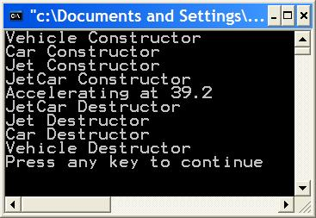
First, notice that in main() nothing special was required to use the acceleration accessor methods because there is no longer any ambiguity. Also, notice the addition of the keyword virtual to the intermediate classes Car and Jet. That's all that is needed to avoid multiple copies of common base classes. Also, notice from the output that the Vehicle constructor is called only once.

Here is a UML diagram showing our redesigned classes using virtual inheritance.
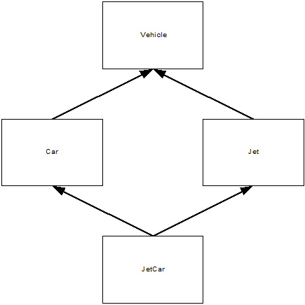
Notice there is only a single Vehicle base class. This introduces a new issue. Normally, in C++ a class can explicitly initialize only its immediate base class. Let's suppose that the Vehicle class now has a constructor that takes a string argument for fuelType. Without virtual inheritance, the constructors for Car or Jet would feed this argument to the constructor for Vehicle. It would be done as follows:
class Vehicle {
public:
Vehicle() {cout << "Vehicle Constructor" << endl;}
Vehicle(string f) : fuelType(f) {cout << "Vehicle ""Fuel"" Constructor" << endl;}
virtual ~Vehicle() {cout << "Vehicle Destructor" << endl;}
virtual void accelerate() const {cout << "Vehicle Accelerating" << endl;}
void setAcceleration(double a) {acceleration = a;}
double getAcceleration() const {return acceleration;}
void setFuel(string f) {fuelType = f;}
string getFuel() const {return fuelType;}
protected:
double acceleration;
string fuelType;
};
class Car: virtual public Vehicle {
public:
Car() {cout << "Car Constructor" << endl;}
Car(string f) : Vehicle(f) {cout << "Car ""Fuel"" Constructor" << endl;}
virtual ~Car() {cout << "Car Destructor" << endl;}
virtual void accelerate() const {cout << "Car Accelerating" << endl;}
virtual void drive() const {cout << "Car Driving" << endl;}
};
class Jet: virtual public Vehicle {
public:
Jet() {cout << "Jet Constructor" << endl;}
Jet(string f) : Vehicle(f) {cout << "Jet ""Fuel"" Constructor" << endl;}
virtual ~Jet() {cout << "Jet Destructor" << endl;}
virtual void fly() const {cout << "Jet flying" << endl;}
};
If we are instantiating Cars and Jets there is no problem. We can just use the constructors that take a "fuel" argument.
Jet plane("Liquid Hydrogen");
Car impala("Gas");
Now, how about our JetCar. When using virtual inheritance, it is the responsibility of the most derived base class to initialize virtual base classes. Contrast this with the usual case when a class initializes only its immediate base class. Here's an updated JetCar class and a main program that exercises it. Assume that the Vehicle, Car and Jet classes are unchanged from above.
class JetCar: public Car, public Jet {
public:
JetCar() {cout << "JetCar Constructor" << endl;}
JetCar(string f) : Vehicle("Pure Energy") {cout << "Jet ""Fuel"" Constructor" << endl;}
virtual ~JetCar() {cout << "JetCar Destructor" << endl;}
virtual void drive() const {cout << "JetCar driving" << endl;}
virtual void fly() const {cout << "JetCar flying" << endl;}
};
int main() {
JetCar myJetCar("Diesel");
cout << myJetCar.getFuel() << endl;
return 0;
}
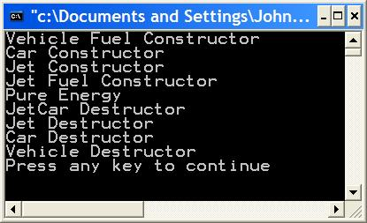
From the output, we can see that the "fuel" constructors are used for JetCar and Vehicle. Car and Jet use their default constructors. As additional evidence that JetCar is initializing Vehicle, notice that the JetCar constructor that accepts a fuel argument disregards the argument passes and sets the fuelType to "Pure Energy". From the output, we can see that the getFuel function return "Pure Energy".

