## Part 1)

**Ncat results:**

1. 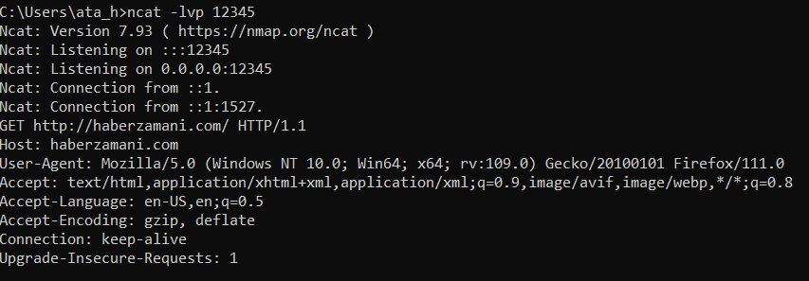

**Figure 1:** Ncat result of <http://haberzamani.com/> with port 12345

1. Text

   Description automatically generated

**Figure 2:** Ncat result of <http://yemek.com/> with port 12345

1. 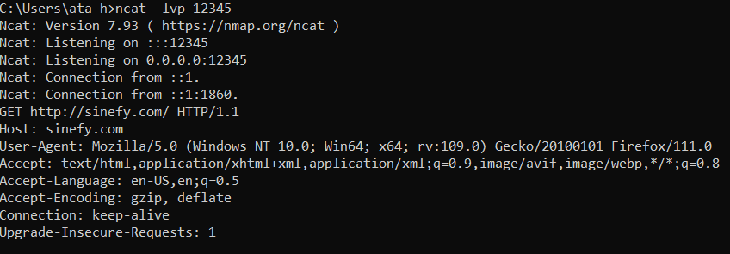

**Figure 3:** Ncat result of <http://sinefy.com> with port 12345

## Part 2)

**ProxyServer.py Test Results:**

1. 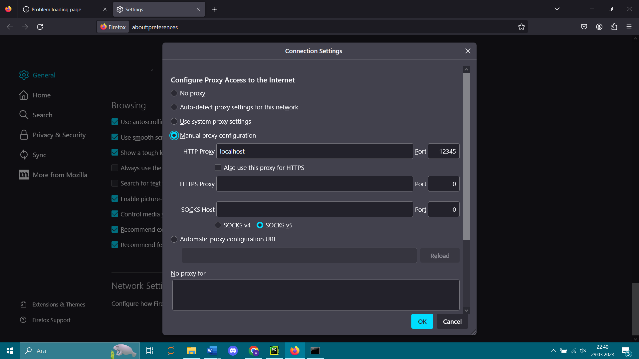
2. Text

   Description automatically generated
3. Text

   Description automatically generated
4. Text

   Description automatically generated
5. Text

   Description automatically generated

**Source Code Explanation:**

**Figure 4:** Request getter method

The function in the figure 4 gets the request using socket library function .recv() with parameter BUFFER_SIZE and decodes it with .decode().

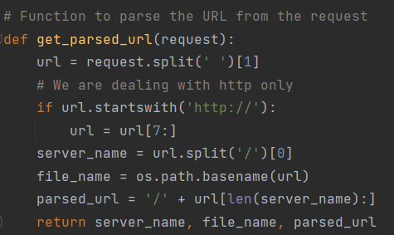

**Figure 5:** Function to parse the URL from the request

The function above in the figure 5 takes request as parameter and it splits it and gets first index, then as we are dealing with http we take array after 7. index then takes its parts where server name file name and parsed url is in.

**Figure 6:** Function to send an HTTP request to remote server

The function above takes url, server name and socket as parameters and it creates a http get request then sends it with help of socket library.

**Figure 7:** Function to get the HTTP response from the remote server and print the status code

The function above takes socket as parameter and receives the response with the first line, then it splits response and takes status code with decode function. This function also have parameters as utf-8 and ignore which makes function to ignore any invalid bytes which are not uft-8 in this occasion. Also, it displays if the status code is 200

**Figure 8:** Function to handle different operations for different status codes

The function in the figure 8, only works if status code is 200, if it is 200, then it writes the data into a file with its file name

**Figure 9:** Main function that takes arguments

**Figure 10:** ProxyDownloader class init and start function (host name “localhost” default)

**Figure 11:** Main function to start the proxy downloader

Start function is the main function of this code, it firstly takes socket.socket, and binds the server and listens server with a certain number of “maximum number of queued connections”. Then, using accept() function we can get client_socket and client address, from client socket all data can be extracted. Also get_request method returns the request. Using get_parsed_url() method, server name, file name and parsed url are returned. Code is then filtered with servername==bilkent statement in which bilkent string is the server name of bilkent. After filtering operation, and printing requests and some informations, code tries to connect remote socket, meanwhile the code measures time between trip time and displays round trip time as a little bonus. After the connection, with send_http_request method it sends http response and from get_http_response it receives status code. With this status code, it executes certain operations with status_code_ops method. Also code throws exceptions if there is an error. Finally, it closes the socket connection.