GIT

**Git Tutorial – Operations & Commands**

Some of the basic operations in Git are:

1. Initialize
2. Add
3. Commit
4. Pull
5. Push

Initialize your repository: use the command **git init.**

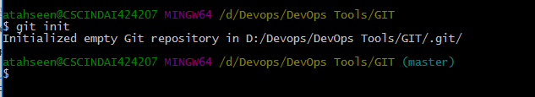

**git init** creates an empty Git repository or re-initializes an existing one. It basically creates a**.git** directory with sub directories and template files. Running a **git init** in an existing repository will not overwrite things that are already there. It rather picks up the newly added templates.

Now that my repository is initialized, I will now create some files in the directory/repository. For e.g. I have created two text files namely *file1.txt*and *file2.txt*.

