**CSE 222 – Data Structures**

**Homework 5**

**Report for Q3**

Atakan Akdogan – 1801042612

Class Diagrams and Problem Solution Approaches

1-Class Diagrams

I created an UML diagram fort his

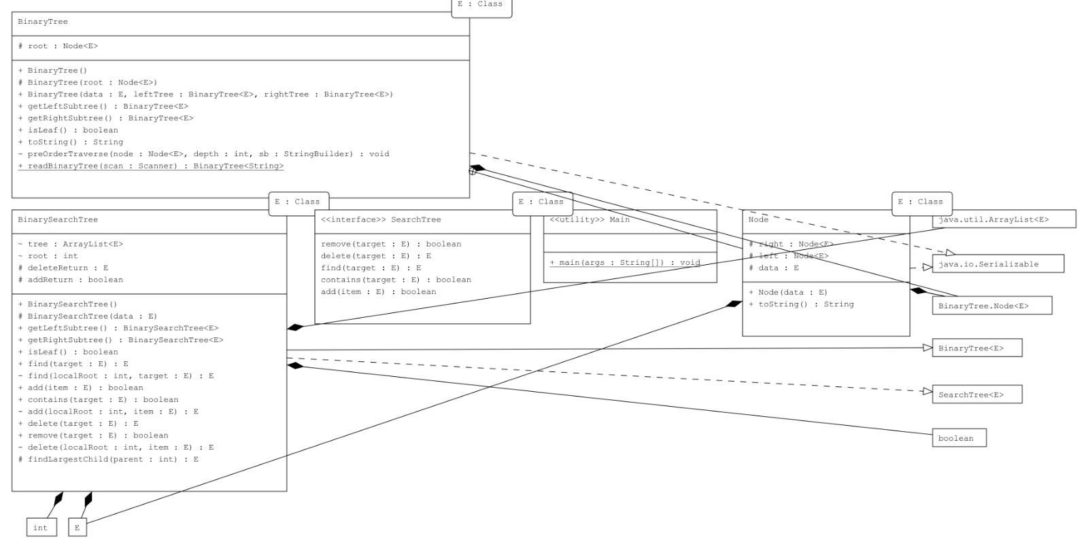

For more HD version, I added jpg file in Q3 folder.

2- Problem Solution Approaches

I wrote full code and it was working, but my changes about code broket he code but I added anyway.

For Javadoc presentation, I wrote details about my code.

metin içeren bir resim

Açıklama otomatik olarak oluşturuldu

Data fields for adding operations, tree named Arraylist for keeping datas inside, and Constructor methods.

metin içeren bir resim

Açıklama otomatik olarak oluşturuldu

Get method for left subtree and right subtree. I used 2n+1 and 2n+2 notations for left and right.

metin içeren bir resim

Açıklama otomatik olarak oluşturuldu

isLeaf checks tree is leaf or not. Same notation above for check left and right.

metin içeren bir resim

Açıklama otomatik olarak oluşturuldu

Find method is recursive method that checks every root,left and right combinations with multiple calls.

metin içeren bir resim

Açıklama otomatik olarak oluşturuldu

Caller methods for finfing item and adding item.

metin, ekran içeren bir resim

Açıklama otomatik olarak oluşturuldu

Method searches index to put item and after adds to tree.

metin içeren bir resim

Açıklama otomatik olarak oluşturuldu

Deletion method. First searches for item and when we found the place, does operation if the index is root or right child or left child.