**USEFUL SYSTEM FOR FARMERS**

**by**

**151220202034 ATAKAN EKEN**

**Group**

**1A**

**Introduction to Electrical-Electronics Engineering Project Report**

**Electrical Electronics Engineering Department**

**ESKISEHIR OSMANGAZI UNIVERSITY**

**JANUARY 2022**

Contents

ABSTRACT 3

1. INTRODUCTION 4

2. METHODOLOGY 5

2.1. Arduino Uno 6

2.2. FC-28 Soil Moisture Sensor 7

2.3. JQC-3FF-S-Z Relay 7

2.4. Switch 8

2.5. I2C LCD Screen (16x2) 8

2.6. PPE-MD30 Water Pump 9

2.7. 9 Volt Battery 9

3. EXPERIMENTAL RESULTS 9

4. CONCLUSION 10

REFERENCES 10

# ABSTRACT

The Covid-19 epidemic, which emerged in Wuhan, China, spread rapidly and affected the whole world. Depending on this epidemic and the speed of its spread, each country has organized its own curfew. In this study, an application has been proposed for people with vineyards and gardens who cannot leave their homes due to the prohibitions applied. In this system, a humidity sensor is connected to the soil and a water pump operates depending on the humidity value. Information important to the user is shown on the LCD screen. In this way, the irrigation process can be done without human interaction.

*Keywords*:Covid-19, humidity, curfew, irrigation

# INTRODUCTION

Coronavirus Disease (COVID-19) is a virus that was first identified on January 13, 2020, as a result of research conducted in a group of patients who developed respiratory symptoms (fever, cough, shortness of breath) in Wuhan Province, China, in late December[1]. Curfews have been imposed due to the pandemic, and people who have a vineyard or garden in a separate place from their home have to stay home. As of March 21, 2020, citizens over the age of 65 are prohibited from going out on the streets as part of the COVID-19 pandemic measures in Turkey[2]. These prohibitions deprived people who earn income from their vineyard or garden and do this job as a hobby, from information such as irrigation of crops, control, and moisture content of the soil.

Watering, which is important to a plant, was interrupted during these forbidden days. Depending on the type of crop such as corn, tomato, broccoli, how many times a day or a week it should be watered varies. For example, if you water the flower more in summer and less in winter according to the seasons, you will increase the yield of your flower. This situation has created the need for an intelligent irrigation system that works depending on the humidity rate. Intelligent irrigation systems are systems developed to irrigate irrigation areas in the most effective way, to give water as much as the plant needs, and to obtain maximum efficiency from water and production[3]. Due to this problem, LCD SCREEN IRRIGATION SYSTEM studies were carried out. In the project, which was made using Arduino and 16x2 LCD, a system aiming to lighten the load of the user was considered. With the temperature-humidity sensors connected to the Arduino, the ambient data is currently written to the LCD. After the user enters the threshold soil moisture percentage to the system to start irrigation with the buttons on the LCD screen, if the soil moisture ratio is below the threshold, the system; It will continue to water until the humidity level is equal to the threshold value. In future studies, the user can optionally create an irrigation program and enter the information on how many days the irrigation will take, what time it will start and how many minutes it will last. If the user wishes, he can also perform manual irrigation by starting the desired motor via the LCD [4].

In this study, a study was conducted that informs the LED screen that the system is on or off and the humidity is more or less than the threshold value, and irrigates by activating the water engine depending on this information. In this system, the humidity sensor connected to the soil sends the humidity value information it receives to the unit where the information is processed, and the system works according to this humidity information. In the second part of the study, a list of methods and materials is given. Details of the project are given in the third part of the study. In the last part the results are given and future studies are mentioned.

# METHODOLOGY

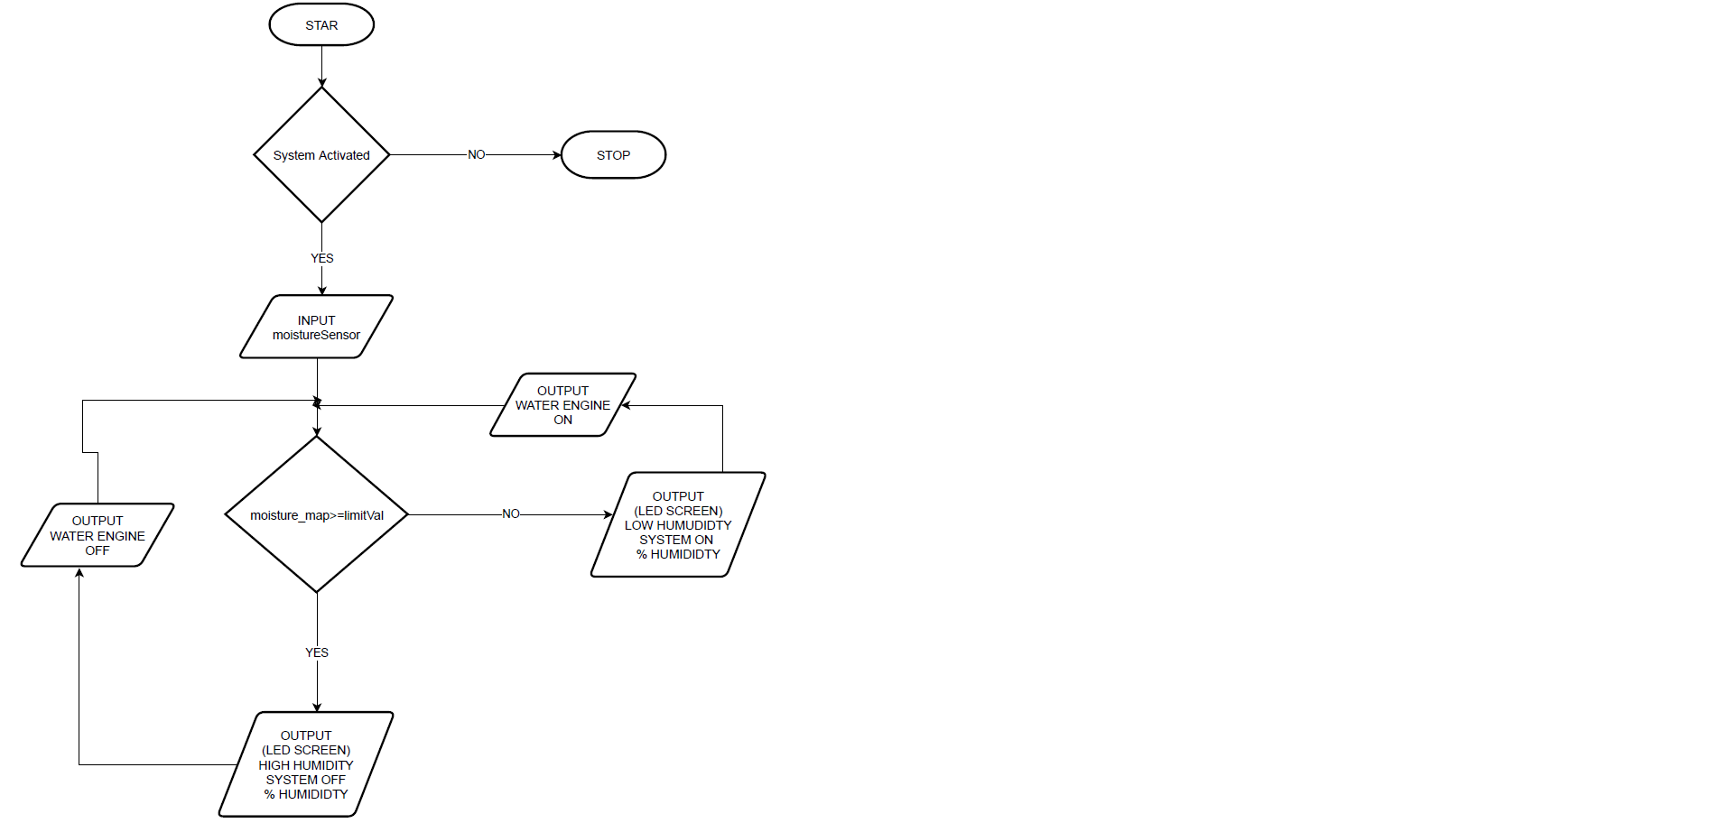

Figure 1. Flowchart of the System

In this study, after the system is activated, it is evaluated whether the humidity rate is more or less than the limit value. If it is less, the motor starts after the necessary information and humidity percentage are shown on the led screen. If it is too much, the motor shuts down after the necessary information and humidity percentage are shown on the led screen.

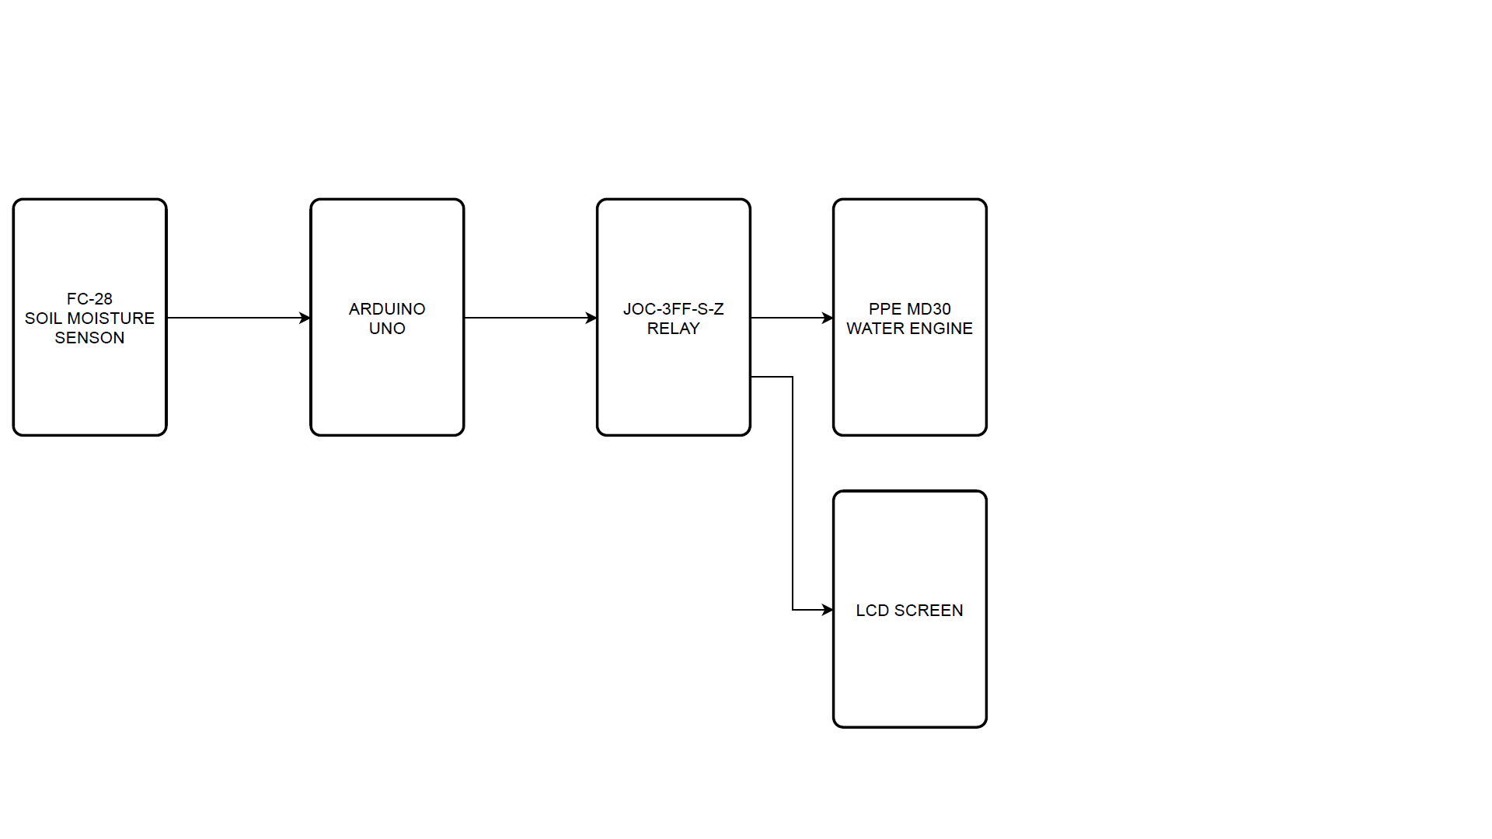Figure 2. Block Diagram of the System

The block diagram of the system is given in Figure 2.

Information about the components used in the system is given in the following subsections.

* 1. Arduino Uno

Hardware platform with wide usage areas developed with open source software. It is a standard size control card that can be used for different applications with its electronic circuit at every level. Arduino Uno model is given in Figure 3.

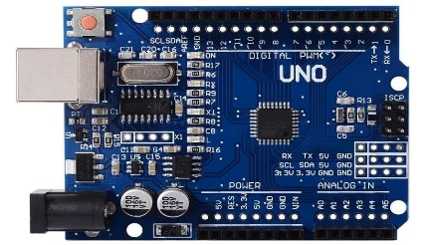

Figure Arduino Uno

Some important features of Arduino Uno is given in Table 1.

Table . Some Features of Arduino Uno

|  |  |  |  |
| --- | --- | --- | --- |
| **Microcontroller** | ATmega328 | **Clock Speed** | 16 MHz |
| **Operating Voltage** | 5V | **Input Voltage (limit**) | 6-20 V |
| **PCB size** | 68.6 mm × 53.3 mm | **DC Current per I/O Pin** | 40 mA |
| **Digital I/O Pins** | 14(6 provide PWM output) | **Analog Input Pins** | 6 |

* 1. FC-28 Soil Moisture Sensor

It is an electronic instrument that measures the humidity in its environment and converts it into a meaningful electrical signal. The plates of the device absorb the humidity in the environment and the humidity is transmitted to the circuit. FC-28 Soil Moisture Sensor model is given in Figure 4.

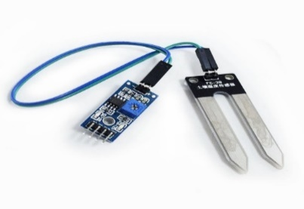

Figure Soil Moisture Sensor

Some important features of Soil Moister Sensor is given in Table 2.

Table

|  |  |  |  |
| --- | --- | --- | --- |
| **OUTPUTS** | 4IR & relays on 2-pin terminal blocks | **Power Consumption** | 5V DC, 230mA |
| **Input Frequencies** | 20kHz to 60kHz | **Output Frequencies** | 20kHz to 1.2MHz |
| **Operating Temperature** | 0° to +40°C | **Storage Temperature** | –40° to +70°C |
| **Humıdıty** | 10% to 90%, RHL non-condensing | **Enclosure Type** | Aluminum |

* 1. JQC-3FF-S-Z Relay

A relay is an electrically operated, electromagnetic switch. It works when current is passed through it and has coil, pallet and contact parts. JQC-3FF-S-Z relay model is given in Figure 5.

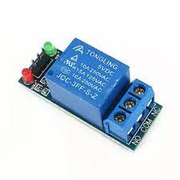

Figure Relay

Some important features of Relay is given in Table 3.

Table

|  |  |  |  |
| --- | --- | --- | --- |
| **Normal Voltage** | 5V DC | **Normal Current** | 70mA |
| **AC load current Max** | 10A at 250V AC or 125V AC | **Dc load current Max** | 10A at 30V DC or 28V DC |
| **Operating Time** | 10m sec | **Release Time** | 5m sec |

* 1. Switch

It is a simple circuit element that cuts the electricity in electrical circuits or changes the direction of the current on the conductors. When the switch is in the open position, there is no electric current in the 2 conductors. When the switch is in the closed position, there is an electric current between the 2 conductors. Swtich model is given in Figure 6.

Figure Switch

* 1. I2C LCD Screen (16x2)

It is an LCD display with SPI communication interface. Microcontroller boards such as Arduino are used to draw simple graphics or text. Model is given in Figure 7.

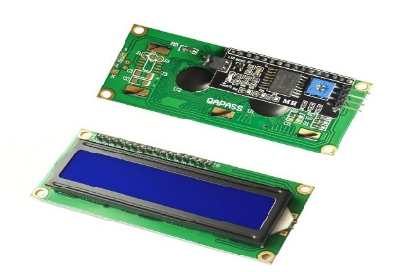

Figure LCD Screen

Some important features of LCD Screen are given Table 4.

Table

|  |  |  |  |
| --- | --- | --- | --- |
| **Address Range** | 0x20 to 0x27 | **Operating Voltage** | 5Vdc |
| **Blacklight** | White | **Size** | 80mm x 36mm x 20mm |

* 1. PPE-MD30 Water Pump

It is an electrically powered mechanical device used to move liquids. It creates pressure differential by moving the liquid from low pressure to high pressure. It works on the principle of physical lifting and pushing. Model is given in Figure 8.

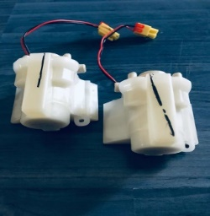

Figure Water Pump

Some importartant features of PPE-MD30 water pump are given in Table 5.

Table

|  |  |  |  |
| --- | --- | --- | --- |
| **Working Voltage** | DC10-13V | **No Load Current** | 250mA |
| **Suction Lift** | 100mm | **Spit Out Lift** | 500mm |

* 1. 9 Volt Battery

It is a device that provides the necessary energy for the system by converting chemical energy into electrical energy.

# EXPERIMENTAL RESULTS

The PPE-MD30 water pump was tested using a 9 volt battery. FC-28 soil moisture sensor is connected to the circuit together with the JGQ-3FF-S-Z relay. The data received with the codes written on the Arduino were examined. The data obtained by the soil moisture sensor has been converted into a logical range of values (0-100). The threshold was determined from the data received by the sensor (40%) and tested. The water pump was connected to the circuit and tested in order to operate according to the threshold value. I2C LCD screen is connected to the circuit and tested. Necessary information was sent to the LCD screen for the user to read the necessary information in the system (high/low humidity ratio, system on/off, humidity percentage). For the Arduino to work, the 9 volt battery was connected to the Arduino and the switch was added and tested. The whole circuit was retested and the system worked successfully.

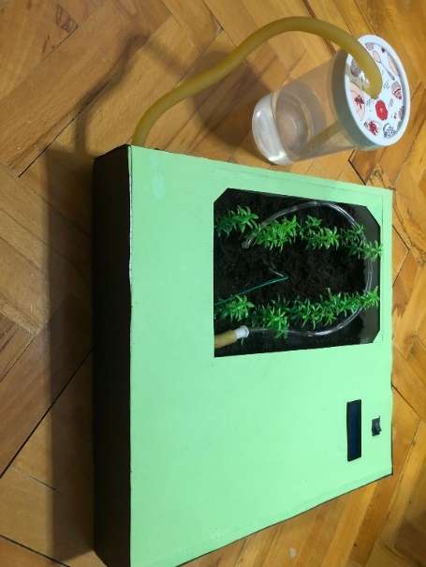

Figure 10 System Design

The reference [5] can be visited fort he source codes of the study.

# CONCLUSION

Curfews were implemented to reduce the risk of pandemics and put people in difficult situations, especially not being able to go out at home during the pandemic period. During this period, people who have vineyards and orchards due to the prohibitions can use this project to take care of them without having to leave the house. The system works with the switch giving electricity to the circuit. When the humidity in the soil drops below 40%, the water pump irrigates the soil with the help of water pipes in order to bring the soil to the required moisture level, and when it exceeds 40%, the system goes into standby again. In this way, they can be irrigated in this way without leaving the house and the humidity of the soil can be followed. In future studies, the plant will be identified after the plant species and required irrigation amounts are pre-loaded into the system.

# REFERENCES

1. <https://covid19.saglik.gov.tr/TR-66300/covid-19-nedir-.html>
2. <https://web.archive.org/web/20200322214630/https://www.icisleri.gov.tr/65-yas-ve-ustu-ile-kronik-rahatsizligi-olanlara-sokaga-cikma-yasagi-genelgesi>
3. <https://esular.com/akilli-sulama/akilli-sulama-sistemleri/>
4. <http://erdembilgicer.com/project1>,
5. <https://github.com/atakaneken2626/Useful-System-For-Farmers>