PROJECT 2- VIDEO SURVEILLANCE OVER IP
In this project, I developed a real-time video surveillance system that captures video and audio from a webcam and microphone, processes and compresses the stream, and broadcasts it live over the web. I used FFmpeg to segment the stream into DASH (Dynamic Adaptive Streaming over HTTP) format. On the client side, I utilized HTML5 and Dash.js to play the stream in the browser. I also implemented interactive video controls, allowing the user to play/pause, rewind/forward, jump to the live point, and take screenshots directly from the web interface.
On the server side, I used the Flask web framework to serve the stream over HTTP. (Although HTTPS support is available through SSL certificates (cert.pem and key.pem), the current configuration runs the server over HTTP. The HTTPS configuration can be enabled by uncommenting the related line in the code.) Additionally, I integrated Flask-SocketIO to enable real-time communication between the server and client through WebSockets. All system configurations (camera/audio input, resolution, segment duration, etc.) were managed through an external config.ini file for flexibility.
In addition to the core features, I implemented several bonus functionalities. I included audio streaming by capturing microphone input and encoding it with FFmpeg. I developed a motion detection system using OpenCV, which triggers instant client-side alerts via Socket.IO when movement is detected. I also enhanced the HTML5 user interface with interactive controls such as rewind/forward, jump to live, and screenshot capture to improve the overall user experience.
Here is a screenshot from my project showing the web interface of the IP-based video surveillance system:
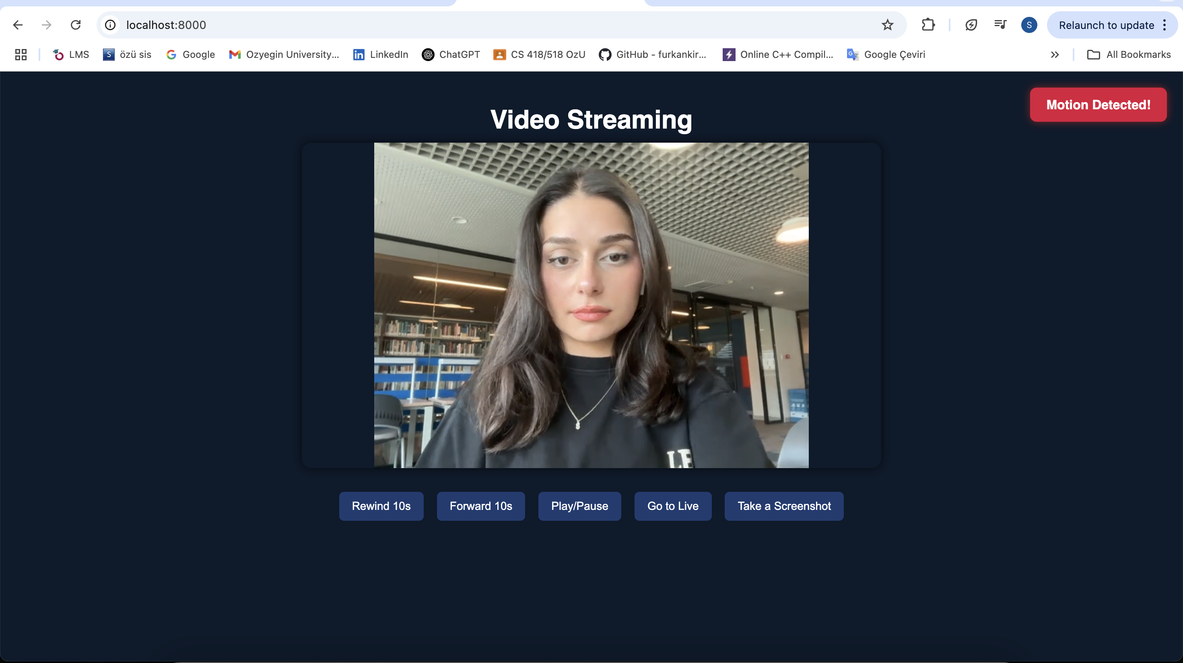
Ffmpeg Command:
ffmpeg \
-f avfoundation \ Input format for macOS
-pixel_format uyvy422 \ Raw pixel format for video input
-framerate 30 \ Capture video at 30 frames per second
-video_size 640x480 \ Set video resolution to 640x480
-i 0:2 \ Input devices: 0 = webcam, 2 = microphone (from config.ini)
-c:v libx264 \ Encode video using H.264 codec
-c:a aac \ Encode audio using AAC codec
-preset veryfast \ Use a fast preset for low-latency encoding
-f dash \ Output format: DASH (Dynamic Adaptive Streaming over HTTP)
-seg_duration 4 \ Duration of each segment in seconds
output/output.mpd Output DASH manifest file location

config.ini:

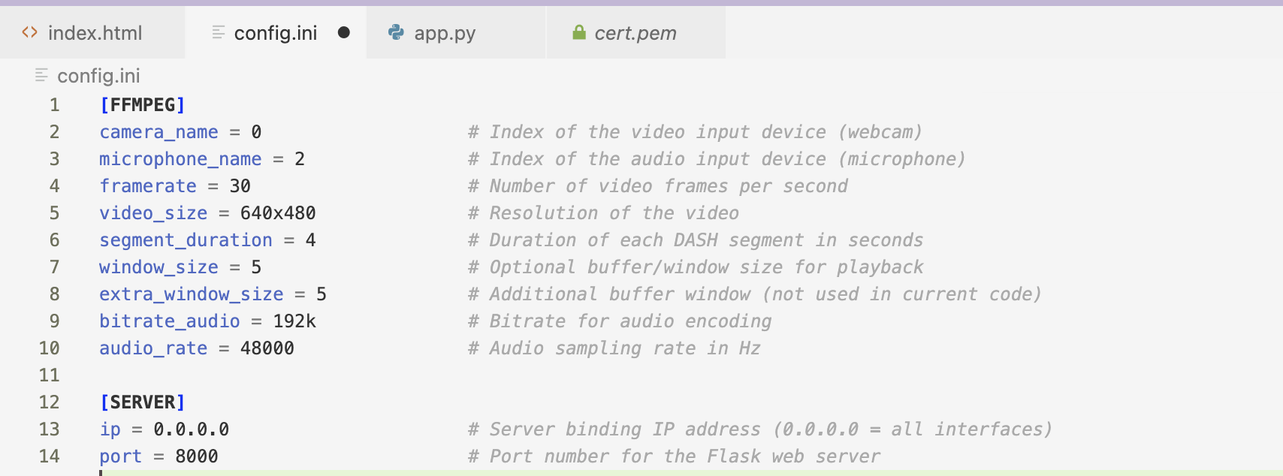
The [FFMPEG] section defines parameters that are inserted into the FFmpeg command dynamically within the app.py script. This includes the video/audio devices, quality settings, and segment size.
The [SERVER] section provides IP and port configuration for the Flask server.
This separation of configuration improves maintainability and allows the server to be reused on different systems without needing code changes.

index.html:
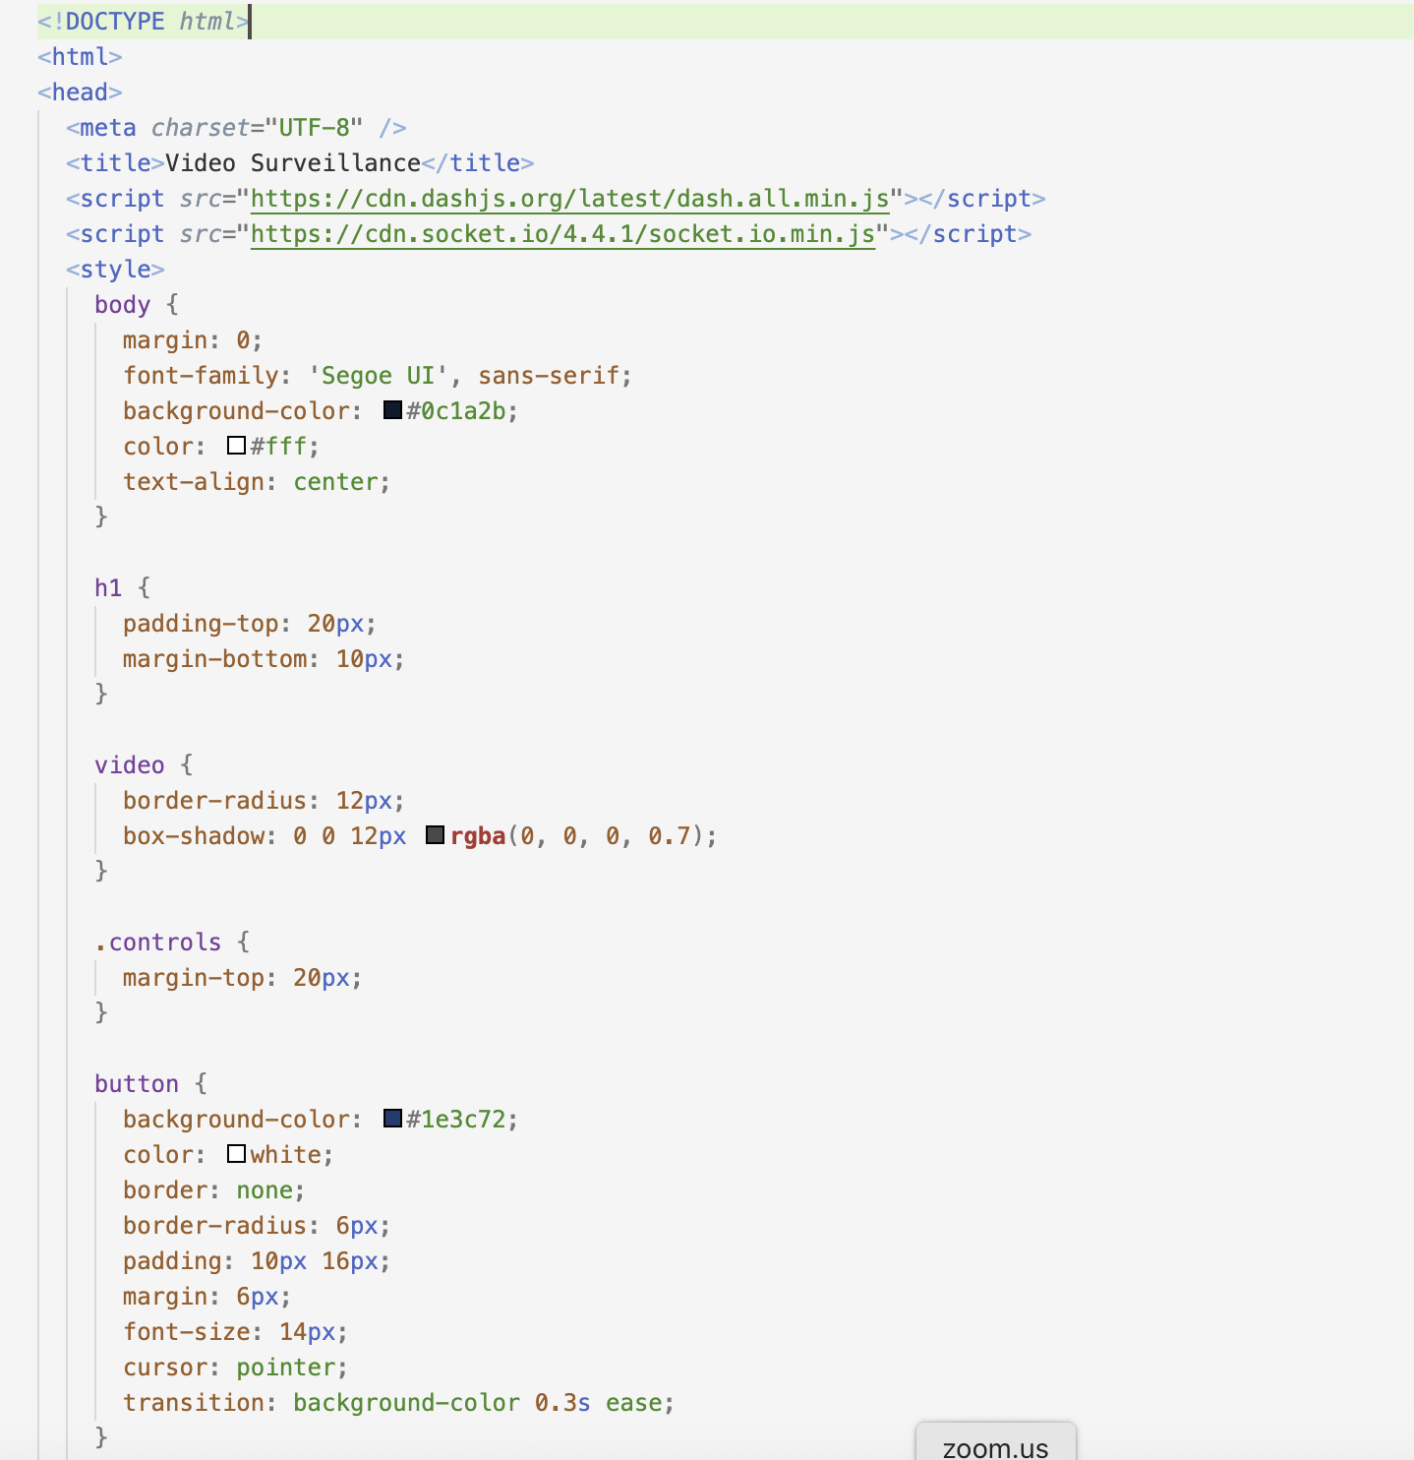
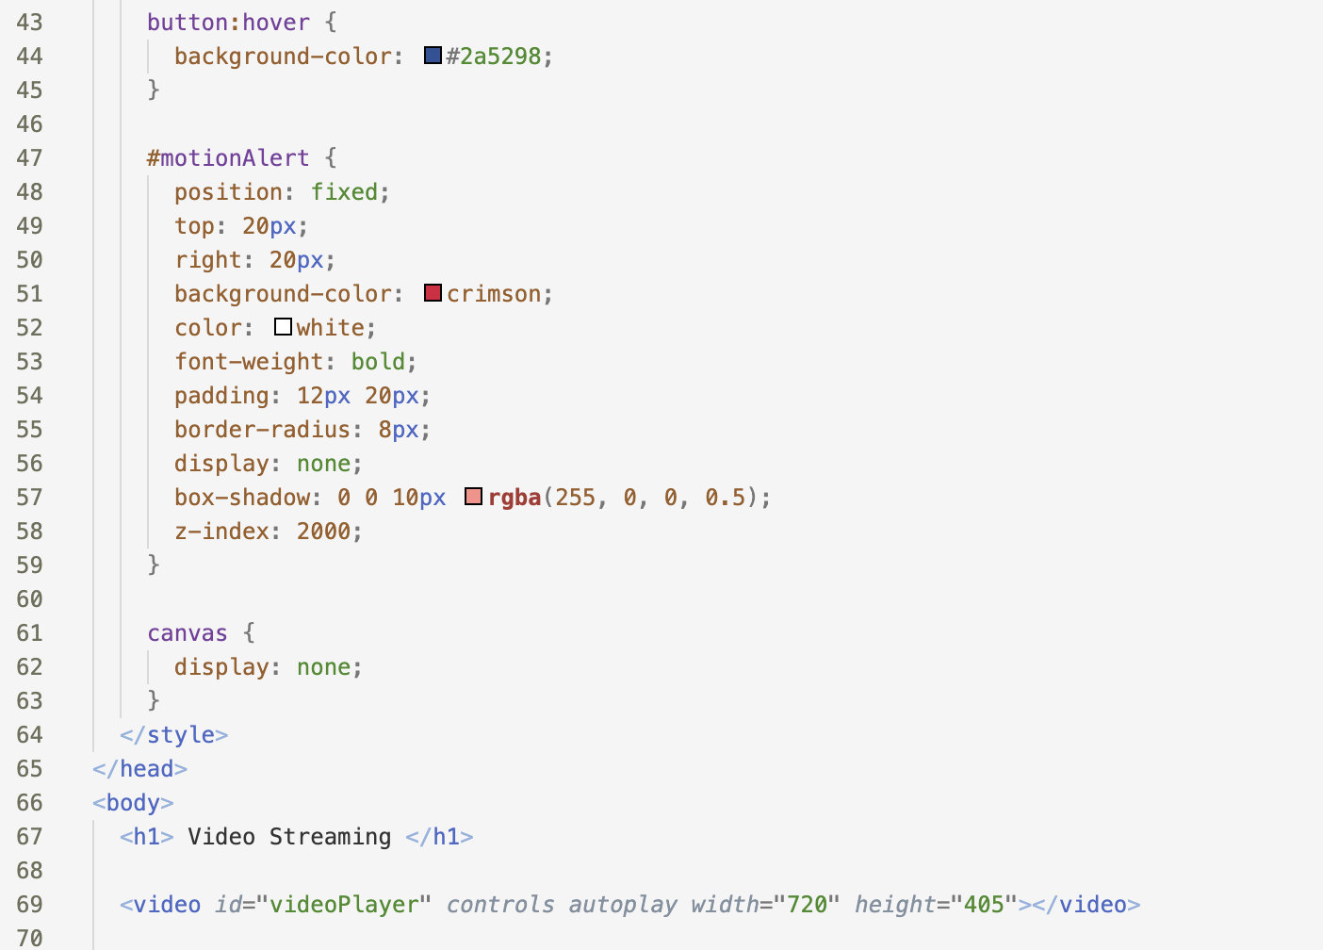
<!DOCTYPE html> starts the document as an HTML5 page.
<html> and <head> tags begin the general structure of the webpage.
<meta charset="UTF-8" /> sets the character encoding of the page to UTF-8.
<title>Video Surveillance</title> defines the title that appears on the browser tab.
The dash.all.min.js script loads the Dash.js library, which is used to play MPEG-DASH formatted video streams.
The socket.io.min.js script loads the Socket.IO library to receive real-time motion detection alerts from the server.
body: dark background, centered white text.
h1: spaces the page title.
video: adds rounded corners and shadow.
controls: margin for buttons.
button: styled with color, hover effect.
#motionAlert: hidden red alert box for motion detection.
canvas: hidden element for screenshots.
<h1> displays “Video Streaming” title.
<video> shows the live stream with controls and autoplay.
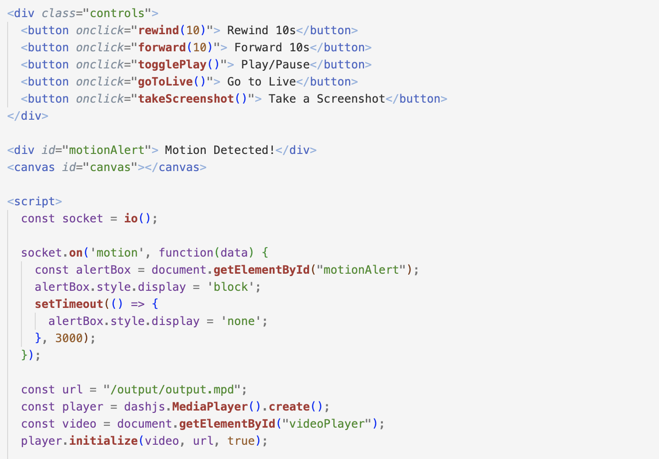

div class="controls": Defines the section for video control buttons.
<button onclick="rewind(10)">Rewind 10s</button>: Rewinds the video by 10 seconds.
<button onclick="forward(10)">Forward 10s</button>: Fast-forwards the video by 10 seconds.
<button onclick="togglePlay()">Play/Pause</button>: Toggles between play and pause.
<button onclick="goToLive()">Go to Live</button>: Jumps to the most recent point in the live stream.
<button onclick="takeScreenshot()">Take a Screenshot</button>: Captures the current video frame and saves it as a .png image.

<div id="motionAlert">: This red alert box appears when motion is detected.
<canvas id="canvas">: Hidden canvas element used for capturing screenshots.
const socket = io();: Initializes Socket.IO connection for real-time communication with the server.
socket.on('motion', ...): When a "motion" event is received, the alert box is shown for 3 seconds.

const url = "/output/output.mpd";: Specifies the path to the DASH stream manifest file.
const player = dashjs.MediaPlayer().create();: Creates the Dash.js video player instance.
const video = ...: Selects the HTML <video> element via JavaScript.
player.initialize(...): Starts playing the DASH stream inside the video element.
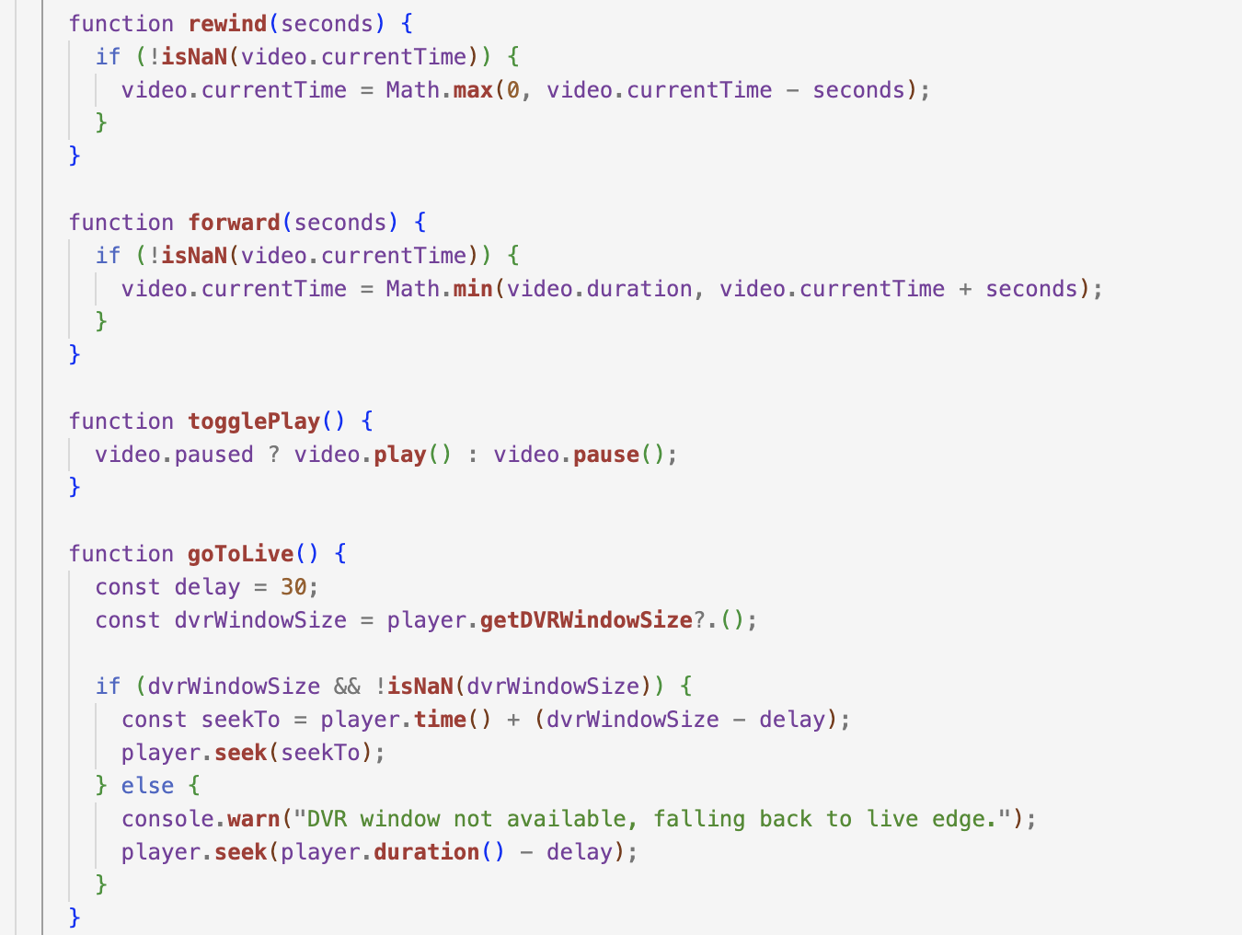

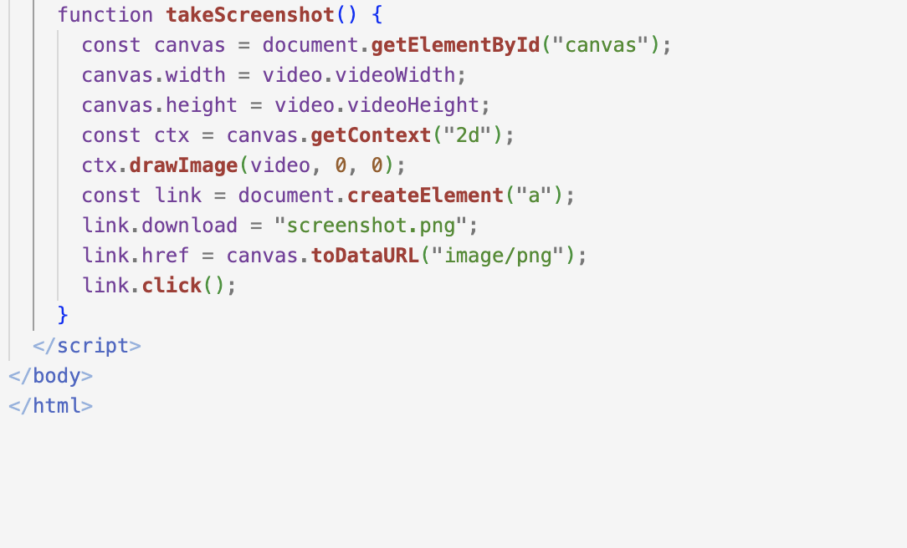

app.py:
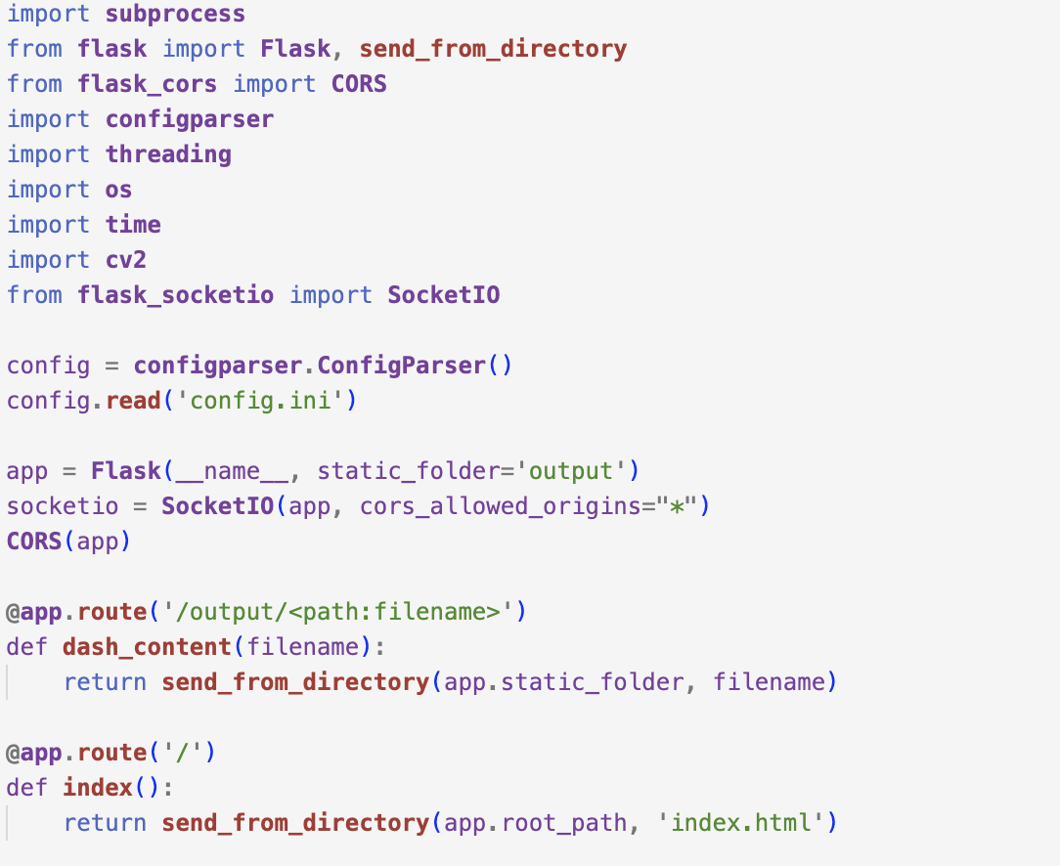
Imports required libraries:
-Flask for the web server
-OpenCV for motion detection
-FFmpeg handled via subprocess
-Socket.IO for real-time notifications
-configparser to load settings from config.ini
Also,
SocketIO(...) initializes real-time server-client communication.
@app.route(...) defines URL routes:
/output/<filename> serves video segments to the browser.
/ serves the main HTML page (index.html).

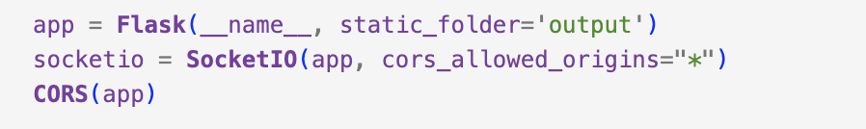
Initializes the Flask app. Static files are served from the output directory. Enables WebSocket communication using Socket.IO and allows cross-origin requests with CORS.
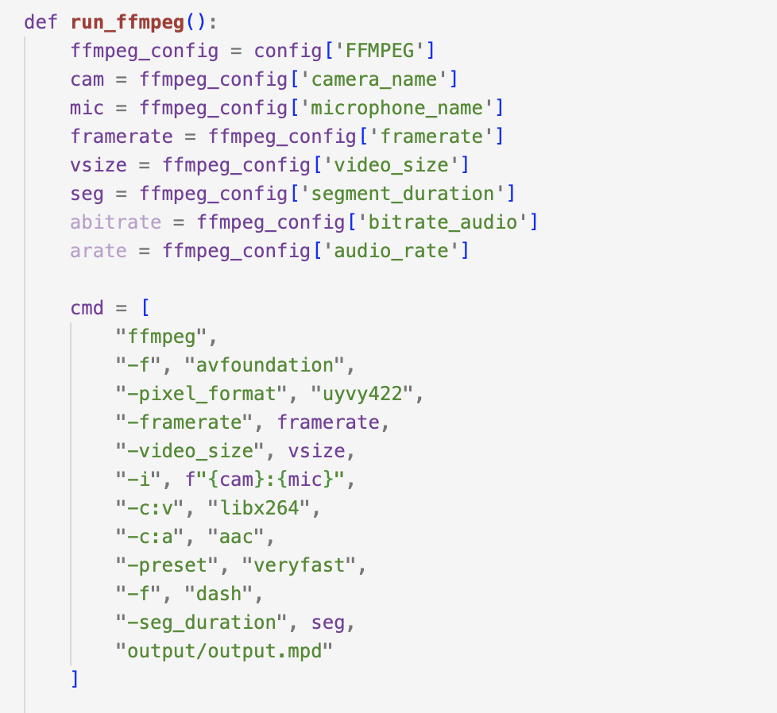
This function reads FFMPEG settings from the config.ini file and prepares an FFmpeg command to capture video/audio and stream it in DASH format.
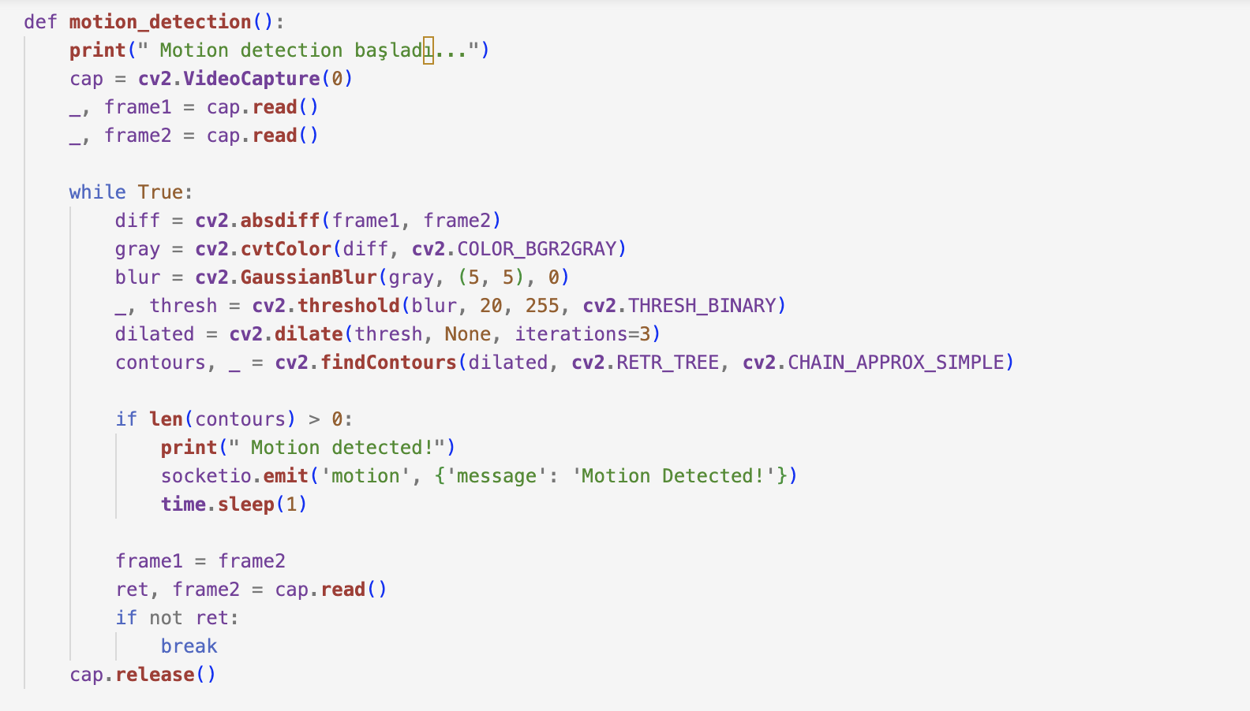
This setup uses the OpenCV library and enables live motion detection with instant feedback in the browser.
run_flask(): Starts the Flask web server. Although it's ready to run with SSL (HTTPS), it's currently using plain HTTP since the ssl_context line is commented out.
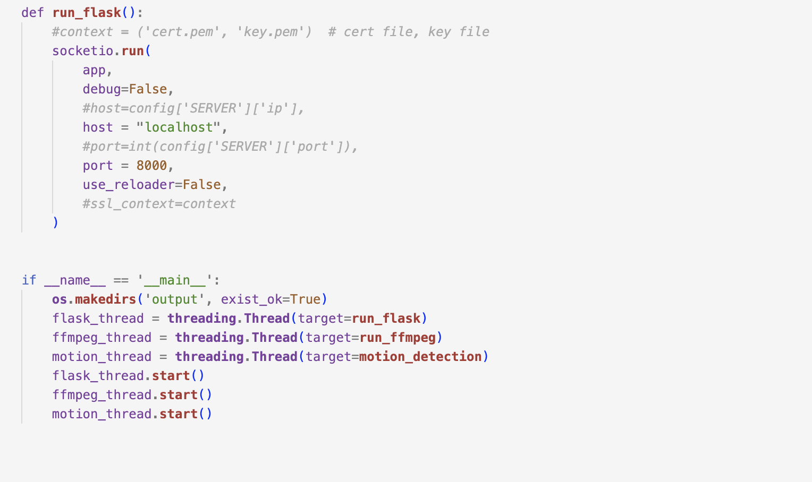
In the __main__ block:
Creates an output folder to store DASH segments.
Starts three separate threads to run: the Flask server, the FFmpeg stream, the motion detection system
This allows all systems to run simultaneously without blocking each other.

HOW TO RUN:
1-Fmpeg and Python should be installed on your system.
2-The following Python libraries must be installed: Flask, flask-cors, flask-socketio
3-Make sure ffmpeg is added to system PATH.
4-opencv-python3- Check or edit the configuration file config.ini to match your camera and microphone settings.
5- To execute the script, run the following command: python3 app.py
6- Open the application in your browser: http://127.0.0.1:8000/

Segment Duration Test Results:
I tested the stream using segment durations of 2, 4, and 6 seconds by modifying the segment_duration value in the config.ini file.
To measure the latency for each segment duration, I added the following line to the browser-side Dash.js player: player.getCurrentLiveLatency()
This allowed me to log the live latency in seconds to the console.
The measured results are as follows:
Segment Size: 2
Segment Size: 4
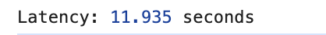
Segment Size: 6
The latency was measured as approximately 7.9 seconds with a 2-second segment size, around 11.9 seconds with 4 seconds, and about 13.9 seconds with 6-second segments. To support the results with examples, screenshots were included showing the observed latency for different segment durations.
The test results clearly show that increasing the segment duration leads to a noticeable rise in playback latency. This behavior is expected due to how DASH streaming works—players must wait for each segment to be fully generated before playback. In conclusion, shorter segments reduce delay but increase system/network demand, while longer segments enhance playback stability at the cost of higher latency. The optimal configuration depends on the specific use case and performance requirements.

