Unit-1 [Core Java]
Write a java code to print your name.
Write a java code to store information about student like rollno, name,age,percentage,address, result,grade.
Write a java code to input any three number and check whether which number is bigger.
Write a java code to input any one number and check whether given number is even or even.
Write a java code to input any one number and check whether given number is prime or not.
Write a java code to input any one number and create fibonancie series of given number.
N=5
Fibonancie series: 0 1 1 2 3 5 7 12…
Write a java code to input any one number and check whether given number is even or even but check based on set up flag variable.
Write a java code to input two number and swap these two numbers using third variable.
Write a java code to input any one number and generate factorial number for given number.
Write a java code to input any one number and create reverse number for given number.
Write a java code to input any one number and calculate sum of each digit of given number.
N=123
Sum=6
Write a java code to store name of the five students inside only one variable.
Write a java code to create a type casting for given inputs. Example: Input: 2.72 output: 2 Input: 5 output: 5.00
Write a java code to create following pyramid.
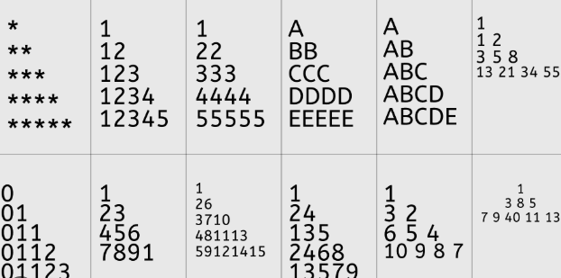
Write a java code to input any string and check whether given string is palindrome or not.

