Command-Line Argument
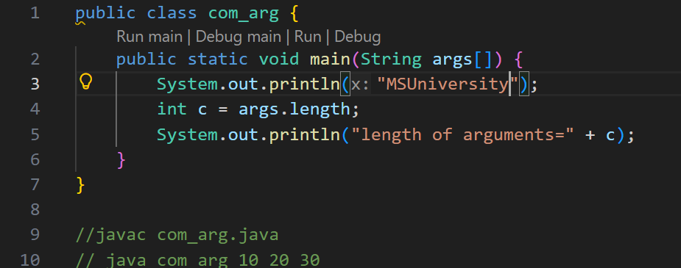

One Dimensional array:
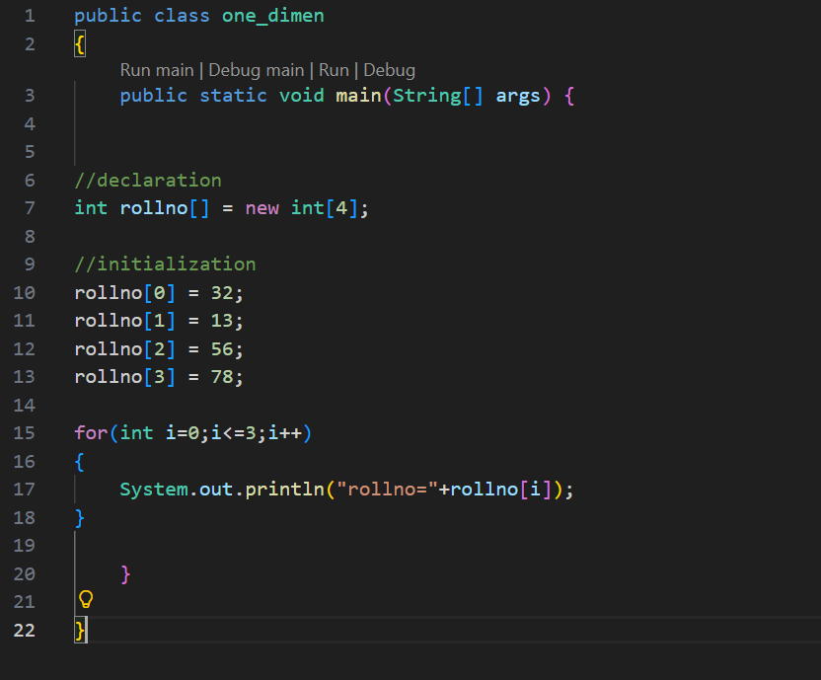

Two-dimensional array:
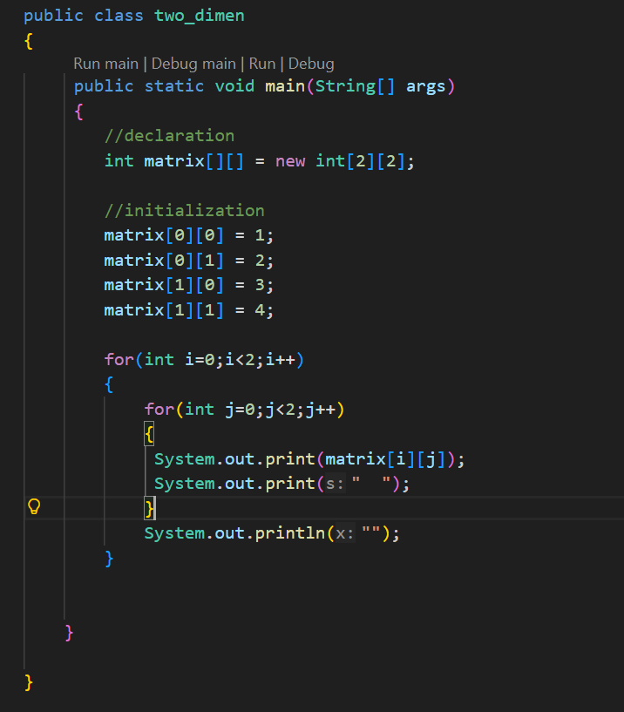

Three Dimension array:
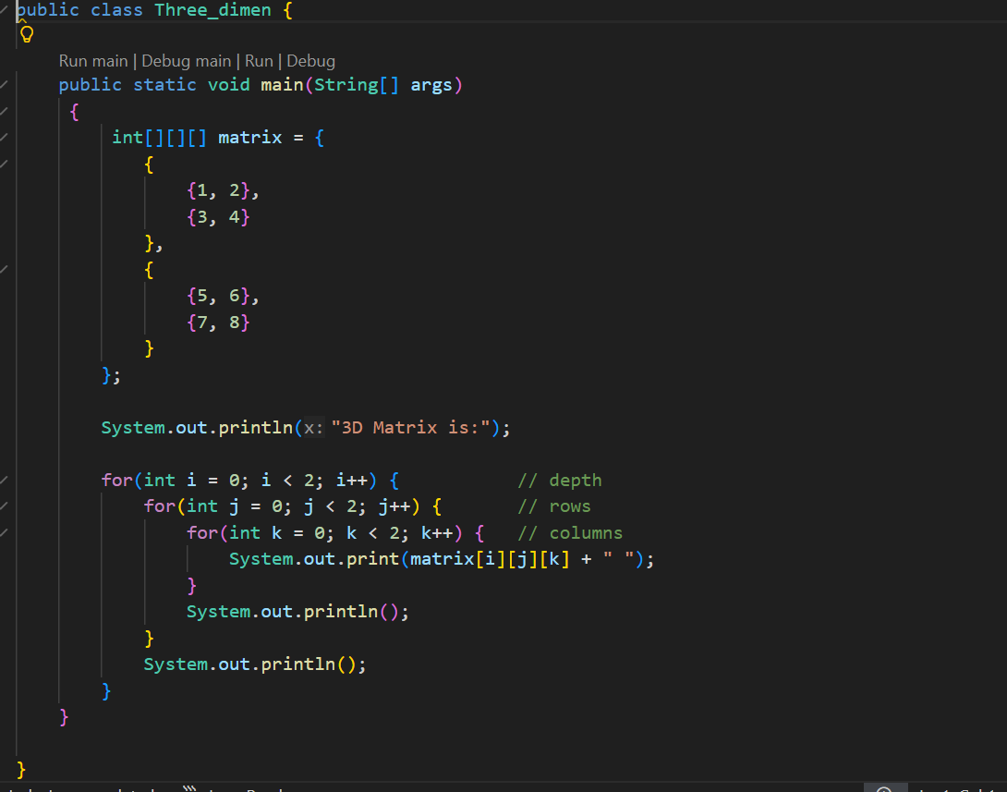

Matrix_3D:
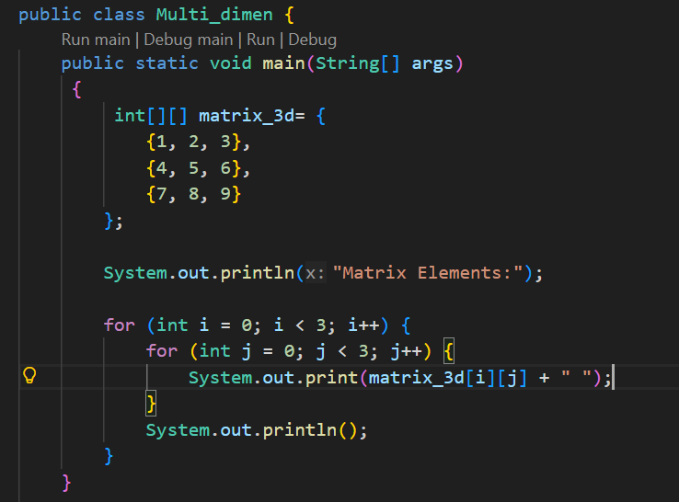

Table creation using an array:
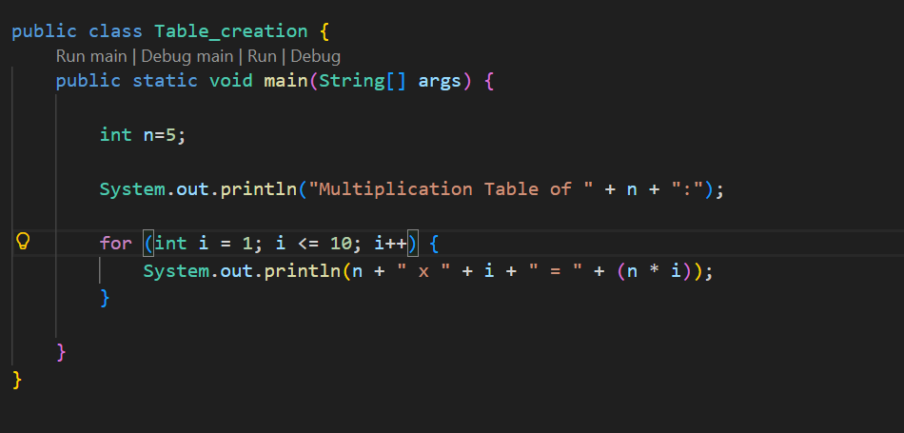
Traversal Of Matrix:
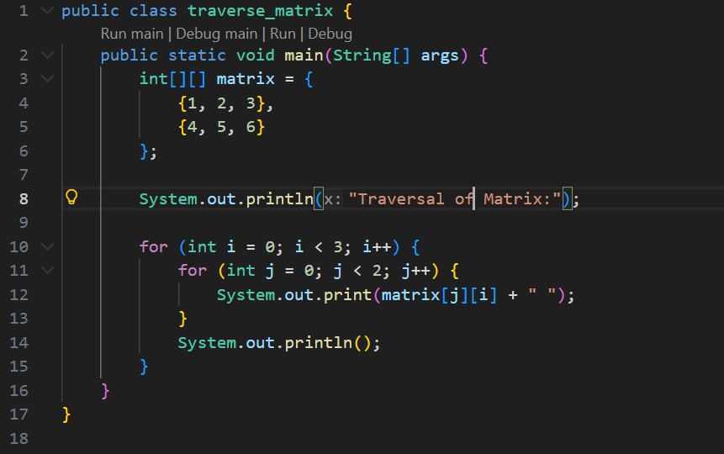

1. | Write a java code to create two different matrix array and calculate sum of it and generate new matrix.
2. | Using by above experiment1,create multiplication of two different matrix.

