Exercise-3
Write a Java code to print employee information (Name, ID, Department) using the Java Method.
Write a java code to calculate sum and cube of given number by creating pass by parameter.
Write a Java code to print average of 3 numbers by creating java methods.
Write a Java code to find factorial number of passing n number with java methods.
Write a java code to find given number is prime or not by using flag variable in java methods.
Write a java code to input any two numbers and then swap it using by third variable in java methods.
Write a Java method to compute the sum of digits in an integer.
Example: 1234 output:4321
Write a Java method to print multiplication table of given number.
Write a Java method to input any string and count how many characters are in given String.

Program-1
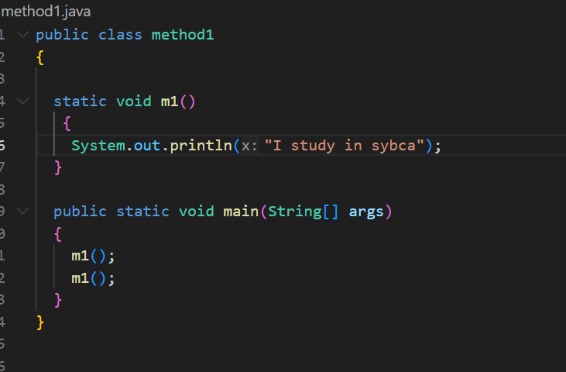

Program-2:
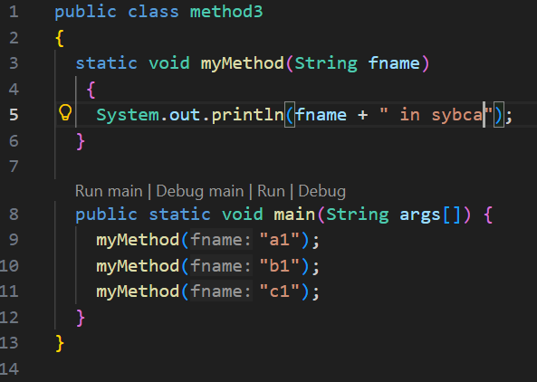

Program-3
Method using by return value with the help of flag variable.
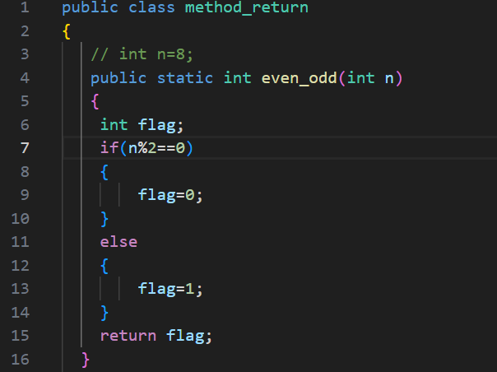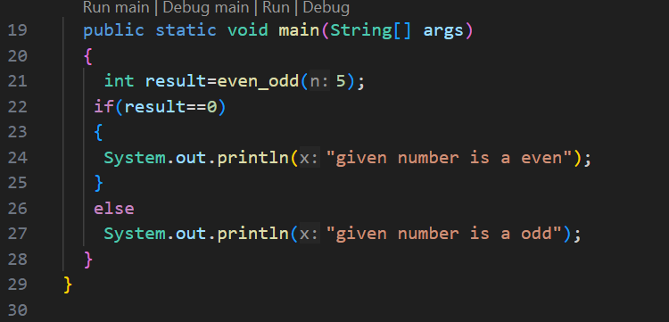

Program:4
