[Packages, Enum class, Wrapper class]
Program-1:
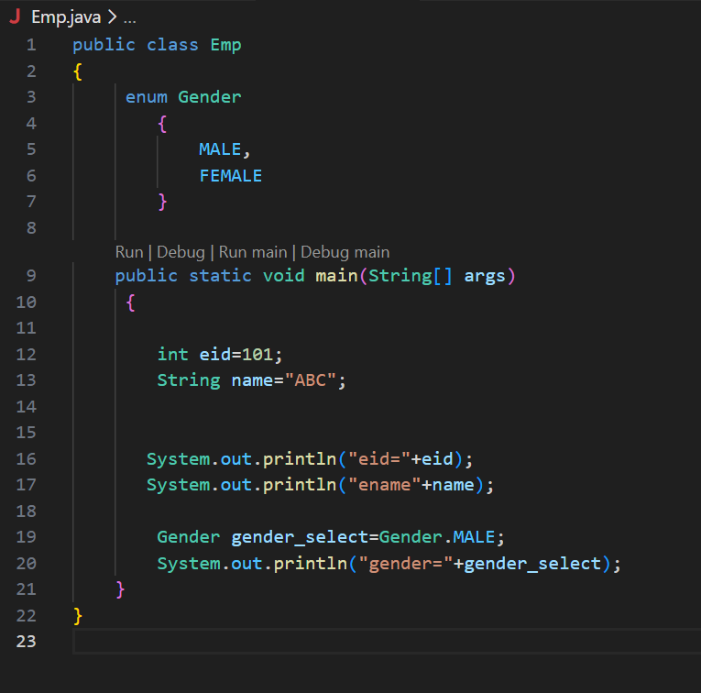

Program-2:
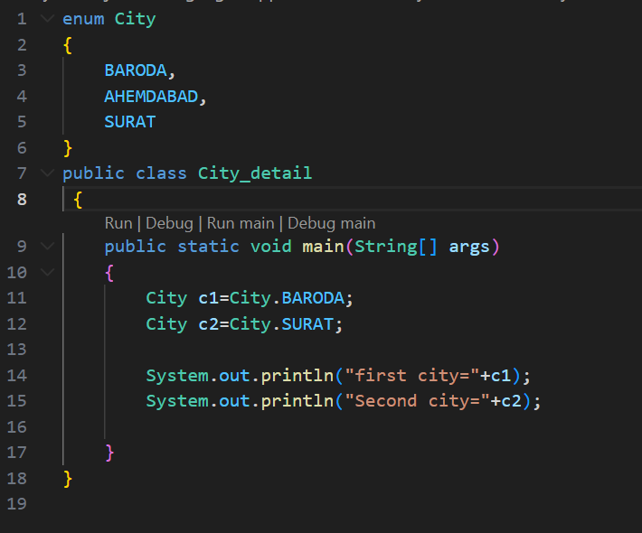

Program-3:
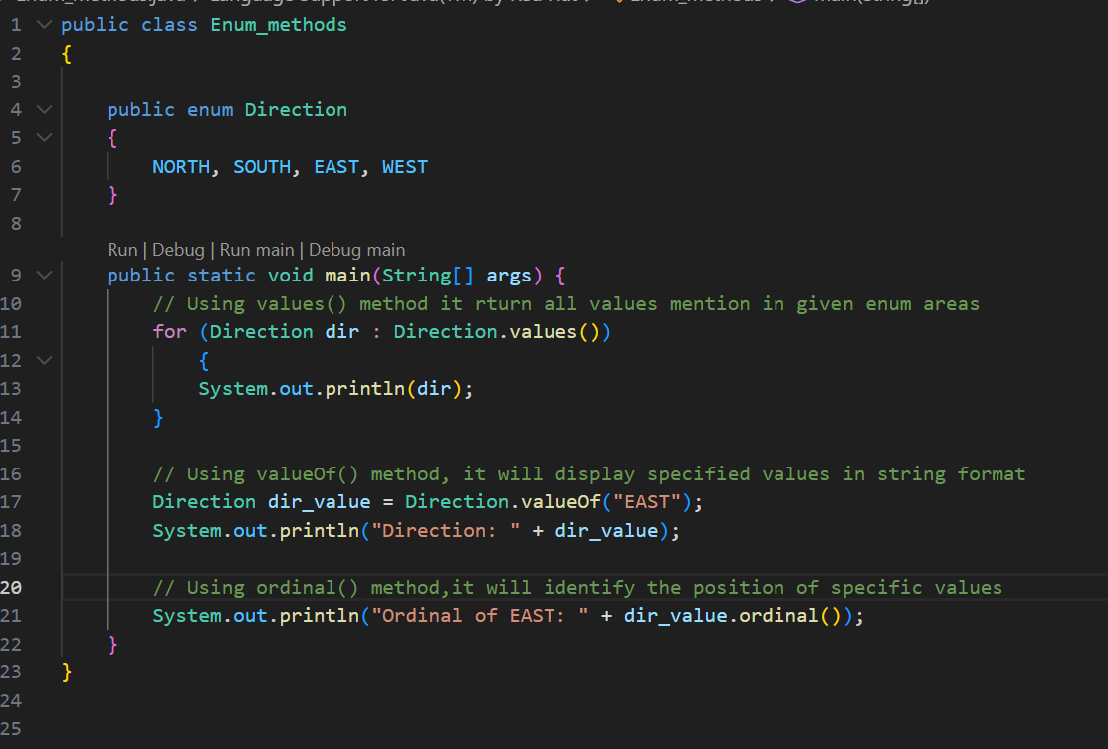

Program:4
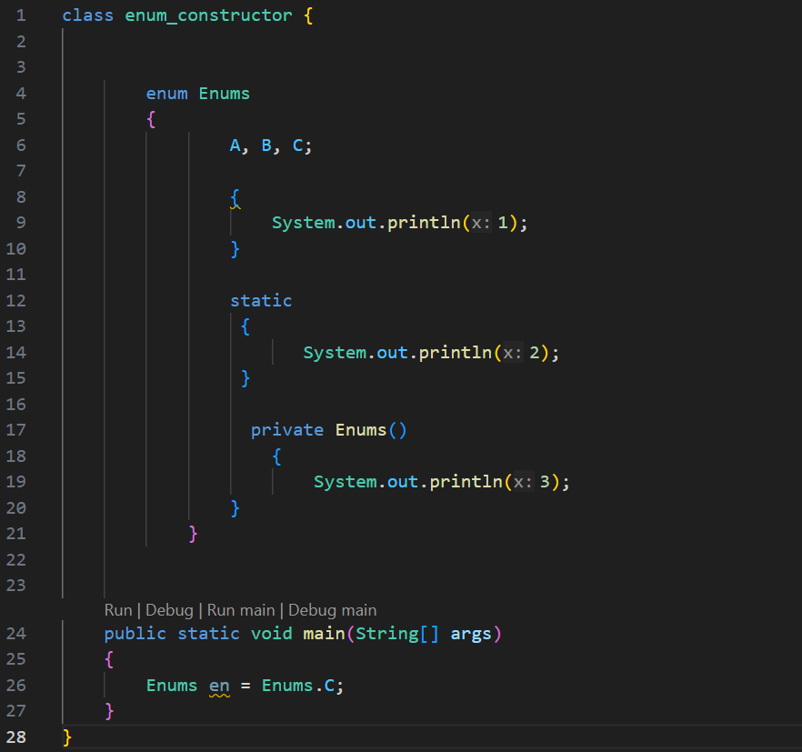

Program-5:
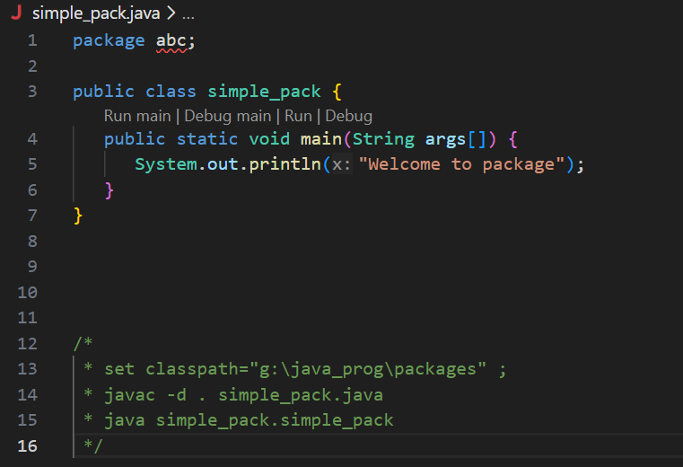

Program-6:
First file:
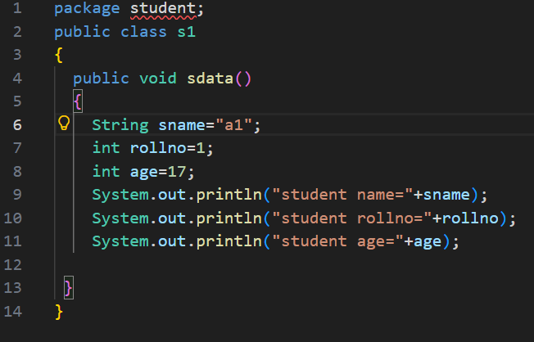

Second file:
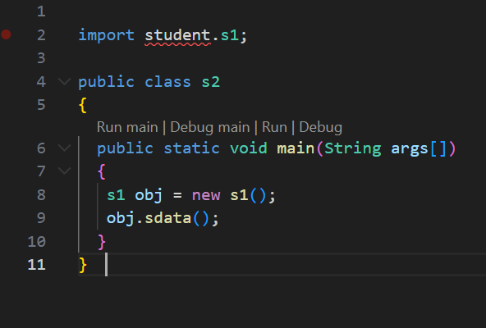

Program:7
First file:
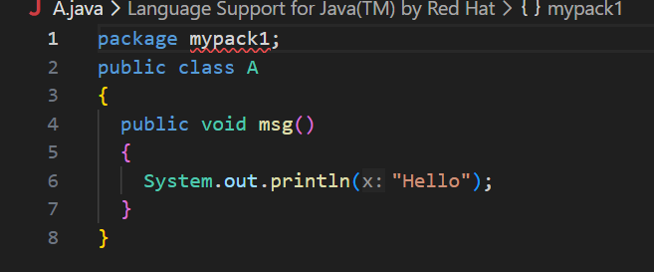

Second File:
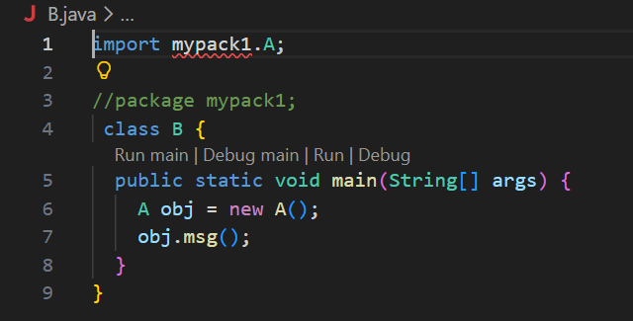

Program-8:
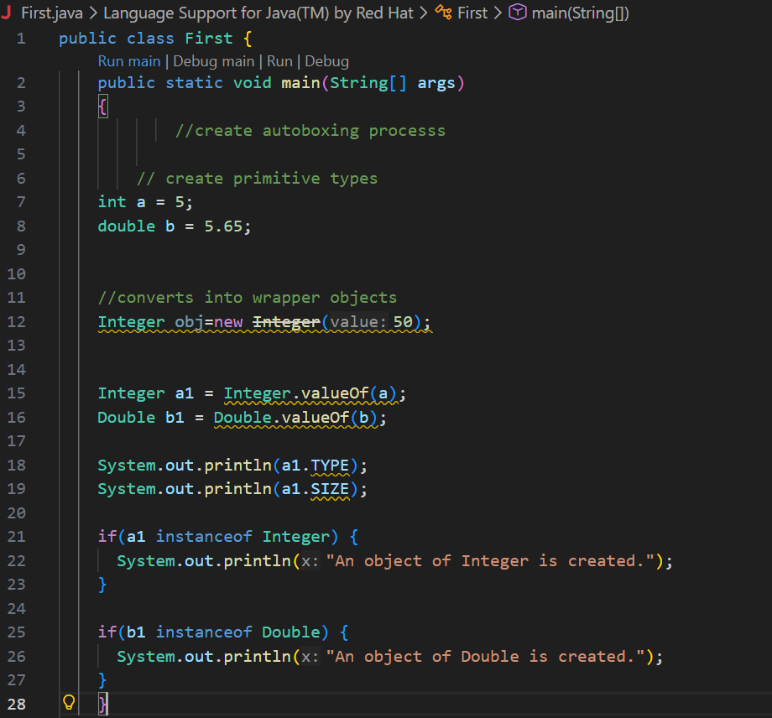
Program-9:

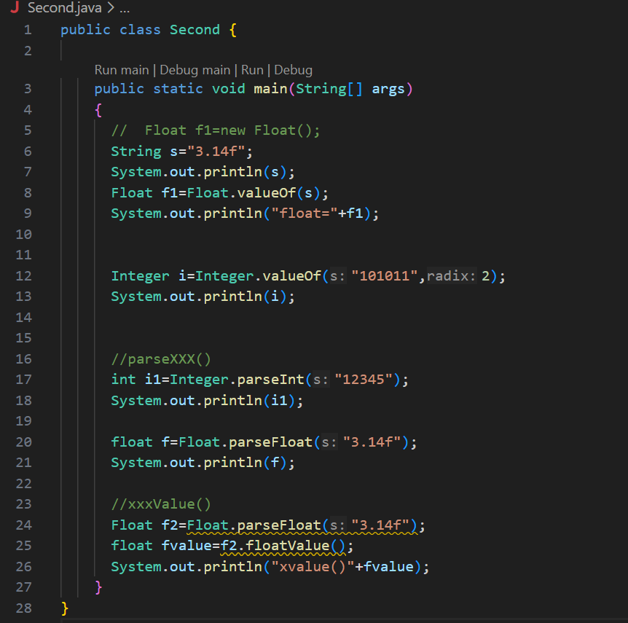

Program-10:
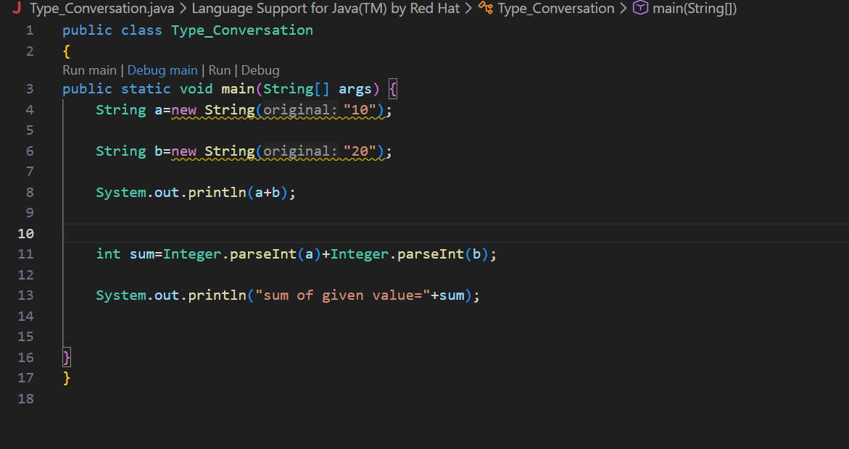

Write a Java program to create an enum called "DaysOfWeek" representing the days of the week.
Write a Java program to implement an enum called "Shape" with constants representing different geometric shapes.
Write a java program to swap two numbers using by third variable by defining UDF function and execute this swapping process package.
Write a java program to check inputted number is a even or odd which execute by creating a package name “EvenOdd”.

