 
Abstract—Inverse Radon Transform based image reconstruction has main importance in biomedical engineering. In this study, some applications in back projection and filtered back projection (FBP) with various filters namely Ram-Lak (ramp), Cosine and Hanning filters will be shown. These techniques will be applied to a simple square image and the Shepp-Logan phantom. Best results as reconstructed image are obtained by FBP technique using Cosine filter.
IMAGE RECONSTRUCTION
UNDER VARIOUS CONDITIONS USING PARALLEL BEAMS
Emre Ataklı, Department of Electrical & Electronics Engineering, METU. e211294@metu.edu.tr

Index Terms— Back-Projection, Filtering, Projection

INTRODUCTION
DR. Willem Roentgen has discovered X-rays in late 1895, in Wurtzburg, Germany, as a typical example of an accidental invention, seemingly, but an inspirational gift in reality. Roentgen was carrying out experiments with a Crookes tube, which is a lot common research tool at that time. When he applied large voltages to the tube to study the behavior of electrons emitted from the metal, he noticed that a piece of phosphorus substance shone. Upon this strange event, he started to try to understand what is really going on by doing a set of experiments. During these experiments he saw that the thing that causes the glow on phosphorus material can help take image of the human anatomy. After that, it had been understood that both light and X-rays are electromagnetic radiation whereas X-rays are different as they are high energy light. X-rays can penetrate through many objects because of being high energy light. But they penetrate differently through different materials according to their densities. For example, X-rays can penetrate through fat/muscle easier than bone. This is the basis in imaging the body with X-rays. After the imaging process, obtained X-ray data can be used to reconstruct medical images thanks to the fact that attenuation rate of X-rays in the body depends on tissue characteristics.[1]
In this study, some mathematical tools that are used in X-ray imaging will be implemented. Moreover, the effects of using different kind of filters, different number of beams and step sizes will be shown by comparing them.

THEORY
This study contains two parts as Projection and Image Reconstruction..

Fig. 1. Basic schematic of the procedure.

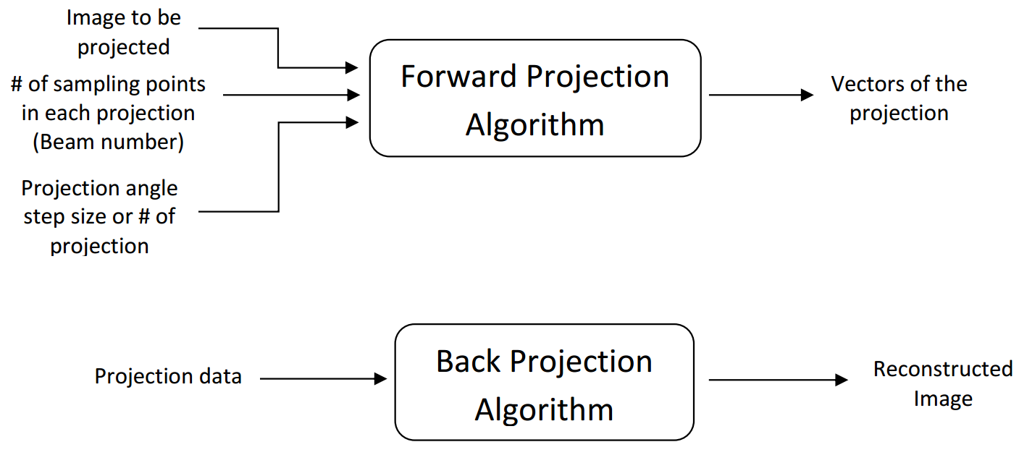Fig 1: Basic schematic of the procedure.

Mathematical background
The Radon transform and its inverse provide the mathematical foundation for reconstructing the tomographic image from projection data. [2]

Filters
Ramp Filter. The ramp filter is a high pass filter that does not permit low frequencies that cause blurring in the image. This type of filter is used to reduce the star artifact.
The Ramp Filter is a compensatory filter because it eliminates the star artifact resulting from simple back projection. High pass filters sharpen the edges of the image and enhance the edge information. A serious disadvantage of high pass filtering is the amplification of random noise in the image. In order to reduce the amplification of high-frequencies the ramp filter is combined with a low-pass filter.
The common method to reduce or remove random noise in a SPECT image is the application of smoothing filters. These filters are low-pass filters. In this study, two of the low pass filters were utilized: Hanning and Cosine Filters. [3]
Hanning Filter. The Hanning filter is a simple low-pass filter. [4]
Cosine Filter. This type of filter is the standard response multiplied by a cosine shape. [5]

Algorithm
In this study, these following steps were applied to take projection of the input image:
- Input image, step size and number of beams were specified by the user.
- Θ values were determined according to the step size and t values were determined according to the number of beams and the size of the image.
- Intersection points for all beams for all projection angles were found using the line equation.
- The points that are irrelevant to the image were removed.
- The relevant points were sorted.
- The midpoints and length of each line segment were calculated.
- The address, i.e. row and column data were found by using the size and midpoint data.
- All pixel values and corresponding distance products. were summed (in other words, taking integral)
Secondly, these following steps were applied to take back projection of the input image:
- Discrete Fourier Transform of the projection data was obtained.
- Projection in the frequency domain was multiplied by a desired filter in order to get rid of low frequency components in the projection data.
- Inverse Fourier Transform was obtained.
- Finally, the filtered projection data was back-projected by multiplying the distance by the projection data.
- The resultant image was shown by normalizing it.

RESULTS
With the help of this study, the effect of different type of filters, different number of beams and step sizes can be easily shown and compared each other. Below some of those results are included.
Python has been used for the implementation of the projection and back projection algorithms and simulation of their resultant images.
The images used for producing the projections for image reconstruction are given in Fig. 4(a) and Fig. 5(a) as a square image and Shepp-Logan phantom.
Results which act as quantitative evaluation measures are listed in tabular form in Table 1.
As seen from two different error measures, (in which MSE is Mean Squared Error), Cosine Filter is the best filter as compared to ramp filter and Hanning Filter.

Conclusion

Although this study shows the effect of various filters, number of projections and step sizes on quality of the back projection image, this study can be extended with more images and filters to show their effects more clearly.
References
- https://sunnybrook.ca/research/content/?page=sri-groups-xray-info-3
- Shahzad Ahmad Qureshi, Sikander M. Mirza, M. Arif, “Inverse Radon Transform-Based Image Reconstruction Using Various Frequency Domain Filters In Parallel Beam Transmission Tomography”
- Maria Lyra and Agapi Ploussi, “Filtering in SPECT Image Reconstruction” International Journal of Biomedical Imaging, June 2011.
- M. N. Salihin Yusoff and A. Zakaria, “Determination of the optimum filter for qualitative and quantitative 99mTc myocardial SPECT imaging,” Iranian Journal of Radiation Research, vol. 6, no. 4, pp. 173–181, 2009.
- https://octave.sourceforge.io/image/function/rho_filter.html

TABLE I
Errors And Elapsed Tımes Under
Dıfferent Condıtıons of Projectıons
Shepp-Logan
 | Average Error | MSE | Elapsed Time
Ramp | 0.148 | 0.043 | 19.2
Hanning | 0.179 | 0.069 | 23.46
Cosine | -0.108 | 0.044 | 18.96
No filter | -2.953 | 9.500 | 18.18
Square
 | Average Error | MSE | Elapsed Time
Ramp | 0.134 | 0.054 | 18.72
Hanning | 0.053 | 0.034 | 19.14
Cosine | -0.076 | 0.026 | 18.54
No filter | -0.952 | 1.061 | 15.3

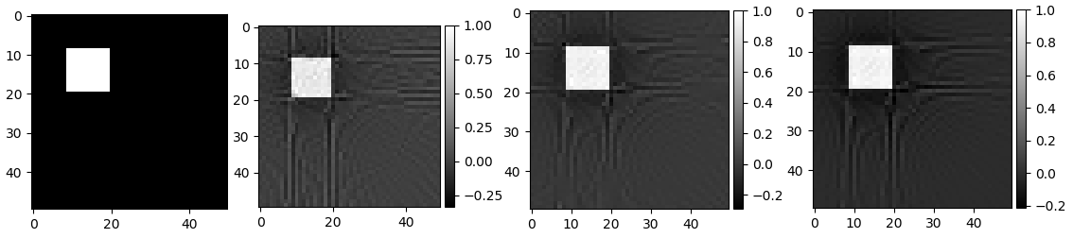
Fig. 1. Images of Square phantom reconstructed with filter for 45, 90 and 180 projections respectively.

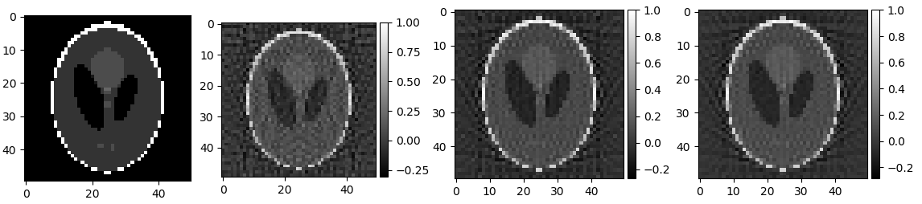
Fig. 1. Images of Shepp-Logan phantom reconstructed with filter for 45, 90 and 180 projections respectively.

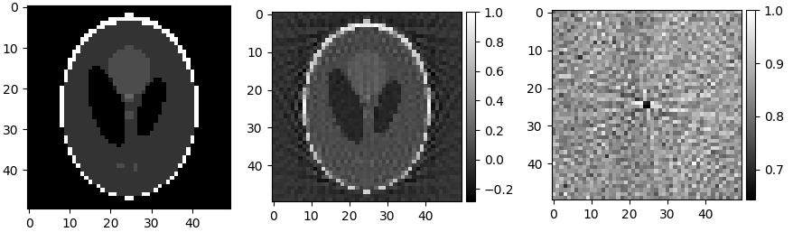Fig 2: Images of Shepp-Logan phantom reconstructed with and without filter. (Filter type is ramp)

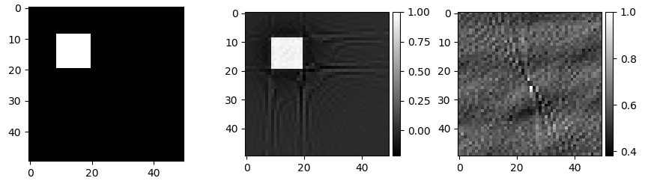
Fig. 1. Images of Square phantom reconstructed with and without filter. (Filter type is ramp)

 

