Emre Ataklı- 2112944 11.12.2019
Abdullah Temel-2167344
EE 430- Project- Part 2
Basic system implementation in MATLAB
We implement the following modulation methods: (The required Matlab codes are in the zip file )
• Frequency-shift keying (FSK)
• Binary phase-shift keying (BPSK)
• Quadrature phase-shift keying (QPSK)

- FSK
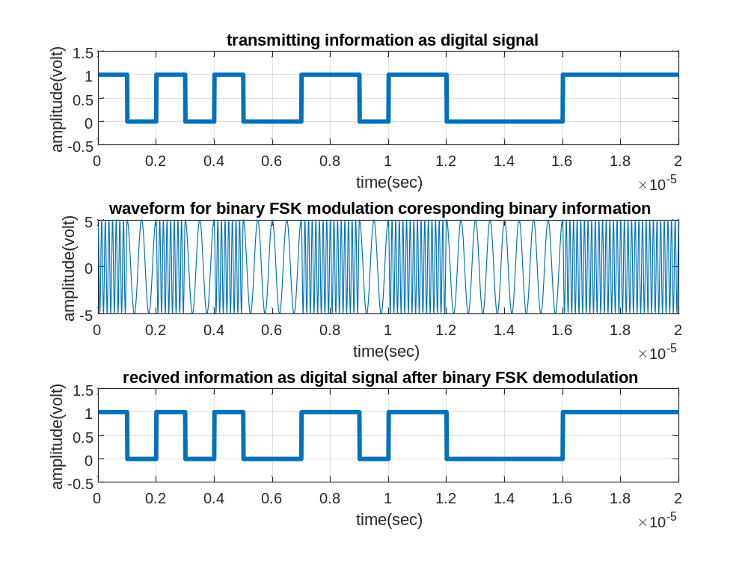
Figure 1.Modulation and demodulation plots for FSK

- BPSK

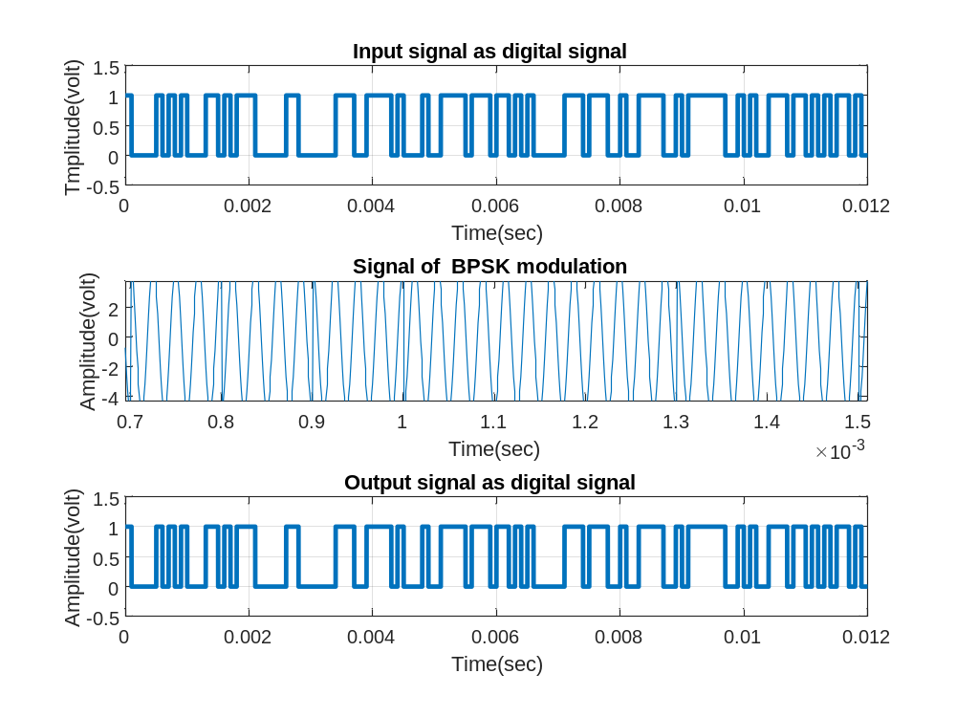
Figure 2.Modulation and demodulation plots for BPSK
- QPSK
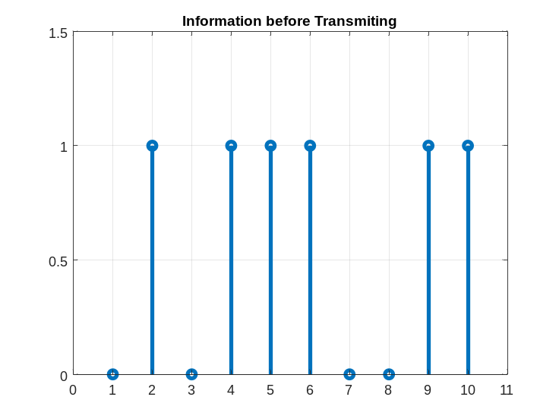
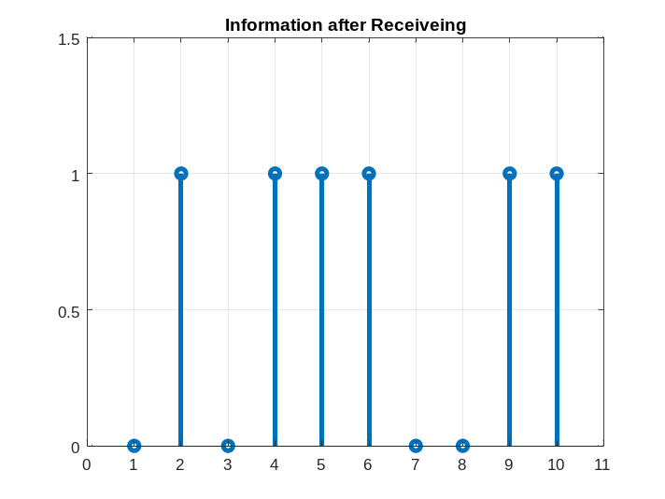
Figure 3. Arbitrary information before transmiting Figure 4. The received information after transmitting using QPSK

