1 How To Use This Document

Highly regulated industries, such as banking and insurance, must comply with government regulations for model validation before a model can be put into production. This includes creating robust model development documentation. DataRobot automates the generation of model documentation, expediting the process required for regulatory compliance and following best practice for reducing model risk.

This document is split into two components: those sections that are automatically produced by DataRobot and those that require further input by the user. The sections in blue italicized font include specific instructions for the documenter and require additional user input of organization-specific information, such as business use cases, data sources, and implementation details. Once the sections are complete, remove the instructions. The remaining sections in non-blue italicized font are automatically populated by DataRobot and require no further input.

Copyright ©2024, DataRobot, Inc.

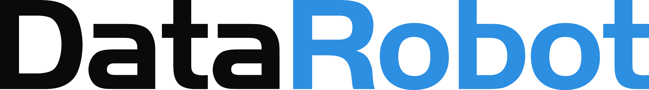

Table of Contents

* 1 How To Use This Document
* 2 Statistical Tests

2 Statistical Tests

Cooks distance

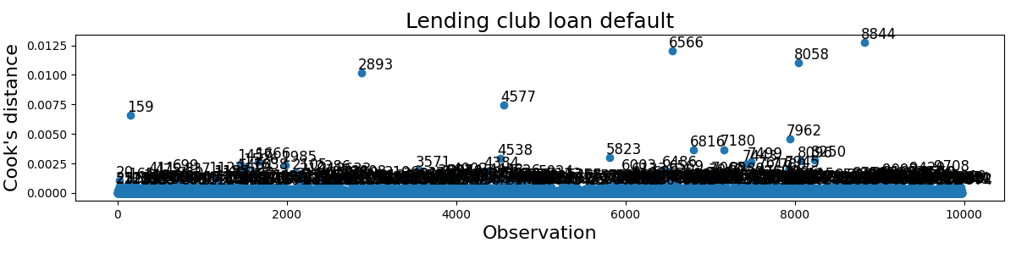

Autocorrelation

