Software Project Proposal: PathFinder
Project Description
PathFinder is a solution to the lack of a unified system between Workday (course registration and tracking academic progress), the Muhlenberg Catalog (course of study overviews), and other digital resources used for academic planning by students at Muhlenberg. It also serves as a solution to the lack of clear explanation of GARs and core curriculum at Muhlenberg to both students and advisors, which results in confusion and inefficient academic planning.

Target Users and Stakeholders
PathFinder’s primary target users are college students at Muhlenberg, who would use PathFinder to get a better understanding of their academic plan so that they can make informed decisions regarding course registration and their chosen area of study. The secondary target users are academic advisors for students at Muhlenberg, who would use PathFinder to easily view the progress of multiple advisees simultaneously in one central portal.

Key Features and Functionality
One key feature of PathFinder is a progress overview tab, which will show how much of the requirements for a major, minor, or GARs a student has completed. It will also show what specifically is left to be completed in a more detailed view if the user selects this. Another feature will be the opportunity finder, which calculates the top few majors or minors the student could add with the most overlap (i.e. least additional courses) to complement their existing area of study. PathFinder would also have a tab at the top of the window that gives a brief overview of the student, listing their name, class year, and declared area of study. The last key feature would be HAL, an AI-based chatbot for the student to receive more information about their academic progress.

Intended Tools and Technologies (Not Finalized)
- Front-End: JavaScript (HTML + CSS) OR Flutter (Dart)
- Back-End: JavaScript (Node.JS and Express)
- Database: SQLite

Tentative Project Timeline
- October 1 - Presentation #1 (preferably we’ll have working front-end to demonstrate)
- Late October - Presentation #2
  - Working Front-End with Basic Features, Prototype of Back-End (if time permits)
- Late November - Presentation #3 (optional presentation)
  - Front-End Finalized, Working Back-End (mostly complete), Professor Demos
- Early December - Class Demo
  - Working Version (ideally with advisor view implemented if time permits)
Hand Drawn Sketch
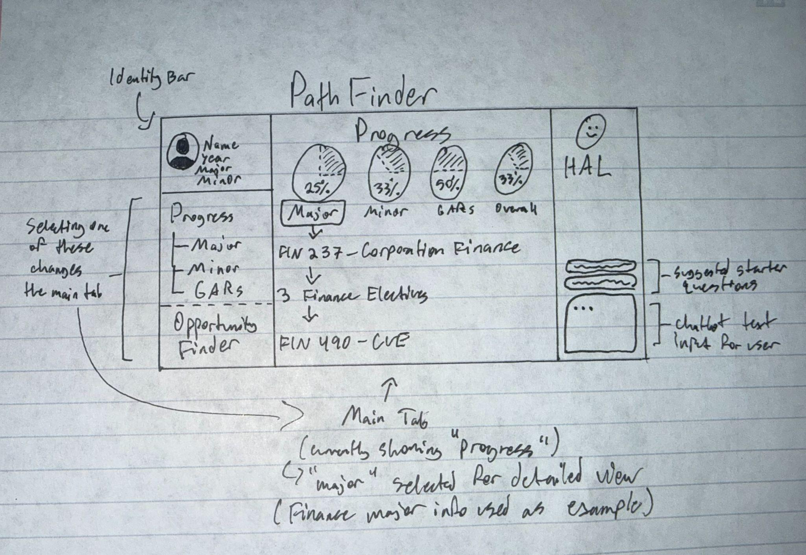

Front-End Prototype (Python with tkinter library)